PatchWing
User Manual
Finding vulnerabilities isn't the bottleneck. Verified fixing is.
PatchWing takes a known bug and produces a fix a maintainer can merge in minutes: a reproducer that fails before and passes after, the patch, the project's suite still green, a byte-exact rollback proof, and a container anyone can re-run. The product is the evidence, not the patch — and a machine never signs off its own work.
Defensive vulnerability closure · self-hosted, single-tenant · every step recorded in an auditable log

Part I — Why PatchWing
The short version: finding vulnerabilities stopped being the hard part. Fixing them — with proof, at the rate they're found — is the bottleneck now, and almost nothing is built for it.

The bottleneck moved
Security tooling spent a decade optimising discovery — scanners, fuzzers, and now AI that finds novel zero-days faster than any human team. It worked; we are drowning in findings. Anthropic's Project Glasswing framing put a number on it: partners have identified 10,000+ high/critical vulnerabilities, and fewer than 1% have been patched.
The thesis, in Anthropic's own framing
Discovering vulnerabilities at scale without remediating them at comparable scale produces a growing list of exposures, not improved security. Past a point, more finding makes things worse — a longer list of live bugs with no one to close them.

The economics are lopsided
Put money on both sides of the gap and it stops being a close call. A breach from a single unpatched vulnerability costs, on average, $4.99M globally — $11.5M in the US (IBM, Cost of a Data Breach 2026); AI-enabled breaches, now one in four, run about $6M. The same report names the gap directly: only 18% of organisations apply AI to vulnerability management at all — the finding side is automated, the fixing side still isn't.
Against those numbers, closing a bug is nearly free. These are real spends from PatchWing's own runs, not projections. The decompress CVE it closed end to end — reproduced, patched, and verified with a byte-exact rollback proof — cost about $1.28 of inference on a hosted Together endpoint (~4¢ on a cheaper model tier, ~$0 self-hosted). Even the worst run — a target it failed to close after eight patch attempts — cost $5.08 before its budget stopped it. Both ran under a $25 per-finding ceiling that was never approached: the cap is a safety rail, not a bill.
The asymmetry
A fix costs single-digit dollars; the breach it forecloses averages millions — a gap of hundreds of thousands to one. Closing the queue isn't a virtue play. On any spreadsheet it's the cheapest line item in security.

Do the math — illustrative, with no breach probability assumed; just the raw cost asymmetry. Annual program cost = fixes per month × 12 × cost per fix, where cost per fix comes from the real runs above (~4¢ cheap tier, ~$1.28 flagship hosted, ~$0 self-hosted), against one $4.99M average breach:
Throughput | Tier | Per fix | Per year | Share of one $4.99M breach
10 fixes / mo | Flash | $0.14 | ~$17 | 0.0003%
50 fixes / mo | flagship | $1.28 | ~$768 | 0.015%
200 fixes / mo | flagship | $1.28 | ~$3,072 | 0.062%
50 fixes / mo | self-hosted | ~$0 | compute only | ~0%

The break-even is absurd in your favour
At the most expensive tier, closing 200 bugs a month, you would run PatchWing for ~1,600 years before its total cost equalled one average breach. The program pays for itself if it prevents a single incident in any plausible lifetime of the software. (The one cost this omits is the genuinely scarce one — maintainer review time — which the evidence bundle is built to cut to ~60 seconds, but which varies too much by team to dollarise.)

The pressure is regulatory now, not just prudent
As of 11 September 2026 the EU Cyber Resilience Act's reporting obligations are in effect. When a manufacturer finds a vulnerability in a third-party component it must notify that component's maintainer — so EU law now pushes more findings at open-source maintainers, with no corresponding obligation on anyone to supply a fix. And for an actively-exploited vulnerability the CRA's final-report clock — due within 14 days of a corrective measure being available — turns a verified, ready-to-merge fix into something with a legal deadline attached. The remediation gap isn't just a security problem anymore; it's a compliance one, on a calendar.

The patch was never the hard part
A model writes a plausible patch on demand. What's actually scarce is the evidence that it closes the bug (nobody merges an AI patch on faith), the reviewer's time (maintainers are the genuine bottleneck, already drowning in low-quality AI-generated reports), and the liability if it regresses. So the patch is nearly free — the product is the evidence. That gives the whole design its governing rule: a PatchWing PR must be cheaper to review than to ignore.

Why the existing tools don't cover this
Scanners find; they don't fix. "Auto-remediation" (Dependabot, GitLab) bumps a dependency to a fixed version when one already exists — but the unpatched findings are unpatched precisely because there is no version to bump to; nobody has written the fix yet. And the AI systems that find these at scale are withheld for lack of misuse safeguards, so you can't compete on discovery against models you can't obtain. The fix queue, by contrast, is wide open — PatchWing is complementary to the finders, not competitive with them.

Why it runs inside your perimeter
When Hugging Face was breached by an autonomous AI agent in July 2026 and its team asked hosted frontier models to analyse the attack logs, the models refused — their guardrails couldn't tell an attacker building an exploit from a defender detecting one. HF fell back to a self-hosted open-weight model (GLM-5.2) inside their own perimeter. That is PatchWing's architecture, improvised live by a marquee victim: no default provider, per-role endpoints you control, keys that never leave your box, a reproducer sandbox with no network.
Nobody is short of findings. Everyone is short of verified fixes. That's the gap PatchWing exists to close — and Part II is how.
Sources: Anthropic, “Project Glasswing: an initial update”; IBM, “Cost of a Data Breach 2026” (ibm.com/reports/data-breach); European Commission, CRA reporting obligations (digital-strategy.ec.europa.eu/en/policies/cra-reporting); Hugging Face, July 2026 security-incident disclosure. PatchWing run costs are its own recorded token counts priced at Together's public GLM-5.2 rate ($1.40/$4.40 per 1M).

Part II — How to use it

1. What PatchWing is
Scanners and fuzzers and AI find vulnerabilities faster than anyone can fix them. Verified fixing is the bottleneck, and PatchWing is built for that half. It is not a scanner — discovery is an input. You bring a known bug (an advisory, a Semgrep hit, a fuzzer crash on code you own) and PatchWing produces a closure a maintainer can accept in the few minutes it takes to read it.
Property | What it means
Sandboxed proof | Every reproducer and verification runs in a disposable container with no network. The bug is demonstrated on real code, not asserted.
Bring your own model | Per-role endpoints for any OpenAI-compatible provider — Together, OpenAI, self-hosted vLLM/Ollama — plus native Claude. Keys stay on your box.
Adversarial by design | The fixer and the verifier are different model families, so the second opinion doesn't share the first's blind spots. A machine never signs off its own work.
Definition-A only | Reproducers demonstrate a trigger and an observable boundary violation, and stop there — exploitability proof, nothing weaponized beyond it.

2. How it works
A finding walks the pipeline strictly forward — there is no branch backward:
ingest -> localize -> provision -> reproduce -> patch -> verify -> package -> review

The part that makes a "green" worth anything is the verdict, and it is read from the reproducer's output — never its exit code, never an event log. There are four states, never two:
State | Meaning
confirmed_red | Marker / rule present AND the crash identity matches the pristine reproducer. The bug fired.
confirmed_green | Clean, no marker; every declared rule affirmatively reached a non-vulnerable reading.
different_bug | A marker fired, but the crash identity does not match. Not our bug.
harness_fault | No marker + non-zero exit, a timeout, or a reading too fast to be real. Absence, not a verdict.

different_bug and harness_fault are neither red nor green and must never fold into either — the whole module exists to keep absence from wearing failure's face.
The chain: red -> apply -> green -> revert -> red again
Inside one persistent container: hash the file, apply the fix, re-hash the frozen reproducer files (any change voids the run — that's the wall), build, run -> must be confirmed_green. Then revert to the exact pre-patch bytes (asserting after_revert == before_patch byte-for-byte — the §6a hash triple), rebuild, run -> must read confirmed_red again. That last step proves the fix is what closed the bug, not a coincidence. The target outcome is verify_green_rollback_red.

Rollback is evidence, not a gate.
If the revert does not come back red, that does not reject the patch — the container already ruled green. It indicts the undo mechanism or the oracle, and is recorded honestly (verify_green_rollback_not_red), never hidden.

3. Install
Zero third-party dependencies — standard library only, Python 3.11+ (it needs tomllib). No build step.
$ git clone <your-clone-url> patchwing
$ cd patchwing
$ python -m patchwing.cli --help # sanity check

All state lives in a single SQLite file (patchwing.db). You can inspect the whole process at any time without running PatchWing: sqlite3 patchwing.db.

4. Configure — point it at your own endpoint
There is no default provider. You point each role at an endpoint you control. Keys live in the environment, never in the config file — the file names an env var, it does not hold the secret. Four roles: detect, provision, patch, verify.
[models.patch] # the fixer -- a strong code model
endpoint = "http://localhost:8000/v1"
model = "your-model"
temperature = 0.2
api_key_env = "PATCHWING_KEY" # names the env var, not the key

[models.verify] # a DIFFERENT model family
endpoint = "http://localhost:8000/v1"
model = "a-different-family-model"
temperature = 0.0 # max determinism for the verdict seat
api_key_env = "PATCHWING_KEY"

[sandbox]
backend = "podman"
network = "none" # the reproducer pod has no network
provision_network = "bridge" # only the build phase may fetch deps

[pipeline]
max_usd_per_finding = 25.0
reproducer_scope = "definition_a"

$ export PATCHWING_KEY=... # the secret lives here, in the environment
$ python -m patchwing.cli config # prints each role: model [family] endpoint key=masked

Make the verifier a different family than the fixer
That is what makes the adversarial second opinion worth anything — a same-family reviewer shares the fixer's blind spots. `config` prints a [family] tag per seat; eyeball that they differ. The container decides the verdict either way; the verify model only writes an advisory opinion.

You can also set the seats from the web Providers page. Those land in the model_config table and override the file. Provider presets (OpenAI, Claude, Together, self-hosted) prefill endpoint and the env-var name for you, never the key. Stored keys are never shown back or written to disk.
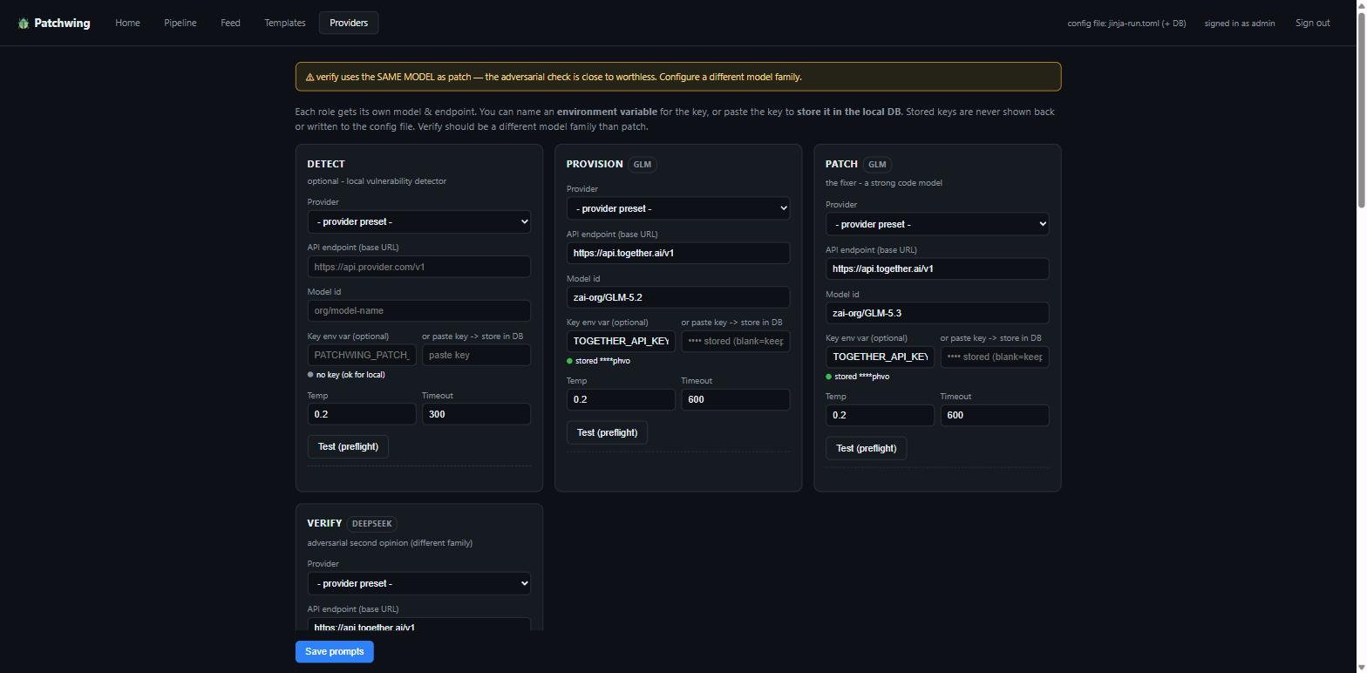
Providers. Each role gets its own endpoint + model. Here patch is on GLM-5.3 and verify on a DeepSeek model — a different family — each with a Test (preflight) button.

5. Preflight — probe before you spend
$ python -m patchwing.cli preflight

For each configured role this checks: reachable (endpoint answers), json_ok (returns parseable structured output), and security_ok — whether the endpoint will engage with a plainly defensive security prompt instead of refusing it. That third check is the one that matters: a guardrailed endpoint that refuses "help me fix this vulnerability" is useless here, and you want to learn that at startup, not three hours into a batch. Non-zero exit if any role fails, so it drops into CI.

6. Add & run a finding
$ python -m patchwing.cli add https://github.com/org/proj \
--source advisory --ref GHSA-xxxx-1111 --cwe CWE-22 \
--title "Path traversal in archive extractor"

$ python -m patchwing.cli run # advance everything ready
$ python -m patchwing.cli run --limit 1 # one step at a time
$ python -m patchwing.cli status # stage x state matrix
$ python -m patchwing.cli show <id> # artifacts, events, staleness
$ python -m patchwing.cli unblock <id> --note "reviewed"

Stages that need a model but have none block with a reason rather than failing, so you can see the shape before committing a key. A verify rejection is terminal for that attempt — the finding stops and waits for you (the "machine never signs off" rule). The recursive retrying happens inside the patch stage (§9), never by the runner re-queuing rejects.

7. The web console
Start the UI with python -m patchwing.cli serve — admin-authenticated; on first start it seeds a default admin/admin login, bound to 127.0.0.1:8700. There is no in-UI password change yet, so keep it on localhost. It mirrors the CLI and adds drill-down.
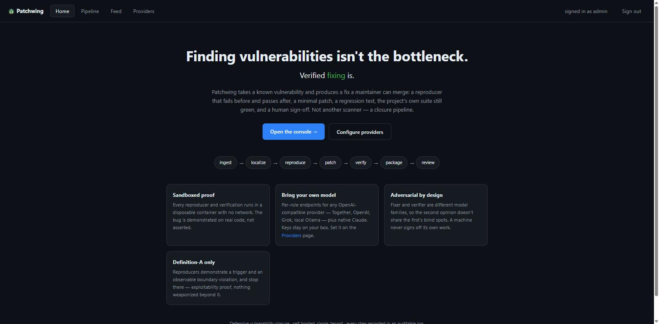
Home. The thesis, the pipeline at a glance, and the four properties.
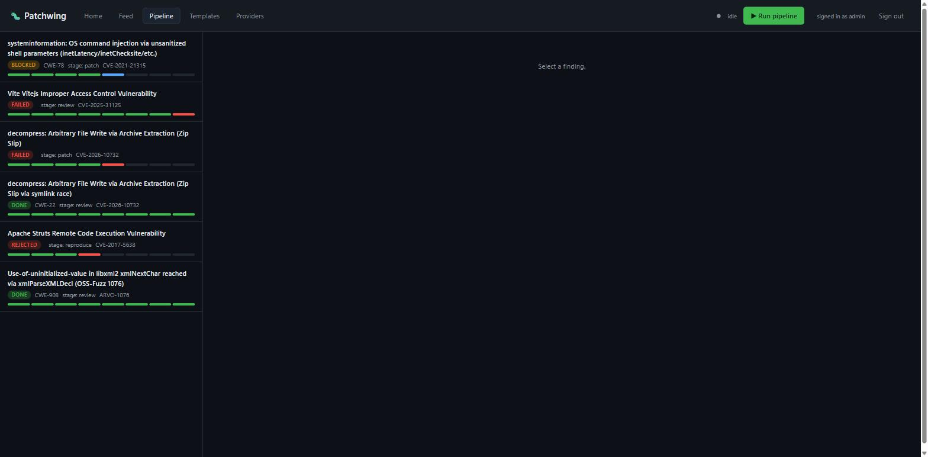
Pipeline console. Every finding with a per-stage progress bar and a state pill. The two DONE findings (a decompress Zip-Slip and a libxml2 use-of-uninitialized) are fully green; the others sit blocked, failed or rejected at the stage they stopped. Click a finding for its full timeline, prompts, responses, verdict readings and a bundle download.

8. Advisory findings with no upstream fix commit
Sometimes localize can't resolve an upstream fix commit and the finding blocks at localize. You then hand it two things through the web API (both only accepted at stage=localize).
Target spec — which file(s) hold the flaw:
POST /api/finding/<id>/target-spec
{
"files": ["lib/extract.js"],
"reproducer_kind": "http"
}

Draft spec — the HTTP evidence rule the classifier uses to call red vs green:
POST /api/finding/<id>/draft-spec
{
"method": "GET",
"endpoint_path_norm": "/extract",
"expected_status_red": 200,
"evidence_rules": [
{"kind":"side_channel_flag", "name":"path_traversal_pwned", "pattern":"True"}
],
"preferred_template": "nodejs-18-official"
}

preferred_template picks the pod base image (GET /api/templates lists verified ones). Then run again — localize picks up your spec and advances to provision, which clones the target, builds it, and authors a reproducer that fires the flaw.

9. The recursive fixer
By default the patch stage takes one shot. The stronger mode is a closed investigation loop: the model proposes a fix, the harness applies + builds + runs the reproducer, and if it's still red it feeds the new trace back and the model tries again — up to a budget. It's the right default for anything non-trivial, because nobody writes the fix in one shot. It reads from the finding's spec [fix_writer] block:
spec.fix_writer = {
"investigation_mode": true,
"investigation_max_turns": 40,
"investigation_max_usd": 5.0,
"investigation_max_recursion_depth": 2
}

Set the dollar cap as the real limit; give turns headroom.
The loop stops at whichever cap it hits first. If turns are too tight the model runs out of turns while barely touching the budget. And bias it toward patch-early: reading the reproducer and proposing a candidate fix teaches the loop more than reading the whole tree.

10. Reading the evidence bundle
When a finding reaches review, package has assembled a portable, offline-verifiable evidence bundle — the actual product. A complete real one ships in the repo at examples/decompress-CVE-2026-10732-evidence-bundle/. The essentials:
File | What it is | What it proves
evidence.md | Human-readable writeup | The story, in prose
manifest.json | Machine-readable provenance | Seats, hashes, four-state readings, chain-proof flag
patch.diff | Unified diff (git-apply-ready) | The fix, in the form you'd merge
apply.sh | Applies the patch to a checkout | The fix, runnable
verify.sh | Fires the reproducer, asserts green | The bug is closed under the patch
rollback.sh | Reverts, so the bug comes back red | The fix is what closed it
hashes.txt | sha256 of every member | Nothing was edited after the fact
prompts/ responses/ spend/ | Every prompt, response, cost | Full provenance: what each model saw, returned, cost

A maintainer verifies the whole claim in about a minute, trusting none of it: fire the reproducer (RED) -> apply.sh + rebuild -> verify.sh (GREEN) -> rollback.sh + rebuild -> RED again.

11. Worked example — a real Zip-Slip closure
Finding 383fc7940acd4a12 · CVE-2026-10732 · CWE-22 · target kevva/decompress (npm) · outcome verify_green_rollback_red · 27 model calls / 405,375 tokens.
The decompress package is vulnerable to arbitrary file write via a symlink race. The extractor processes every archive entry concurrently with Promise.all(files.map(...)), so the symlink guard's fs.readlink check for a file entry can run before the earlier symlink entry finished being created — the guard sees "not a symlink yet", lets the write proceed, and the bytes travel through the symlink. The fix serialises extraction so each entry is fully written before the next entry's checks run:
--- a/lib/index.js
+++ b/lib/index.js
return files.length
- return Promise.all(files.map(x => {
+ return files.reduce((promise, x) => promise.then(() => {
const dest = path.join(output, x.path);
// ... write entry x ...
- }));
+ }), Promise.resolve()).then(() => files);

The container proved the chain, verbatim from the verdict:
Leg | Reading | State
Unpatched reproduce | {"status":"extracted","zipslip_pwned":"True"} | confirmed_red
Patched reproduce | {"error":"Refusing to write into a symlink","zipslip_pwned":"False"} | confirmed_green
Reverted + rebuilt | {"status":"extracted","zipslip_pwned":"True"} | confirmed_red

The §6a hash triple on the patched file: before 8829ae54... -> after 9029a6d8... -> after_revert 8829ae54..., asserting after_revert == before_patch byte-for-byte; the wall's 3 frozen reproducer files stayed sha256-intact throughout.
The honest caveat — and why it's in the bundle
The advisory reviewer (a second model) returned "concerns": the serial fix closes the reproduced race, but it flagged residual CWE-22 surface the reproducer does not exercise, and stamped its own independence WEAK (it shared a family with the fixer). The container proves this reproducer is closed — not that the patch is globally correct. That distinction is recorded in the bundle, not hidden.

12. Troubleshooting
Symptom | Cause & fix
preflight or a run returns AuthError HTTP 401 | The seat's key is missing, expired, or revoked. Keys resolve from model_config.api_key (DB) first, then the api_key_env variable. A hosted key deleted at the provider can still authenticate for a minute or two (caching) before it hard-fails.
A stage blocks with "no model config" | That seat isn't configured. Set it in patchwing.toml or the Providers page. Block-with-reason is by design; non-model stages still run.
The fixer loops without landing a patch, spending little | You're turn-bound, not money-bound. Raise investigation_max_turns so investigation_max_usd is the real limit; bias the fixer to patch-early.
localize blocks: "could not resolve an upstream fix" | No fix commit found. Hand it a target-spec + draft-spec at stage=localize (§8).
Verify green but rollback won't go red on a server target | A daemon reproducer reused a stale server across the rollback. Ensure the reproducer restarts its server rather than reusing a running one.

13. CLI reference
Command | Does
config | Show the resolved seats (keys masked)
preflight | Probe every seat: reachable / json_ok / security_ok
add <repo> | Add a finding (--source --ref --cwe --title)
run | Advance ready findings (--limit N)
status | Stage x state matrix
list | Findings (--state blocked, ...)
show <id> | One finding's artifacts, events, staleness
unblock <id> | Human sign-off / clear a block (--note)
serve | Start the web control plane

PatchWing — defensive vulnerability closure. Verified fixing, not another scanner. A machine never signs off its own work.

