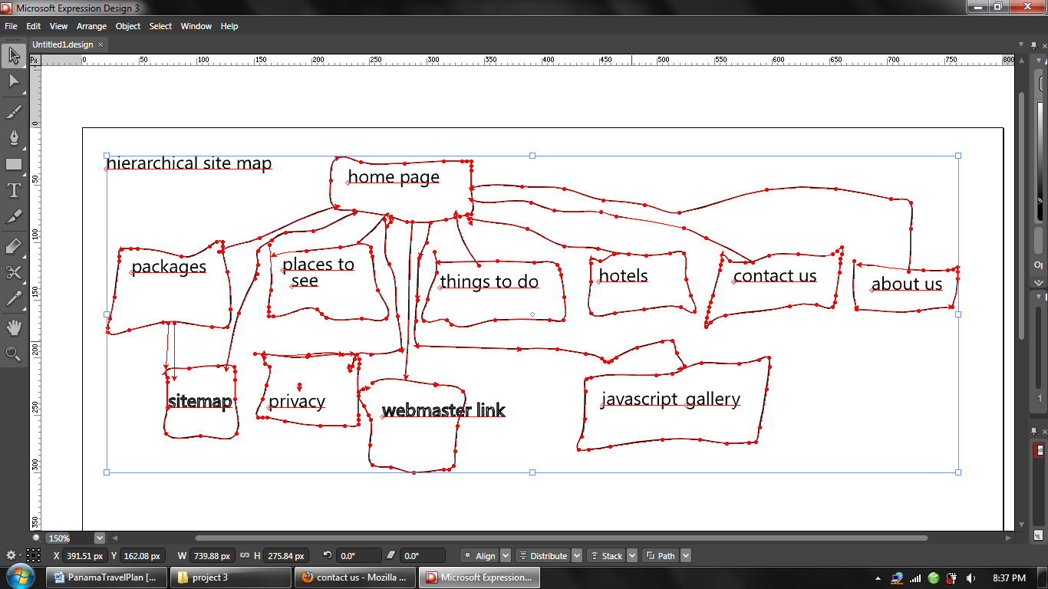

File names:
Homepage –home.htm
Packages- packages.htm
Privacy- privacy.htm
Places to see- placestosee.htm
Things to do- thingstodo.htm
sitemap- sitemap.htm
Hotels—hotels.htm
Contact us- contact.htm
About us- about.htm
Webmaster link- webmaster.htm
The javascript gallery is - jscriptgallery.htm
Other files include the images folder with all the images
And the web page css page called layout.css
For the JavaScript gallery, the css is called javascriptgallery.css
In the styles folder gamescript.js is also located here in order to be html compliant.
Page Layout:

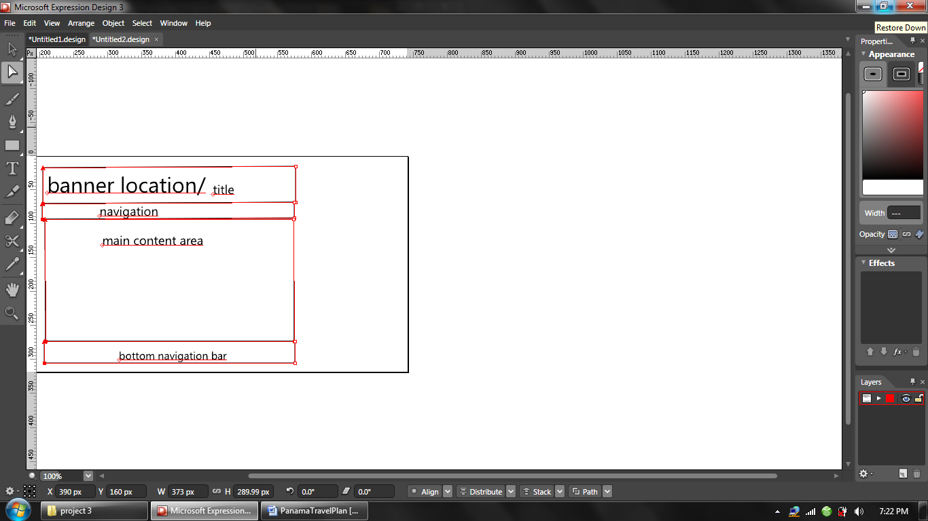
I chose this design because it will focus the main attention of people in the center of the page. Pictures will be sized in here too. there will be blank space on both sides of the screens

