The ABC University want to build a Web site for library management, including 3 activities: Book information management, Reader information management, Book loan and Book return management. Students who want to borrow books from the library must first register for a library card by class, library card includes information (Reader ID, full name, class name, date of birth, gender).

Then the librarian enters information about the library card into the system ad prints the library card to give to the students after one month. When the information about the library card is wrong, the systems allows to remove the library card of reader.

The books in the library a managed by title, each book in the library has many different copies. Information about book titles includes (Title ID, Reader ID, publisher, page number, size, authors, number of book), Information about book copies including(Copy ID, Book ID, condition status, Date).

When the library put new book into the library, the librarian is responsible for intering the book information into the library. If the book information is changed or removed from the library, the librarian correct the book information or delete the book from the library.

The library managed books by areas, the titles are divided into different areas. Information of one areas includes (Area ID, major name, description).

Each reader can only borrow one book at a time. When a reader wants to borrow a book, he/she can find a book in the library and write information on the loan slip, including the book's ID, the reader's ID, and send it to the librarian.

The librarian records the loan slip Information to the system, keeps the reader's card and delivers the book to the reader. Borrowing slip information includes (Book ID, reader ID, library ID,, loan date, status).

When a reader returns a book, the librarian performs the book return function to record the return

status of the book for the loan slip. Periodically, the librarian must make statistical reports and send to the library leaders the following reports: Information about the most lent books, information about readers who have not returned books.

To manage end users, in the library there is a staff member who plays the role of administrator.

This employee has the right to manage information of end users. If there is a new librarian, the administrator updates librarian information to the system, creates an account and grants permissions to library staff. When library staff information is incorrect or removed from the system, the administrator edits or deletes this librarian’s information frora the system. The administrator and the librarian must log in before doing any task.

This application must run as fast as possible and 24/24, 7 days over one week. It allows more than 1000 people accessing at the same time. The system ensures the high available and high security. There are 2 web server and 2 SQL server database server running standby mode.

Besides, there is one firewall for security monitoring, There are 2 FTTH with bandwith about 10Mbs provides by 2 ISP (FPT & Viettel) which connected to 2 different routers running standby mode This application is built by MVC model with Java language and data storage is average 1TB/year. This system and ess backup by daily, weekly and yearly.

|  |  |
| --- | --- |
|  | Use case diagram for Book loan and Book return management in this system |

|  |  |
| --- | --- |
|  | activity diagram for Book infomation management in this systems |

sequence diagram when the administrator update librarian’s information in tis system

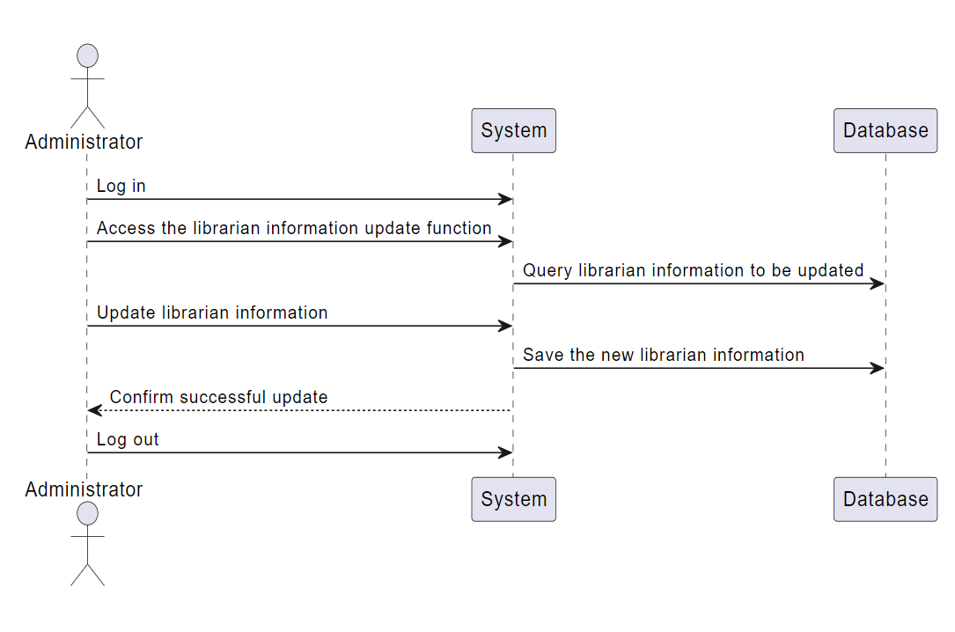

state diagram when the librarian remove library card of reader i this system

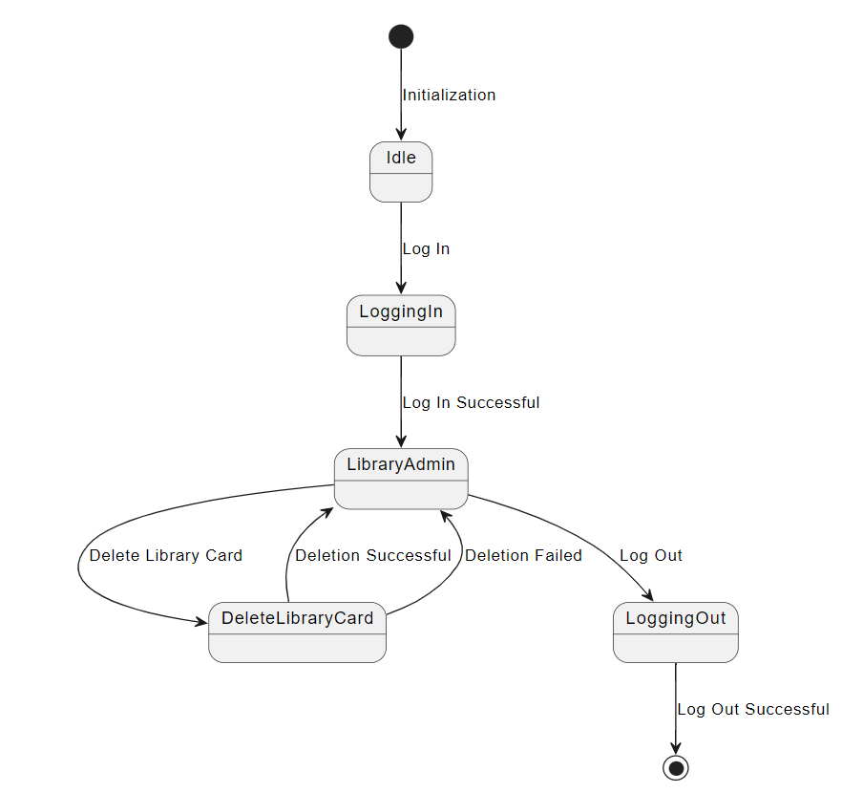

Component

