Bonbons à la Maison

Bonbons à la Maison is a site designed for everyone for ordering cakes, cupcakes, dessert, and pastas online, you can also book a catering service in which you could ask a buffet or not.

**USER INTERFACE**

**Homepage**



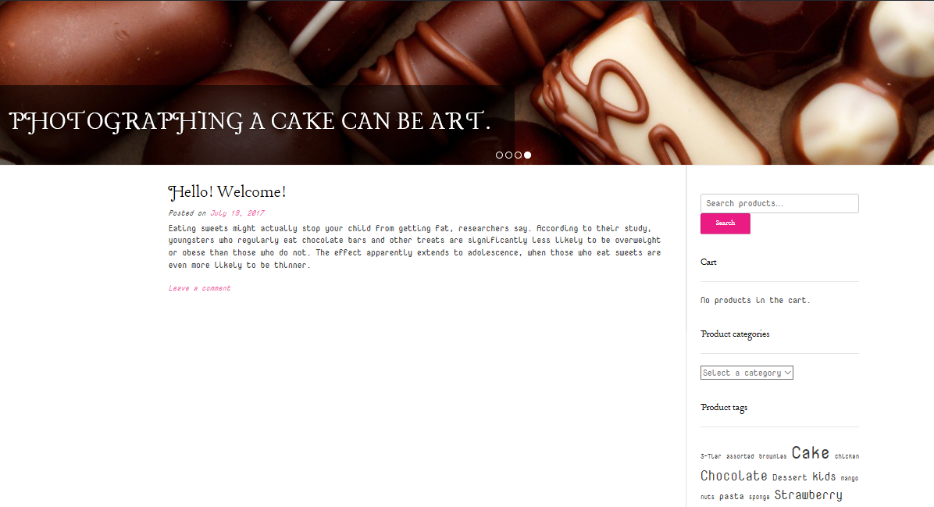

Homepage

In this page, the posts, reviews, tags, categories of the products are shown that would help the user to browse what he or she likes depending on the category and tags he or she wants

**Shop**

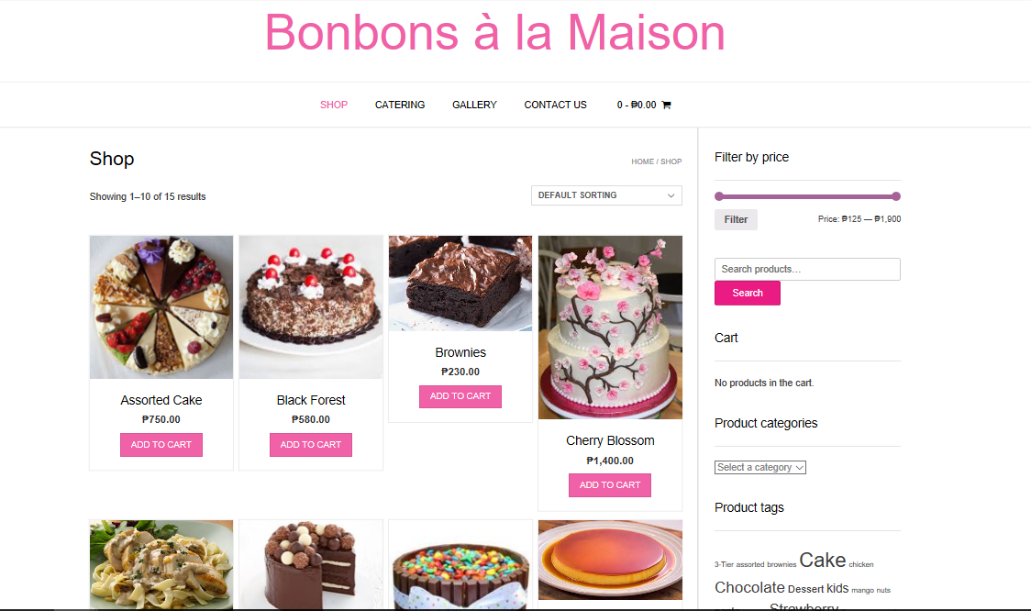

Where you can find the products that is on sale. Out of stock products will be not shown. Name, price, description is also shown. There is also a filter price at the upper right where you can customize the products being displayed depending in your budget.

**Cart**

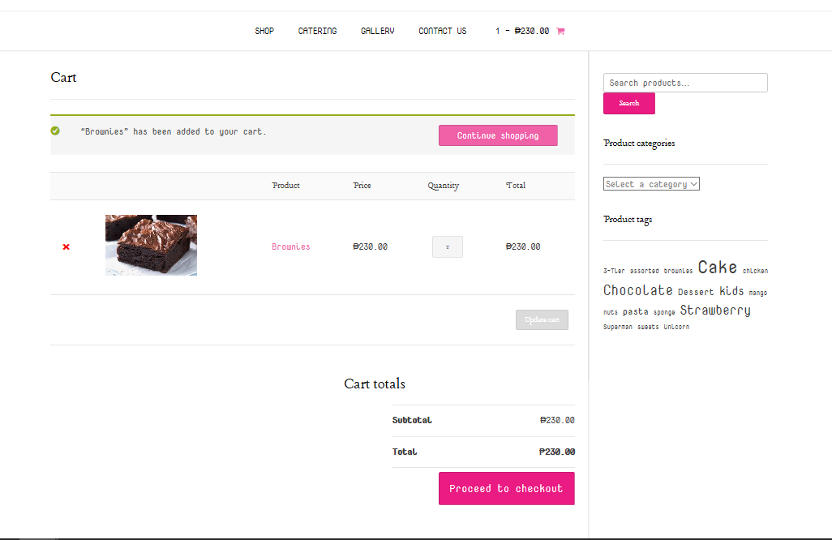

Product/s that are added to the cart will be viewed here. You can still add or remove products.

**Checkout**

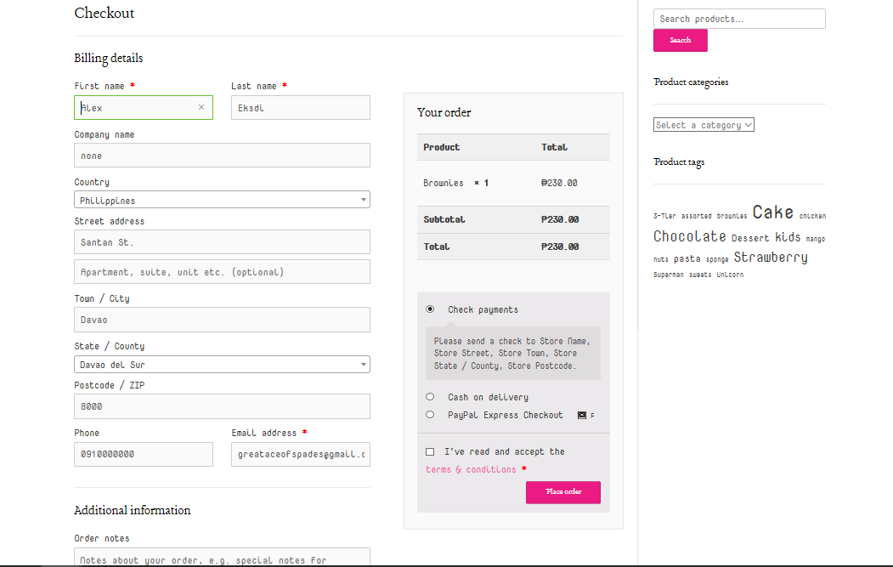

After placing order/s in the cart, if the user proceeds to the Checkout section, the user should fill up a form for information and details, the user should also accept the terms and policy of the shop for the delivery and the payment.

**Catering**

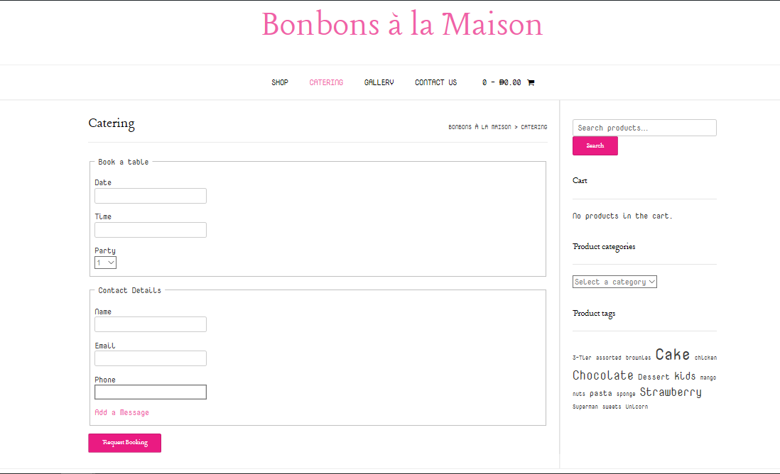

Our shop also caters on events depending on how many guests to cater. Prices varies on number of guests and this will be the form for the booking and what kind of sweets they want.

**Gallery**

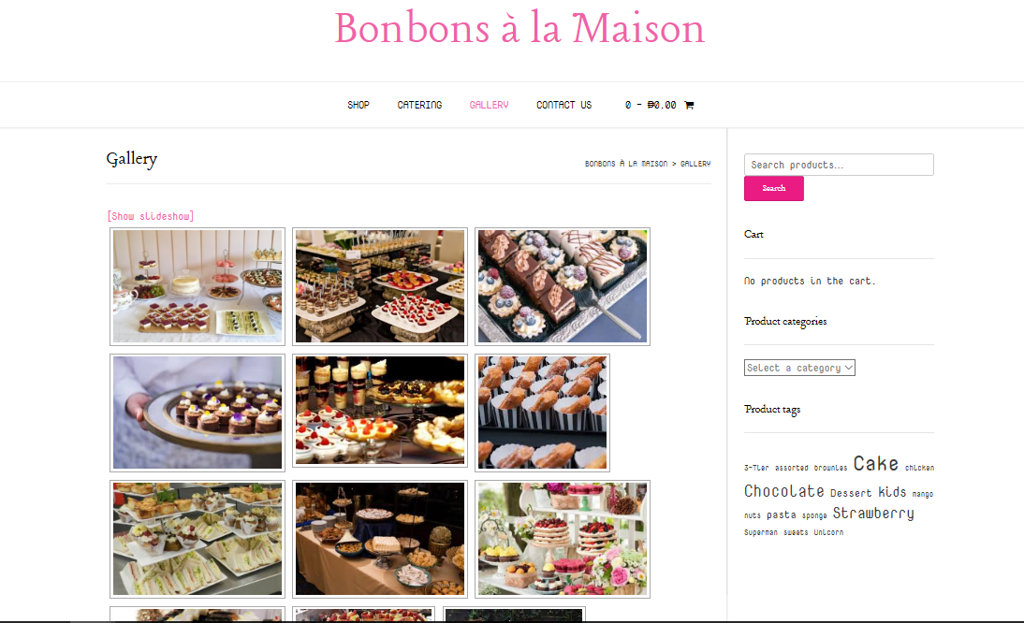

Photos of the previous events we had, it will be viewed here as a documentation.

**Contact Us**

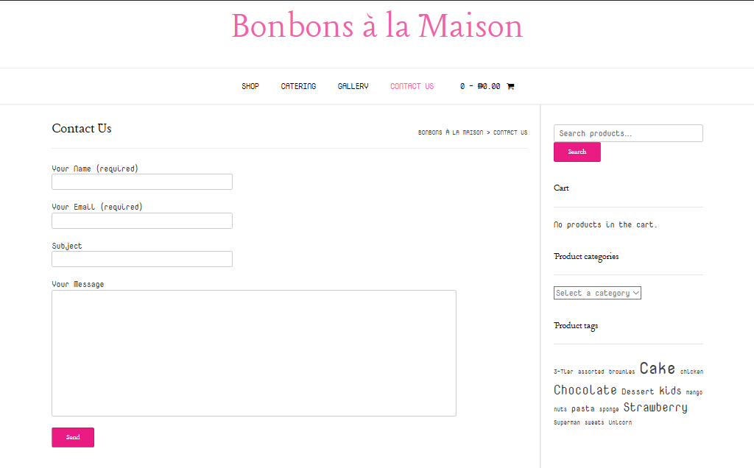

Where the user/customer is free to message the admin of the site if he/she has concern, opinion, suggestion, and etc. about the site and the products that is being sold in the site.

**Terms and Policy**

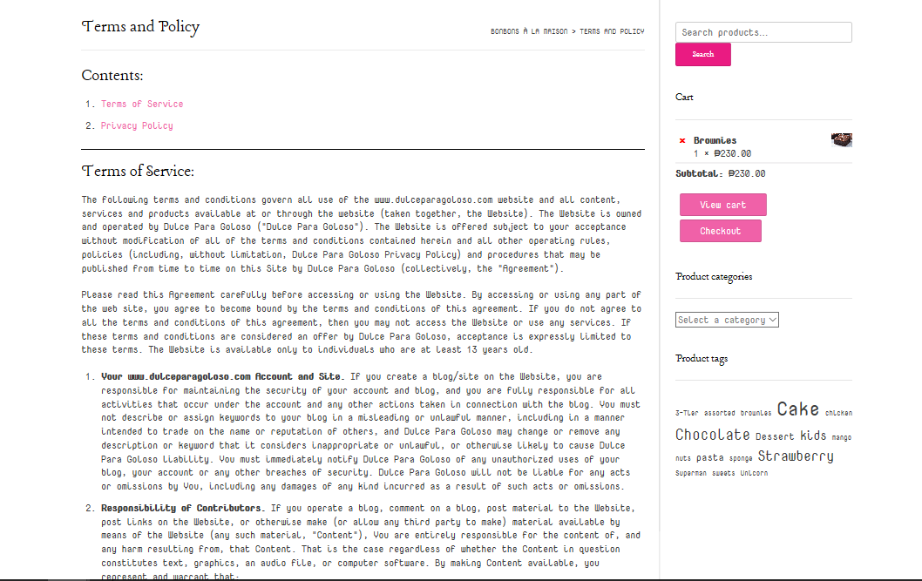

The Terms & Conditions of the shop for the buyers.

**ADMIN INTERFACE**

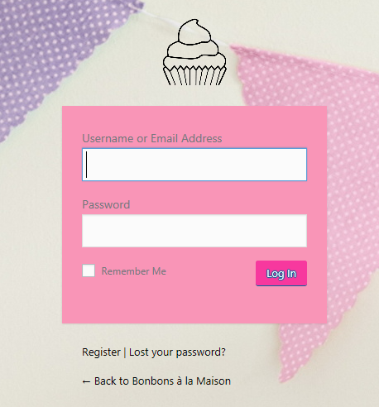**Login**

This is the section or the first page for the admin to log in and have access to their site.

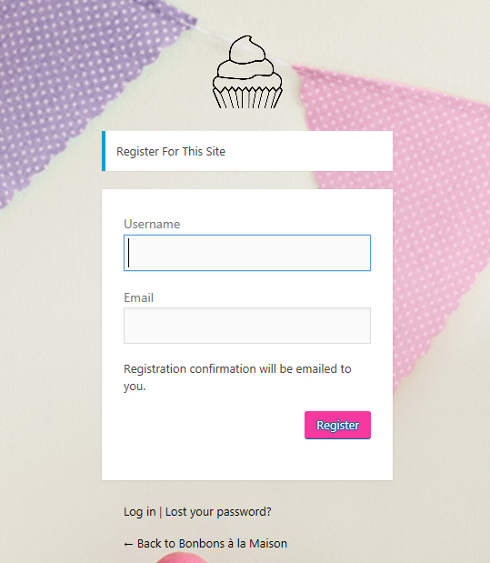

**Register**

For the users who don't have an

account and wants to register.

**Booking List**

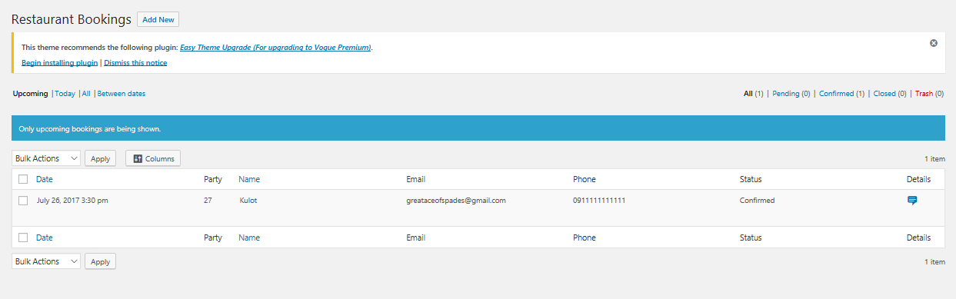

The admin will also be able to view the Caterings that was booked by users and every information that is needed.

**Order List**

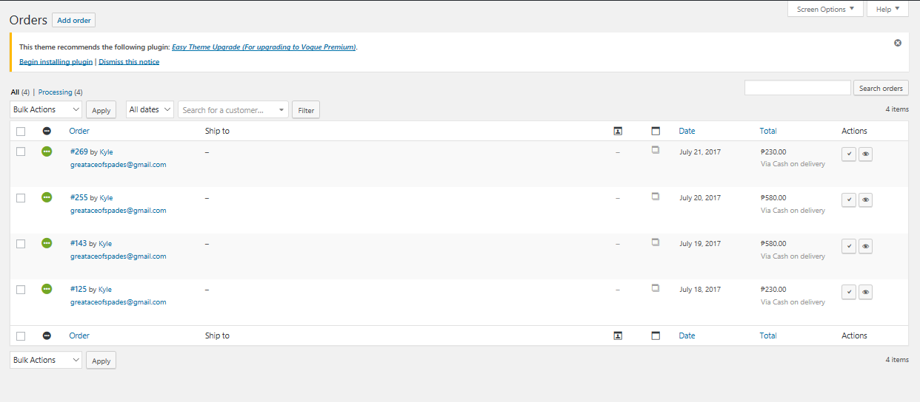

The admin will also be able to view every orders that was made by users or customers and will be able to update if the order is on process, on hold, on delivery, or received

**Report**

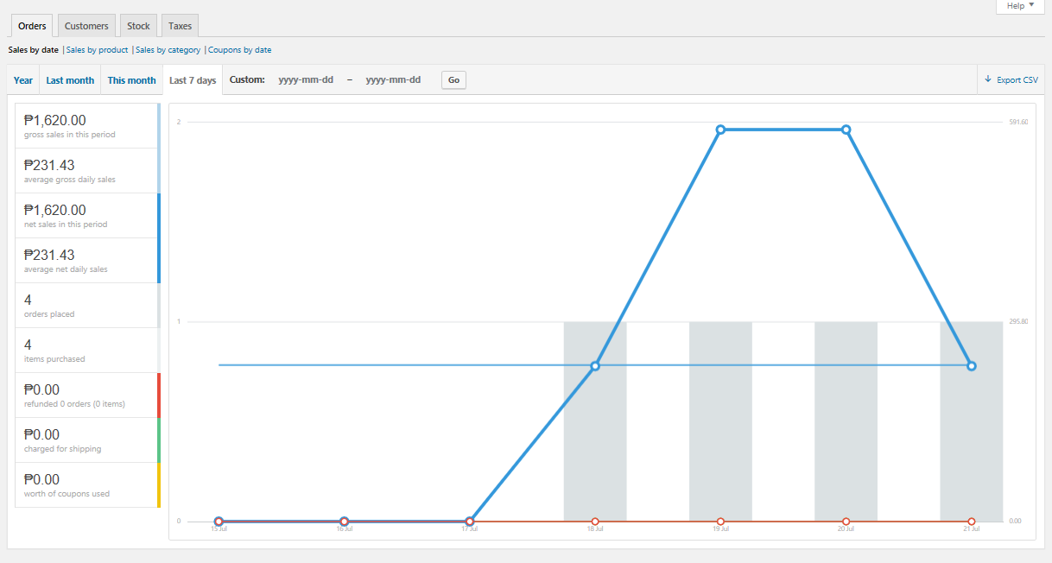

The section where the admin can view the reports or the summarization of the sales through a graph.