**System Name : Tutor Finder System**

**Name :- Samarth Dastanwala**

**Sem :- 6**

**Div :- A**

**Subject :- Project [607]**

**Group Rno :- 17, 36, 55, 56**

**Definition** :

This project is about to search tutor for a student for variety of subjects. Student can search tutors based on subjects, area and city.

Tutors can register themselves, if they love teaching and helping students to learn.

**Database Design :**

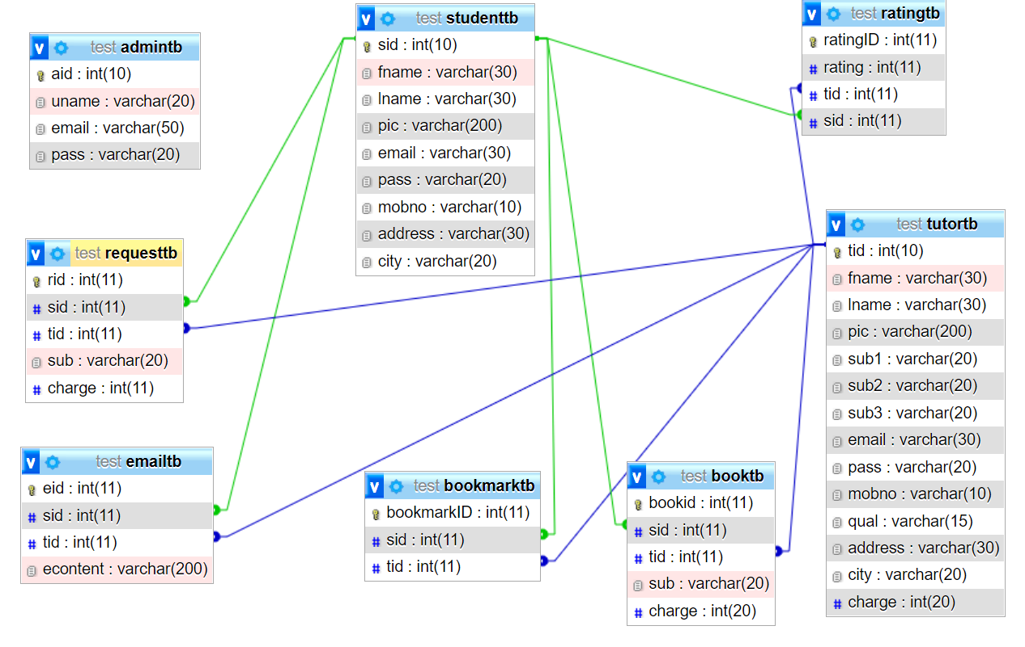

**Features & Functinalities:**

* **Admin :**

**->Login :** Admin can login using credentials

**->View Student:** Admin can check register Students and delete them.

**->View Tutor:** Admin can check register Tutors and delete them.

**->Edit Detail:** Admin can edit his details

* **Student :**

**->Login/Register :** Student can login/register using credentials

**->View Tutor:** Student can check register Tutors.

**->Bookmark Tutor:** Student can Bookmark Tutors and Unbookmark them.

**->Book Tutor:** Student can send request to the particular tutor for booking. After tutor accepts the request student can pay and book the tutor

**->Filter tutor :** Student can filter tutor by Subject, City and Rate

**->Send Email :** Student can mail tutor for contacting him or getting details about his classes’ time information.

**->Feedback tutor** : Student can feedback or give rating to tutor.

**->Edit Detail:** Student can edit his details.

* **Tutor :**

**->Login/Register :** Tutor can login/register using credentials

**->Add subject:** Tutor can add or edit subjects that he can teach.

**->Show Request:** Tutor can see all the request sent by the students and can accept one for booking

**->Show Ratings:** Tutor can see his rating given by students.

**->Show email:** Tutor can see his email received from his students(from this website)

**->Edit Detail:** Tutor can edit his details.