**MU**Ñ**OZ UNITED METHODIST CHURCH LEARNING CENTER INCORPORATED**

T. Delos Santos St., Science City of Muñoz, Nueva Ecija

COMPARATIVE STAIN REMOVING EFFECTS OF *Citrofortunella macrocarpa* and *Averrhoa bilimbi* EXTRACT ON WHITE FABRIC

Audrey Nicole D. Iñigo

GRADE 6

SUBMITTED TO: THALIA M. DELA CRUZ

TEACHER

**INTRODUCTION**

Laundry stains are difficult to remove. It is well known to be one of the reasons of laundry problems. It discolors clothes, adheres to the fabric, and wears them out over time, posing a problem for those people who wish to keep their clothes looking nice. When the staining substance, which is commonly a liquid or chemical, is spilled onto the surface or material, stains are generated. People receive surface stains from time to time due to business and clumsiness, but other people obtain stains that are difficult to remove and leave a mark for a long time.

Commercially produced detergents, which are widely distributed around the world, include hazardous compounds that represent a serious threat not only to the environment but also to consumers. The researcher focuses on stain removal because it is the most prevalent problem that people face today as a result of excessive work. Commercial stain removers can be used to remove stains, but they are dangerous since they contain ingredients that are harmful to human health and the environment.

While bleach has long been used as a cheaper alternative to pricey detergents, citrus fruits are also a popular stain remover because they are much more common in homes. Calamansi (*Citrofortunella* *macrocarpa*) is a citrus fruit and one of the Philippines' fruit crops. According to Morton (1987), the extracted juice is pasteurized and bottled commercially, with the addition of gum tragacanth as an emulsifier, and then used to bleach ink stains from garments and as a body deodorant in the Philippines.

Oxalate is a plant-derived organic acid. Oxalic acid is found in minor concentrations in many foods and in substantial amounts in a few. Oxalic acid is abundant in Kamias (*Averrhoa bilimbi*), to the point where some companies use it as the primary ingredient in organic detergents. Kamias is an affordable stain remover that is gentle on fabrics and safer than chlorine bleach and fabric softeners. It's a gentle stain remover that consumes the stain but doesn't harm the basic surfaces, including fragile fabrics. Kamias can be used as a light abrasive to remove stains or residue from the bottom of your iron.

As a result of these considerations, the researcher decided to conduct an investigational project using kamias and calamansi extract as a bleaching agent. Calamansi has antibacterial, carminative, and refrigerant characteristics, therefore it can be used for more than just stain removal. Kamias is a fruit-bearing tree that is high in B and C vitamins, iron, phosphorus, and antioxidants. Its leaves can treat coughing, thrush, hemorrhoids, stings, itches, acne, and skin eruption. The researcher chose kamias and calamansi because they are both inexpensive and readily available.

**Statement of Hypothesis**

There is a possibility that calamansi extract is better than kamias extract in removing stain.

**Significance of the Study**

The following sectors will benefit from this research: the community, the soap and detergent business, and future chemist researchers.

To the community. The findings will help the community understand how to use organic citrus compounds in their regular laundry. This will benefit the community by lowering costs and expenses, especially for stain cleaning methods, by providing a considerably less expensive option.

To the soap and detergent business. This research has a long-term influence on the soap and detergent industry by providing novel information regarding stain-removal characteristics of Calamansi (*Citrofortunella macrocarpa*) and Kamias (*Averrhoa bilimbi*) extracts. The researcher's findings will aid this industry by adding new knowledge into soap and detergent formulations.

To the future chemist researchers. Researchers working on subjects related to the stain-removal characteristics of Calamansi (*Citrofortunella microcarpa*) and Kamias (*Averrhoa bilimbi*) extracts may benefit from this study by using this as a reference.

**METHODOLOGY**

1. **Materials**

* 15 mL calamansi extract
* 15 mL kamias extract
* 2 plain white t-shirt
* Water
* Coffee
* Soy sauce
* Chocolate
* Timer
* Strainer
* Tape

**B. Procedures**

1. The calamansi and kamias were squeezed to get the extract. The extract was strained using a strainer to make it pure. Then, the extract was put on two separate containers.

2. 15 mL of calamansi extract and 15 mL of kamias extract were poured on the three different stains of the white t-shirt. The three different stains were coffee, soy sauce, and chocolate.

3. The shirts with stains were soaked for 10 minutes using a timer to test the efficacy of the extracts. After that, the shirt was scrubbed on running water to remove the stain properly.

4. Then, the shirts were hanged under the sun to make it dry. This helped to observe the result easily.

**RESULTS AND DISCUSSION**

|  |  |  |
| --- | --- | --- |
|  | Calamansi Extract | Kamias Extract |
| Chocolate Stain |  |  |
| Coffee Stain |  |  |
| Soy sauce Stain |  |  |

The kamias extract is more effective than kalamansi extract. The stains were more removed after using the kamias extract. Although, some stain also lightned when kalamansi extract was utilized. In addition, the kamias extract is faster than calamansi extract as stain remover. Therefore, kamias extract was a better stain remover than kalamansi extract.

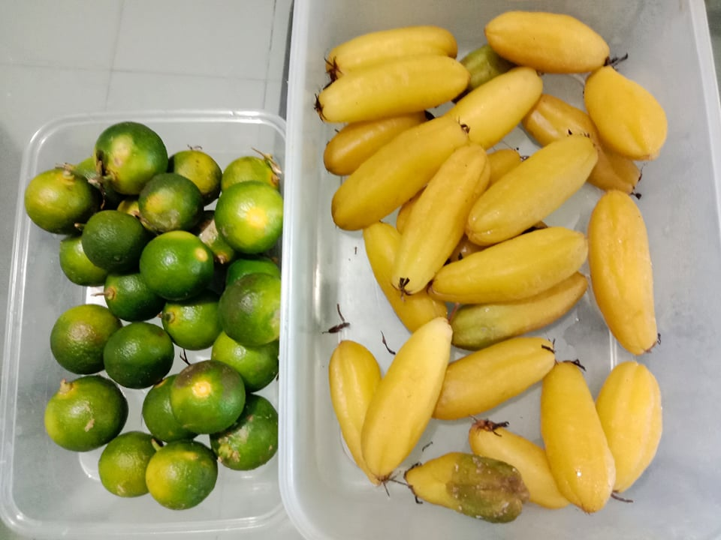**DOCUMENTATION**

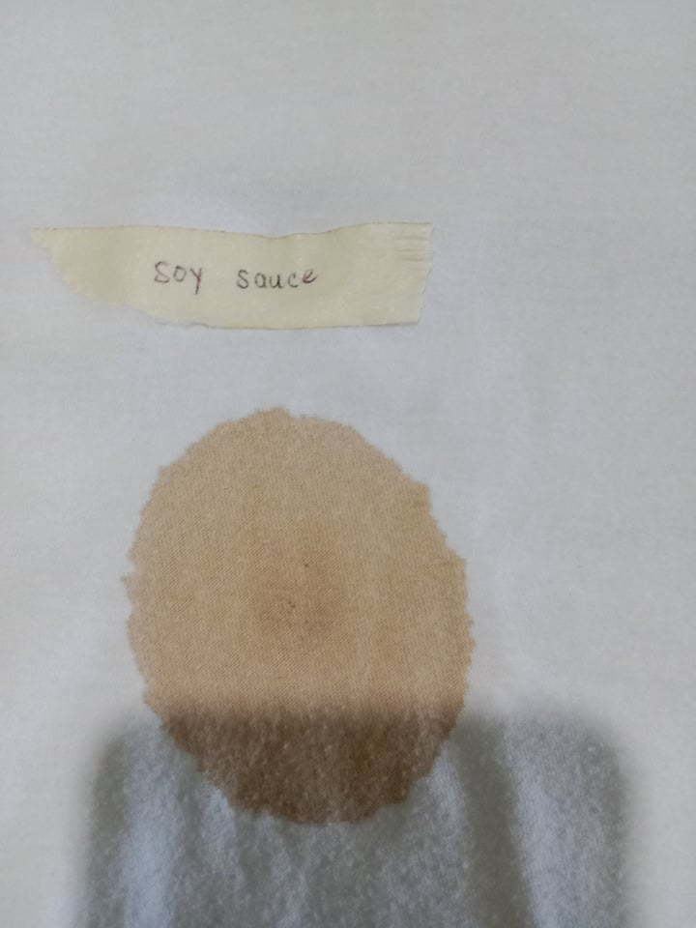

Calamansi and Kamias Soy Sauce Stain

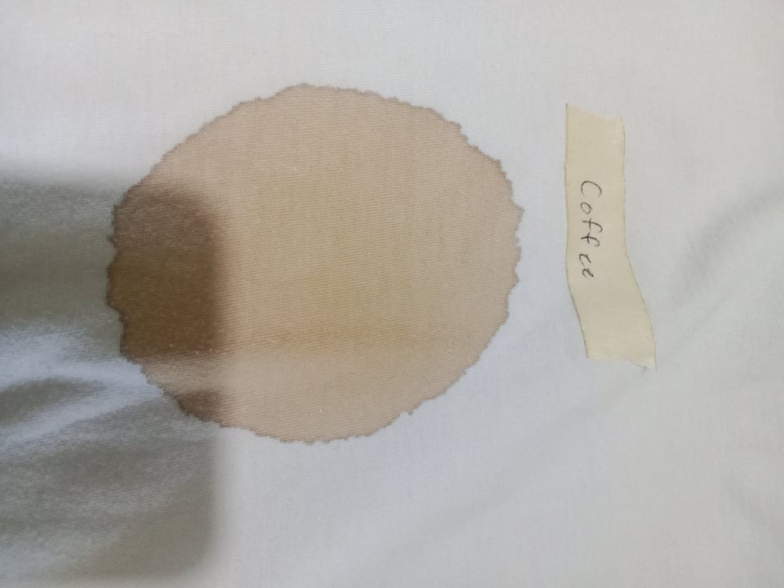

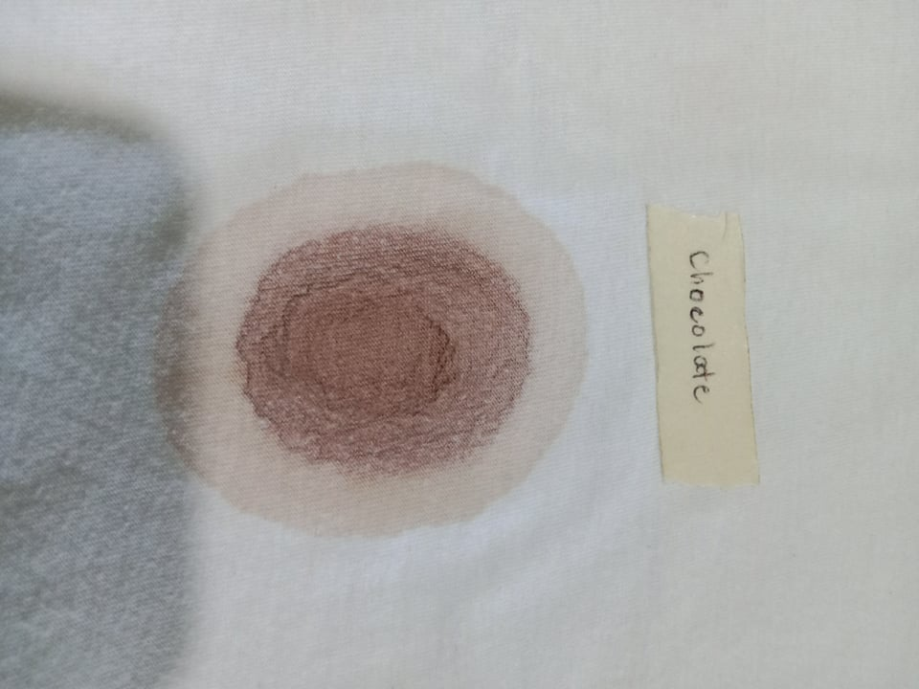

Chocolate Stain Coffee Stain

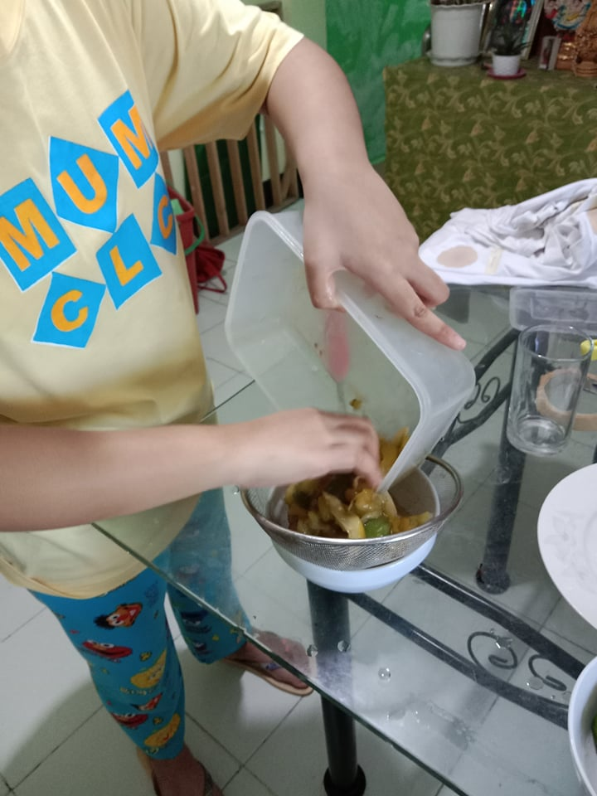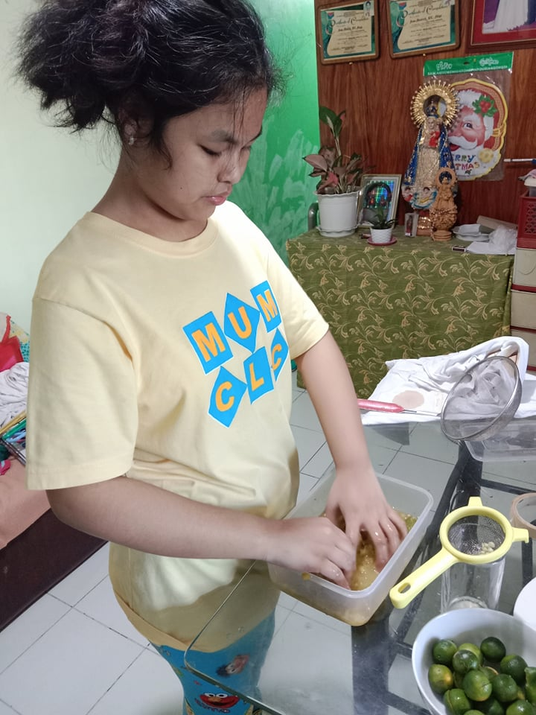

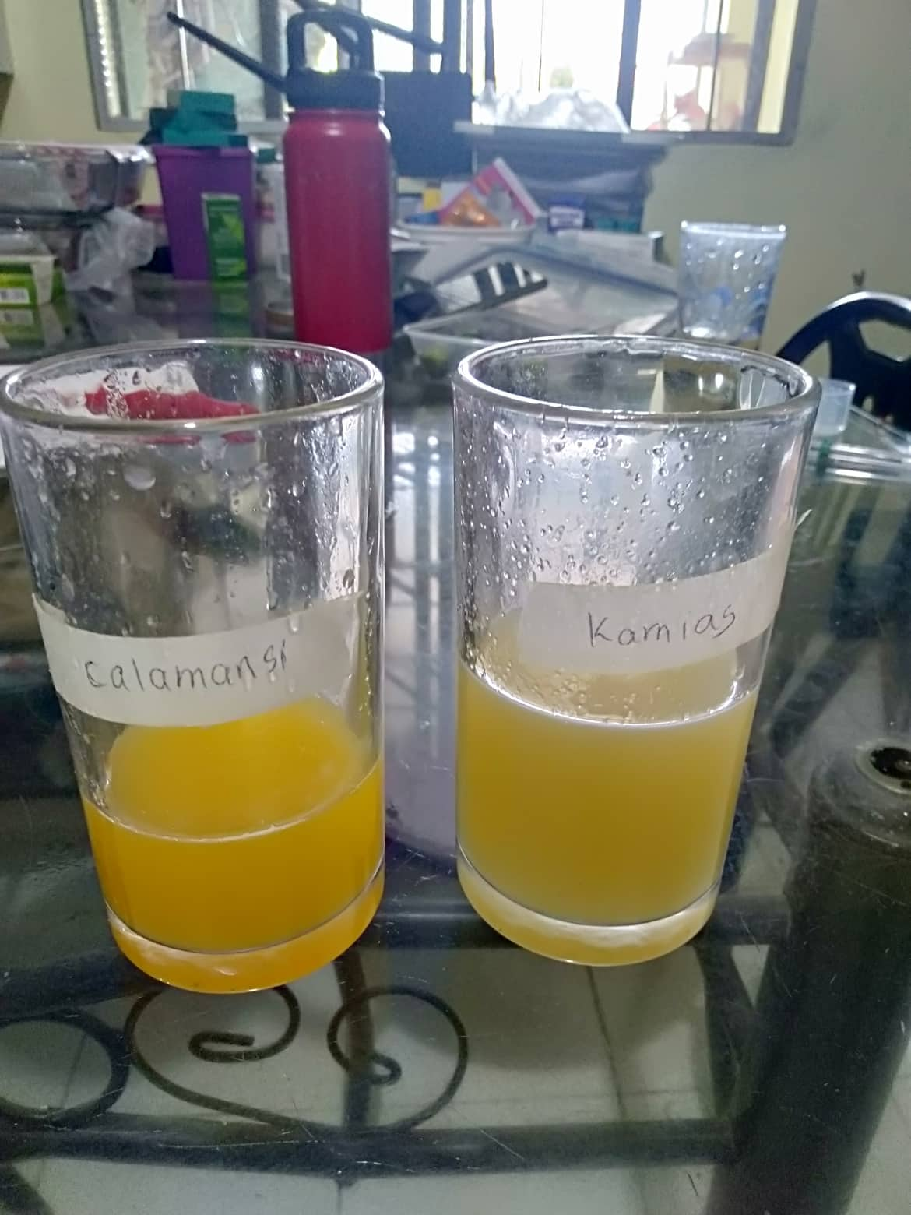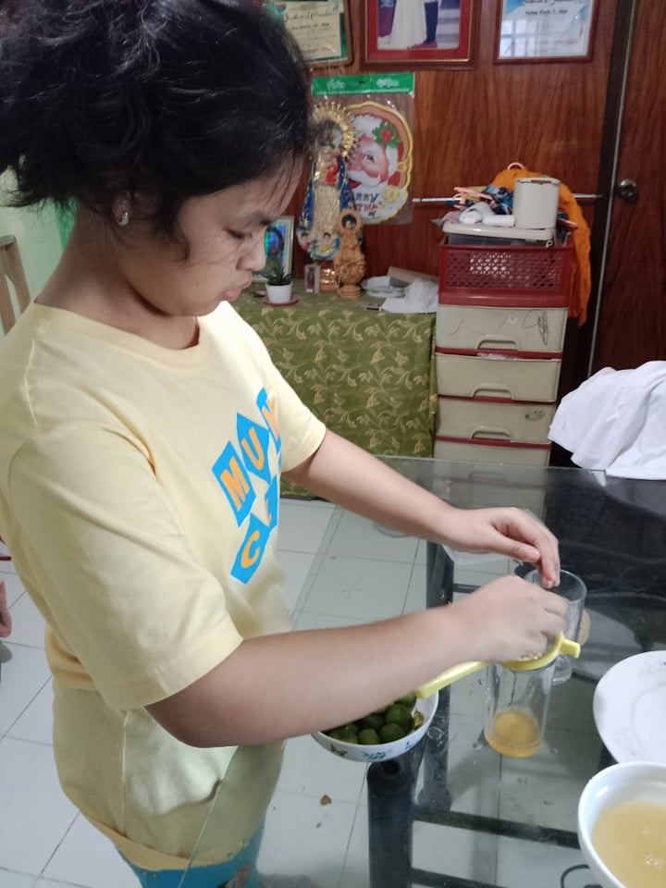Squeezing of Kamias Extract Filtering of Kamias Extract

Squeezing and Filtering of Calamansi Extract Calamansi and Kamias Extract

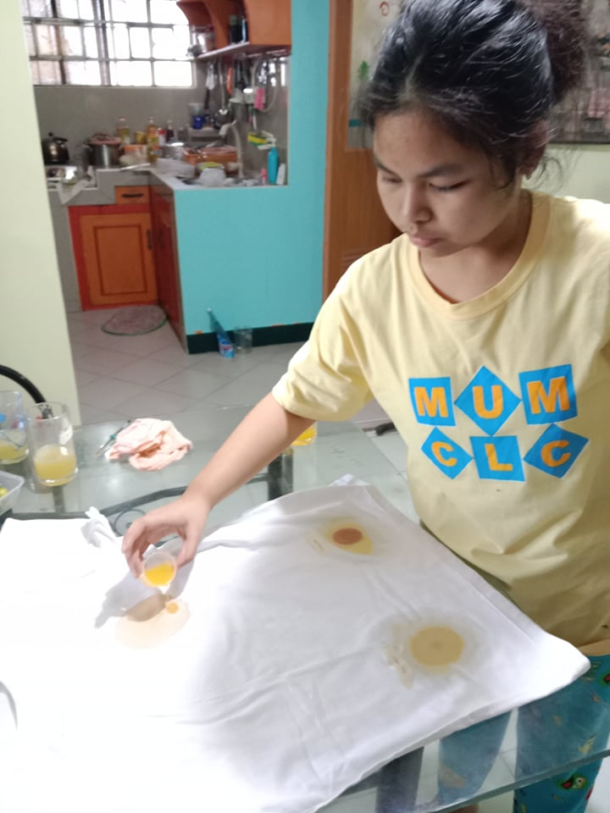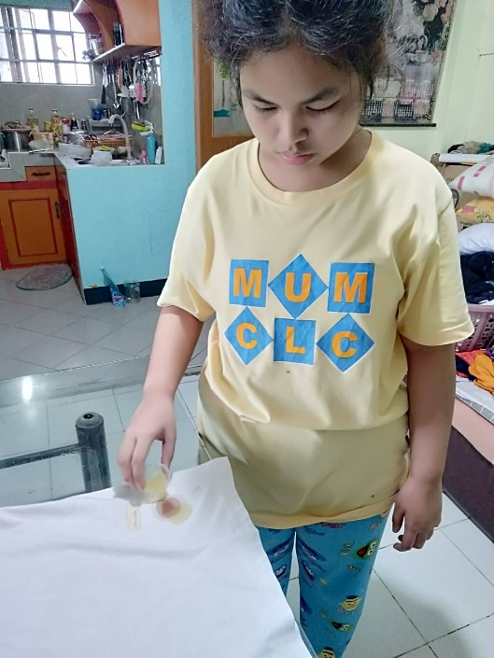

Putting the 15mL Kamias Extract on Putting the 15mL Calamansi Extract on Different Stains on Different Stains

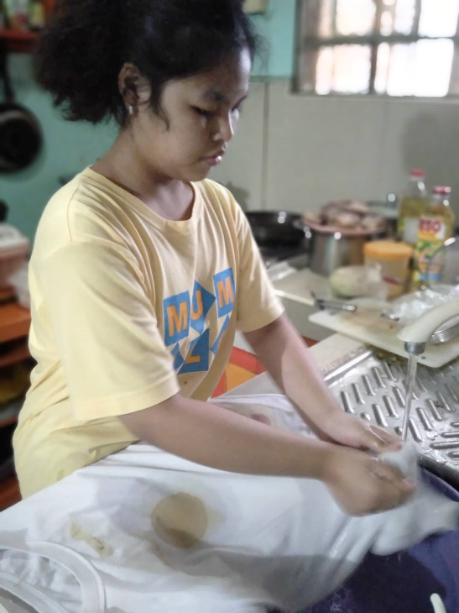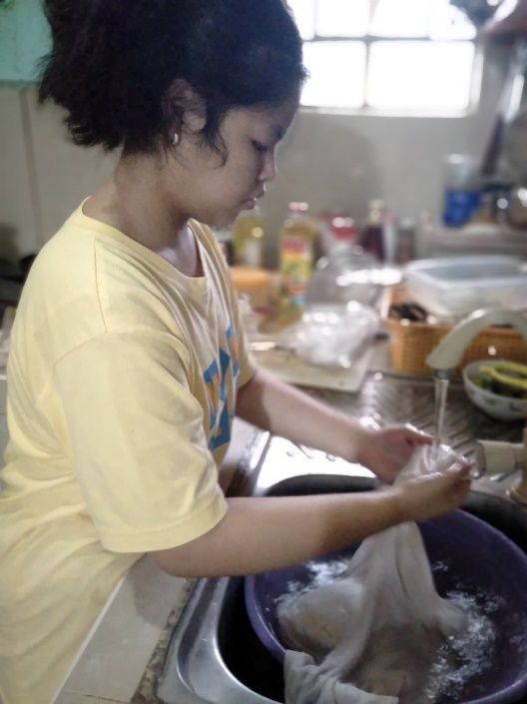

Scrubbing the Shirt with Kamias Extract Scrubbing the Shirt with Calamansi Extract

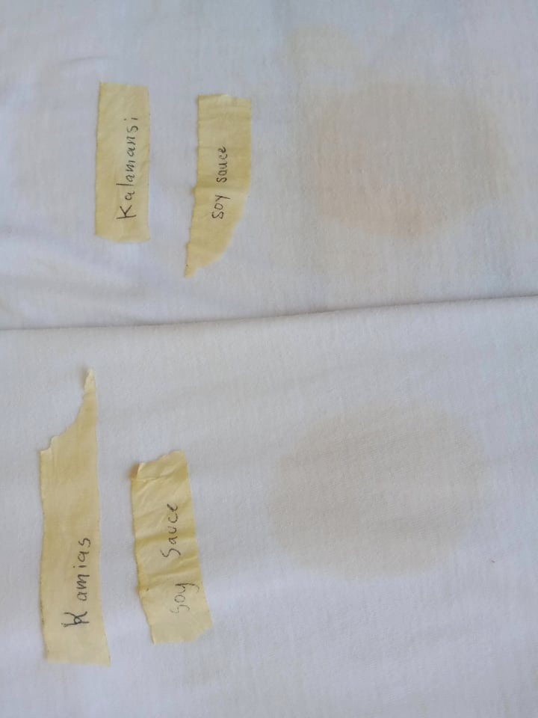

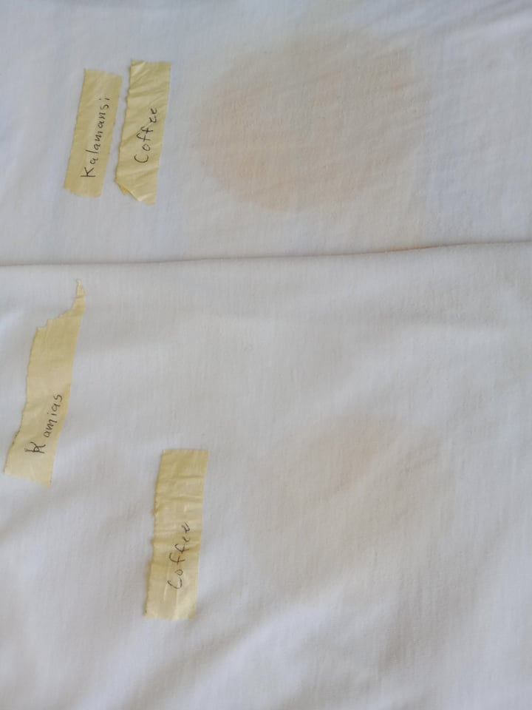

Dried Shirt with Soy Sauce Stain after Applying Kamias and Kalamansi Extract

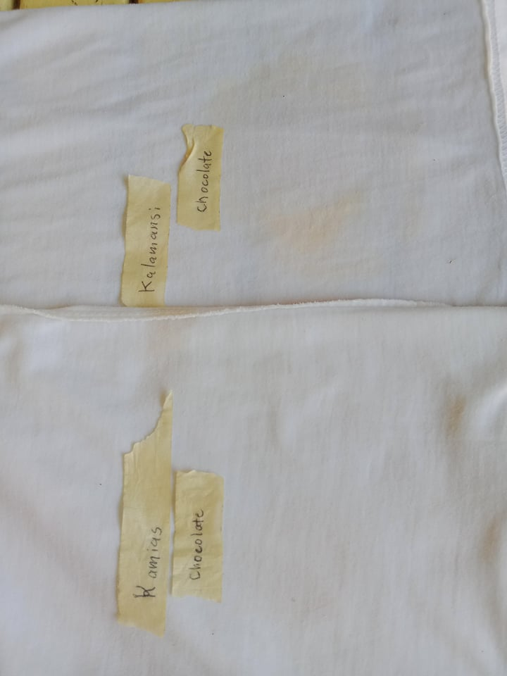

Dried Shirt with Coffee Stain after Applying Kamias and Kalamansi Extract

Dried Shirt with Chocolate Stain after Applying Kamias and Kalamansi Extract

**REFERENCES**

*"A comparative study between Citrofortunella microcarpa and citrus limon in removing hard stains"*. Abode of Berto. (2016, April 2). Retrieved May 3, 2022, from https://uscpharmacytimes.wordpress.com/a-comparative-study-between-citrofortunella-microcarpa-and-citrus-limon-in-removing-hard-stains/

*Calamansi and Kamias as bleaching agent: [essay example], 829 words*. GradesFixer. (2020, December 11). Retrieved May 3, 2022, from https://gradesfixer.com/free-essay-examples/calamansi-and-kamias-as-bleaching-agent/

Morton, J. (1987). In: Fruits of warm climates. Miami, Florida, U.S.A.: Florida Flair Books.

*Using Kamias as a stain remover will make your life so much easier*. Healthy Huemans. (2021, September 17). Retrieved May 3, 2022, from https://healthyhuemans.com/kamias-as-stain-remover/