Task M1.T1P – Submission

Student ID: 219265968

Student Name: Nguyen Minh Cuong

In my implementation, I used the PIR sensor as INPUT and LED as output.

The following image will demonstrate how the circuit looks like.

* 1. A schematic diagram
* 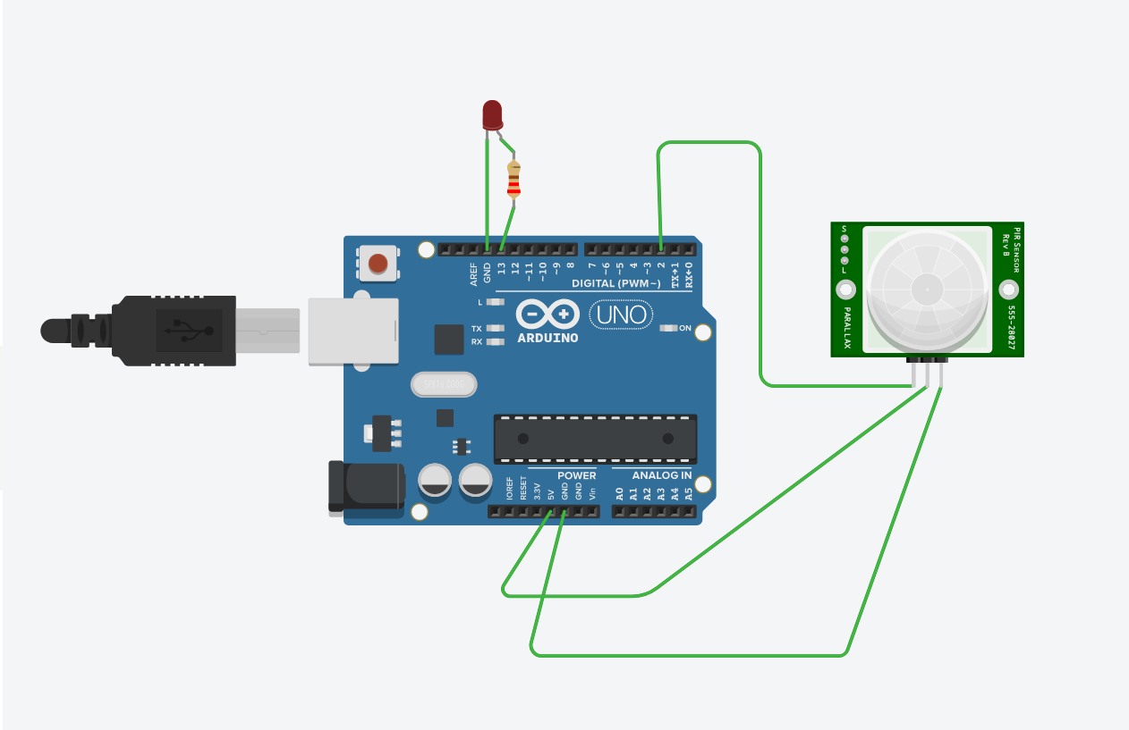

If the sensor detect any motion in its range, the LED will light on.

* 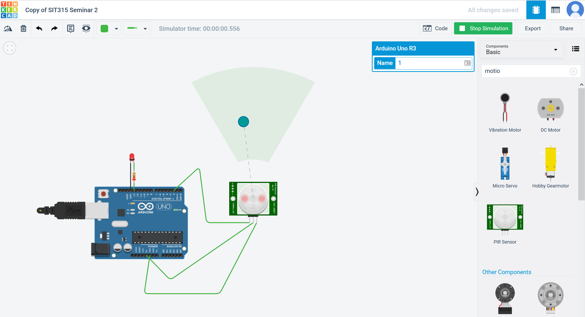

Otherwise the LED light will turn off, like the following image.

* 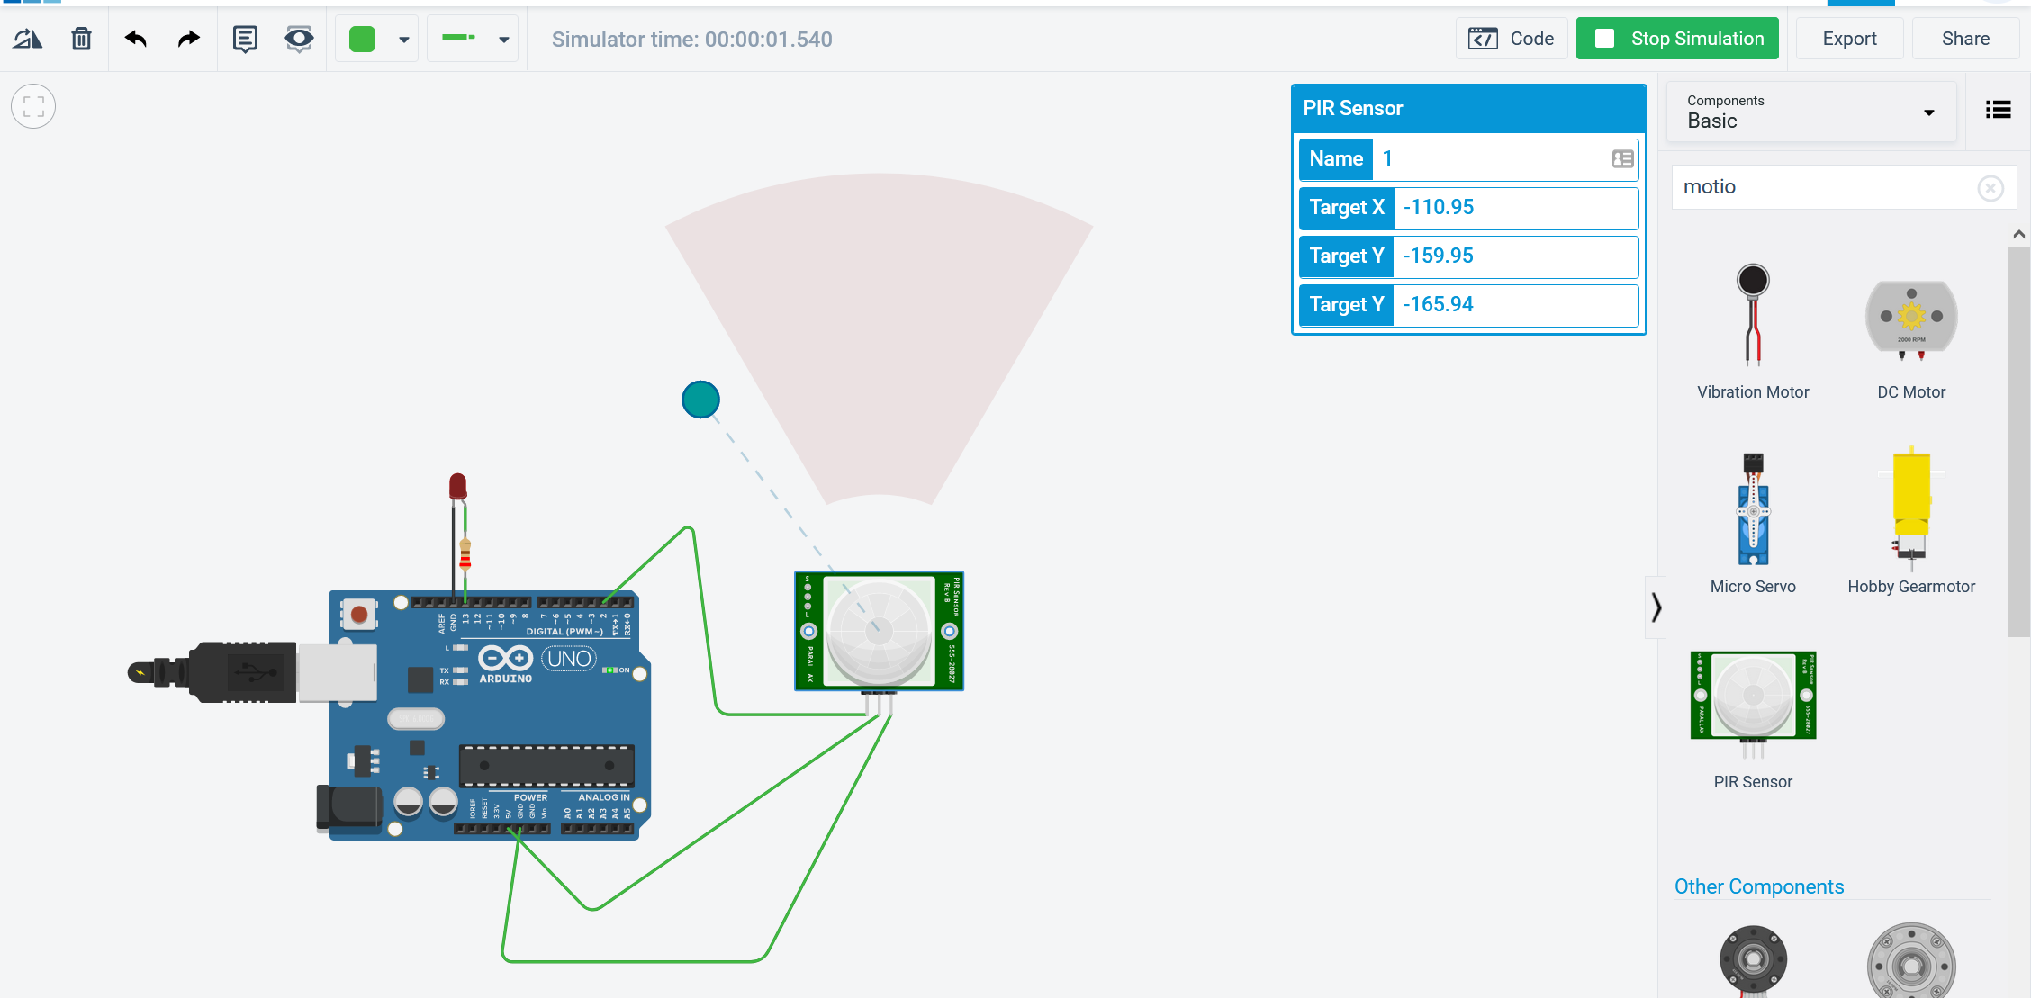
* In my implementation code, I also set up the Serial log to capture LED state. Specifically, if the LED is on, monitoring log will print 1, else print 0, as we can see in the “Serial Monitor” log image
* 2. Monitoring log
* 
* 3. Here is the example code of my program.

