Q-1 using the newfilpcart.html create exam.csv

Q-2 From the given TrumpLies.html, load the file ensuring the utf-8 encoding and do the following

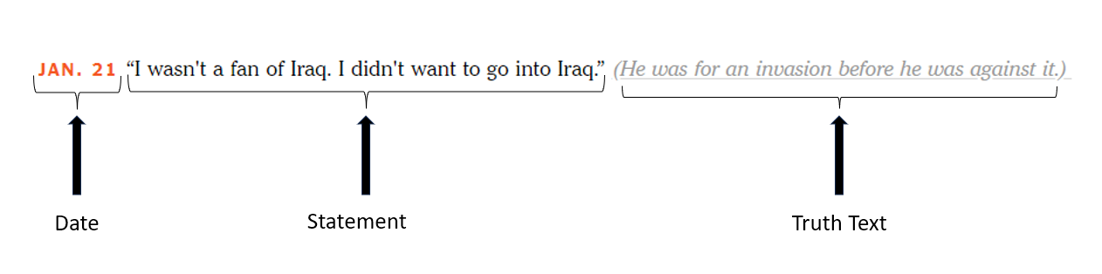tasks using BeautifulSoup library in python –

From the given TrumpLies.html, load the file ensuring the utf-8 encoding and do the following tasks using BeautifulSoup library in python –

1. Extract the title text and display it.
2. Extract the date given in the footer text and display it.
3. Extract the p tag with the class ‘secret-word’ and display it.
4. Extract all h1and h2 tags and print them.
5. Extract all links which starts with http or https and display them.

An example record from the given page is shown below –

1. How many records are present on the page?
2. Extract all the records. Print all the records as per the format given below

An example output of record is given below –



The output should strictly follow the above given format.

1. Convert the extracted records into dataframe and display the output.

Q-3

Using the "IPL Auction.html" file and BeautifulSoup, create and print the data frame with the following structure and print the data type of each column.

