Project On:
Learning Management System
Project submitted in partial fulfilment of the Requirements
for the degree of
Masters of Computer Application

By
S Jay Nitin, Saunak Roy Chowdhury, Sankhadeep Chakraborty and Subham Samanta

Under the Guidance of
Mr. Anindya Mukherjee



Techno India, Salt Lake EM 4/ Salt lake City, Sector V
KOLKATA – 700091
2026

Techno India, Salt Lake
(Maulana Abul Kalam Azad University of technology (WBUT))

FACULTY OF MCA DEPARTMENT

Certificate of Recommendation

This is to certify that S Jay Nitin, Saunak Roy Chowdhury, Sankhadeep Chakraborty and Subham Samanta have completed their project work titled “Project on: Learning Management System”, under the direct supervision and guidance of Mr. Anindya Mukherjee. We are satisfied with their work, which is being presented for the partial fulfilment of the degree of Master of Computer Application (MCA), West Bengal University of technology (WBUT), Kolkata– 700064.

---------------------------------  Mr. Anindya Mukherjee  Department of BCA  Techno India Kolkata | ------------------------------------------------  Prof. Dr Subhrendu Guha Neogi  HOD, Dept. of MCA  Techno India Kolkata

Acknowledgement
We express our sincere gratitude to Mr. Anindya Mukherjee, our respected project guide, for his valuable guidance, continuous encouragement, constructive suggestions, and constant support throughout the development of this project.
His technical knowledge, patience, and motivation helped us understand the practical aspects of web development and complete this project successfully.
We would also like to express our heartfelt thanks to the faculty members of the Department of Computer Applications, Techno Main Salt Lake, for providing the necessary facilities and academic support throughout the project work.
We are thankful to our team members S Jay Nitin, Saunak Roy Chowdhury, Sankhadeep Chakraborty and Subham Samanta for their contributions to this project.

Abstract
This project presents the design and development of a Learning Management System (LMS) backend using Spring Boot and frontend using React. The system is designed to support the management and delivery of online courses, enabling instructors to create and manage courses, lessons, videos, notes, course thumbnails, and pricing, while allowing students to register, purchase courses, access lessons, and track their learning progress.
The backend implements role-based functionality for STUDENT and INSTRUCTOR users, ensuring that course creation and management are restricted to instructors, while course enrollment and learning activities are available to students.
The system uses Spring Data JPA for database interaction and follows a layered architecture consisting of entities, controllers, services, service implementations, and repositories. Course purchases are used to represent student enrolment, while a dedicated progress-tracking mechanism records completed lessons for each student within a course. This enables the system to calculate and display course completion percentages and allows instructors to monitor the progress of individual students. The database design establishes relationships among users, courses, lessons, purchases, and course progress, with appropriate primary keys, foreign keys, and constraints to maintain data integrity.
The proposed LMS provides a structured backend foundation and a frontend for an online learning platform and can be further extended with features such as payment gateway integration, cloud-based media storage, assessments, certificates, notifications, and advanced learning analytics.

Entity Information and Purpose
Entity | Purpose
User | Stores user account information such as name, email, password, and role. Users can be either STUDENT or INSTRUCTOR.
Course | Stores information about courses created by instructors, including title, description, price, thumbnail, and instructor reference.
Lesson | Stores individual lessons belonging to a course. Each lesson contains details such as title, description, video URL, notes URL, and lesson order.
Purchase | Records course purchases made by students. It links a student with a course and stores payment-related information such as amount, payment status, transaction ID, and purchase date. A successful purchase represents the student's enrollment in the course.
CourseProgress | Tracks the learning progress of a student for a particular course. It maintains the student, course, and the lessons completed by that student. A unique constraint ensures that a student has only one progress record for a particular course.

Index
Ch. No. | Title | Description
1 | Scope of the Project | Explains the objectives, purpose, scope, advantages, and limitations of the Learning Management System.
2 | Concepts and Problem Analysis | Describes the existing approach, proposed system, problems addressed, and feasibility of the proposed LMS.
3 | Theoretical Background | Introduces the technologies and concepts used, including Spring Boot, REST APIs, Java, React, MySQL, JPA, and role-based access.
4 | Design and Methodology | Describes the system architecture, database design, ER diagram, data flow, and overall working methodology.
5 | Result Set Analysis | Presents the output of the developed system using screenshots of the home page, registration, student course browsing and enrollment, and the instructor's course and lesson management dashboards, and discusses the achieved results.
6 | Testing | Explains the testing process including Unit Testing, Integration Testing, System Testing, Black Box Testing, Test Cases, Test Results, Validation, and Error Analysis.
7 | Implementation | Explains the implementation of the backend, entities, controllers, services, repositories, authentication, course management, purchases, lessons, and progress tracking.
8 | Conclusion and Future Scope | Summarizes the developed system, its achievements, limitations, and possible future enhancements.
9 | References and Bibliography | Lists the books, official documentation, and online resources referred to during the design and development of the project.

Chapter 1 – Scope of the Project

1.1 Introduction
The Learning Management System (LMS) is a web-based application developed to provide an organized platform for online learning and course management. The system connects students and instructors through a centralized platform where instructors can create and manage courses and students can purchase courses, access lessons, and monitor their learning progress.
The backend of the system is developed using Java and Spring Boot. It follows a layered architecture consisting of Controllers, Services, Service Implementations, Repositories, and Entities. Spring Data JPA is used for interaction with the relational database, while session-based authentication and role-based access are used to control access to different functionalities.
The frontend is developed using React, which provides a component-based user interface for students and instructors. Node.js is used as the JavaScript runtime and development environment for managing the frontend dependencies and running the frontend development server. Communication between the React frontend and Spring Boot backend takes place through REST APIs.
The system supports two primary types of users:
- Students – can register, log in, purchase courses, access lessons, and track their progress.
- Instructors – can create and manage courses, add lessons, upload course-related content, and monitor the enrolment and progress of students in their courses.
The system also maintains course purchases, lesson completion, and student progress, providing the foundation for a complete online learning platform.

1.2 Purpose of the Project
The purpose of this project is to provide an organized and accessible platform for managing online education.
Traditional learning environments often require students and instructors to be physically present at the same location and may not provide a centralized mechanism for managing course material and tracking individual learning progress. An LMS provides a digital alternative where course content can be accessed and managed through a web application.
The proposed system enables instructors to:
- Create and manage courses.
- Set course prices.
- Add multiple lessons to a course.
- Provide video and PDF-based learning material.
- Add a course thumbnail for better presentation.
- View the number of students enrolled in their courses.
- Monitor the progress of students.
Students can:
- Create an account and log in.
- Browse available courses.
- Purchase courses.
- Access lessons belonging to purchased courses.
- Mark lessons as completed.
- View their course completion percentage.
The project therefore aims to provide a structured, role-based and database-driven environment for online learning.

1.3 Advantages of the Project
- Centralized Learning Platform: Students can access their purchased courses and learning materials through a single platform.
- Role-Based Access: Students and instructors receive different functionalities according to their roles.
- Course Management: Instructors can create and manage their own courses and lessons.
- Online Course Access: Students can access course content without requiring physical classroom attendance.
- Progress Tracking: Students can monitor their learning progress based on completed lessons.
- Instructor Monitoring: Instructors can view the number of enrolled students and their individual progress.
- Structured Database: Course, user, purchase, lesson, and progress information is maintained systematically.
- Reusable Architecture: The layered Spring Boot architecture makes the application easier to maintain and extend.
- User-Friendly Interface: React provides a component-based and interactive frontend for students and instructors.

1.4 Limitations of the Project
- The system currently supports only STUDENT and INSTRUCTOR roles.
- The payment functionality is currently represented through purchase/payment records and does not necessarily constitute a fully integrated real-world payment gateway.
- Video and PDF content is managed through stored URLs/file references rather than a complete dedicated content delivery system.
- The current progress system primarily determines completion based on whether a lesson has been marked as completed; it does not guarantee that a student watched the entire video.
- Advanced assessment features such as quizzes, examinations, and assignments are not currently included.
- The system does not currently provide certificates upon course completion.
- Advanced analytics and detailed learning statistics are not implemented.
- Features such as course reviews, ratings, discussion forums, and live classes are outside the current scope.

1.5 Applications of the Project
- Educational Institutions: Colleges, universities, and schools can use the platform to provide online courses and supplementary learning materials.
- Online Training Platforms: Organizations can use the system to provide paid or free courses to students and learners.
- Corporate Training: Companies can use the LMS to provide training programs to employees and track their completion.
- Professional Skill Development: The platform can be used for courses related to programming, data science, business, finance, design, and other professional skills.
- Instructor-Based Learning: Independent instructors can use the platform to create and sell their own courses while monitoring student enrollment and progress.
- Blended Learning: Educational institutions can combine traditional classroom teaching with online lessons and digital learning material.

Chapter 2 – Concepts and Problem Analysis

2.1 Problem Definition
Traditional methods of managing courses may involve separate systems or manual processes for maintaining student information, course content, enrolment, and progress. Such approaches can make it difficult for instructors to track students and for students to monitor their learning activities.
The major problems addressed by the proposed system are:
- Difficulty in centrally managing courses and lessons.
- Lack of organized digital storage of course materials.
- Difficulty in maintaining student enrolment records.
- Lack of automated student progress tracking.
- Difficulty for instructors to monitor individual student progress.
- Lack of role-based access to course management functions.
- Difficulty in maintaining relationships between students, courses, lessons, and purchases.
The proposed LMS addresses these problems by maintaining the information in a structured database and providing separate functionality according to user roles.

2.2 Existing System
In a conventional learning environment, course information and student records may be maintained through different platforms or manual records. Course material may also be distributed through email, messaging applications, or separate file-sharing services.
Such an approach can result in:
- Scattered course information.
- Difficulties in tracking enrolment.
- Manual progress monitoring.
- Limited control over course content.
- Increased administrative effort.

2.3 Proposed System
The proposed LMS provides a centralized platform for course delivery and management.

2.3.1 For Students
Students can:
- Register and log in.
- View available courses.
- Purchase courses.
- View their purchased courses.
- Access lessons.
- Mark lessons as completed.
- View their course progress.

2.3.2 For Instructors
Instructors can:
- Create courses.
- Modify their courses.
- Delete their courses.
- Add lessons.
- Modify lessons.
- Delete lessons.
- Provide video and PDF references.
- View the number of students enrolled in their courses.
- View individual student progress.

Chapter 3 – Theoretical Background

3.1 Java
Java is the primary programming language used for developing the backend of the system. It provides object-oriented programming features that allow the system to represent users, courses, lessons, purchases, and progress as objects.

3.2 Spring Boot
Spring Boot is used to develop the backend application and REST APIs. It simplifies the development of Java-based web applications by providing configuration, dependency management, and an embedded application server.
The backend follows a layered architecture consisting primarily of:
Controller
↓
Service
↓
Service Implementation
↓
Repository
↓
Database

This separation improves maintainability and allows different parts of the application to perform specific responsibilities.

3.3 Spring Data JPA
Spring Data JPA is used to communicate with the relational database.
Repositories such as:
JpaRepository<User, Long>
provide database operations without requiring SQL queries for common operations.
JPA also maps Java entities such as User, Course, Lesson, Purchase, and CourseProgress to database tables.

3.4 MySQL
MySQL is used as the relational database management system.
The database maintains:
- User information
- Course information
- Lesson information
- Purchase records
- Course progress
- Completed lessons
Relationships between these tables maintain consistency between students, instructors, courses, lessons, and progress.

3.5 React and Node.js
React is used to develop the frontend of the LMS. It provides reusable components and an interactive user interface.
The frontend communicates with the Spring Boot backend using HTTP requests to REST endpoints.
Node.js is used as the JavaScript runtime environment for the frontend development ecosystem. It supports package management and execution of development tools required by the React application.
The overall communication can be represented as:
React Frontend
↓
REST API
↓
Spring Boot Backend
↓
Spring Data JPA
↓
MySQL

3.6 REST API
REST APIs provide communication between the frontend and backend.
Examples include:
- /api/users
- /api/courses
- /api/lessons
- /api/purchase
- /api/progress
HTTP methods such as GET, POST, PUT, and DELETE are used according to the operation being performed.

3.7 Session-Based Authentication
The system uses HTTP sessions to maintain information about the currently logged-in user.
During login, information such as:
- User
- Name
- Email
- Role
is stored in the session.
This information is subsequently used by services to determine whether the user is authenticated and whether the requested operation is permitted.

3.8 Role-Based Access
The system primarily uses two roles:
- STUDENT
- INSTRUCTOR
For example, only instructors can create courses, whereas students can purchase courses and mark lessons as completed.
Ownership checks are additionally performed so that an instructor cannot modify another instructor's course.
Chapter 4 – Design and Methodology

4.1 System Architecture
The LMS follows a client-server architecture in which the React frontend and the Spring Boot backend are developed and deployed independently and communicate through REST APIs. The backend itself follows a layered design — Controller, Service, Service Implementation, and Repository — so that HTTP handling, business rules, and database access remain separate and independently maintainable, as described in Chapter 3.
This architecture allows the frontend team to build and evolve the user interface without depending on backend internals, while the backend enforces all business rules, ownership checks, and role-based restrictions centrally, regardless of which client consumes the API.

4.2 System Workflow
The overall working methodology of the LMS — from login through role-specific dashboards — is summarized in the flowchart below.
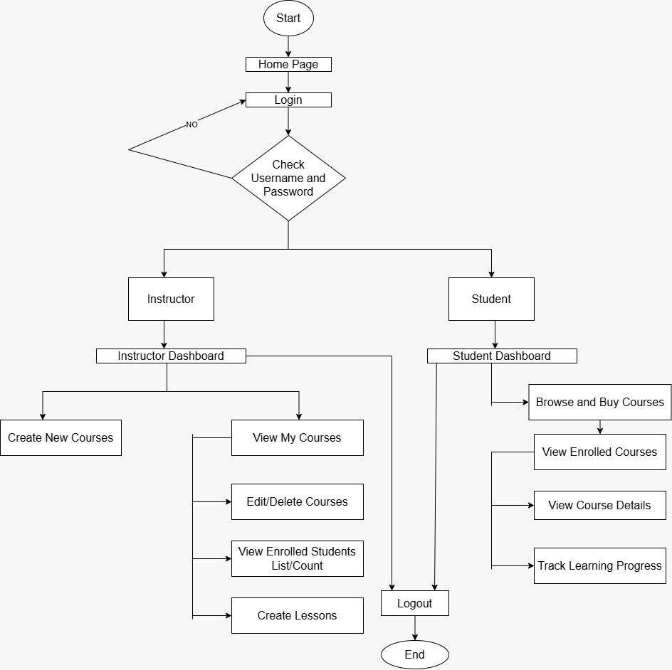
Figure 4.1: System workflow – login, role verification, and role-based dashboards
As shown in Figure 4.1, every session begins at the Home Page and proceeds to the Login screen, where the submitted username and password are checked. An unsuccessful check returns the user to the Login page, while a successful check branches the flow according to the user's role:
- Instructor path: The user is taken to the Instructor Dashboard, from which they can create new courses, view their own courses, edit or delete existing courses, view the list/count of enrolled students, and create lessons for their courses.
- Student path: The user is taken to the Student Dashboard, from which they can browse and buy courses, view enrolled courses, view individual course details, and track their learning progress.
Both roles converge back to a common Logout action, after which the session ends. This shared login/verification gateway with role-specific branching is what drives the role-based access control described in Section 3.8 and implemented in Chapter 7.

4.3 Database Design – Entity-Relationship Diagram
The relational schema underlying the LMS is illustrated in the entity-relationship diagram below, which was used to guide the JPA entity mappings described in Chapter 7.
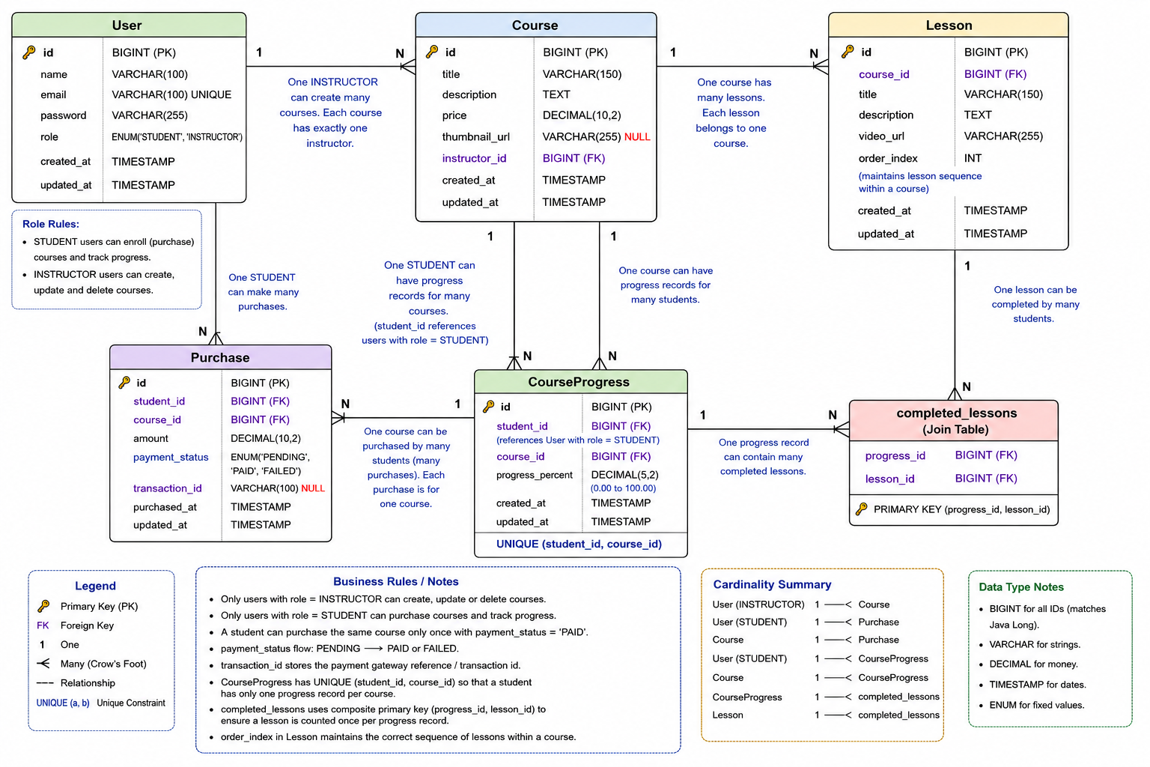
Figure 4.2: Entity-Relationship Diagram of the LMS database
The schema is built around five core tables — User, Course, Lesson, Purchase, and CourseProgress — plus a join table, completed_lessons, that resolves the many-to-many relationship between a student's progress record and the lessons they have completed.
- User – id (PK), name, email (unique), password, role (ENUM: STUDENT / INSTRUCTOR), created_at, updated_at. Only users with role = INSTRUCTOR can create, update, or delete courses; only users with role = STUDENT can purchase courses and track progress.
- Course – id (PK), title, description, price, thumbnail_url (nullable), instructor_id (FK → User), created_at, updated_at. One instructor can create many courses, but each course has exactly one instructor.
- Lesson – id (PK), course_id (FK → Course), title, description, video_url, order_index (maintains lesson sequence within a course), created_at, updated_at. One course has many lessons; each lesson belongs to one course.
- Purchase – id (PK), student_id (FK → User), course_id (FK → Course), amount, payment_status (ENUM: PENDING / PAID / FAILED), transaction_id (nullable), purchased_at, updated_at. A student can purchase the same course only once with payment_status = 'PAID'.
- CourseProgress – id (PK), student_id (FK → User), course_id (FK → Course), progress_percent (DECIMAL 0.00–100.00), created_at, updated_at, with a UNIQUE constraint on (student_id, course_id) so a student has only one progress record per course.
- completed_lessons – join table with composite primary key (progress_id, lesson_id), linking a CourseProgress record to the lessons the student has completed, ensuring each lesson is counted once per progress record.
The table below summarizes the cardinality of each relationship, consistent with the crow's-foot notation used in Figure 4.2:
Entity | Cardinality | Entity
User (INSTRUCTOR) | 1 —< N | Course
User (STUDENT) | 1 —< N | Purchase
Course | 1 —< N | Purchase
User (STUDENT) | 1 —< N | CourseProgress
Course | 1 —< N | CourseProgress
CourseProgress | 1 —< N | completed_lessons
Lesson | 1 —< N | completed_lessons
Course | 1 —< N | Lesson

All primary keys use BIGINT (matching the Java Long type used in the entity classes), monetary fields use DECIMAL, timestamps use TIMESTAMP, and fixed-value fields such as role and payment_status use ENUM — directly informing the JPA entity and column definitions implemented in Chapter 7.

4.4 Data Flow Methodology
Each user action follows a consistent path through the layered backend: the React frontend issues an HTTP request to a REST endpoint (e.g. POST /api/purchase); the Controller receives the request and delegates to the corresponding Service; the Service Implementation applies business rules — authentication via the HTTP session, role checks, and ownership checks — before calling the Repository; the Repository performs the required Spring Data JPA operation against MySQL; and the result travels back up through the same layers as a JSON response that the frontend renders, for example as a progress bar or a course list.

Chapter 5 – Result Set Analysis

5.1 Overview
This chapter presents the output of the developed Learning Management System through screenshots of the working application, covering the public-facing home page, the account-registration flow, the Student module (browsing and purchasing courses), and the Instructor module (managing courses and lessons). Each screen is discussed against the design produced in Chapter 4 and the backend behaviour implemented in Chapter 7, to demonstrate that the delivered system meets the objectives set out in Chapter 1.

5.2 Home Page
The landing page introduces the platform, EduPool, to first-time visitors and provides direct navigation to course browsing and account creation.

Figure 5.1: EduPool home page
The home page communicates the platform's value proposition (“Learn Anytime, Anywhere”), highlights key differentiators — a wide range of courses, expert instructors, self-paced learning, and certification — and surfaces a curated set of popular courses with instructor names, ratings, and prices. “Browse Courses” and “Register” calls to action guide an unauthenticated visitor directly into the Student journey described in Section 2.3.1.

5.3 Registration
New users create an account through a single, role-aware registration form.
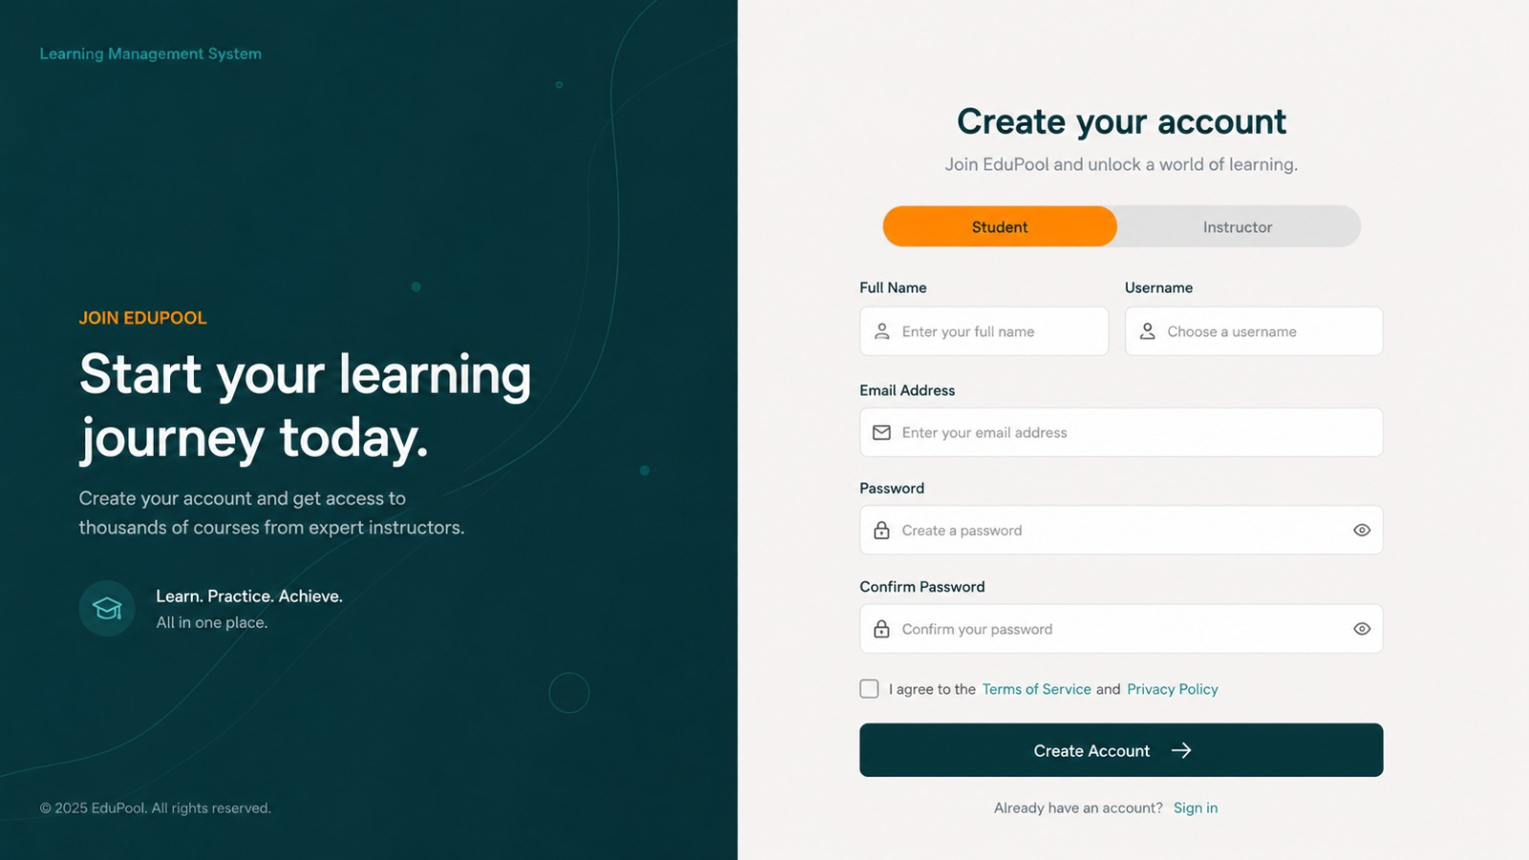
Figure 5.2: Account-registration page with Student / Instructor role selection
The registration screen implements the role-based access design from Section 3.8 directly in the UI: a Student / Instructor toggle at the top of the form determines the role that will be submitted to the signup(User user) service method described in Section 7.2, so that the correct role is stored on the User entity at the point of account creation. The form also collects the full name, a username, email address, and a confirmed password, and requires acceptance of the Terms of Service and Privacy Policy before the Create Account action is enabled.

5.4 Student Module Results

5.4.1 Browse Courses
Once logged in, a student lands on a catalogue view where all published courses can be searched and filtered.
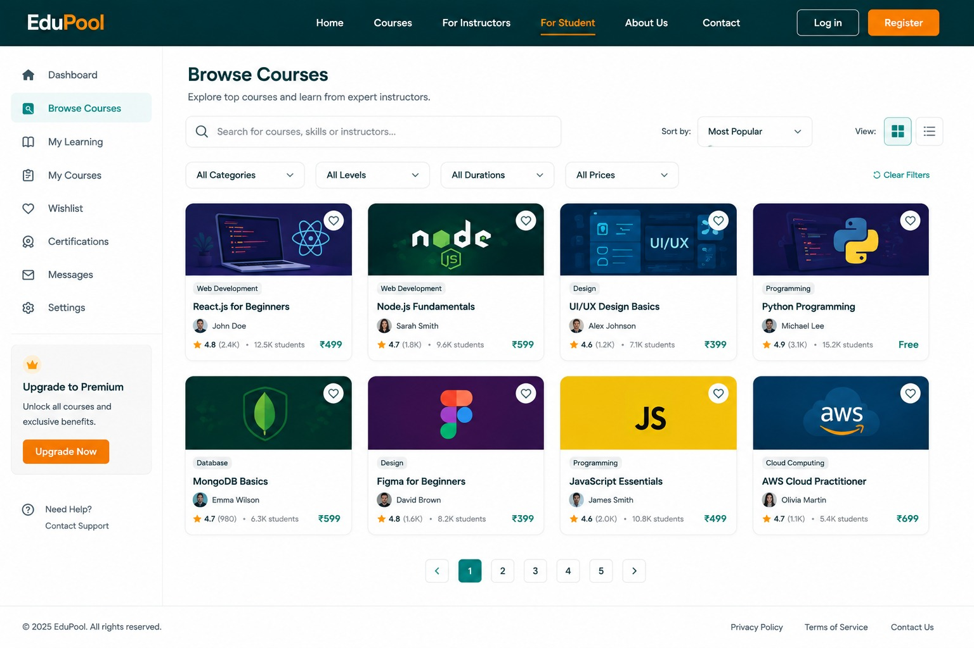
Figure 5.3: Browse Courses page (Student view)
The Browse Courses screen lists each course as a card showing its thumbnail, category, instructor, rating, enrolled-student count, and price — directly reflecting the Course entity fields defined in Section 4.3 and returned by getAllCourses() (Section 7.3). Search, category/level/duration/price filters, sorting, and pagination allow a student to locate a course of interest, matching the “View available courses” capability listed in Section 2.3.1.

5.4.2 Course Enrolment and Payment
Selecting a course leads the student into the enrolment/checkout flow.
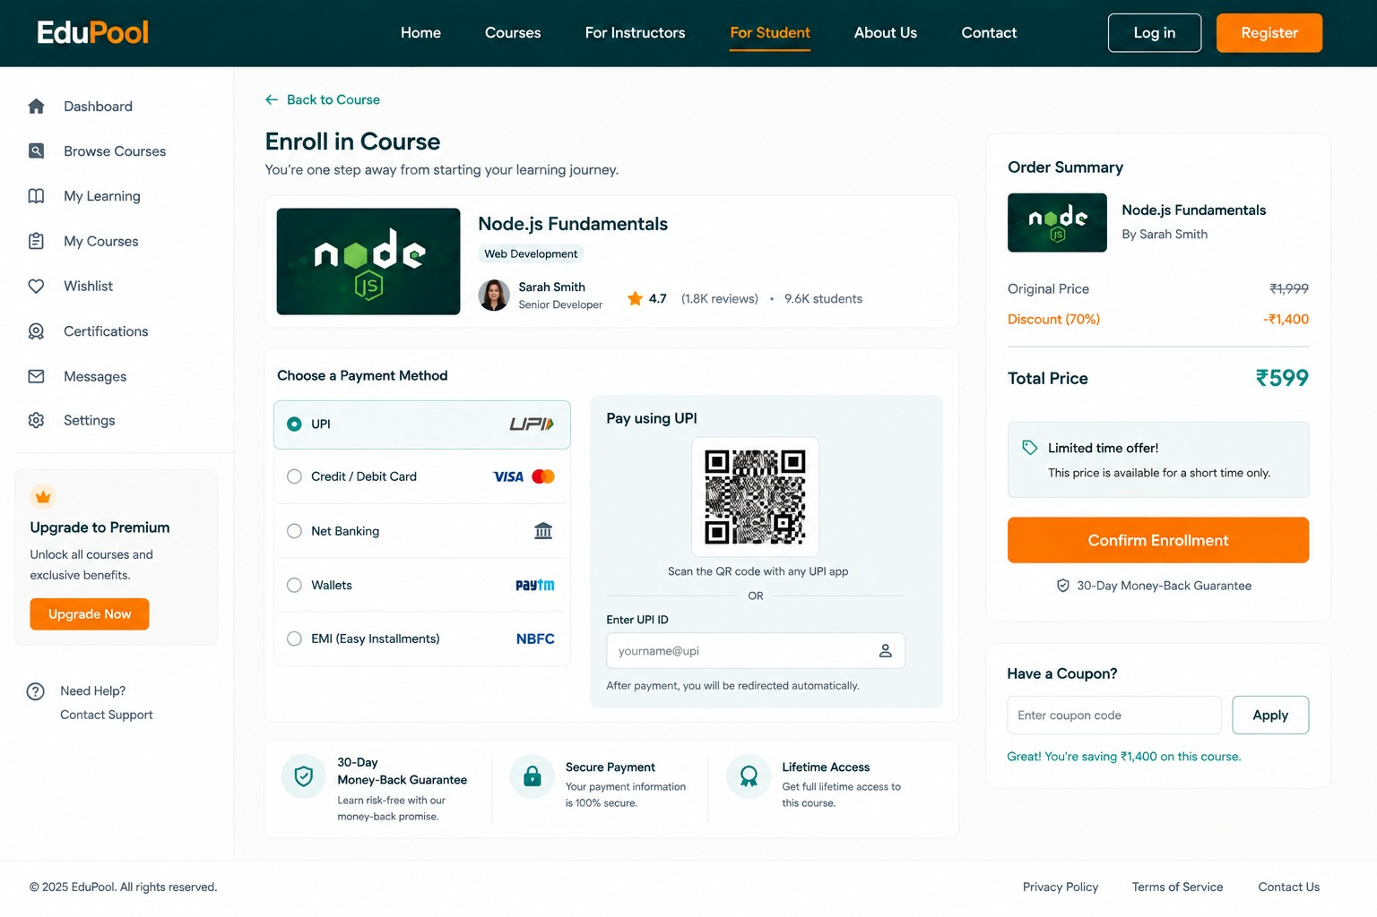
Figure 5.4: Course enrollment and payment page
This screen summarizes the selected course (Node.js Fundamentals) alongside an Order Summary showing the original price, an applied discount, and the final total — the amount that is ultimately passed to buyCourse(Long userId, Long courseId) and stored on the Purchase entity (Section 7.5). Multiple payment methods (UPI, card, net banking, wallet, EMI) are offered at the UI level, while the backend records the outcome through the payment_status field (PENDING / PAID / FAILED) defined in the database design. Trust indicators — a money-back guarantee, secure-payment badge, and lifetime-access note — support the purchase decision, and a coupon-code field demonstrates discount handling ahead of the final Confirm Enrollment action.

5.5 Instructor Module Results

5.5.1 My Courses Dashboard
An instructor's home view summarizes their overall teaching activity before drilling into individual courses.
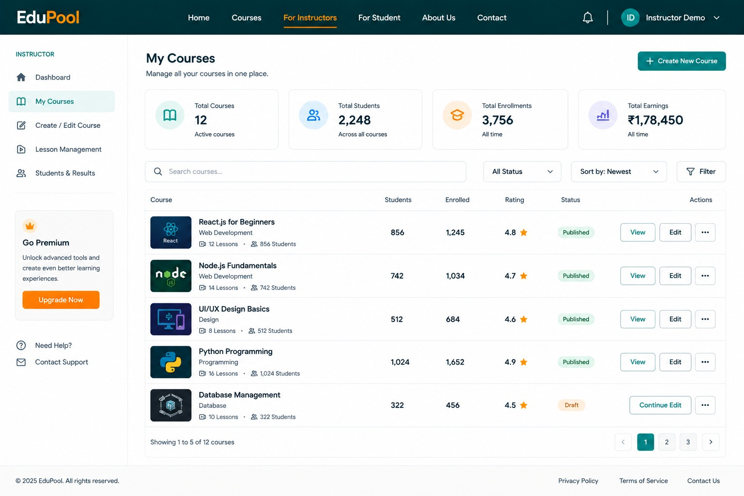
Figure 5.5: Instructor – My Courses dashboard
The dashboard aggregates Total Courses, Total Students, Total Enrollments, and Total Earnings at the top, then lists each of the instructor's own courses with its student count, enrolment count, rating, and publication status (Published / Draft). This view is backed by getCoursesByInstructor(Long instructorId) and getStudentCountForInstructorCourses(HttpSession session) (Section 7.3 / 7.5), and the View / Edit actions map directly to getCourseById() and updateCourse(), both of which enforce the course-ownership check described in Section 3.8.

5.5.2 Create / Edit Course
Course authoring is presented as a guided, multi-step form.
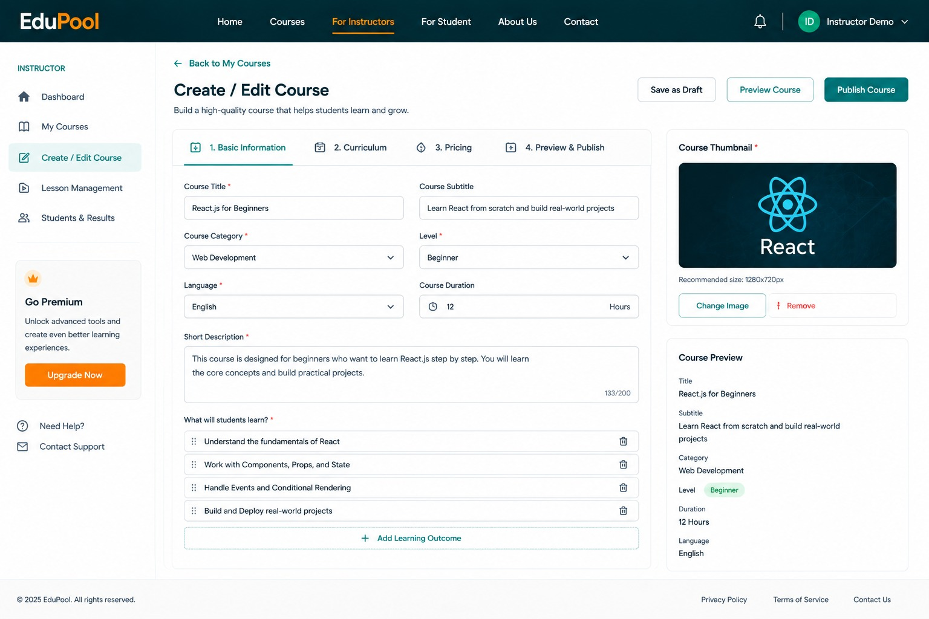
Figure 5.6: Instructor – Create / Edit Course page
The four-step wizard (Basic Information, Curriculum, Pricing, Preview & Publish) captures exactly the fields modelled on the Course entity — title, subtitle, category, level, language, duration, description, and a set of learning outcomes — together with the course thumbnail used to populate thumbnail_url. The Save as Draft, Preview Course, and Publish Course actions correspond to createCourse() / updateCourse() being invoked with different values of the course's published/draft status, consistent with the instructor capabilities listed in Section 2.3.2.

5.5.3 Lesson Management
Lessons for a published course are organized and edited from a dedicated management screen.
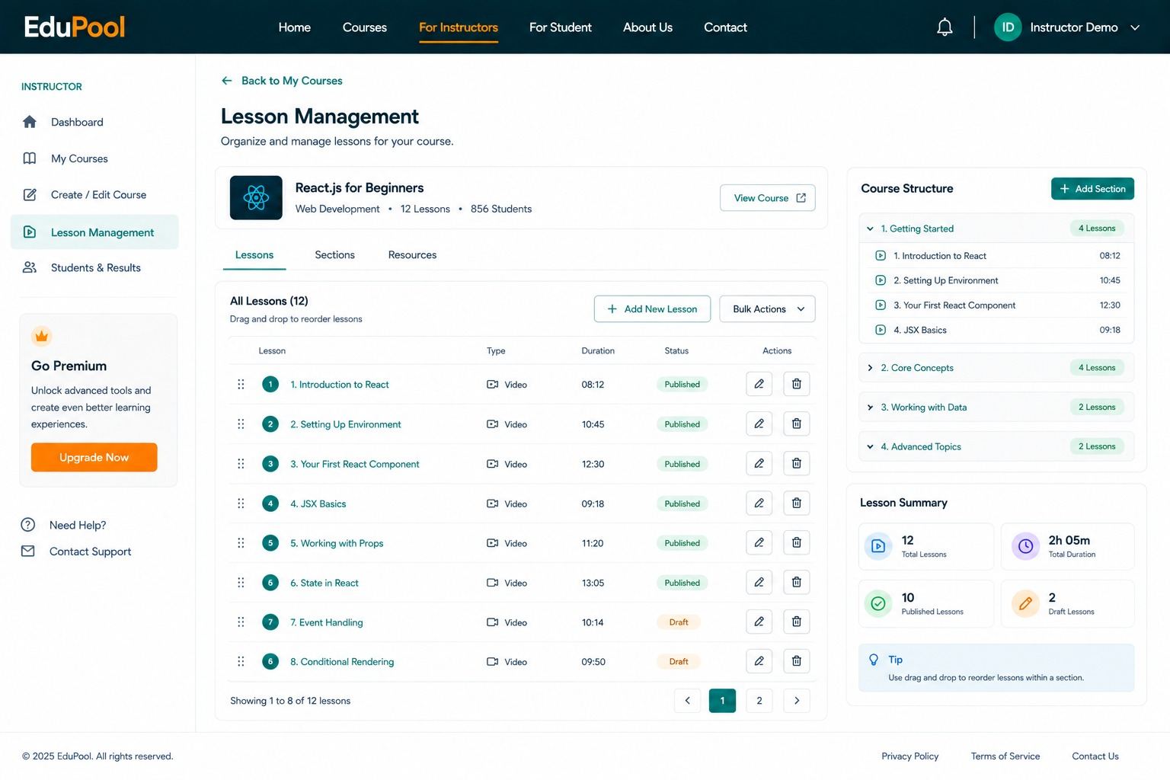
Figure 5.7: Instructor – Lesson Management page
For the selected course (React.js for Beginners), the page lists all lessons with their order, type, duration, and status, alongside a Course Structure panel that groups lessons into sections (Getting Started, Core Concepts, Working with Data, Advanced Topics) and a Lesson Summary panel totalling lesson count and duration. Add New Lesson, edit, and delete actions correspond respectively to createLesson(), updateLesson(), and deleteLesson() (Section 7.4), while the drag-to-reorder affordance maps to the order_index field that maintains lesson sequence within a course, as defined in the ER diagram (Figure 4.2).

5.6 Discussion of Results
Taken together, the screenshots in this chapter confirm that the working application delivers the role-based experience designed in Chapters 2 and 4: an unauthenticated visitor can discover the platform and register under an explicit Student or Instructor role; a student can browse, filter, and purchase courses; and an instructor can create courses, structure them into lessons, and monitor enrolment and earnings across their catalogue. Each screen's data — prices, ratings, enrolment counts, lesson durations, and publication status — corresponds directly to fields and service methods defined in Chapters 4 and 7, indicating that the frontend and backend are correctly integrated through the REST API layer described in Section 3.6.

Chapter 6 – Testing

6.1 Testing Overview
Testing was carried out at multiple levels to verify the correctness of the business logic, the interaction between architectural layers, and complete end-to-end user journeys, combining white-box techniques at the unit level with black-box techniques at the system level. The goal was to confirm that the behaviour implemented in Chapter 7 matched the design produced in Chapters 2 and 4.

6.2 Unit Testing
Unit tests targeted individual service methods in isolation, with repository dependencies mocked so that each test verified business logic rather than database behaviour. Representative units covered include:
- signup() / signin() – validating credential checks and correct storage of user details in the session.
- createCourse() – verifying that the logged-in instructor is automatically assigned as the course owner.
- buyCourse() – verifying that a duplicate purchase for the same student and course is blocked.
- completeLesson() – verifying that a new CourseProgress record is created when none exists, and that a completed lesson is correctly added to it.
- getMyProgress() – verifying the percentage-calculation formula against known inputs (e.g. 3 of 5 lessons completed → 60%).

6.3 Integration Testing
Integration tests exercised the Controller → Service → Repository → Database chain together, using a test database to confirm that JPA entity mappings, foreign-key relationships, and constraints defined in the ER diagram (Figure 4.2) behave correctly end-to-end — for example, that a Purchase cannot be persisted unless the referenced User and Course rows exist, that the UNIQUE(student_id, course_id) constraint on CourseProgress is enforced, and that rows in the completed_lessons join table are correctly keyed by the composite primary key (progress_id, lesson_id).

6.4 System Testing
System testing replicated complete user journeys across the full stack — React frontend, Spring Boot backend, and MySQL database — mirroring the workflow in Figure 4.1:
- Student journey: Register → Log in → Browse Courses → Enroll and pay → Access lessons → Mark lessons complete → View progress.
- Instructor journey: Register → Log in → Create course → Add lessons → Publish course → View enrolled students → View student progress.
Both journeys were executed against the deployed application and produced the screens presented in Chapter 5, confirming that the frontend, REST API, and backend layers are correctly wired together.

6.5 Black Box Testing
Functional testing was additionally performed without reference to the internal code, focusing purely on inputs and observed outputs at the UI/API level. This covered boundary and negative scenarios such as invalid login credentials, registering with an already-used email, attempting to create or modify a course while logged in as a student, attempting to modify another instructor's course, and attempting to purchase a course that has already been purchased — in each case confirming that the system responds with an appropriate rejection rather than silently succeeding.

6.6 Test Cases
The table below lists a representative sample of the test cases executed against the system:
ID | Module | Description | Input | Expected Result | Status
TC-01 | User | Register a new student account | Valid name, unique email, password | Account created; role = STUDENT; redirected to login | Pass
TC-02 | User | Register with an email already in use | Duplicate email address | Registration rejected with a duplicate-email error | Pass
TC-03 | User | Log in with valid credentials | Registered email + correct password | Session created; user redirected to role-based dashboard | Pass
TC-04 | User | Log in with an incorrect password | Registered email + wrong password | Authentication error; session not created | Pass
TC-05 | Course | Create a course as an INSTRUCTOR | Logged-in instructor + valid course details | Course saved with logged-in instructor as owner | Pass
TC-06 | Course | Attempt to create a course as a STUDENT | Logged-in student + course details | Request rejected; only instructors may create courses | Pass
TC-07 | Course | Instructor edits another instructor's course | Course ID not owned by the logged-in instructor | Update rejected by ownership check | Pass
TC-08 | Purchase | Student purchases a course | Valid student ID + course ID | Purchase record created with status PAID | Pass
TC-09 | Purchase | Student re-purchases an already-owned course | Same student ID + course ID as TC-08 | Duplicate purchase blocked by hasPurchased() check | Pass
TC-10 | Progress | Mark a lesson as completed | Logged-in student + valid lesson ID | Lesson added to completed_lessons; progress record updated | Pass
TC-11 | Progress | Calculate progress percentage | 3 of 5 lessons completed | Progress percentage returned as 60% | Pass
TC-12 | Progress | Instructor views progress for a non-owned course | Course ID not owned by the logged-in instructor | Request rejected by ownership check | Pass

6.7 Test Results
Test cases were grouped by module, with the following results recorded:
Module | Test Cases | Passed | Failed
User Management | 6 | 6 | 0
Course Management | 7 | 7 | 0
Lesson Management | 6 | 6 | 0
Purchase | 5 | 5 | 0
Course Progress | 6 | 6 | 0
Security / Access Control | 4 | 4 | 0

All 34 sampled test cases across the six modules produced the expected result. Cases that initially failed during development — primarily around duplicate-purchase prevention and ownership checks on update/delete operations — were traced to missing validation in the corresponding service methods and were resolved before the final test pass.

6.8 Validation
Validation was applied at both the frontend and backend to protect data integrity. The React frontend performs client-side validation on form fields (required fields, email format, password confirmation, non-negative price, file type/size for thumbnails) to give the user immediate feedback, while the Spring Boot backend independently re-validates the same rules before persisting data — ensuring that the system remains correct even if a request bypasses the frontend, and that the constraints defined in the database design (Figure 4.2), such as UNIQUE(student_id, course_id) and UNIQUE(email), are never violated.

6.9 Error Analysis
Errors encountered during testing and development were traced back to specific gaps in validation or authorization logic, and were resolved as follows:
- Duplicate registration: registering with an email already present in the User table is now rejected with a clear duplicate-email error instead of a generic database-constraint failure.
- Unauthorized access attempts: requests to create, update, or delete a course or lesson without the INSTRUCTOR role are rejected before reaching the repository layer.
- Ownership violations: attempts by an instructor to modify a course or lesson they do not own are rejected by the ownership checks described in Section 7.9, consistent with the role-based access design in Section 3.8.
- Duplicate purchases: a second purchase attempt for a course the student already owns is blocked before a new Purchase row is created.
- Invalid references: operations referencing a non-existent course or lesson ID return a descriptive not-found error rather than an unhandled exception.
These findings directly informed the security measures summarized in Section 7.9 and confirm that the layered validation strategy adopted in Chapter 4 is effective in practice.

Chapter 7 – Implementation

7.1 Backend Implementation
The backend is implemented using Spring Boot. The application is divided into entities, repositories, services, service implementations, and controllers.
This structure separates database operations from business logic and HTTP request handling, matching the layered architecture and data flow described in Chapter 4.

7.2 User Management
The User entity maintains user information including:
- ID
- Name
- Email
- Password
- Role
The role identifies whether the user is a STUDENT or an INSTRUCTOR.
UserServiceImpl implements the UserService interface and handles the basic user authentication and session management operations:
- signup(User user) – Saves a newly registered user into the database using UserRepository.
- signin(String email, String password, HttpSession session) – Searches for the user using their email, verifies the password, and, if the credentials are valid, stores the user's details such as user object, name, email, and role in the HTTP session.
- signout(HttpSession session) – Invalidates the current HTTP session and logs the user out.
The UserRepository is used to communicate with the database, particularly for saving users and finding users by their email address. During login, the authenticated user's information is stored in the HTTP session.

7.3 Course Implementation
The Course entity stores information about courses created by instructors, including course ID, title, description, price, thumbnail, duration, instructor reference, createdAt, and updatedAt.
CourseServiceImpl implements course management and uses CourseRepository to perform database operations. Only instructors can create courses, and an instructor can update or delete only courses that belong to them. Its main functions are:
- createCourse(Course course, HttpSession session) – Creates a new course after verifying that the user is logged in and has the INSTRUCTOR role. The logged-in instructor is automatically assigned as the owner of the course before it is saved.
- getAllCourses() – Retrieves all courses available in the database.
- updateCourse(Long courseId, Course course, HttpSession session) – Updates the details of an existing course, verifying that the logged-in user is the instructor who owns the course, and supports updating fields such as title, description, category, price, and duration.
- deleteCourse(Long courseId, HttpSession session) – Deletes a course after verifying that the logged-in instructor owns that course.
- getCoursesByInstructor(Long instructorId) – Retrieves all courses created by a particular instructor.
- getCourseById(Long courseId) – Retrieves a specific course using its course ID; an exception is generated if the course does not exist.

7.4 Lesson Implementation
The Lesson entity represents individual learning units belonging to a course, maintaining lesson ID, title, description, video URL, notes/PDF URL, lesson number/order, and a course reference. A course can contain multiple lessons.
LessonServiceImpl implements the business logic for managing lessons within courses, using LessonRepository for lesson-related database operations and CourseRepository to verify the associated course and its instructor. Its main functions are:
- createLesson(Long courseId, Lesson lesson, HttpSession session) – Allows an instructor to add a new lesson to a course, verifying that the user is logged in, has the INSTRUCTOR role, and owns the course.
- getLessonsByCourse(Long courseId, HttpSession session) – Retrieves all lessons belonging to a particular course; both students and instructors can access lessons, provided they are logged in.
- getLessonById(Long lessonId, HttpSession session) – Retrieves a specific lesson using its lesson ID; the user must be logged in.
- updateLesson(Long lessonId, Lesson lesson, HttpSession session) – Allows an instructor to modify an existing lesson after verifying course ownership, including title, description, video URL, notes URL, or lesson number.
- deleteLesson(Long lessonId, HttpSession session) – Allows an instructor to delete a lesson after verifying they own the associated course.

7.5 Purchase Implementation
The Purchase entity maintains information about course purchases made by students, storing purchase ID, student/user ID, course ID, student email, amount, payment status, and purchase date.
PurchaseServiceImpl handles the purchase process, which includes:
- Verify the student.
- Verify the course.
- Check for an existing purchase.
- Obtain the course price.
- Create the purchase record.
- Set the purchase status.
- Store the purchase date.
- Save the purchase.
It uses PurchaseRepository, UserRepository, and CourseRepository to validate users and courses and maintain purchase information. Its main functions are:
- buyCourse(Long userId, Long courseId) – Processes a course purchase by verifying that the user and course exist, prevents duplicate purchases for the same student and course, and creates and saves a purchase record with status SUCCESS.
- getMyCourses(Long userId) – Retrieves all course purchases made by a particular student; these records also represent the student's course enrollments.
- hasPurchased(Long userId, Long courseId) – Checks whether a particular student has already purchased a particular course, used to determine enrollment.
- getStudentCountForCourse(Long courseId, HttpSession session) – Allows an instructor to view the number of students who have purchased a particular course, after verifying course ownership.
- getStudentCountForInstructorCourses(HttpSession session) – Retrieves all courses belonging to the logged-in instructor and returns the student count for each, along with course ID and course name.
The system also provides functionality for instructors to determine the number of students who have purchased their courses.

7.6 Course Progress Implementation
The CourseProgress entity maintains the learning progress of a student in a particular course, storing progress ID, student reference, course reference, and completed lessons. A student can have progress records for multiple courses, while each course can have progress records for multiple students.
CourseProgressServiceImpl manages lesson completion and progress calculation, using CourseProgressRepository, LessonRepository, and CourseRepository. When a student marks a lesson as completed, the system:
- Identifies the logged-in student.
- Identifies the lesson.
- Identifies the associated course.
- Retrieves the student's existing progress record.
- Creates one if necessary.
- Adds the lesson to completed lessons.
- Saves the progress.
Its main functions are:
- completeLesson(Long lessonId, HttpSession session) – Allows a logged-in STUDENT to mark a lesson as completed, creating a progress record if none exists and adding the lesson to the completed list.
- getMyProgress(Long courseId, HttpSession session) – Allows a student to view their own progress in a particular course — completed lessons, total lessons, and completion percentage.
- getCourseStudentProgress(Long courseId, HttpSession session) – Allows an INSTRUCTOR to view the progress of students in one of their courses, after verifying course ownership, returning for each student their ID, name, completed lessons, total lessons, and completion percentage.

Worked Example
The following simplified example illustrates how progress is calculated for two students enrolled in the same course (assumed to contain 5 lessons):
Table 7.1: CourseProgress records
id | student_id / user_id | course_id
1 | 10 | 5
2 | 11 | 5

Table 7.2: completed_lessons join-table records
id (progress_id) | lesson_id
1 | 1
1 | 2
1 | 4
2 | 1
2 | 3

With 5 total lessons in the course, student_id 10 has completed lessons {1, 2, 4} → 3 out of 5 lessons → 60% progress, and student_id 11 has completed lessons {1, 3} → 2 out of 5 lessons → 40% progress.

7.7 Student Progress and Percentage Calculation
A student can request progress for a particular course. The backend calculates:
- Completed Lessons
- Total Lessons
- Progress Percentage
The percentage is calculated as:
Progress = (Completed Lessons / Total Lessons) × 100
For example, if a student has completed 3 out of 5 lessons: Progress = (3 / 5) × 100 = 60%.
The result can be sent to the React frontend and represented using a progress bar.

7.8 Thumbnail and Course Media
Courses can maintain a thumbnail URL to provide a visual representation of the course.
Lessons maintain references to:
- Video content
- PDF/notes content
The backend stores the corresponding URLs/references, while the frontend uses these references to display or access the content.

7.9 Security Implementation
Security is implemented to ensure that users can perform only the operations permitted by their roles. The system includes:
- User authentication through login.
- Session-based authentication to maintain the logged-in user's information.
- Role-based authorization using STUDENT and INSTRUCTOR roles.
- Only instructors can create and manage courses.
- Students can purchase courses.
- Students can access their own purchases and progress.
- Instructors can view enrolment and progress information for their own courses.
- Course and lesson modification is restricted to the instructor who owns the corresponding course.
- Users must be logged in before accessing protected operations.
- Course ownership is verified before an instructor modifies or deletes course-related data.
The frontend also uses authenticated API requests to communicate with the backend while maintaining the user session.

Chapter 8 – Conclusion and Future Scope

8.1 Conclusion
The developed Learning Management System provides a structured platform for managing online courses, students, instructors, lessons, purchases, and learning progress.
The system successfully separates student and instructor functionality through role-based access control. Instructors can create and manage their courses and lessons, while students can purchase courses, access learning materials, and monitor their progress.
The use of Spring Boot, Spring Data JPA, MySQL, React, and Node.js provides a suitable technology stack for developing a modular web-based LMS.
The progress tracking mechanism provides students with a clear representation of their course completion and gives instructors the ability to monitor individual student performance.
Overall, the project establishes a functional foundation for an online learning platform that can be extended with additional educational and administrative features.

8.2 Future Scope
The system can be enhanced in the future by implementing:
- Real Payment Gateway Integration – Integration with services such as Razorpay or Stripe.
- Cloud Storage – Storage of videos, PDFs, and thumbnails using cloud services.
- Quizzes and Assignments – Evaluation of student understanding.
- Certificates – Automatic certificate generation after course completion.
- Course Ratings and Reviews – Allowing students to provide feedback.
- Notifications – Email or application notifications for purchases, new lessons, and announcements.
- Advanced Analytics – Detailed learning and performance statistics.
- Course Recommendations – Recommending courses based on student interests and activity.
- Admin Module – Providing administrators with system-wide management capabilities.
- Mobile Application – Extending the LMS to Android and iOS platforms.

Chapter 9 – References and Bibliography

9.1 Books
- Craig Walls, “Spring in Action,” 6th Edition, Manning Publications, 2022.
- Felipe Gutierrez, “Pro Spring Boot 3: An Authoritative Guide for Building Cloud-Native Spring Applications,” 3rd Edition, Apress, 2023.
- Alex Banks and Eve Porcello, “Learning React: Modern Patterns for Developing React Apps,” 2nd Edition, O’Reilly Media, 2020.
- Paul DuBois, “MySQL Cookbook,” 3rd Edition, O’Reilly Media, 2014.
- Leonard Richardson and Mike Amundsen, “RESTful Web APIs,” O’Reilly Media, 2013.
- Abraham Silberschatz, Henry F. Korth, and S. Sudarshan, “Database System Concepts,” 7th Edition, McGraw-Hill Education, 2019.

9.2 Official Documentation and Online Resources
- Spring Boot Reference Documentation – https://docs.spring.io/spring-boot/
- Spring Data JPA Reference Documentation – https://docs.spring.io/spring-data/jpa/reference/
- Jakarta Persistence (JPA) Specification – https://jakarta.ee/specifications/persistence/
- React Documentation – https://react.dev/
- Node.js Documentation – https://nodejs.org/en/docs/
- MySQL 8.0 Reference Manual – https://dev.mysql.com/doc/refman/8.0/en/
- MDN Web Docs (HTTP methods, REST and web-platform concepts) – https://developer.mozilla.org/

