**COMP 3133 – Full Stack Development – Lab 2**

* ES6 Promises & Async/Await Exercises

**Developer Note:**

* Try to solve the problems without using search engines or stack overflow for the solutions.
* Create separate files for each exercise

**Exercise 1:**

* Write a function **compareNumToTen** that takes a number as an argument and returns a **Promise** that tests and rejects if the value is less than or resolves if greater than the value 10.

***Promise Reference***[**https://developer.mozilla.org/en-US/docs/Web/JavaScript/Reference/Global_Objects/Promise**](https://developer.mozilla.org/en-US/docs/Web/JavaScript/Reference/Global_Objects/Promise)

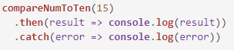

**Output**



**Exercise 2:**

* Write two functions that use Promises that you can chain! The first function, **makeUpperCase(),** will take in an array of words and capitalize them, and then the second function, **sortWords(),** will sort the words in alphabetical order. If the array contains anything but strings, it should throw an error.

***Promise Chaining Reference***

<https://developer.mozilla.org/en-US/docs/Web/JavaScript/Reference/Global_Objects/Promise>



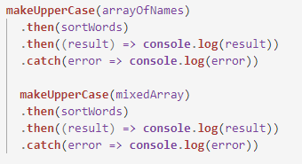

**Output** 

**Exercise 3:**

* Use the **Promise.all** syntax to resolve all three promises below and return a new promise. Call the function and use the thenable .then() keyword to output the result.

***Promise.all() Reference***[**https://developer.mozilla.org/en-US/docs/Web/JavaScript/Reference/Global_Objects/Promise/all**](https://developer.mozilla.org/en-US/docs/Web/JavaScript/Reference/Global_Objects/Promise/all)

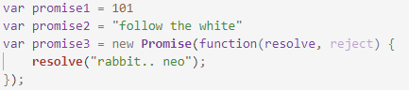

**Output**

* 

**Exercise 4:**

* Recall the delayed function using setTimeout  
  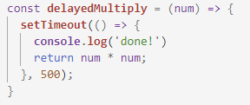
* **Task 1**. Rewrite the function and name it **delayedPromise**, so that it uses a **Promise**. Resolving new function in the in the following way returns an output of 25



**Output**

* 25
* **Task 2**. Rewrite the **delayedPromise** function and create a new function named **asyncPromise** that uses the **async** and **await** keywords.

***Async Function Reference***  
<https://developer.mozilla.org/en-US/docs/Web/JavaScript/Reference/Statements/async_function>



Output

* 36

.