COMP 3133 – Full Stack Development – Lab 5
- File Module and Processes

Developer Note:
- Try to solve the problems without using search engines or stack overflow for the solutions.
- Create separate files for each exercise

References:
- https://nodejs.org/api/process.html
- https://nodejs.org/api/fs.html
- https://nodejs.org/api/path.html
- https://nodejs.org/api/child_process.html

Exercise 1:

- Write a script that lists files in current directory, filtered by a given extension from the command line.
  - Use the file and path module
  - User the process object to get the current directory and command line args
  - Use fs.readdir(path[, options], callback) to asynchronously read the contents of the file directory and output the file names
- Input
- Output

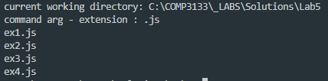

Exercise 2:
- Using the process object write a script that logs the following
https://nodejs.org/api/process.html
  - OS platform
  - processor architecture
  - version of NodeJS
  - version of V8
  - version of LibUV
  - PID
  - title
  - working directory

- Output

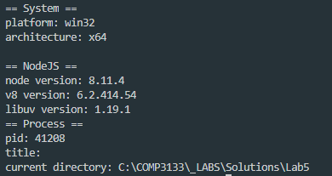

Exercise 3:
- Using following setInterval code to run an infinite loop on the process that runs it. Add event listeners on the process exit and signal interrupt events and log the process running uptime. Use Ctrl+X Ctrl+C to kill the current process and trigger the events.

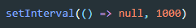

- Output
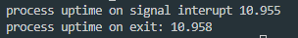

Exercise 4:
- Given the following compute.js file, create a script that will use the child process module and fork a child process that will execute the compute script and do the following:
  - send a message to the child process to start the calculation
  - create an event listener to receive the message sent from child process and log result
compute.js
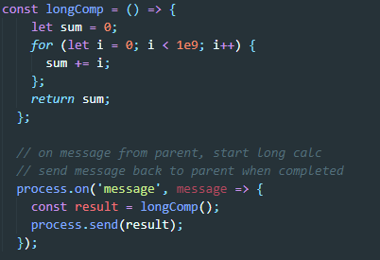

- Output

Bonus

- Write a script that reads input from the CLI (command line interface) and logs the uppercased version of the input after Enter is pressed. It should continuously prompt User for an input and end on Ctrl-C + Ctrl-X. Hint, use process stdout and stdin

> Output

