**COMP 3133 – Full Stack Development – Lab 2**

* ES6 Practice Exercises

**Developer Note:**

* Try to solve the problems without using search engines or stack overflow for the solutions.

**Exercise 1:**

* Rewrite the following code block using ES6 syntax, *ie. const, let, arrow function, template literals and for..of*

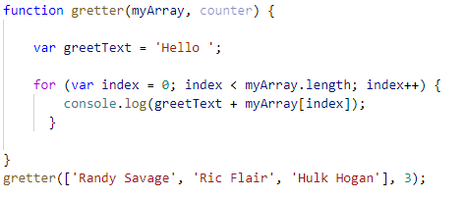

**Exercise 2:**

* Using destructuring assignment syntax and the spread operator, write a function will capitalize the first letter of a string.

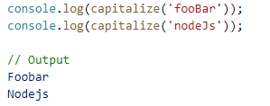

**Exercise 3:**

* Using **array.proto.map** create function to use the capitalize method in Exercise 2 to upper case the first character of each Color in the following array..

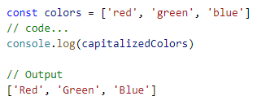

**Exercise 4:**

* Using **array.proto.filter** create a function that will filter out all the values of the array that are less than twenty.

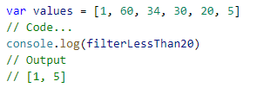

**Exercise 5:**

* Using **array.proto.reduce** create calculate the sum and product of a given array.

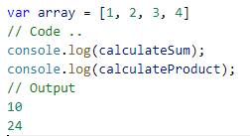

**Exercise 6:**

* Using ES6 syntax for class and subclass using extends to create a Sedan subclass which derives from Car Class. The parameters for the Car class is the model and year. The parameters for the subclass is the model, year and balance.
* Use the super key word in the Sedan subclass to set the model and name in base Car constructor.

