Jonathan Ou

June 1, 2021

Foundations of Programming: Python

Assignment 08

<https://github.com/jayohhhh/IntroToProg-Python-Mod08>

Working with Classes Documentation

# Introduction

Working with classes in this assignment gave me perspective into object oriented programming. This is different way to work with data and functions, enabling new possibilities for programming. There are various tools that can be utilized with classes that enable specific functions or actions such as constructors and private/public attributes and methods.

# Product Class

Figure 1 shows the starting variables which are set to enable for later use. Also the constructor is shown in this figure. In this constructor, the name and price of the product is set based on the inputs of the class.

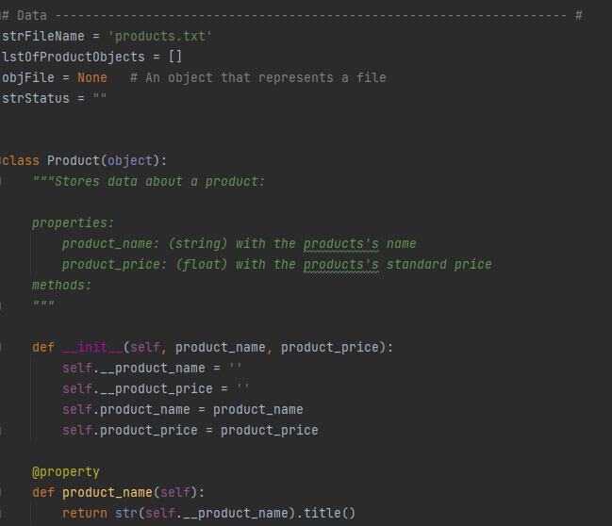

Figure : Product Class Part 1

Figure 2 shows the continuation of the product class setup. Here are the setter attributes for name and price properties which ensures that the properties can only be set without numbers or with numbers. This makes use of exceptions as it informs the user what can fix the exception that was prompted.

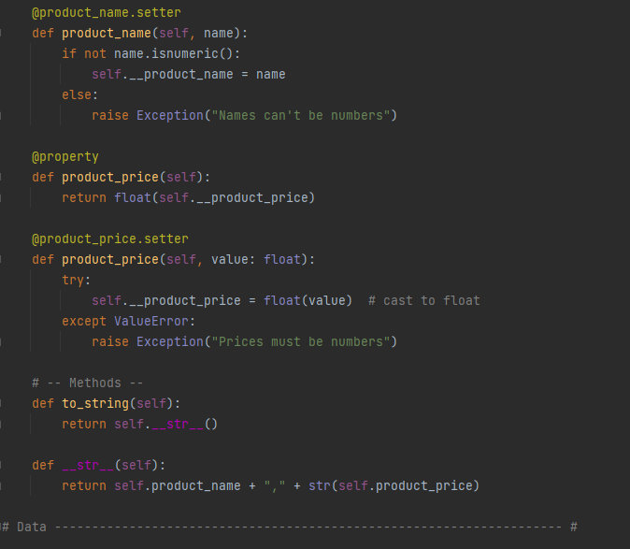

Figure : Product Class Part 2

# File Processor Class

In Figure 3, the File Processor class is being defined. There are two functions. The first function executes reading a file into python. In terms of how it is different from the other times this call function was used, objects are being stored in this case and the product class is called to form the data entry.

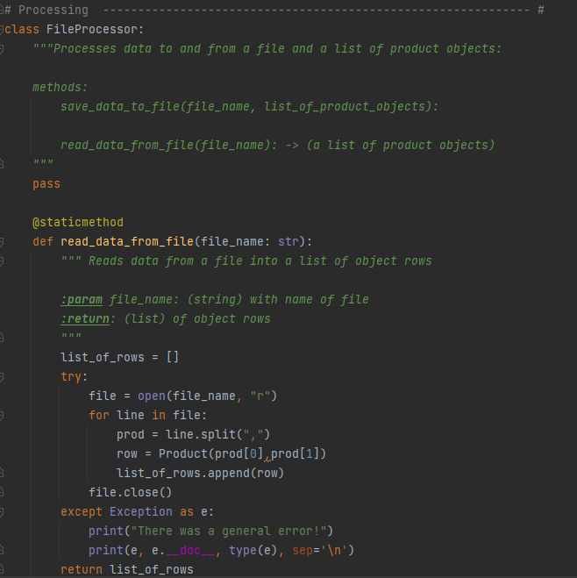

Figure : File Processor Part 1

Figure 4 shows the last function or method shown in the class file processor. This method calls for saving the data from python into a file on the local drive. It uses similar construction as other instances that calls for saving data, however, since this is an object that is being saved, the additional callout of __str__() was required.

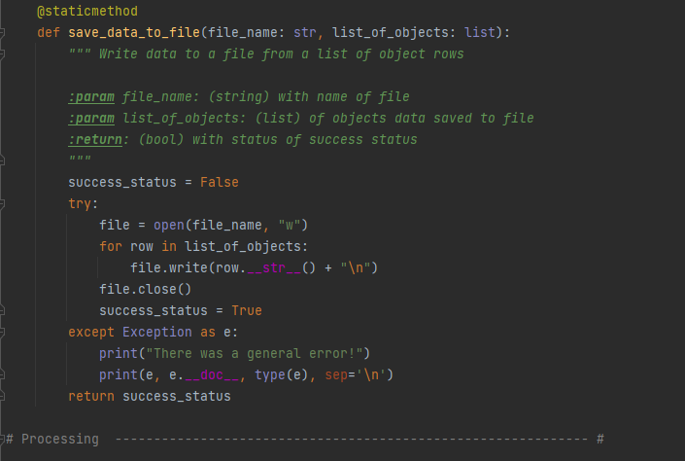

Figure : File Processor Part 2

# Input/Output Class

Below are the methods stored in the class for input and output. All methods located here are referenced in a previous assignment. Figure 5 shows the docstring for the input/output class, calling out the contents of the class.

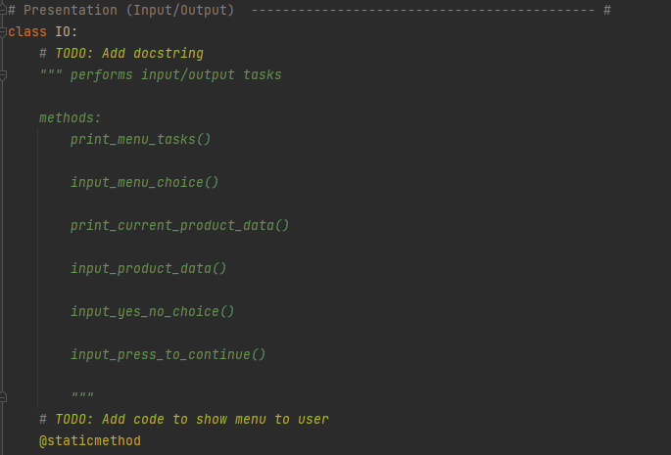

Figure : IO Class Part 1

Figure 6 shows two methods which are the menu print and the input request for menu task selection. These functions were taken from previous assignments and simply utilize the print and input functions.

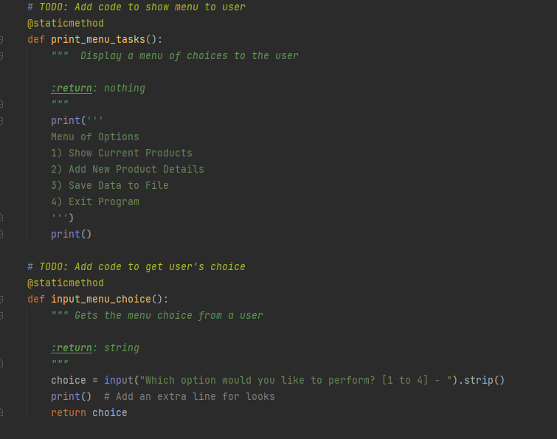

Figure : IO CLass Part 2

Figure 7 continues the methods under the IO class. Here are functions which print out the current data stored for the list of products, ask for more inputs to the list of products, and include the yes/no function which was included in previous assignments. One difference for the printing out the data is that the printout must refer to the attributes as opposed to other methods prior.

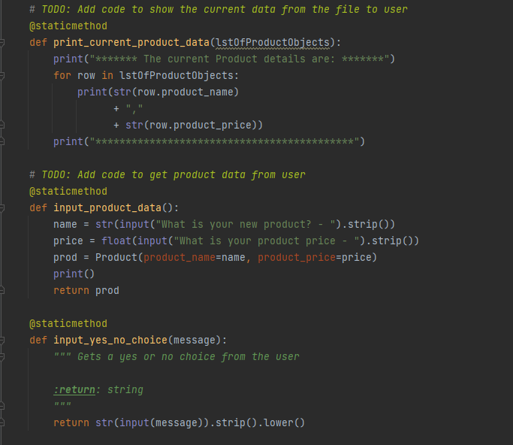

Figure : IO Class Part 3

The last method for the IO class was a take away from the previous assignment as well which prompts the user to press enter inbetween menu tasks.

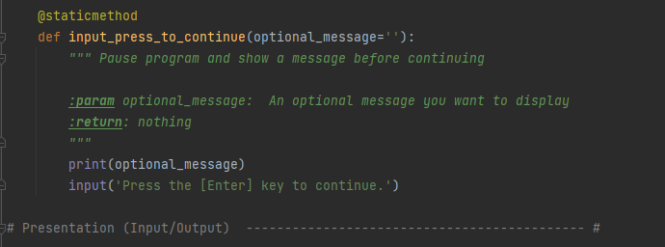

Figure : IO Class part 4

# Main Script Execution

Finally Figure 9 shows the main script execution which utilizes all of the classes created above. This execution cycles through the various if conditions which are prompted when the user selects a specific number.

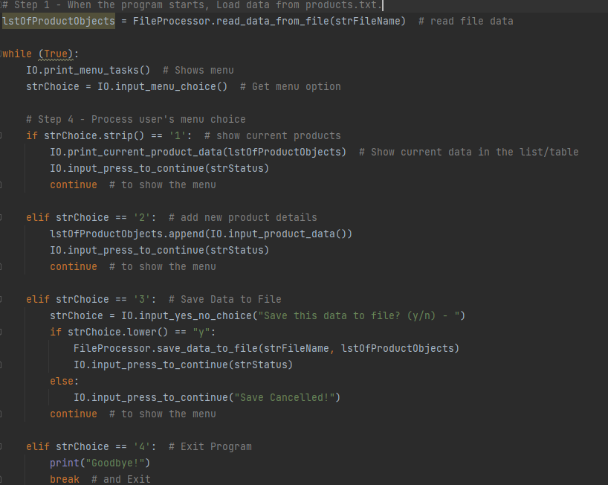

Figure

# Pycharm Output

The following figures show the output of the script in Pycharm. Figure 10 shows the stored values in products.txt and asks the user for inputs on products and price. These are available after the user selects 1 and 2.

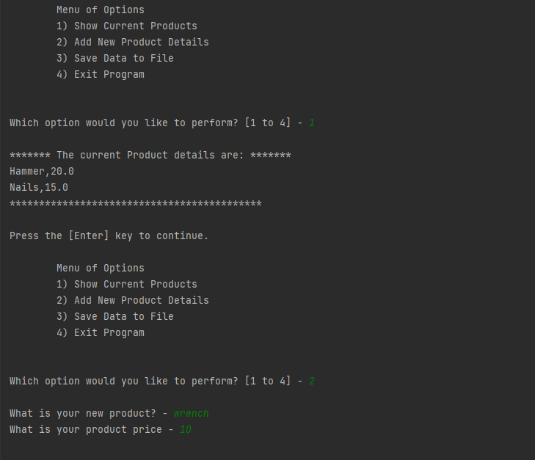

Figure : Pycharm Output 1

Figure 11 shows the final outputs of Pycharm, displaying steps 3 and 4. Selecting task 3 will prompt a yes/no query which will allow the user one last chance to decide if saving is desired. Task 4 will exit the script with a friendly goodbye!

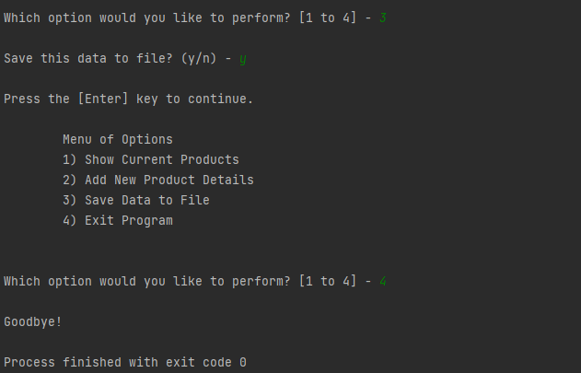

Figure : Pycharm Output 2

# CMD Output

The following figure shows the output for the command console. The only difference shown is that the products.txt file was impacted by the actions shown in the Pycharm output and showing what occurs when not selecting y for the save yes/no query.

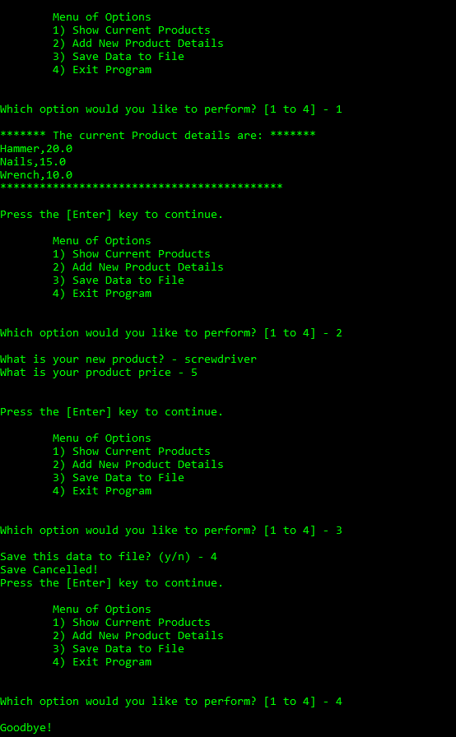

Figure : CMD Output of Script

# Text File Output

Finally, the last output for this assignment is showing the changes to the products.txt after both the Pycharm and CMD executions.

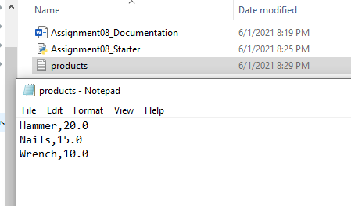

Figure

# Summary

Classes allow for a different execution of the similar script that has been utilized throughout the assignments. In this iteration, the classes gave more tools to define the properties as well as separating out the functions and definitions per the class. This was certainly a different concept that I will need to review but will be interested in learning more about.