3D Object Detection

# Introduction

The goal of this project is to perform object detection using Lidar data from Waymo open dataset.

## Task 1: ID_S1_EX1

In the Waymo Open dataset, lidar data is stored as a range image. Therefore, this task is about extracting two of the data channels within the range image, which are "range" and "intensity", and convert the floating-point data to an 8-bit integer value range. Sample output is shown below.

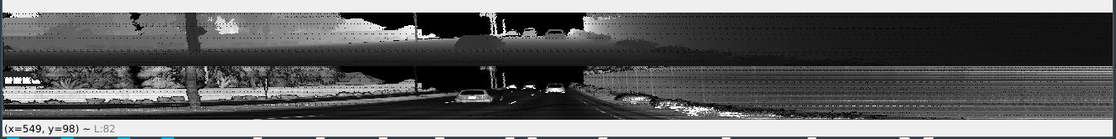

## Task 1: ID_S1_EX2

The goal of this task is to use the Open3D library to display the lidar point-cloud in a 3d viewer in order to develop a feel for the nature of lidar point-clouds.

The scenario here is that the vehicle is moving across an intersection. Thus, vehicle can be observed in multiple directions with varying degrees of visibility.

Three vehicles with high visibility

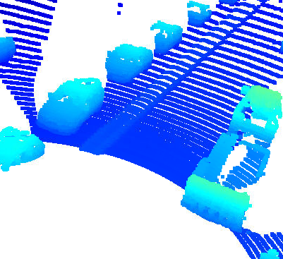

Two medium levels of visibility of vehicles created by occlusion of sensor due to mounting and vehicles.



Three examples of good visibility on the other side of the intersection.

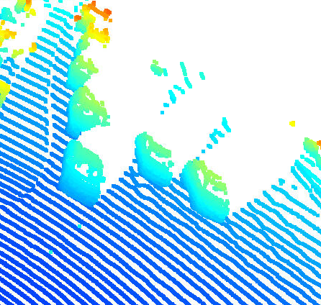

Three examples of barely visible vehicles behind the lidar.

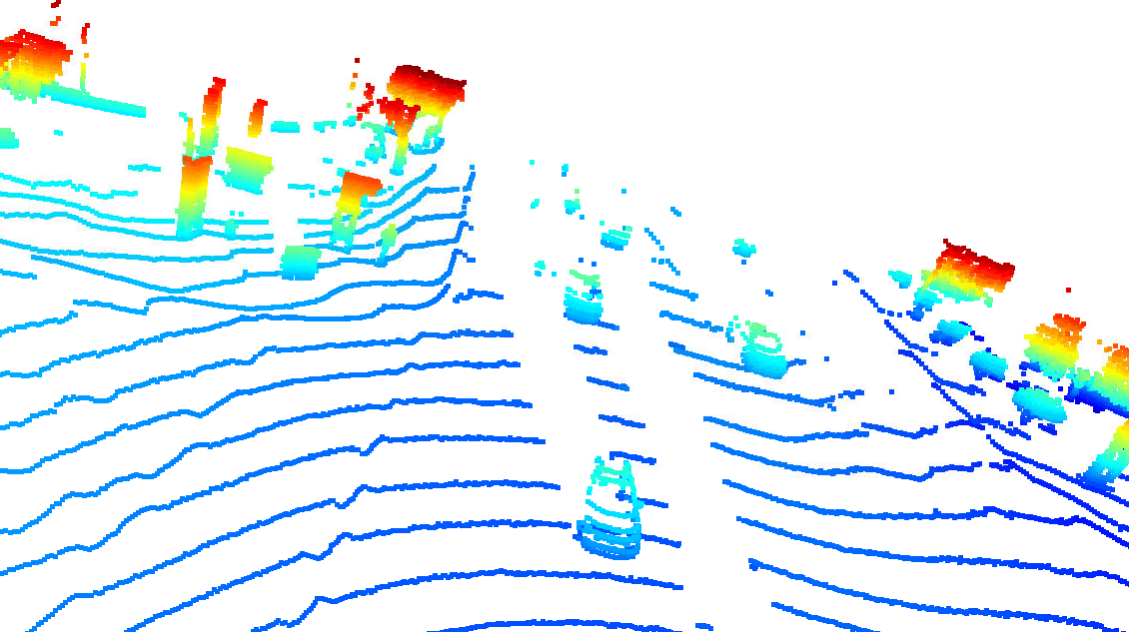

Features Identified on vehicles – Side View mirror, Trailer attached to pick up truck. So we can identify type of vehicle as well in this data.

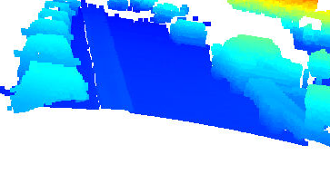

From this image we can also get a sense of direction of direction of travel of the vehicle as the shape of the vehicle is identified by the front bumper and windshield

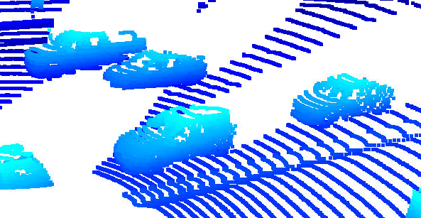

From this angle we can see the start and end of the pickup truck bed and also the rear wheel can be spotted.

