Genki Shadowcast and USB HDMI Video Capture
Tips and Tricks (Windows 10)

This Guide is intended to help setting up „MPV“ (mpv.io) and to reduce Video Latency on Windows10. Also how to enable the recording audio device with a batch to mitigate many mouse clicks and menu surfing. I tested it with a cheap „USB2.0 HDMI Video Capture“ device, but this document should be also applicable for Genki’s Shadowcast. Hopefully i get mine soon.

Changing Audio Recoding Device to „Listen“ to get Audio:
First you will need the Free Tool „Sound Volume View“ from Nirsoft.
Direct download links:
https://www.nirsoft.net/utils/soundvolumeview-x64.zip
https://www.nirsoft.net/utils/soundvolumeview.zip

Choosing the right Recoding device:
In this case it is „USB Digital Audio“ the digital audio interface
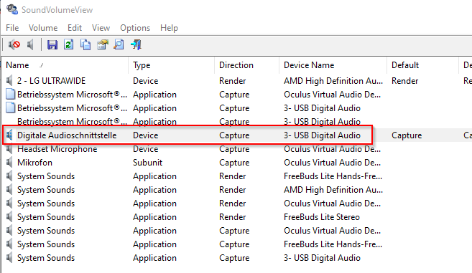

Next, double click on the device and copy „Item ID“. In this case „{0.0.1.00000000}.{bff85e23-a353-4a56-9009-9fd143dce793}“. For your set-up, please copy your „Item ID“.
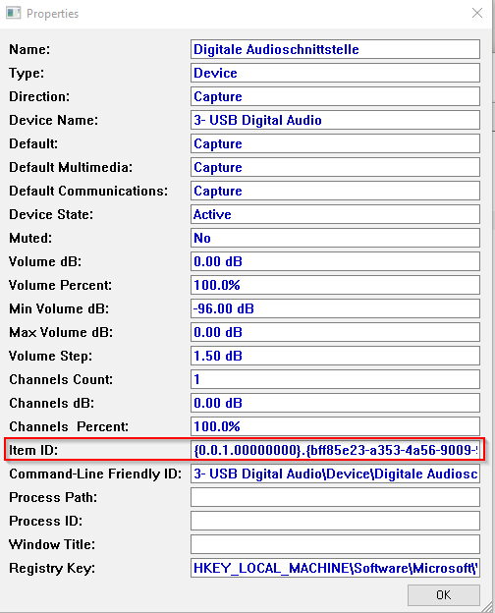

Enabling recording device to „Listen“:
Now, open Command Line „cmd“ in your „Sound Volume View“ Folder.
With following command you enable your recoding device to „Listen“ and enables the sound from your captured Device.
SoundVolumeView.exe /SetListenToThisDevice "{0.0.1.00000000}.{bff85e23-a353-4a56-9009-9fd143dce793}" 1

Disabling:
SoundVolumeView.exe /SetListenToThisDevice "{0.0.1.00000000}.{bff85e23-a353-4a56-9009-9fd143dce793}" 0

You can put these lines in two different batch files. Or put the enabling one in batch files that also start you mpv for a „seamless“ experience.

MPV standard settings from Genki Facebook Group:
(Thx to Daniel Houghtaling) (https://discord.gg/7Wa4AjGjQD) (https://www.reddit.com/r/genkilab)
mpv.exe av://dshow:video="ShadowCast" --profile=low-latency –untimed
or (in my case the USB 2.0 HDMI Video Capture device“)
mpv.exe av://dshow:video="USB Video" --profile=low-latency –untimed
To use these setting, you make a shortcut for you MPV executable and the edit it’s properties and put it „av://dshow:video="USB Video" --profile=low-latency –untimed“ in „Target“ behind mpv.exe.

Config options that helped me to reduce Video latency:
(These helped on my System set-up, your mileage may vary)
In the subfolder „mpv“ there is „mpv.conf“, that you can manually edit.

# High quality video rendering for fast computer.
deband=yes
fullscreen=yes
profile=gpu-hq
fps=60
opengl-glfinish=yes
opengl-swapinterval=0
framedrop=no
speed=1.01

How i tested Video latency?
Is used the 240p Test Suite for SNES on my „MiSTer FPGA“ Console and a 2.4Ghz Gamepad.
I chose „Manual Lag Test“ and made 3 - 4 retries each.
With „standard“ settings my average lag was 7-8 frames.
With above setting my average lag was 4-5 frames.
Like mentioned above your mileage may vary on used system-setup and console. With „deband=no“ you could alos reduce lag, but i had screnn tearing, so i prefer „deband=yes“.
This is not a scientific approach, but easy to realize for me right now.

How do i find the Name for my USB Video Capture device?
You got to your System Settings and look under devices.
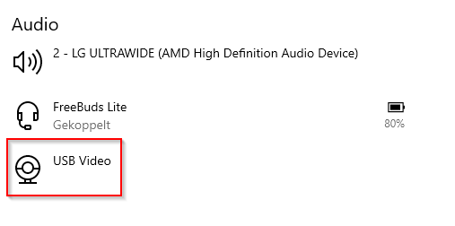
Or

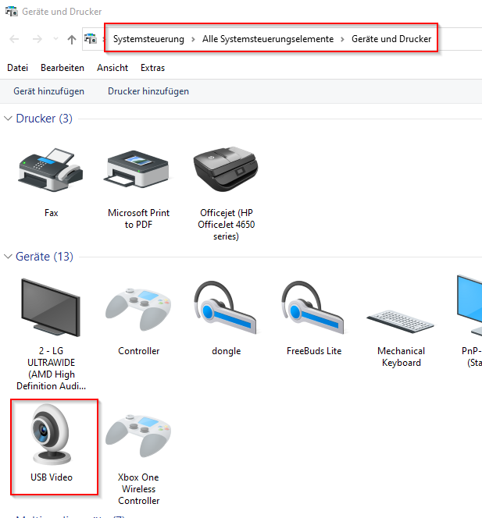

MPV example conf:
https://github.com/mpv-player/mpv/blob/master/etc/mpv.conf

my Profile example:
Shortcut: C:\Users\UserName\Desktop\mpv\mpv.exe av://dshow:video="USB Video" --profile=low-latency --untimed –profile=USBVideoCapture

mpv.conf:
# High quality video rendering for fast computer.
profile=gpu-hq

[ShadowCast]
deband=yes
fullscreen=yes
fps=60
opengl-glfinish=yes
opengl-swapinterval=0
framedrop=no
speed=1.01

[USBVideoCapture]
deband=yes
fullscreen=yes
fps=60
opengl-glfinish=yes
opengl-swapinterval=0
framedrop=no
speed=1.01

Batch File examples:
For ease of use i put „SoundVolumeView.exe“ in the root of my MPV installation folder.

Starting batch file silently/minimized:
@echo off
START /MIN CMD.EXE /C USBVideo.bat
exit

Starting MPV and Audio:
@echo off
set scriptFolder=%~dp0
REM Setting recording audio to "Listen"
SoundVolumeView.exe /SetListenToThisDevice "{0.0.1.00000000}.{bff85e23-a353-4a56-9009-9fd143dce793}" 1
REM Start MPV with Profile
mpv.exe av://dshow:video="USB Video" --profile=low-latency --untimed --profile=USBVideoCapture
exit

Stopping MPV and audio:
@echo off
set scriptFolder=%~dp0
REM Setting recording audio to "Listen"
SoundVolumeView.exe /SetListenToThisDevice "{0.0.1.00000000}.{bff85e23-a353-4a56-9009-9fd143dce793}" 0
REM Exit MPV
taskkill /F /im mpv.exe
exit

Final thoughts:
This are examples i use. Probably there are more elegant code solutions and hope other users can make these better. For now have fun fellow Gamers.

