ex_plot.R

USER

Thu Oct 11 17:29:21 2018

#  
# PROJECT07. [EX] Plot  
#  
# COPYRIGHT (c) 2018 AJOU University  
# Author : Seo, Jooyoung  
# History : 2018/09/01  
#

#install.packages(c("gcookbook", "ggplot2"))  
library(gcookbook)  
library(ggplot2)  
  
View(uspopchange)  
  
# scatter-plot  
ggplot(uspopchange, aes(x=Region, y=Change, color=State)) + geom_point(size=5)

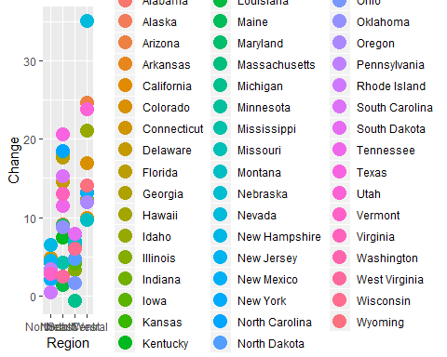

# bar plot  
ggplot(uspopchange, aes(x=Region, y=Change, fill=State)) + geom_col()

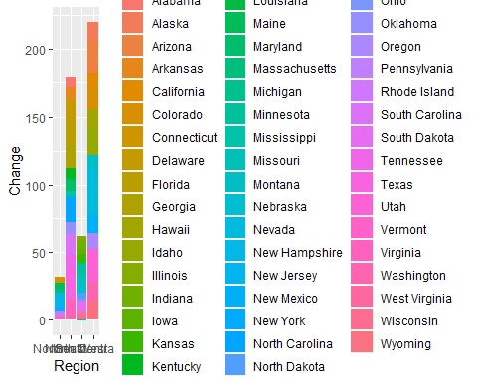

# box-plot  
ggplot(uspopchange, aes(x=Region, y=Change, color=Region)) + geom_boxplot()

