**MODULE: 2 (HTML)**

* **Define the terms: Website, Webpage, Web browser, Web server, HTML, CSS.**

1. Website: - A website is said to be a collection of web pages which can be access through domain name or URL (Uniform Resource Locator). It is hosted on a web server. It is designed and developed using HTML language.
2. Webpage: - A webpage is a single document or a file which is inside a particular website which is accessed through URL. It is basically a block of website which represents specific portion of website.
3. Web browser: - Web browser is an application used to access and view the websites and web pages on the internet. It acts as a bridge between user and world wide web (WWW). Some popular web browsers include Google Chrome, Mozilla Firefox, Apple Safari, Microsoft Edge, and Opera.
4. Web server: - A web-server is a computer or a software application which serves the content to the user or client as per their requests through web browsers. It stores the data process it and delivers the webpages and files to the user.
5. HTML: - HTML (Hyper Text Markup Language) is a standard markup language which is used to create webpages on world wide web (WWW) using set of tags or elements to define a particular structure and content on a webpage.
6. CSS: - Cascading style sheets (CSS) is a style sheet language which is used in HTML through which the presentation and visualization of web documents can be described. By CSS a developer can define layout, color, fonts, spacing and other styling in HTML elements.

* **Create a webpage to show “This is my first HTML page”.**

Code:

<!DOCTYPE html>

<html lang="en">

<head>

<meta charset="UTF-8">

<meta name="viewport" content="width=device-width, initial-scale=1.0">

<title>Document</title>

</head>

<body>

"This is my first HTML page"

</body>

</html>

Output:

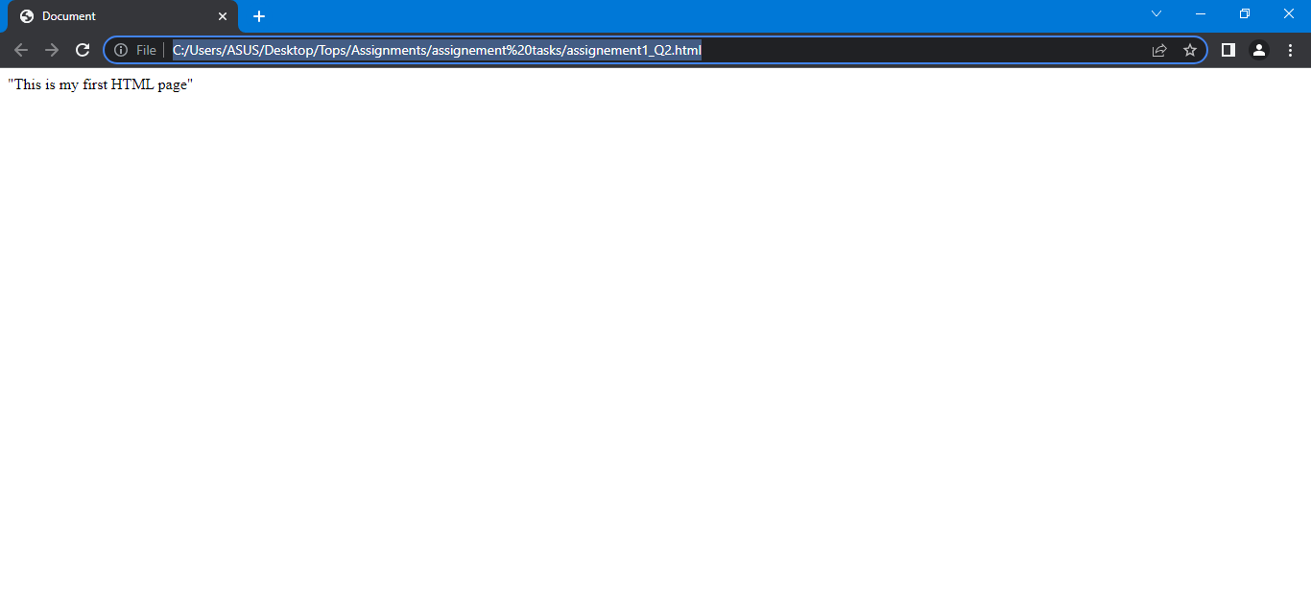

* **Display top 10 IT companies list in html webpage.**

Code:

<!DOCTYPE html>

<html lang="en">

<head>

<meta charset="UTF-8">

<meta name="viewport" content="width=device-width, initial-scale=1.0">

<title>Document</title>

</head>

<body>

<h1>Top 10 IT companies</h1><br>

<ol>

<li>Microsoft</li>

<li>Apple</li>

<li>Amazon</li>

<li>Alphabet Inc.</li>

<li>IBM</li>

<li>Cisco Systems</li>

<li>Oracle</li>

<li>Intel</li>

<li>SAP</li>

<li>Dell Technologies</li>

</ol>

</body>

</html>

Output:

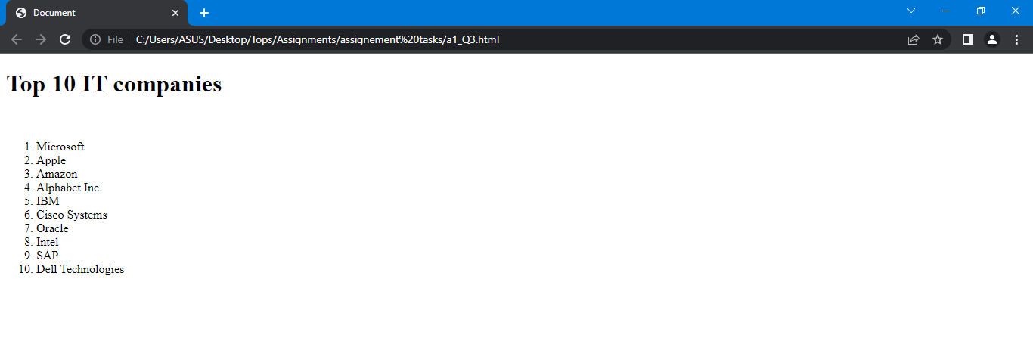

* **Create a dropdown list**

Code:

<!DOCTYPE html>

<html lang="en">

<head>

<meta charset="UTF-8">

<meta name="viewport" content="width=device-width, initial-scale=1.0">

<title>Document</title>

</head>

<body>

<select name="" id="">

<option value="" selected disabled>Drop down list</option>

<option value="">One</option>

<option value="">Two</option>

<option value="">Three</option>

<option value="">Four</option>

<option value="">Five</option>

</select>

</body>

</html>

Output:

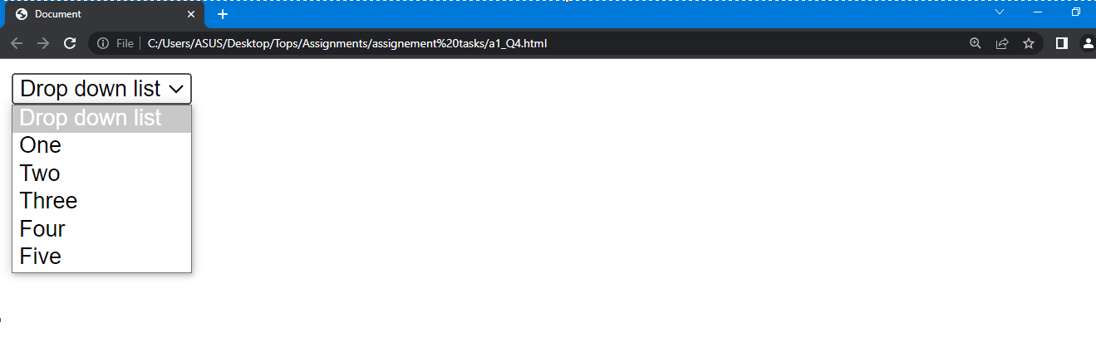

* **Create a Table Of college Management system using row span & col span.**

Code:

<!DOCTYPE html>

<html lang="en">

<head>

<meta charset="UTF-8">

<meta http-equiv="X-UA-Compatible" content="IE=edge">

<meta name="viewport" content="width=device-width, initial-scale=1.0">

<title>Document</title>

</head>

<body>

<table border="1">

<tr>

<th rowspan="3">day</th>

<th colspan="3">College management system</th>

</tr>

<tr>

<th colspan="2">schedule</th>

<th rowspan="2">Lecture</th>

</tr>

<tr>

<td align="center">begin</td>

<td align="center">end</td>

</tr>

<tr>

<td rowspan="2">Monday</td>

<td rowspan="2" bgcolor="orange">8:00a.m.</td>

<td rowspan="2" bgcolor="blue">5:00p.m.</td>

<td>Introduction to HTML</td>

</tr>

<tr>

<td>Basic Concepts of HTML</td>

</tr>

<tr>

<td rowspan="3">Tuesday</td>

<td bgcolor="orange">8:00a.m.</td>

<td bgcolor="orange">11:00a.m.</td>

<td>HTML structure</td>

</tr>

<tr>

<td bgcolor="orange">11:00a.m.</td>

<td bgcolor="green">2:00p.m.</td>

<td rowspan="2">Elements and Tags</td>

</tr>

<tr>

<td bgcolor="green">2:00p.m.</td>

<td bgcolor="blue">5:00p.m.</td>

</tr>

<tr>

<td>Wednesday</td>

<td bgcolor="orange">8:00a.m.</td>

<td bgcolor="green">12:00p.m.</td>

<td>Creating a Web page</td>

</tr>

</table>

</body>

</html>

Output:

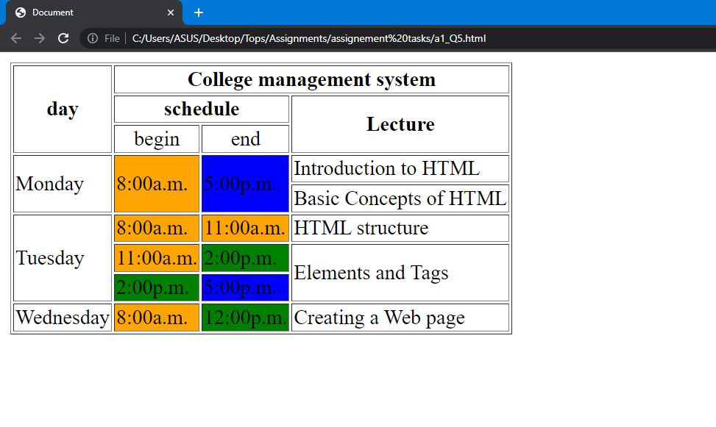

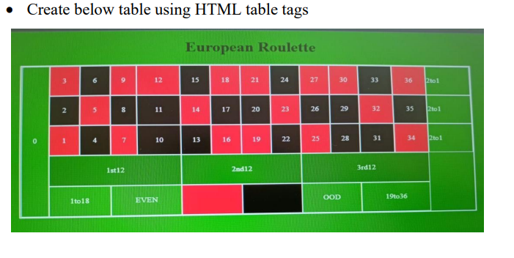

Code:

<!DOCTYPE html>

<html lang="en">

<head>

<meta charset="UTF-8">

<meta name="viewport" content="width=device-width, initial-scale=1.0">

<title>Document</title>

</head>

<body bgcolor="green">

<h1 align="center">European Roulette</h1>

<table border="1" bordercolor="white" cellpadding="10" align="center">

<tr>

<td rowspan="5" align="center"><font color="white">0</font></td>

<td bgcolor="red" align="center"><font color="white">3</font></td>

<td bgcolor="black" align="center"><font color="white">6</font></td>

<td bgcolor="red" align="center"><font color="white">9</font></td>

<td bgcolor="red" align="center"><font color="white">12</font></td>

<td bgcolor="black" align="center"><font color="white">15</font></td>

<td bgcolor="red" align="center"><font color="white">18</font></td>

<td bgcolor="red" align="center"><font color="white">21</font></td>

<td bgcolor="black" align="center"><font color="white">24</font></td>

<td bgcolor="red" align="center"><font color="white">27</font></td>

<td bgcolor="red" align="center"><font color="white">30</font></td>

<td bgcolor="black" align="center"><font color="white">33</font></td>

<td bgcolor="red" align="center"><font color="white">36</font></td>

<td><font color="white">2to1</font></td>

</tr>

<tr>

<td bgcolor="black" align="center"><font color="white">2</font></td>

<td bgcolor="red" align="center"><font color="white">5</font></td>

<td bgcolor="black" align="center"><font color="white">8</font></td>

<td bgcolor="black" align="center"><font color="white">11</font></td>

<td bgcolor="red" align="center"><font color="white">14</font></td>

<td bgcolor="black" align="center"><font color="white">17</font></td>

<td bgcolor="black" align="center"><font color="white">20</font></td>

<td bgcolor="red" align="center"><font color="white">23</font></td>

<td bgcolor="black" align="center"><font color="white">26</font></td>

<td bgcolor="black" align="center"><font color="white">29</font></td>

<td bgcolor="red" align="center"><font color="white">32</font></td>

<td bgcolor="black" align="center"><font color="white">35</font></td>

<td><font color="white">2to1</font></td>

</tr>

<tr>

<td bgcolor="red" align="center"><font color="white">1</font></td>

<td bgcolor="black" align="center"><font color="white">4</font></td>

<td bgcolor="red" align="center"><font color="white">7</font></td>

<td bgcolor="black" align="center"><font color="white">10</font></td>

<td bgcolor="black" align="center"><font color="white">13</font></td>

<td bgcolor="red" align="center"><font color="white">16</font></td>

<td bgcolor="red" align="center"><font color="white">19</font></td>

<td bgcolor="black" align="center"><font color="white">22</font></td>

<td bgcolor="red" align="center"><font color="white">25</font></td>

<td bgcolor="black" align="center"><font color="white">28</font></td>

<td bgcolor="black" align="center"><font color="white">31</font></td>

<td bgcolor="red" align="center"><font color="white">34</font></td>

<td><font color="white">2to1&nbsp;&nbsp;&nbsp;&nbsp;</font></td>

</tr>

<tr>

<td colspan="4" align="center"><font color="white">1st12</font></td>

<td colspan="4" align="center"><font color="white">2nd12</font></td>

<td colspan="4" align="center"><font color="white">3rd12</font></td>

<td rowspan="2"></td>

</tr>

<tr>

<td colspan="2" align="center"><font color="white">&nbsp;&nbsp;&nbsp;1to18&nbsp;&nbsp;&nbsp;</font></td>

<td colspan="2" align="center"><font color="white">&nbsp;&nbsp;&nbsp;EVEN&nbsp;&nbsp;&nbsp;</font></td>

<td colspan="2" align="center" bgcolor="red"></td>

<td colspan="2" align="center" bgcolor="black"></td>

<td colspan="2" align="center"><font color="white">&nbsp;&nbsp;&nbsp;ODD&nbsp;&nbsp;&nbsp;</font></td>

<td colspan="2" align="center"><font color="white">&nbsp;&nbsp;&nbsp;19to36&nbsp;&nbsp;&nbsp;</font></td>

</tr>

</table>

</body>

</html>

Output:

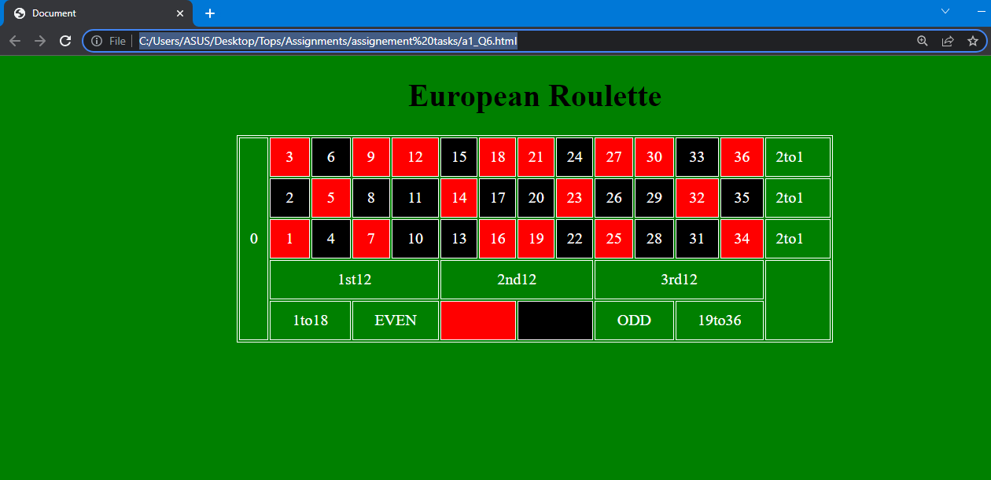

* **Create Registration form using HTML, CSS.**

Code:

<!DOCTYPE html>

<html lang="en">

<head>

<meta charset="UTF-8">

<meta http-equiv="X-UA-Compatible" content="IE=edge">

<meta name="viewport" content="width=device-width, initial-scale=1.0">

<title>Document</title>

</head>

<body>

<fieldset>

<legend>Registration Form</legend>

<form method="post" style="background-color: rgb(56, 178, 230);">

<table>

<tr>

<td>FIRST NAME</td>

<td><input type="text" style="border: none; border-radius: 5px;"> (max 30 characters a-z and A-Z)</td>

</tr>

<tr>

<td>LAST NAME</td>

<td><input type="text" style="border: none; border-radius: 5px;"> (max 30 characters a-z and A-Z)</td>

</tr>

<tr>

<td>DATE OF BIRTH</td>

<td><select style="background-color: pink;">

<option selected disabled>Day:</option>

<option>mon</option>

<option>tue</option>

<option>wed</option>

</select>

<select style="background-color: royalblue;">

<option selected disabled>Month:</option>

<option>jan</option>

<option>feb</option>

<option>mar</option>

<option>apr</option>

<option>june</option>

<option>july</option>

</select>

<select style="background-color: darkkhaki;">

<option selected disabled>Year:</option>

<option>2000</option>

<option>2001</option>

<option>2002</option>

<option>2003</option>

<option>2022</option>

<option>2023</option>

</select></td>

</tr>

<tr>

<td>EMAIL ID</td>

<td><input type="email" style="background-color: rgb(56, 178, 230); border: none;border-bottom: 2px solid black;"></td>

</tr>

<tr>

<td>MOBILE NUMBER</td>

<td><input type="text" minlength="1" maxlength="10" style="border: none; border-radius: 5px;"> (10 digit number)</td>

</tr>

<tr>

<td>GENDER</td>

<td><label>Male</label>

<input type="radio" name="xyz">

<label>Female</label>

<input type="radio" name="xyz"></td>

</tr>

<tr>

<td>ADDRESS</td>

<td><textarea name="" id="" cols="30" rows="5" style="border: none; border-radius: 5px;"></textarea></td>

</tr>

<tr>

<td>CITY</td>

<td><input type="text" minlength="1" maxlength="30" placeholder="Mahemdabad" style="border: none; border-radius: 5px;"> (max 30 characters a-z and A-Z)</td>

</tr>

<tr>

<td>PIN CODE</td>

<td><input type="text" minlength="1" maxlength="6" placeholder="123456" style="border: none; border-radius: 5px;"> (6 digit number)</td>

</tr>

<tr>

<td>STATE</td>

<td><input type="text" minlength="1" maxlength="30" placeholder="Gujarat" style="border: none; border-radius: 5px;"> (max 30 characters a-z and A-Z)</td>

</tr>

<tr>

<td>COUNTRY</td>

<td><input type="text" name="" id="" value="" placeholder="India" style="border: none; border-radius: 5px;"></td>

</tr>

<tr>

<td>HOBBIES</td>

<td>

<label for="">Drawing</label>

<input type="checkbox" name="" id="">

<label for="">Singing</label>

<input type="checkbox" name="" id="">

<label for="">Dancing</label>

<input type="checkbox" name="" id="">

<label for="">Sketching</label>

<input type="checkbox" name="" id=""><br>

<label for="">Others</label>

<input type="checkbox" name="" id="">

<input type="text" name="" id="" placeholder="If yes" style="border: none; border-radius: 5px;">

</td>

</tr>

<tr>

<td>QUALIFICATION</td>

<td>

<table>

<tr>

<td>SI.NO.</td>

<td>Examination</td>

<td align="center">Board</td>

<td align="center">Percentage</td>

<td align="center">Year of passing</td>

</tr>

<tr>

<td>1</td>

<td>Class X</td>

<td><input type="text" name="" id="" style="border: none; border-radius: 5px;"></td>

<td><input type="text" name="" id="" style="border: none; border-radius: 5px;"></td>

<td><input type="text" name="" id="" style="border: none; border-radius: 5px;"></td>

</tr>

<tr>

<td>2</td>

<td>Class XII</td>

<td><input type="text" name="" id="" style="border: none; border-radius: 5px;"></td>

<td><input type="text" name="" id="" style="border: none; border-radius: 5px;"></td>

<td><input type="text" name="" id="" style="border: none; border-radius: 5px;"></td>

</tr>

<tr>

<td>3</td>

<td>Graduation</td>

<td><input type="text" name="" id="" style="border: none; border-radius: 5px;"></td>

<td><input type="text" name="" id="" style="border: none; border-radius: 5px;"></td>

<td><input type="text" name="" id="" style="border: none; border-radius: 5px;"></td>

</tr>

<tr>

<td>4</td>

<td>Masters</td>

<td><input type="text" name="" id="" style="border: none; border-radius: 5px;"></td>

<td><input type="text" name="" id="" style="border: none; border-radius: 5px;"></td>

<td><input type="text" name="" id="" style="border: none; border-radius: 5px;"></td>

</tr>

<tr>

<td colspan="2"></td>

<td align="center">(10 char max)</td>

<td align="center">(upto 2 decimal)</td>

</tr>

</table>

</td>

</tr>

<tr>

<td>COURSES<br>APPLIED FOR</td>

<td><label for="">BCA</label>

<input type="radio" name="" id="">

<label for="">B.Com</label>

<input type="radio" name="" id="">

<label for="">B.Sc</label>

<input type="radio" name="" id="">

<label for="">B.A</label>

<input type="radio" name="" id="">

</td>

</tr>

<tr>

<td></td>

<td align="center"><input type="submit" name="" id="">

<input type="reset" name="" id=""></td>

</tr>

</table>

</form>

</fieldset>

</body>

</html>

Output:

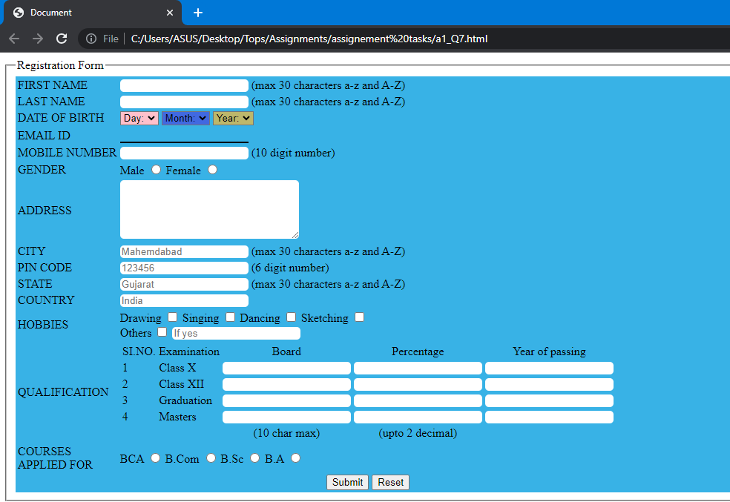

* **In how many ways can a CSS be integrated as a web page?**

**There are three ways to integrate CSS.**

> Inline CSS

> Internal CSS

> External CSS

* **Create simple three pages using External CSS, Internal CSS, and Inline CSS.**

**-> Inline CSS: -**

Code:

<!DOCTYPE html>

<html lang="en">

<head>

<meta charset="UTF-8">

<meta name="viewport" content="width=device-width, initial-scale=1.0">

<title>Document</title>

</head>

<body>

<div style="height: 200px; width: 300px; background-color: aqua;text-align: center;">

<h1 style="color: red;text-decoration: underline;">Inline CSS</h1>

</div>

</body>

</html>

Output:

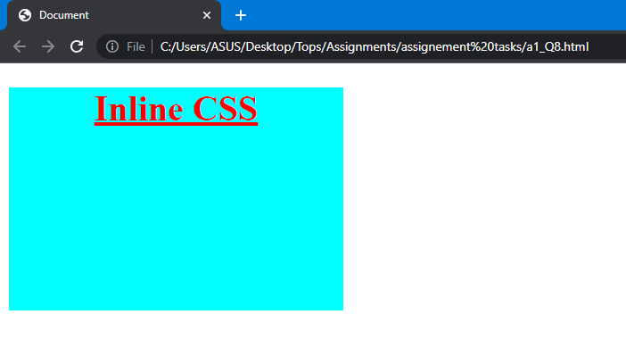

**-> Internal CSS: -**

Code:

<!DOCTYPE html>

<html lang="en">

<head>

<meta charset="UTF-8">

<meta name="viewport" content="width=device-width, initial-scale=1.0">

<title>Document</title>

<style>

*{

margin: 0;

padding: 0;

box-sizing: border-box;

}

div{

height: 200px;

width: 300px;

background-color: aqua;

}

h1{

text-align: center;

color: red;

text-decoration: underline;

}

</style>

</head>

<body>

<div>

<h1>Internal CSS</h1>

</div>

</body>

</html>

Output:

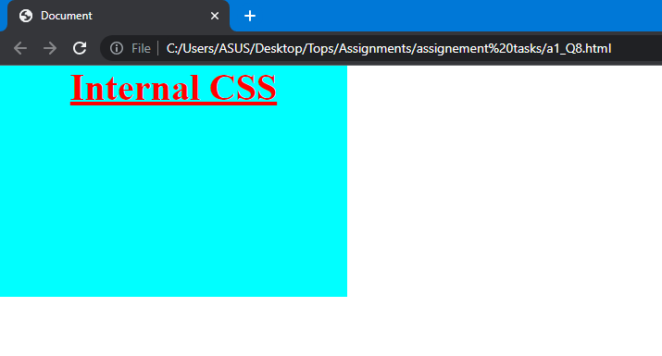

**-> External CSS: -**

Code:

File name: - a1_Q8.css

*{

margin: 0;

padding: 0;

box-sizing: border-box;

}

div{

height: 200px;

width: 300px;

background-color: aqua;

}

h1{

text-align: center;

color: red;

text-decoration: underline;

}

File name: - a1_Q8.html

<!DOCTYPE html>

<html lang="en">

<head>

<meta charset="UTF-8">

<meta name="viewport" content="width=device-width, initial-scale=1.0">

<title>Document</title>

<link rel="stylesheet" href="a1_Q8.css">

</head>

<body>

<div>

<h1>External CSS</h1>

</div>

</body>

</html>

Output:

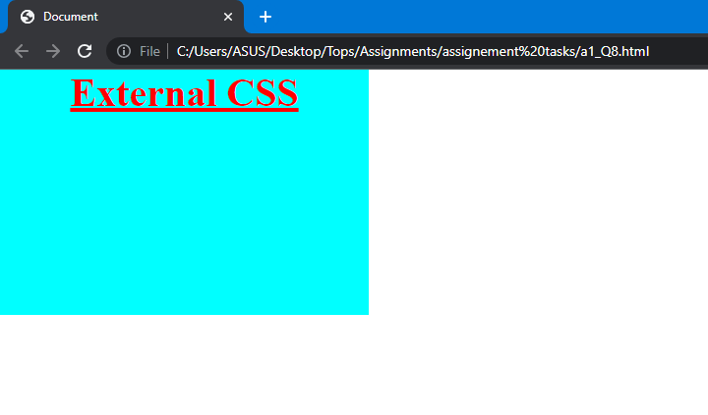

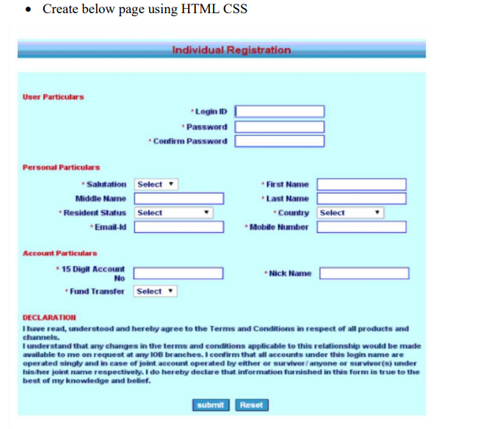

Code:

<!DOCTYPE html>

<html lang="en">

<head>

<meta charset="UTF-8">

<meta name="viewport" content="width=device-width, initial-scale=1.0">

<title>Document</title>

<style>

*{

margin: 0;

padding: 0;

box-sizing: border-box;

}

.top{

height: 50px;

width: 100%;

text-align: center;

background-color: rgb(9, 184, 184);

color: red;

}

.two{

height: 130px;

width: 100%;

background-color: aqua;

}

.three{

height: 130px;

width: 100%;

background-color: aqua;

display: flex;

}

.three1{

height: inherit;

width: 40%;

background-color: aqua;

}

.three2{

height: inherit;

width: 60%;

background-color: aqua;

}

.four{

height: 100px;

width: 100%;

background-color: aqua;

display: flex;

}

.four1{

height: inherit;

width: 40%;

background-color: aqua;

}

.four2{

height: inherit;

width: 60%;

background-color: aqua;

}

.dec{

height: 180px;

width: 100%;

background-color: aqua;

}

</style>

</head>

<body>

<div class="top">

<h1>Individual Registration</h1>

</div><br><br>

<div class="two"><br>

<p style="margin-left: 20px; color: rgb(148, 6, 6); font-weight: bolder;font-size: large;">User particulars</p>

<div class="table1" style="text-align: right;">

<table style="margin-left: 20%;">

<tr>

<td align="right" style="color: rgb(148, 6, 6); font-weight: 900;">*Login ID</td><td>&nbsp;&nbsp;&nbsp;<input type="text" style="border-radius: 5px;"></td>

</tr>

<tr>

<td align="right" style="color: rgb(148, 6, 6); font-weight: 900;">*Password</td><td>&nbsp;&nbsp;&nbsp;<input type="password" style="border-radius: 5px;"></td>

</tr>

<tr>

<td align="right" style="color: rgb(148, 6, 6); font-weight: 900;">*Confirm Password</td><td>&nbsp;&nbsp;&nbsp;<input type="password" style="border-radius: 5px;"></td>

</tr>

</table>

</div>

</div>

<div class="three">

<div class="three1">

<p style="margin-left: 20px; color: rgb(148, 6, 6); font-weight: bolder;font-size: large;">Personal particulars</p>

<table style="margin-left: 30%;">

<tr>

<td align="right" style="color: rgb(148, 6, 6); font-weight: 900;">*Salutation</td>

<td>&nbsp;&nbsp;&nbsp;<select name="" id="">

<option value="" selected disabled>Select&nbsp;&nbsp;&nbsp;</option>

<option value="">Mr.</option>

<option value="">Ms.</option>

<option value="">Mrs.</option>

</select></td>

</tr>

<tr>

<td align="right" style="color: rgb(148, 6, 6); font-weight: 900;">*Middle Name</td><td>&nbsp;&nbsp;&nbsp;<input type="text" style="border-radius: 5px;"></td>

</tr>

<tr>

<td align="right" style="color: rgb(148, 6, 6); font-weight: 900;">*Resident Status</td>

<td>&nbsp;&nbsp;&nbsp;<select name="" id="">

<option value="" selected disabled>Select&nbsp;&nbsp;&nbsp;&nbsp;&nbsp;&nbsp;</option>

<option value="">one</option>

<option value="">two</option>

<option value="">three</option>

</select></td>

</tr>

<tr>

<td align="right" style="color: rgb(148, 6, 6); font-weight: 900;">*Email</td><td>&nbsp;&nbsp;&nbsp;<input type="email" style="border-radius: 5px;"></td>

</tr>

</table>

</div>

<div class="three2"><br>

<table>

<tr>

<td align="right" style="color: rgb(148, 6, 6); font-weight: 900;">*First Name</td><td>&nbsp;&nbsp;&nbsp;<input type="text" style="border-radius: 5px;"></td>

</tr>

<tr>

<td align="right" style="color: rgb(148, 6, 6); font-weight: 900;">*Last Name</td><td>&nbsp;&nbsp;&nbsp;<input type="text" style="border-radius: 5px;"></td>

</tr>

<tr>

<td align="right" style="color: rgb(148, 6, 6); font-weight: 900;">*Country</td>

<td>&nbsp;&nbsp;&nbsp;<select name="" id="">

<option value="" selected disabled>Select&nbsp;&nbsp;&nbsp;&nbsp;&nbsp;&nbsp;</option>

<option value="">India</option>

<option value="">Pakistan</option>

<option value="">Srilanka</option>

<option value="">bangladesh</option>

<option value="">nepal</option>

<option value="">japan</option>

</select></td>

</tr>

<tr>

<td align="right" style="color: rgb(148, 6, 6); font-weight: 900;">*Mobile number</td><td>&nbsp;&nbsp;&nbsp;<input type="text" minlength="1" maxlength="10" style="border-radius: 5px;"></td>

</tr>

</table>

</div>

</div>

<div class="four">

<div class="four1">

<p style="margin-left: 20px; color: rgb(148, 6, 6); font-weight: bolder;font-size: large;">Account particulars</p>

<table style="margin-left: 30%;">

<tr>

<td align="right" style="color: rgb(148, 6, 6); font-weight: 900;">*15 Digit Account <br>number</td><td>&nbsp;&nbsp;&nbsp;<input type="text" minlength="1" maxlength="10" style="border-radius: 5px;"></td>

</tr>

<tr>

<td align="right" style="color: rgb(148, 6, 6); font-weight: 900;">*Fund Transfer</td>

<td>&nbsp;&nbsp;&nbsp;<select name="" id="">

<option value="" selected disabled>Select&nbsp;&nbsp;&nbsp;&nbsp;&nbsp;&nbsp;</option>

<option value="">one</option>

<option value="">two</option>

<option value="">three</option>

</select></td>

</tr>

</table>

</div>

<div class="four2"><br>

<table><br>

<tr>

<td align="right" style="color: rgb(148, 6, 6); font-weight: 900;">&nbsp;&nbsp;&nbsp;&nbsp;&nbsp;&nbsp;&nbsp;*Nick Name</td><td>&nbsp;&nbsp;&nbsp;<input type="text" style="border-radius: 5px;"></td>

</tr>

</table>

</div>

</div>

<div class="dec">

<p style="margin-left: 20px; color: rgb(148, 6, 6); font-weight: bolder;font-size: large;">DECLARATION</p>

<p style="margin-left: 20px; font-weight: 900;">

I have read,understood and hereby agree to the Terms and Condition in respect of all products and channels.

</p>

<p style="margin-left: 20px; font-weight: 900;">

I understand that any changes in the terms and condition applicable to this relationship would be made available to me on request <br>at any IOB branches. I confirm that all accounts under this login name are operated singly and in cavse of joint account operated by <br>either or survivor / anyone or survivors under his/her joint name respectively. I do hereby declare that information furnished in <br>this form is true to the best of my knowledge and belief.

</p><br><br>

<input type="submit" style="width: 100px;margin-left: 30%;">&nbsp;&nbsp;&nbsp;&nbsp;<input type="reset" style="width: 100px;">

</div>

</body>

</html>

Output:

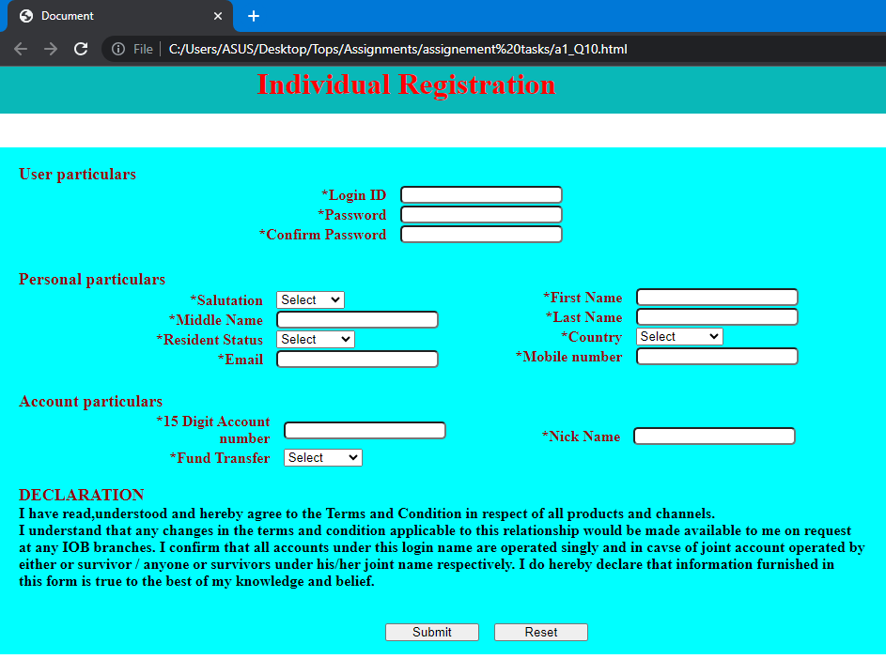

* **Create link-pseudo classes using external css, to format links on the pages.**

Code:

File name: a1_Q11.css

a{

text-decoration: none;

font-size: x-large;

}

a:link{

color: red;

}

a:hover{

color: purple;

}

File name: a1_Q11.html

<!DOCTYPE html>

<html lang="en">

<head>

<meta charset="UTF-8">

<meta name="viewport" content="width=device-width, initial-scale=1.0">

<title>Document</title>

<link rel="stylesheet" href="a1_Q11.css">

</head>

<body>

<a href="http://">This is pseudo class link using external CSS.</a>

</body>

</html>

Output:

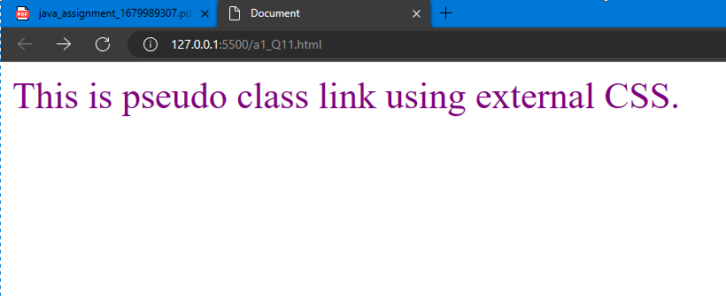

* **Create a dynamic pseudo class using HTML, CSS**

Code:

<!DOCTYPE html>

<html lang="en">

<head>

<meta charset="UTF-8">

<meta name="viewport" content="width=device-width, initial-scale=1.0">

<title>Document</title>

<style>

div{

height: 200px;

width: 200px;

background-color: aqua;

text-align: center;

margin-left: 40%;

border: 2px solid red;

border-radius: 5px;

}

div::first-letter{

font-size: 50px;

color: red;

}

</style>

</head>

<body>

<a href=""><div>This is a dynamic pseudo class</div></a>

</body>

</html>

Output:

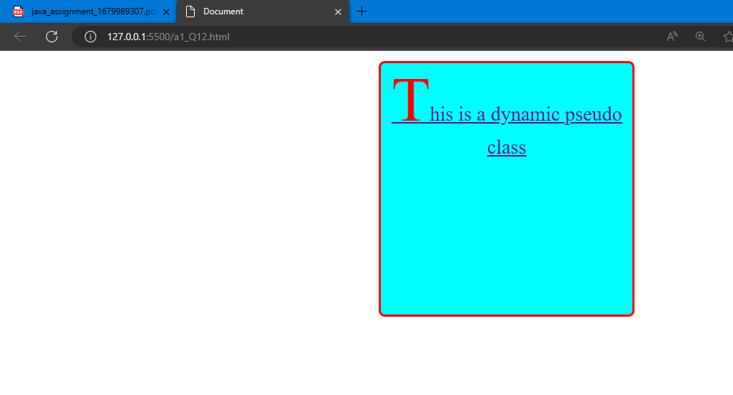

**Web Designing Assignment**

**Term-1**

**Module (HTML) -1**

* **Are the HTML tags and elements the same thing?**

- No HTML tags and elements are not the same things but they are related to each other.

For example:

<h1>HELLO</h1>

-Here, <h1> is a tag and <h1> including the text or content HELLO with </h1> is an element.

* **What are tags and attributes in HTML?**

**Tags:**

- HTML tags are fundamental building blocks of a document and they are represented by an opening tag <h1> and closing tag </h1>. As shown below,

<h1> hello</h1>

**Attributes:**

- HTML attributes provide additional information about an HTML element. It is used within an opening tag of element and is represented as,

Example:

<a href=https://> hello</a>

Here “href” attribute is used to define the destination of hyperlink.

* **What are void elements in HTML?**

- Void elements in HTML are elements that do not require a closing tag because they cannot contain any content. They are self-closing elements and are written with an opening tag only.

For example:

<br>, <input>, <img>, <hr>.

* **What are HTML Entities?**

- HTML entities are special codes used to represent reserved characters, symbols, or special characters in HTML markup. These codes start with an ampersand ("&") and end with a semicolon (";"). HTML entities are used to display characters that have special meanings in HTML or that cannot be easily typed or represented directly in the HTML code.

For example:

- &amp; used for ampersand.

- &lt; used for less than.

- &gt; used for greater than.

* **What are different types of lists in HTML?**

There are three types of lists in HTML.

- Ordered List (<ol>): Represents a numbered list.

- Unordered List (<ul>): Represents a bulleted list.

- Definition List (<dl>): Represents a list of terms and their definitions.

* **What is the ‘class’ attribute in HTML?**

- The 'class' attribute in HTML is used to assign one or more class names to an HTML element. It allows you to apply specific styles or behaviors to multiple elements with the same class, making it easier to target and style them through CSS.

* **What is the difference between the ‘id’ attribute and the ‘class’ attribute of HTML elements?**

**- Uniqueness:**

'id' attribute: Must be unique within the entire HTML document; can only be assigned to one element.

'class' attribute: Can be used multiple times within the same HTML document; can be assigned to multiple elements.

**- Targeting and Specificity:**

'id' attribute: Provides a highly specific way to target a single element; has the highest specificity in CSS.

'class' attribute: Targets multiple elements, allowing you to apply styles or behaviors to a group of elements; has lower specificity than 'id'.

**- Usage:**

'id' attribute: Typically used to uniquely identify a specific element for CSS styling when targeting a single element.

'class' attribute: Used to group and apply shared styles or behaviors to multiple elements, creating sets of related elements.

* **What are the various formatting tags in HTML?**

- Formatting tags in HTML are used to apply various visual styles to the content, such as bold, italic, underline, superscript, subscript, and more.

For example:

<b>, <i>, <u>, <sup>, <sub>, <strong>, <em> etc.

* **How is Cell Padding different from Cell Spacing?**

**Cell Padding:**

Cell padding (cellpadding in HTML) defines the space between the content of a table cell and its borders. It allows you to add some extra space inside each cell to visually separate the cell content from the cell's border. You can set the cell padding to a specific number of pixels or use percentages.

Example: <table cellpadding="5">

**Cell Spacing:**

Cell spacing (cellspacing in HTML) defines the space between adjacent cells in a table. It specifies the gap between the borders of neighboring cells, creating a visible separation between cells. The spacing is applied equally around all sides of each cell.

Example: <table cellspacing="10">

* **How can we club two or more rows or columns into a single row or column in an HTML table?**

- We can combine two or more rows into a single row using the rowspan attribute, two or more columns into a single column using the colspan attribute in an HTML table. These attributes allow cells to span across multiple rows or columns, creating merged cells.

* **What is the difference between a block-level element and an inline element?**

**Block-level element:**

- It occupies the full available width of its parent container, creating a new line before and after the element. For example, <div>, <p>, <h1>, <ul>.

- By default, block-level elements start on a new line and stretch to fill the entire available width of the container.

- It can contain other block-level and inline elements.

**Inline element:**

- It only takes up as much width as necessary for its content, and it does not force line breaks. Multiple inline elements can appear on the same line. Examples include <span>, <a>, <strong>, <em>, and more.

- By default, inline elements do not create line breaks and flow with the surrounding text.

- It can only contain other inline elements and text.

* **How to create a Hyperlink in HTML?**

- Hyperlink is created using anchor <a> element in HTML.

- To create hyperlink, it is necessary to specify the destination URL using ‘href’ attribute.

For example:

<a href="https://www.google.com">Google</a>

* **What is the use of an iframe tag?**

- The <iframe> tag in HTML is used to embed another web page or content within the current web page. It allows you to display external content, such as a video, map, or social media widget, as a part of your webpage.

- The <iframe> tag is useful for integrating content from other sources seamlessly into your website while keeping the content isolated and separate from the rest of the page.

* **What is the use of a span tag? Explain with example?**

- The <span> tag in HTML is used to apply styles or add additional formatting to a specific section of text or inline content. It does not create any visible structure or line breaks on its own. Instead, it acts as an inline container for styling purposes.

For example:

<p> Hello welcome to <span style="color: blue;">JP’s</span> world. </p>

- Here the text (JP’s) is individually styled as blue color and rest of text remains same using span.

* **How to insert a picture into a background image of a web page?**

- To insert background image of a webpage:

- CSS styling is used, so first of all creat the css code

Use backgroung image: URL() in particular styling tag and insert the image path in URL.

For example.

File name: image.css

.image{

background-image: url('path/to/background.jpg');

background-size: cover;

background-position: center;

background-repeat: no-repeat;

width: 300px;

height: 200px;

}

File name: image.html

<!DOCTYPE html>

<html>

<head>

<title>Document</title>

<link rel="stylesheet" href="image.css">

</head>

<body>

<div class="picture"></div>

</body>

</html>

* **How are active links different from normal links?**

- By default, a link will appear in blue color.

- Unvisited link is underlined and blue.

- Visited link is underlined and purple.

- Active link is underlined and red.

* **What are the different tags to separate sections of text?**

- <br> tag is used to separate the lines of text.

- some other tags are <p>,<blockquote>, etc used to separate sections of text.