**Module (CSS and CSS 3) -2**

**• What are the benefits of using CSS?**

->Benefits of using CSS are:

**Separation of Presentation and Content:** CSS allows you to separate the visual presentation of a website from its underlying HTML structure, making it easier to maintain and update the design without altering the content.

**Consistency and Efficiency:** By defining styles once and applying them to multiple elements, CSS ensures consistent design across a website and reduces the need for redundant coding.

**Flexibility and Customization:** CSS offers a wide range of styling options, enabling designers to customize layouts, colors, fonts, and other visual aspects to create unique and appealing user experiences.

**Page Load Speed:** External CSS files can be cached by the browser, resulting in faster loading times for subsequent visits to a website since the styles need not be re-downloaded.

**Responsive Design:** CSS supports media queries, allowing developers to create responsive layouts that adapt to different screen sizes and devices, improving the overall user experience.

**Accessibility:** CSS can be used to optimize websites for accessibility, ensuring that content is easily readable and navigable for users with disabilities.

**Search Engine Optimization (SEO):** Properly structured HTML and CSS can improve a website's SEO rankings by providing clean and semantic code, making it easier for search engines to crawl and index the content.

**Maintenance and Updates:** With CSS, design changes can be made efficiently and applied globally, simplifying maintenance and reducing the risk of errors across a website.

**Print-Friendly Pages:** CSS allows designers to create separate stylesheets optimized for printing, making web pages more suitable for physical printing.

**• What are the disadvantages of CSS?**

-> Disadvantages of CSS are:

**Browser Compatibility:** Different browsers may interpret CSS rules differently, leading to inconsistencies in the appearance of a website across various platforms and versions.

**Learning Curve:** CSS can be challenging for beginners to grasp, especially when dealing with complex layouts or trying to achieve specific design goals.

**Limited Layout Control:** CSS is primarily designed for styling and layout, but it may not offer the same level of control as some other programming languages or frameworks when it comes to complex interactions and dynamic behavior.

**Performance Impact:** Overusing or inefficiently writing CSS can result in slower page loading times, affecting user experience and SEO rankings.

**Specificity and Overriding Issues:** Managing the specificity of CSS selectors can be tricky, leading to unexpected styling conflicts and difficulties in maintaining a coherent and organized stylesheet.

**Lack of Variables and Functions:** CSS lacks some programming features like variables and functions, making it less modular and potentially resulting in repetitive code.

**• What is the difference between CSS2 and CSS3?**

-> Difference between CSS2 and CSS3 are:

|  |  |
| --- | --- |
| - In CSS 2, developers would use web-safe fonts to ensure that the font they use appears the same on every device. | - CSS 3 has made it possible for developers to use special fonts just like those available in Google Fonts and Typecast. |
| - CSS 2 has issues with the browser extensions. | - CSS 3 provides complete support for all types of browsers. |
| - CSS 2 has limited styling options. | - Styling options expanded with CSS 3. Also, CSS 3 supports adding animations to your website. |
| - CSS 2 have simple selectors. | - CSS 3 comes with advanced and multiple selectors. |
| - Grid system is not possible with CSS 2. | - CSS 3 comes with the grid system and template layout module that help developers design the web layout. |

**• Name a few CSS style components.**

-> CSS style components:

**Typography:** Includes font styles, sizes, weights, line heights, and letter spacing to control the appearance of text on a website.

**Colors:** Specifies the color of various elements, including text, backgrounds, borders, and links.

**Layouts:** Defines the positioning and arrangement of elements on a page using properties like float, position, flexbox, and grid.

**Box Model:** Describes how elements are sized and spaced by incorporating properties like width, height, margin, padding, and border.

**Backgrounds:** Controls the background of elements using properties like background-color, background-image, background-repeat, and background-position.

**Transitions and Animations:** Defines smooth transitions and animations for elements using properties like transition, transform, and animation.

**Pseudo-classes and Pseudo-elements:** Allows styling based on the state of elements (e.g., :hover, :active) or applying styles to specific parts of elements (e.g., ::before, ::after).

**Lists and Tables:** Styles lists and table elements with properties like list-style, table-layout, and border-collapse.

**Forms:** Customizes the appearance of form elements, such as input fields, buttons, and checkboxes, using properties like border-radius, box-shadow, and outline.

**Responsive Design:** Utilizes media queries to create responsive layouts that adapt to different screen sizes and devices.

**• What do you understand by CSS opacity?**

-> Opacity in CSS is basically used to change the texture of back-ground color. It is always between 0 to 1.

Example:

Code:

<!DOCTYPE html>

<html lang="en">

<head>

    <meta charset="UTF-8">

    <meta name="viewport" content="width=device-width, initial-scale=1.0">

    <title>Document</title>

    <style>

        .one{

            height: 100px;

            width: 50%;

            background-color: black;

            opacity: 0.5;

        }

    </style>

</head>

<body>

    <div class="one"></div>

</body>

</html>

Output:

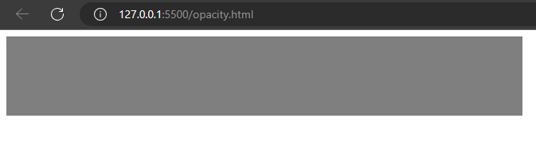

**• How can the background color of an element be changed?**

-> By using style named “background-color: ;” background color of an element can be changed.

Example:

Code:

<!DOCTYPE html>

<html lang="en">

<head>

    <meta charset="UTF-8">

    <meta name="viewport" content="width=device-width, initial-scale=1.0">

    <title>Document</title>

    <style>

        .one{

            height: 100px;

            width: 50%;

            background-color: black;

            color: white;

            text-align: center;

            font-size: xx-large;

        }

    </style>

</head>

<body>

    <div class="one">welcome to CSS assignment.</div>

</body>

</html>

Output:

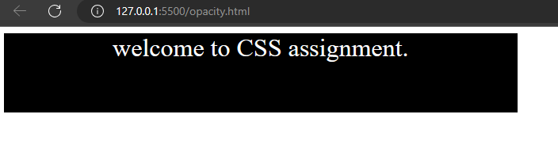

**• How can image repetition of the backup be controlled?**

-> image repetition can be controlled using ‘background-repeat:’.

Example:

Code using repeat:

<!DOCTYPE html>

<html lang="en">

<head>

    <meta charset="UTF-8">

    <meta name="viewport" content="width=device-width, initial-scale=1.0">

    <title>Document</title>

    <style>

        .one{

            height: 500px;

            width: 50%;

            color: white;

            background-image: url(image/India.png);

            background-repeat: repeat;

        }

    </style>

</head>

<body>

    <div class="one"></div>

</body>

</html>

Output:

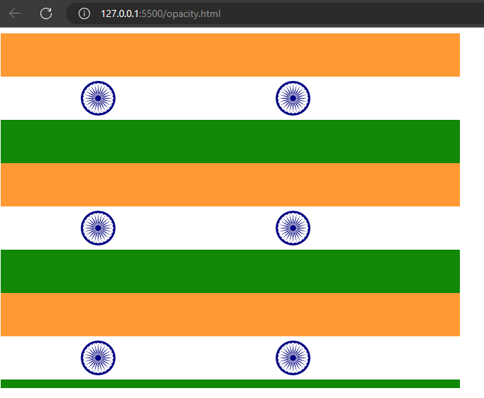

Code using no-repeat:

<!DOCTYPE html>

<html lang="en">

<head>

    <meta charset="UTF-8">

    <meta name="viewport" content="width=device-width, initial-scale=1.0">

    <title>Document</title>

    <style>

        .one{

            height: 500px;

            width: 50%;

            color: white;

            background-image: url(image/India.png);

            background-repeat: no-repeat;

        }

    </style>

</head>

<body>

    <div class="one"></div>

</body>

</html>

Output:

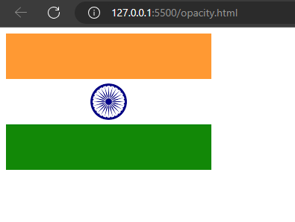

**• What is the use of the background-position property?**

-> The ‘background-position’ property in CSS is used to control the placement or alignment of a background image within its containing element. It allows you to specify where the background image should be positioned relative to the element's box. The property accepts different values, including keywords (e.g., center, top, left).

Example:

Code:

<!DOCTYPE html>

<html lang="en">

<head>

    <meta charset="UTF-8">

    <meta name="viewport" content="width=device-width, initial-scale=1.0">

    <title>Document</title>

    <style>

        .one{

            height: 500px;

            width: 50%;

            color: white;

            background-color: black;

            background-image: url(image/India.png);

            background-repeat: no-repeat;

            background-position: center;

        }

    </style>

</head>

<body>

    <div class="one"></div>

</body>

</html>

Output:

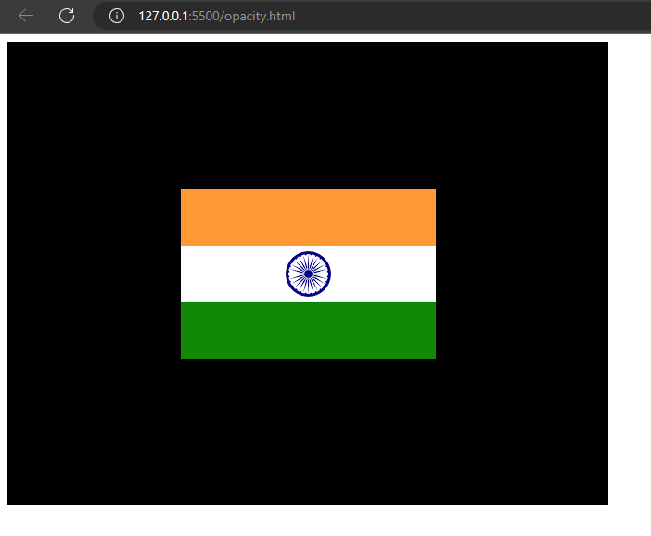

**• Which property controls the image scroll in the background?**

-> Property named ‘background-attachment’ conrols the image scroll in the background.

Example:

Code:

<!DOCTYPE html>

<html lang="en">

<head>

    <meta charset="UTF-8">

    <meta name="viewport" content="width=device-width, initial-scale=1.0">

    <title>Document</title>

    <style>

        .one{

            height: 500px;

            width: 100%;

            color: white;

            background-color: black;

            background-image: url(image/India.png);

            background-position: center;

            background-repeat: no-repeat;

            background-attachment: fixed;

        }

    </style>

</head>

<body>

    <div class="one"></div>

</body>

</html>

Output:

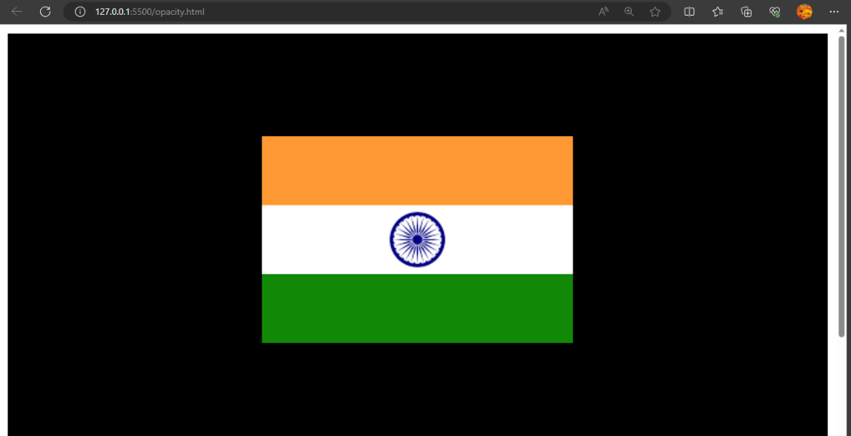

**• Why should background and color be used as separate properties?**

-> By using separate background and color properties in CSS provides greater flexibility and control over the design, readability, and accessibility of web pages.

**Layered Styling:** Background properties (e.g., background-color, background-image) are used to set backgrounds and can be layered with other elements. This enables creating visually appealing designs with background images, gradients, or patterns, while keeping the text or content color distinct and readable.

**Transparency:** Background colors and images can have transparency (alpha) values, which allows elements to appear partially transparent. This is particularly useful when overlapping elements or creating effects like overlays or transparency effects.

**Performance Optimization:** Using separate background properties can optimize performance since browsers can handle background rendering separately from text and foreground color rendering.

**Accessibility:** Separating background and color properties helps maintain a contrast ratio between text and background, which is crucial for accessibility. It ensures that text remains readable, especially for users with visual impairments.

**Responsive Design:** Different background properties can be used to adapt the layout to different screen sizes, orientations, or resolutions, while color properties remain consistent across various devices.

**Ease of Maintenance:** By keeping background and color properties separate, it becomes easier to update and modify the visual appearance of elements without affecting the layout or structure of the content.

**• How to center block elements using CSS1?**

-> To center block elements using CSS1 property ‘margin’ is used.

Example:

Code:

<!DOCTYPE html>

<html lang="en">

<head>

    <meta charset="UTF-8">

    <meta name="viewport" content="width=device-width, initial-scale=1.0">

    <title>Document</title>

    <style>

        .center{

            width: 200px;

            margin: 0 auto;

            background-color: blue;

        }

    </style>

</head>

<body>

    <div class="center">Block element centered.</div>

</body>

</html>

Output:

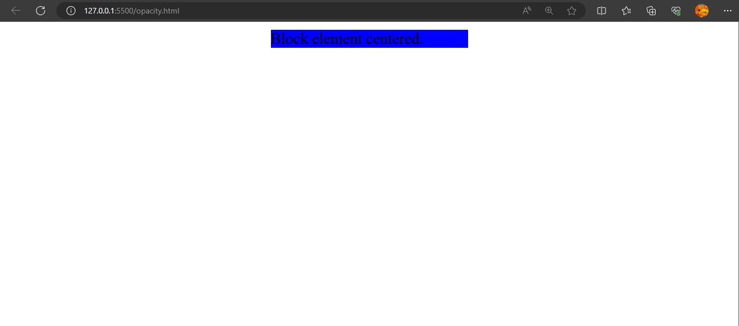

**• How to maintain the CSS specifications?**

-> Maintaining CSS specifications involves:

- Regular updates

- Community involvement

- Testing

- Backward compatibility

- Documentation

- Version control

- Vendor collaboration

- Openness to feedback

- Clear governance

**• What are the ways to integrate CSS as a web page?**

-> The ways to integrate CSS as a web page:

- **Inline CSS:** You can include CSS directly within the HTML elements using the "style" attribute. It applies the styles only to that specific element.

Example:

Code:

<!DOCTYPE html>

<html lang="en">

<head>

    <meta charset="UTF-8">

    <meta name="viewport" content="width=device-width, initial-scale=1.0">

    <title>Document</title>

</head>

<body>

    <div style="color: red; font-size: 16px;background-color: cyan;">Inline CSS.</div>

</body>

</html>

Output:

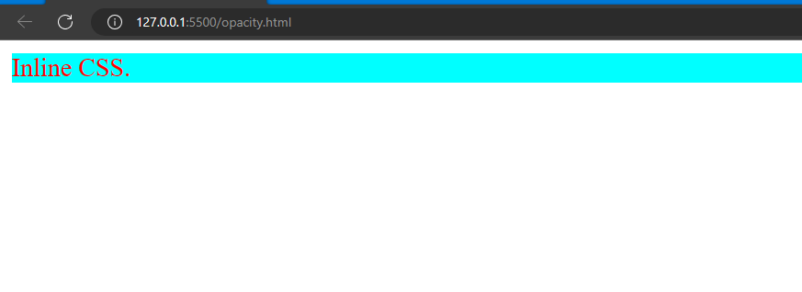

- **Internal CSS:** Internal CSS is placed within the <style> element in the <head> section of the HTML document. It applies styles to the entire page.

Example:

Code:

<!DOCTYPE html>

<html lang="en">

<head>

    <meta charset="UTF-8">

    <meta name="viewport" content="width=device-width, initial-scale=1.0">

    <title>Document</title>

    <style>

        div{

            color: red; font-size: 16px;

            background-color: cyan;

        }

    </style>

</head>

<body>

    <div>Internal CSS.</div>

</body>

</html>

Output:

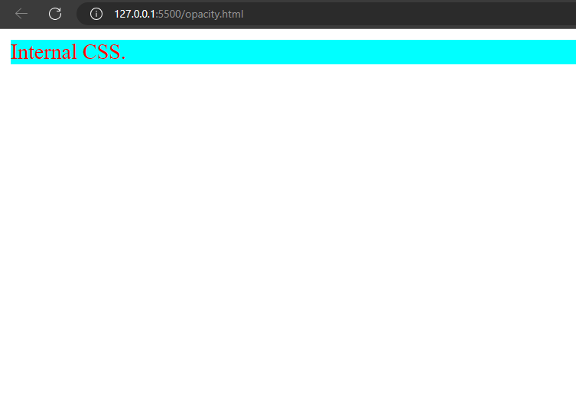

- **External CSS:** The preferred method for larger projects, external CSS files are separate files with a .css extension. You link the CSS file to the HTML document using the <link> element in the <head> section.

Example:

Code:

Filename: external.css

div{

    color: red; font-size: 16px;

    background-color: cyan;

}

Filename: opacity.html

<!DOCTYPE html>

<html lang="en">

<head>

    <meta charset="UTF-8">

    <meta name="viewport" content="width=device-width, initial-scale=1.0">

    <title>Document</title>

    <link rel="stylesheet" href="external.css">

</head>

<body>

    <div>External CSS.</div>

</body>

</html>

Output:

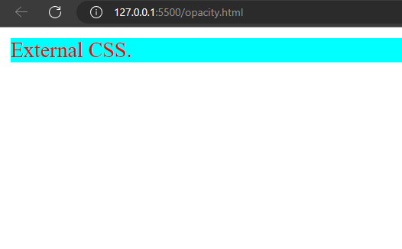

**• What are the external style sheets?**

-> An external style sheet is a standalone file with a .css extension. It contains CSS rules that define various styles, such as colors, fonts, margins, and more. You link the CSS file to the HTML document using the <link> element in the <head> section.

Example:

Code:

Filename: external.css

div{

    color: red; font-size: 16px;

    background-color: cyan;

}

Filename: opacity.html

<!DOCTYPE html>

<html lang="en">

<head>

    <meta charset="UTF-8">

    <meta name="viewport" content="width=device-width, initial-scale=1.0">

    <title>Document</title>

    <link rel="stylesheet" href="external.css">

</head>

<body>

    <div>External CSS.</div>

</body>

</html>

Output:



**• What are the advantages and disadvantages of using external style sheets?**

-> **Advantages:**

**Separation of Concerns:** External style sheets separate the presentation (CSS) from the content (HTML), making it easier to maintain and update styles without affecting the structure of the document.

**Consistency:** By using the same external style sheet across multiple pages, you ensure a consistent design and layout throughout your website, promoting a cohesive user experience.

**Caching:** Once the external style sheet is loaded, it is cached by the browser. Subsequent pages will load faster since the styles are already stored locally, improving website performance.

**Modularity:** External style sheets allow you to organize styles into different files for different components or sections of your website, promoting a modular and organized approach to styling.

**Reusability:** With external style sheets, you can apply the same styles to multiple HTML documents, reducing redundancy and making maintenance more efficient.

**Ease of Collaboration:** When multiple developers work on a project, external style sheets enable them to work on the CSS independently, minimizing conflicts and improving collaboration.

**Accessibility:** Separating styles from content allows screen readers and other assistive technologies to better understand the document structure, enhancing web accessibility.

**Disadvantages:**

**Dependency on External Files:** External style sheets require an additional HTTP request to fetch the CSS file, which can slightly increase the page loading time.

**Increased Network Traffic:** Multiple external style sheets can lead to increased network traffic, especially if the stylesheets are large or numerous.

**Potential FOUC (Flash of Unstyled Content):** If the external style sheet takes longer to load, the page might briefly display unstyled content before the styles are applied, causing a FOUC issue.

**Not Suitable for Small Projects:** For very small projects or single-page websites, the overhead of external style sheets may outweigh the benefits of modularity.

**Caching Issues:** While caching is an advantage, it can also be a disadvantage when making frequent updates to the styles. Users may need to clear their cache to see the latest changes.

**Limited Cross-Domain Styling:** Due to browser security restrictions, external style sheets cannot be used to style content on a different domain (unless CORS headers are properly set).

**Compatibility Issues:** In rare cases, some older browsers might have problems loading external style sheets or interpreting specific CSS features.

**• What is the meaning of the CSS selector?**

-> A selector is a pattern that is used to select and target HTML elements within a document to apply specific styles or rules to them.

Types:

**Element selector:** Targets all elements of a specific type. For example, p targets all <p> elements.

**Class selector:** Targets elements with a specific class attribute.

For example, ‘.one’ targets all elements with class="one".

**ID selector:** Targets an element with a specific ID attribute.

For example, #main-title targets the element with id="main-title".

**Descendant selector:** Targets an element that is a descendant of another specific element.

For example, ‘ul li’ targets all <li> elements that are inside a <ul>.

**Child selector:** Targets an element that is a direct child of another specific element.

For example, ’ ul > li’ targets all <li> elements that are immediate children of a <ul>.

**Attribute selector:** Targets elements with a specific attribute value.

For example, input[type="text"] targets all <input> elements with type="text".

**Pseudo-class selector:** Targets elements in a specific state or condition.

For example, ‘a:hover’ targets anchor elements when they are being hovered over by the mouse.

**Pseudo-element selector:** Targets a specific part of an element.

For example, p::first-line targets the first line of all <p> elements.

**• What are the media types allowed by CSS?**

-> Media types:

**All:** This is the default media type and applies to all devices.

**Screen:** This is used for screens like desktop monitors, laptops, tablets, and smartphones.

**Print:** This is used for print media, such as when a webpage is being printed.

**Speech:** This is used for screen readers and other speech synthesis devices for accessibility purposes.

**Projection:** This is used for projected presentations, like those used in projectors.

**Handheld:** This is used for handheld devices like mobile phones and small tablets.

**Tv:** This is used for television-type devices, such as smart TVs.

**Braille:** This is used for braille tactile feedback devices.

**Embossed:** This is used for devices that create raised or embossed output.

Example:

@media screen and (max-width: 768px) {

body {

font-size: 16px;

}

}

**• What is the rule set?**

-> A rule set is a combination of a selector and one or more declarations. It defines how a specific set of HTML elements should be styled.

**Selector:** The selector is used to target HTML elements that you want to apply styles to. It can be an element name, class, ID, attribute, or a combination of these.

**Declaration:** A declaration consists of a property and its corresponding value. It specifies how a specific aspect of the selected element should be styled. Multiple declarations can be grouped within the same rule set.

**• Create Layouts.**

-> code:

<!DOCTYPE html>

<html lang="en">

<head>

    <meta charset="UTF-8">

    <meta name="viewport" content="width=device-width, initial-scale=1.0">

    <title>Document</title>

    <style>

        .main{

            height: 600px;

            background-color: rgb(216, 211, 211);

            width: 100%;

            display: grid;

            grid-template-columns: repeat(3);

            row-gap: 10px;

            column-gap: 20px;

        }

        .one{

            border: 2px solid rgba(0, 0, 0, 0.366);

        }

        #t-1{

            grid-column: 1/2;

            text-align: center;

            margin-top: 50;

        }

        .a11{

            height: 60%;

            width: 100%;

            background-color: rgb(56, 54, 54);

            position: relative;

        }

        .a12{

            height: 40%;

            width: 100%;

            background-color: white;

        }

        #t-2{

            grid-column: 2/3;

            text-align: center;

            margin-top: 50;

        }

        .a1{

            height: 60%;

            width: 100%;

            background-color: rgb(56, 54, 54);

            position: relative;

        }

        .a2{

            height: 40%;

            width: 100%;

            background-color: white;

        }

        #t-3{

            grid-column: 3/4;

            text-align: center;

            margin-top: 50;

        }

        .a3{

            height: 60%;

            width: 100%;

            background-color: rgb(56, 54, 54);

            position: relative;

        }

        .a4{

            height: 40%;

            width: 100%;

            background-color: white;

        }

        #t-4{

            grid-column: 1/2;

            text-align: center;

            margin-top: 50;

        }

        .a5{

            height: 60%;

            width: 100%;

            background-color: rgb(56, 54, 54);

            position: relative;

        }

        .a6{

            height: 40%;

            width: 100%;

            background-color: white;

        }

        #t-5{

            grid-column: 2/3;

            text-align: center;

            margin-top: 50;

        }

        .a7{

            height: 60%;

            width: 100%;

            background-color: rgb(56, 54, 54);

            position: relative;

        }

        .a8{

            height: 40%;

            width: 100%;

            background-color: white;

        }

        #t-6{

            grid-column: 3/4;

            text-align: center;

            margin-top: 50;

        }

        .a9{

            height: 60%;

            width: 100%;

            background-color: rgb(56, 54, 54);

            position: relative;

        }

        .a10{

            height: 40%;

            width: 100%;

            background-color: white;

        }

        .view{

            margin-left: 20px;

            background-color: white;

        }

        .edit{

            background-color: white;

        }

    </style>

</head>

<body>

    <div class="main">

            <div class="one" id="t-1">

                <div class="a11"><span style="color: white; position: absolute;top: 50%; left: 40%;font-size: larger;">Thumbnail</span></div>

                <div class="a12" style="text-align: justify;"><br> Lorem ipsum dolor sit, amet consectetur adipisicing elit. Labore repellendus Lorem ipsum dolor sit amet consectetur adipisicing elit. Ducimus, recusandae!

                   <br><br> <button class="view">view</button><button class="edit">Edit</button><span></span>

                </div>

            </div>

            <div class="one" id="t-2">

                <div class="a1"><span style="color: white; position: absolute;top: 50%; left: 40%;font-size: larger;">Thumbnail</span></div>

                <div class="a2" style="text-align: justify;"><br>Lorem ipsum dolor sit, amet consectetur adipisicing elit. Labore repellendus Lorem ipsum dolor sit amet consectetur adipisicing elit. Ducimus, recusandae!

                    <br><br><button class="view">view</button><button class="edit">Edit</button>

                </div>

            </div>

            <div class="one" id="t-3">

                <div class="a3"><span style="color: white; position: absolute;top: 50%; left: 40%;font-size: larger;">Thumbnail</span></div>

                <div class="a4" style="text-align: justify;"><br>Lorem ipsum dolor sit, amet consectetur adipisicing elit. Labore repellendus Lorem ipsum dolor sit amet consectetur adipisicing elit. Ducimus, recusandae!

                    <br><br> <button class="view">view</button><button class="edit">Edit</button>

                </div>

            </div>

            <div class="one" id="t-4">

                <div class="a5"><span style="color: white; position: absolute;top: 50%; left: 40%;font-size: larger;">Thumbnail</span></div>

                <div class="a6" style="text-align: justify;"><br>Lorem ipsum dolor sit, amet consectetur adipisicing elit. Labore repellendus Lorem ipsum dolor sit amet consectetur adipisicing elit. Ducimus, recusandae!

                    <br><br> <button class="view">view</button><button class="edit">Edit</button>

                </div>

            </div>

            <div class="one" id="t-5">

                <div class="a7"><span style="color: white; position: absolute;top: 50%; left: 40%;font-size: larger;">Thumbnail</span></div>

                <div class="a8" style="text-align: justify;"><br>Lorem ipsum dolor sit, amet consectetur adipisicing elit. Labore repellendus Lorem ipsum dolor sit amet consectetur adipisicing elit. Ducimus, recusandae!

                    <br><br> <button class="view">view</button><button class="edit">Edit</button>

                </div>

            </div>

            <div class="one" id="t-6">

                <div class="a9"><span style="color: white; position: absolute;top: 50%; left: 40%;font-size: larger;">Thumbnail</span></div>

                <div class="a10" style="text-align: justify;"><br>Lorem ipsum dolor sit, amet consectetur adipisicing elit. Labore repellendus Lorem ipsum dolor sit amet consectetur adipisicing elit. Ducimus, recusandae!

                    <br><br> <button class="view">view</button><button class="edit">Edit</button>

                </div>

            </div>

    </div>

</body>

</html>

Output:

