**Module (HTML5) – 3**

**• What are the new tags added in HTML5?**

-> HTML tags added in HTML5 are:

**Header:** The <header> tag is used to define the header section of a document or a section within a document. The header typically contains introductory content, such as headings, logos, navigation menus, and other elements that provide context or identify the content of the page.

**Navigation:** The <nav> tag is used to define a section of a web page that contains navigation links.

**Article:** The <article> tag is used to define a self-contained and independent piece of content within a document.

**Section:** The <section> tag is used to define a grouping or section of content within a document. It's used to semantically structure the content of a webpage into meaningful sections, making it easier to understand and style the page.

**Aside:** The <aside> tag is used to define content that is tangentially related to the main content of a document. It's typically used for sidebars, pull quotes, advertisements, or other content that is supplementary to the main content but not an integral part of it.

**Footer:** The <footer> tag is used to define the footer section of a document or a section within a document.

**• How to embed audio and video in a webpage?**

-> We can embed audio and video content into a webpage using the <audio> and <video> tags in HTML5.

Example:

Code:

<!DOCTYPE html>

<html lang="en">

<head>

    <meta charset="UTF-8">

    <meta name="viewport" content="width=device-width, initial-scale=1.0">

    <title>Document</title>

    <style>

        .main{

            height: 500px;

            background-color: aqua;

            display: flex;

        }

        .audio{

            height: inherit;

            width: 50%;

        }

        .video{

            height: inherit;

            width: 50%;

        }

    </style>

</head>

<body>

    <div class="main">

    <div class="audio">

    <audio style="margin-top: 80px; width: 100%;" controls src="image/file_example_OOG_1MG.ogg"></audio>

    </div>

    <div class="video">

        <video style="height: 500px; width: 100%" controls src="image/big_buck_bunny_720p_1mb.mp4"></video>

    </div>

</div>

</body>

</html>

Output:

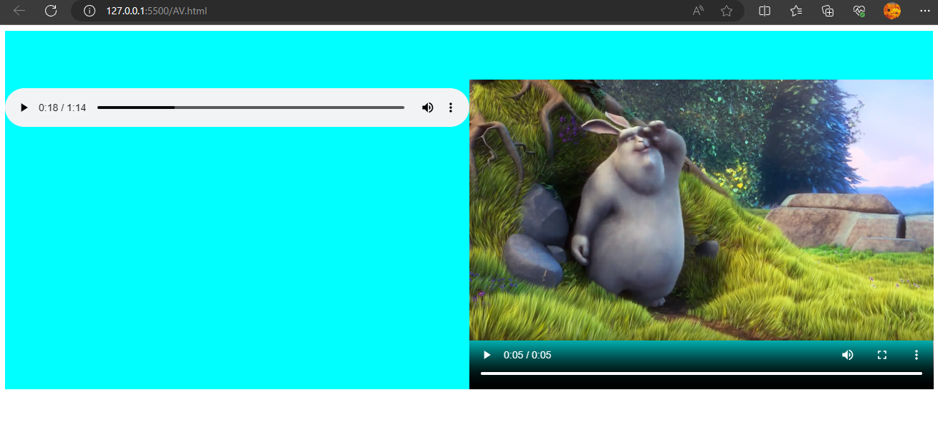

**• Semantic element in HTML5?**

-> Semantic elements in HTML5 are special tags that carry meaningful information about the structure and content of a web page. These elements provide context and convey the purpose of the enclosed content to both browsers and developers.

Example:

**- <header>**

**- <nav>**

**- <article>**

**- <section>**

**- <footer>**

**- <aside>**

**• Canvas and SVG tags?**

->

**Canvas:** The <canvas> tag is an HTML5 element that provides a way to draw graphics, animations, and interactive visual elements directly on a web page using JavaScript. It allows you to create dynamic content and visualizations without relying solely on static images or external plugins like Flash.

Example:

Code:

<!DOCTYPE html>

<html lang="en">

<head>

    <meta charset="UTF-8">

    <meta name="viewport" content="width=device-width, initial-scale=1.0">

    <title>Document</title>

</head>

<body>

    <canvas id="myCanvas" width="100" height="100"></canvas>

    <script>

        var canvas = document.getElementById("myCanvas");

        var context = canvas.getContext("2d");

        context.fillStyle = "blue";

        context.fillRect(10, 10, 180, 80);

    </script>

</body>

</html>

Output:

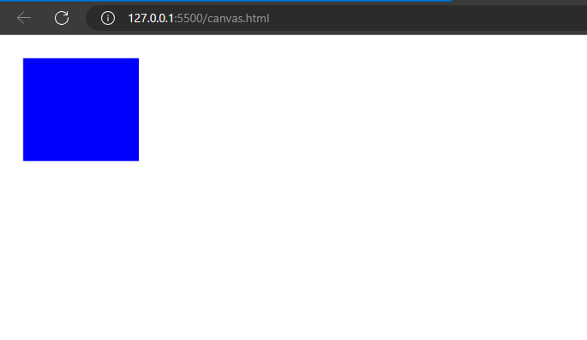

**Svg:** The <svg> tag is an HTML5 element used to embed Scalable Vector Graphics (SVG) directly within an HTML document. SVG is a markup language for describing two-dimensional vector graphics, which can be used to create a wide range of visual elements, from simple shapes to complex illustrations.

Example:

Code:

<!DOCTYPE html>

<html lang="en">

<head>

    <meta charset="UTF-8">

    <meta name="viewport" content="width=device-width, initial-scale=1.0">

    <title>Document</title>

</head>

<body>

    <svg width="200" height="100">

        <rect x="10" y="10" width="180" height="80" fill="blue" />

    </svg>

</body>

</html>

Output:

