**Module (JQuery Basic, Effects & Advanced) – 5**

**• What is jQuery?**

-> jQuery is in-built library of javascript.

- It provides a set of functions and methods that make it easier to manipulate HTML documents, handle events and create animations.

- jQuery is known for its cross-browser compatibility, which means it helps developers write code that works consistently across different web browsers.

- To add library

<script src=”https://cdnjs.cloudflare.com/ajax/libs/jquery/3.7.0/jquery.min.js”>

</script>

- jQuery allows developers to easily select and modify elements in the Document Object Model (DOM) of a web page. This simplifies tasks like adding, removing, or changing HTML content and attributes.

- jQuery simplifies event handling by providing methods to attach event listeners to elements. This makes it easier to respond to user interactions like clicks, mouseovers, and keyboard events.

- jQuery provides functions to create animations and transitions on web pages. This can be used for creating visually appealing effects and enhancing user experience.

- One of jQuery's strengths is its ability to handle the differences between web browsers, ensuring that code works consistently across various platforms.

- jQuery has a vast ecosystem of plugins and extensions created by the community, which can be easily integrated into your projects to add additional functionality.

**• How to Apply CSS Using JQuery, How to Add Class and Remove Class in Jquery,**

**JQuery Animation?**

-> Add class:

Code:

<!DOCTYPE html>

<html lang="en">

<head>

    <meta charset="UTF-8">

    <meta name="viewport" content="width=device-width, initial-scale=1.0">

    <title>Document</title>

    <script src="https://cdnjs.cloudflare.com/ajax/libs/jquery/3.7.0/jquery.min.js"></script>

    <style>

        .one{

            background-color: black;

            color: wheat;

            font-size: 200px;

        }

    </style>

</head>

<body>

    <button>xyz</button>

    <div class="one">gjfgh</div>

    <script>

        $(document).ready(function () {

            $("button").click(function () {

                $("div").addClass("one")

            })

        })

    </script>

</body>

</html>

Output:

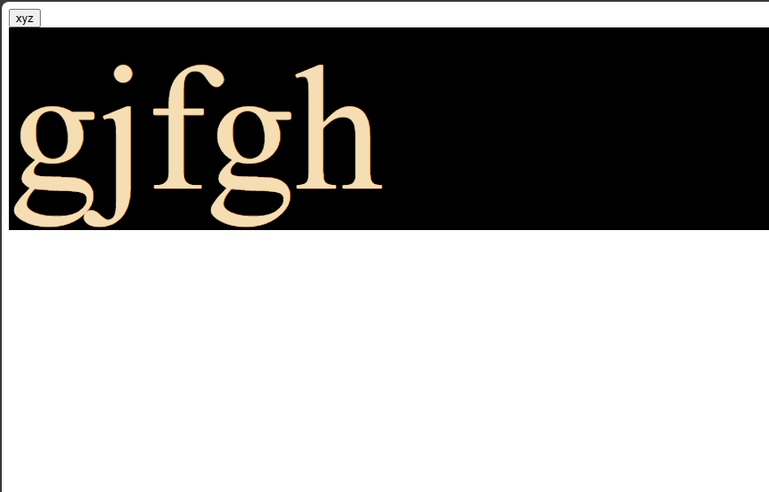

Remove class:

Code:

<!DOCTYPE html>

<html lang="en">

<head>

    <meta charset="UTF-8">

    <meta name="viewport" content="width=device-width, initial-scale=1.0">

    <title>Document</title>

    <script src="https://cdnjs.cloudflare.com/ajax/libs/jquery/3.7.0/jquery.min.js"></script>

    <style>

        .one{

            background-color: black;

            color: wheat;

            font-size: 200px;

        }

    </style>

</head>

<body>

    <button>xyz</button>

    <div class="one">gjfgh</div>

    <script>

        $(document).ready(function () {

            $("button").click(function () {

                $("div").removeClass("one")

            })

        })

    </script>

</body>

</html>

Output:

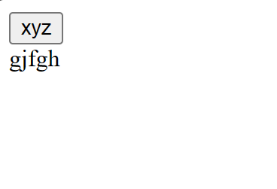

**• How to create slider with animation?**

-> slider:

Code:

<!DOCTYPE html>

<html>

<head>

<meta name="viewport" content="width=device-width, initial-scale=1">

<style>

* {box-sizing: border-box}

.mySlides1, .mySlides2 {display: none}

img {vertical-align: middle;}

/* Slideshow container */

.slideshow-container {

  max-width: 1000px;

  position: relative;

  margin: auto;

}

/* Next & previous buttons */

.prev, .next {

  cursor: pointer;

  position: absolute;

  top: 50%;

  width: auto;

  padding: 16px;

  margin-top: -22px;

  color: white;

  font-weight: bold;

  font-size: 18px;

  transition: 0.6s ease;

  border-radius: 0 3px 3px 0;

  user-select: none;

}

.next {

  right: 0;

  border-radius: 3px 0 0 3px;

}

.prev:hover, .next:hover {

  background-color: #f1f1f1;

  color: black;

}

</style>

</head>

<body>

<p>Slider</p>

<div class="slideshow-container">

  <div class="mySlides1">

    <img src="https://www.w3schools.com/howto/img_nature_wide.jpg" style="width:100%">

  </div>

  <div class="mySlides1">

    <img src="https://www.w3schools.com/howto/img_snow_wide.jpg" style="width:100%">

  </div>

  <div class="mySlides1">

    <img src="https://www.w3schools.com/howto/img_mountains_wide.jpg" style="width:100%">

  </div>

  <a class="prev" onclick="plusSlides(-1, 0)">&#10094;</a>

  <a class="next" onclick="plusSlides(1, 0)">&#10095;</a>

</div>

<script>

let slideIndex = [1,1];

let slideId = ["mySlides1", "mySlides2"]

showSlides(1, 0);

showSlides(1, 1);

function plusSlides(n, no) {

  showSlides(slideIndex[no] += n, no);

}

function showSlides(n, no) {

  let i;

  let x = document.getElementsByClassName(slideId[no]);

  if (n > x.length) {slideIndex[no] = 1}

  if (n < 1) {slideIndex[no] = x.length}

  for (i = 0; i < x.length; i++) {

     x[i].style.display = "none";

  }

  x[slideIndex[no]-1].style.display = "block";

}

</script>

</body>

</html>

Output:

