**Module (Bootstrap Basic & Advanced) – 6**

**• What are the advantages of Bootstrap?**

-> Bootstrap provides pre-designed, responsive components and layouts, saving time in development.

-> It ensures a consistent look and feel across browsers and devices, reducing cross-browser compatibility issues.

-> Bootstrap is designed with a mobile-first approach, making websites and applications responsive by default.

-> While it provides default styles, Bootstrap is highly customizable through variables and themes.

-> Comprehensive documentation and a large community of users make it easy to find resources and solutions.

-> Bootstrap follows accessibility best practices, helping create inclusive web experiences.

-> It handles cross-browser compatibility, reducing the need for extensive testing and fixes.

-> A vast ecosystem of themes, plugins, and third-party integrations is available.

-> Using Bootstrap can save development time and costs by offering ready-made UI components.

-> The grid system simplifies layout design for various screen sizes and devices.

**• What is a Bootstrap Container, and how does it work?**

-> A Bootstrap container is a fundamental layout element that helps control the width and alignment of content on a web page. It works by creating a fixed-width container with responsive behavior.

Fixed Width: Containers have a fixed maximum width, which helps maintain content readability and prevent it from stretching too wide on large screens.

Responsive: Containers adapt their width based on the user's screen size, ensuring the content looks good on both small and large devices.

Centered Content: By default, the content within a container is horizontally centered, providing a neat and visually pleasing layout.

Nested Structure: Containers can be nested inside each other to create different layout sections on a webpage.

Example:

Code:

<!DOCTYPE html>

<html lang="en">

<head>

  <meta charset="UTF-8">

  <meta name="viewport" content="width=device-width, initial-scale=1.0">

  <title>Document</title>

  <link href="https://cdn.jsdelivr.net/npm/bootstrap@5.0.2/dist/css/bootstrap.min.css" rel="stylesheet" integrity="sha384-EVSTQN3/azprG1Anm3QDgpJLIm9Nao0Yz1ztcQTwFspd3yD65VohhpuuCOmLASjC" crossorigin="anonymous">

  <script src="https://cdn.jsdelivr.net/npm/bootstrap@5.0.2/dist/js/bootstrap.bundle.min.js" integrity="sha384-MrcW6ZMFYlzcLA8Nl+NtUVF0sA7MsXsP1UyJoMp4YLEuNSfAP+JcXn/tWtIaxVXM" crossorigin="anonymous"></script>

</head>

<body>

  <div class="container bg-danger mt-5">

    <p>Lorem ipsum dolor sit amet consectetur adipisicing elit. Aperiam quos possimus aut accusantium sequi reprehenderit maiores deleniti id rem illo.</p>

  </div>

</body>

</html>

Output:

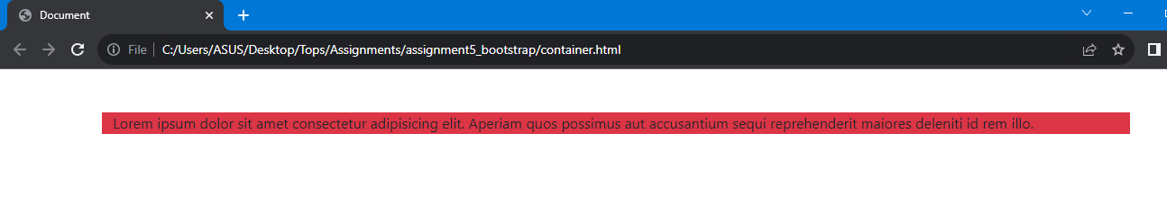

**• What are the default Bootstrap text settings?**

-> Font Family: Bootstrap uses a default sans-serif font stack for text, providing a clean and modern appearance.

Font Size: The base font size is typically set to 16 pixels (px), with responsive text sizing for different screen sizes.

Font Weight: Regular (400) and bold (700) font weights are commonly used for normal and emphasized text, respectively.

Line Height: Bootstrap sets a comfortable line height for readability, typically around 1.5 times the font size.

Text Color: The default text color is often black (#000), but it can be customized using Bootstrap's text color classes.

Text Alignment: Text is aligned left by default. You can use Bootstrap's alignment classes (e.g., text-center) to change alignment.

Text Decoration: Hyperlinks are underlined by default. Bootstrap includes classes for various text decorations, such as removing underlines (text-decoration-none).

Responsive Text: Bootstrap offers responsive text classes like text-sm, text-lg, etc., to adjust text size on different devices.

Text Transform: You can use classes like text-uppercase to change text capitalization (e.g., to uppercase).

Font Style: Bootstrap doesn't apply italic styling by default but provides classes like font-italic for italicizing text.

**• What do you know about the Bootstrap Grid System?**

-> Bootstrap's grid system is built with flexbox and allows up to 12 columns across the page.

The grid system is responsive, and the columns will re-arrange automatically depending on the screen size.

The Bootstrap 5 grid system has six classes:

-> .col- (extra small devices - screen width less than 576px)

-> .col-sm- (small devices - screen width equal to or greater than 576px)

-> .col-md- (medium devices - screen width equal to or greater than 768px)

-> .col-lg- (large devices - screen width equal to or greater than 992px)

-> .col-xl- (xlarge devices - screen width equal to or greater than 1200px)

-> .col-xxl- (xxlarge devices - screen width equal to or greater than 1400px)

Example

Code:

<!DOCTYPE html>

<html lang="en">

<head>

    <meta charset="UTF-8">

    <meta name="viewport" content="width=device-width, initial-scale=1.0">

    <title>Document</title>

    <link href="https://cdn.jsdelivr.net/npm/bootstrap@5.0.2/dist/css/bootstrap.min.css" rel="stylesheet" integrity="sha384-EVSTQN3/azprG1Anm3QDgpJLIm9Nao0Yz1ztcQTwFspd3yD65VohhpuuCOmLASjC" crossorigin="anonymous">

    <script src="https://cdn.jsdelivr.net/npm/bootstrap@5.0.2/dist/js/bootstrap.bundle.min.js" integrity="sha384-MrcW6ZMFYlzcLA8Nl+NtUVF0sA7MsXsP1UyJoMp4YLEuNSfAP+JcXn/tWtIaxVXM" crossorigin="anonymous"></script>

</head>

<body>

    <div class="row bg-danger mt-5">

        <div class="col">one</div>

        <div class="col">Two</div>

        <div class="col">Three</div>

      </div>

</body>

</html>

Output:

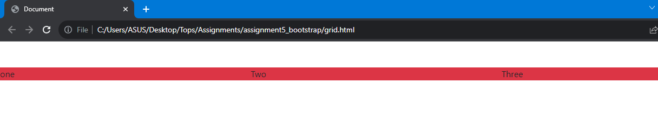

**• What is the difference between Bootstrap 4 and Bootstrap 5?**

->

|  |  |  |
| --- | --- | --- |
| **Feature** | **Bootstrap 4** | **Bootstrap 5** |
| CSS file structure | Multiple CSS files. | Single CSS file. |
| Grid system | Uses float for layouts. | Uses CSS flexbox for layouts. |
| Java script dependencies | jQuery and popper.js | No jQuery and popper.js dependencies. |
| Customization options | Less customization options. | Increased customization options with SASS. |
| Reboot CSS | Based on Normalize.css | Improved and streamlined reboot css |
| Responsive breakpoints | 5 breakpoints: xs,sm,md,lg,xl | 4 breakpoints: sm,md,lg,xl |
| Typography | Font size units are in pixels. | Font size units are in rems. |
| Components | Similar components as bootstrap 3 | Refined and new components. |
| Documentation | Well-documented, separate documentation sites. | Combined documentation for CSS and JS. |

**• What is a Button Group, and what is the class for a basic Button Group?**

-> A button group in Bootstrap is a collection of buttons grouped together for a common action or purpose. It allows you to visually group related buttons, making it easier for users to identify their function.

The class for creating a basic button group in Bootstrap is ‘btn-group’.

Example:

Code:

<!DOCTYPE html>

<html lang="en">

<head>

    <meta charset="UTF-8">

    <meta name="viewport" content="width=device-width, initial-scale=1.0">

    <title>Document</title>

    <link href="https://cdn.jsdelivr.net/npm/bootstrap@5.0.2/dist/css/bootstrap.min.css" rel="stylesheet" integrity="sha384-EVSTQN3/azprG1Anm3QDgpJLIm9Nao0Yz1ztcQTwFspd3yD65VohhpuuCOmLASjC" crossorigin="anonymous">

    <script src="https://cdn.jsdelivr.net/npm/bootstrap@5.0.2/dist/js/bootstrap.bundle.min.js" integrity="sha384-MrcW6ZMFYlzcLA8Nl+NtUVF0sA7MsXsP1UyJoMp4YLEuNSfAP+JcXn/tWtIaxVXM" crossorigin="anonymous"></script>

</head>

<body>

    <div class="btn-group">

        <button class="btn btn-primary">Button 1</button>

        <button class="btn btn-primary">Button 2</button>

        <button class="btn btn-primary">Button 3</button>

      </div>

</body>

</html>

Output:

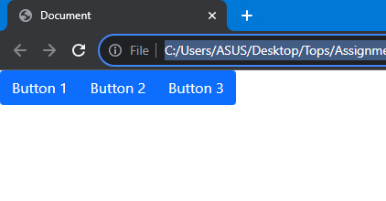

**• How can you use Bootstrap to make thumbnails?**

-> HTML Structure: Create an HTML structure for each thumbnail, typically using a <div> with the class "thumbnail."

-> Add Content: Inside the thumbnail <div>, add your content, such as an image and caption.

-> Apply Bootstrap Styles: Bootstrap will automatically style the thumbnail with borders and padding. You can further customize the appearance using additional Bootstrap classes or your own CSS.

-> Repeat: Create additional thumbnails by duplicating the HTML structure for each one.

Example:

<!DOCTYPE html>

<html lang="en">

<head>

  <meta charset="UTF-8">

  <meta name="viewport" content="width=device-width, initial-scale=1.0">

  <title>Document</title>

  <link href="https://cdn.jsdelivr.net/npm/bootstrap@5.0.2/dist/css/bootstrap.min.css" rel="stylesheet" integrity="sha384-EVSTQN3/azprG1Anm3QDgpJLIm9Nao0Yz1ztcQTwFspd3yD65VohhpuuCOmLASjC" crossorigin="anonymous">

  <script src="https://cdn.jsdelivr.net/npm/bootstrap@5.0.2/dist/js/bootstrap.bundle.min.js" integrity="sha384-MrcW6ZMFYlzcLA8Nl+NtUVF0sA7MsXsP1UyJoMp4YLEuNSfAP+JcXn/tWtIaxVXM" crossorigin="anonymous"></script>

</head>

<body>

    <div class="container d-flex">

    <div class="thumbnail">

        <img src="image/hyper2_02_1280.jpg" class="h-50 w-50" alt="Thumbnail Image">

        <div class="caption">

          <h3>Thumbnail Heading</h3>

          <p>Thumbnail description or details.</p>

        </div>

      </div>

      <div class="thumbnail">

        <img src="image/hyper2_02_1280.jpg" class="h-50 w-50" alt="Thumbnail Image">

        <div class="caption">

          <h3>Thumbnail Heading</h3>

          <p>Thumbnail description or details.</p>

        </div>

      </div>

    </div>

</body>

</html>

Output:

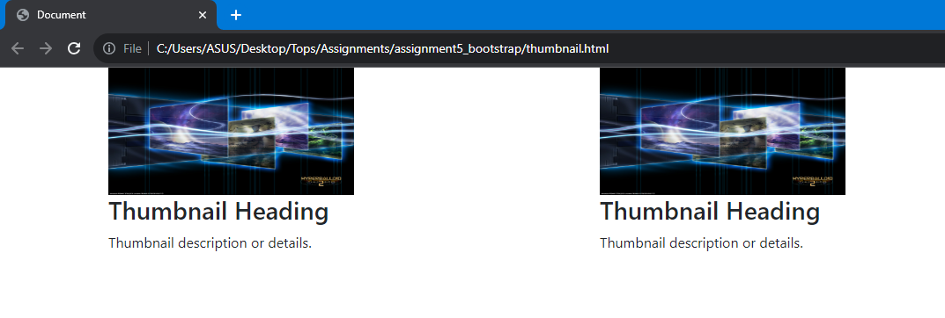

**• In Bootstrap 4, what is flexbox?**

-> In Bootstrap 4, flexbox is a layout system that is used to design and align elements within a container, making it easier to create responsive and flexible web layouts. Flexbox allows you to distribute space and align content inside a container, even when their sizes are unknown or dynamic. It is designed to simplify complex layouts and improve their flexibility.

Container and Rows: In Bootstrap, you typically start with a container element to create a flex container. Inside the container, you use rows and columns as the basic building blocks of your layout.

Display Utility: To enable flexbox behavior, you can use the d-flex class to make an element a flex container. For example:

Flex Direction: You can set the direction of the flex container using classes like flex-row (the default), flex-column, flex-row-reverse, or flex-column-reverse. These classes determine whether items are arranged horizontally or vertically within the container.

Alignment: Bootstrap provides classes like justify-content-* and align-items-* to control the alignment of flex items both horizontally and vertically.

Flex Items: Elements inside the flex container are referred to as flex items. You can use classes like flex-grow-*, flex-shrink-*, and align-self-* to control how these items behave within the container.

Responsive Flexbox: Bootstrap's flexbox system is responsive, so you can apply different flexbox classes based on screen size using the responsive utility classes like d-*-flex, flex-*-column, etc.

example:

code:

<!DOCTYPE html>

<html lang="en">

<head>

    <meta charset="UTF-8">

    <meta name="viewport" content="width=device-width, initial-scale=1.0">

    <title>Document</title>

    <link href="https://cdn.jsdelivr.net/npm/bootstrap@5.0.2/dist/css/bootstrap.min.css" rel="stylesheet" integrity="sha384-EVSTQN3/azprG1Anm3QDgpJLIm9Nao0Yz1ztcQTwFspd3yD65VohhpuuCOmLASjC" crossorigin="anonymous">

  <script src="https://cdn.jsdelivr.net/npm/bootstrap@5.0.2/dist/js/bootstrap.bundle.min.js" integrity="sha384-MrcW6ZMFYlzcLA8Nl+NtUVF0sA7MsXsP1UyJoMp4YLEuNSfAP+JcXn/tWtIaxVXM" crossorigin="anonymous"></script>

</head>

<body>

    <div class="container bg-primary">

        <div class="row">

            <div class="col-md-4">

                Lorem ipsum dolor sit amet consectetur adipisicing elit. Molestiae eligendi exercitationem ullam unde, aliquam nemo doloribus quis mollitia voluptatem minima.

            </div>

            <div class="col-md-4">

                Lorem ipsum dolor sit amet consectetur adipisicing elit. Molestiae eligendi exercitationem ullam unde, aliquam nemo doloribus quis mollitia voluptatem minima.

            </div>

            <div class="col-md-4">

                Lorem ipsum dolor sit amet consectetur adipisicing elit. Molestiae eligendi exercitationem ullam unde, aliquam nemo doloribus quis mollitia voluptatem minima.

            </div>

        </div>

    </div>

</body>

</html>

output:

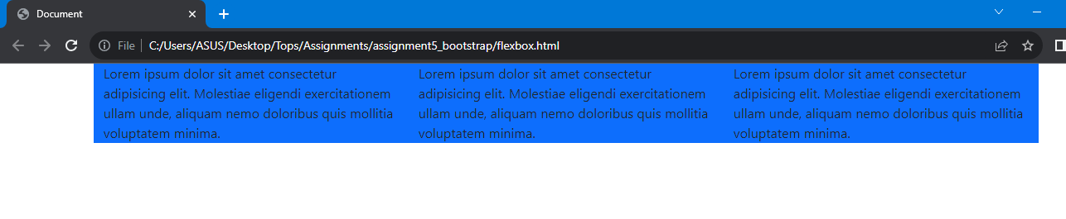

**• How can one create an alert in Bootstrap?**

In Bootstrap, you can create alerts to display various types of messages or notifications to the user. Alerts are often used for displaying information, warnings, errors, or success messages. Bootstrap provides classes to style and customize alerts easily.

alert-success: Indicates a success message.

alert-info: Indicates an informational message.

alert-warning: Indicates a warning message.

alert-danger: Indicates an error or danger message.

example:

code:

<!DOCTYPE html>

<html lang="en">

<head>

  <title>Bootstrap Example</title>

  <meta charset="utf-8">

  <meta name="viewport" content="width=device-width, initial-scale=1">

  <link href="https://cdn.jsdelivr.net/npm/bootstrap@5.3.1/dist/css/bootstrap.min.css" rel="stylesheet">

  <script src="https://cdn.jsdelivr.net/npm/bootstrap@5.3.1/dist/js/bootstrap.bundle.min.js"></script>

</head>

<body>

<div class="container mt-3">

  <div class="alert alert-success">

    <strong>Success!</strong> This alert box could indicate a successful or positive action.

  </div>

  <div class="alert alert-info">

    <strong>Info!</strong> This alert box could indicate a neutral informative change or action.

  </div>

  <div class="alert alert-warning">

    <strong>Warning!</strong> This alert box could indicate a warning that might need attention.

  </div>

  <div class="alert alert-danger">

    <strong>Danger!</strong> This alert box could indicate a dangerous or potentially negative action.

  </div>

  <div class="alert alert-primary">

    <strong>Primary!</strong> Indicates an important action.

  </div>

  <div class="alert alert-secondary">

    <strong>Secondary!</strong> Indicates a slightly less important action.

  </div>

  <div class="alert alert-dark">

    <strong>Dark!</strong> Dark grey alert.

  </div>

  <div class="alert alert-light">

    <strong>Light!</strong> Light grey alert.

  </div>

</div>

</body>

</html>

output:

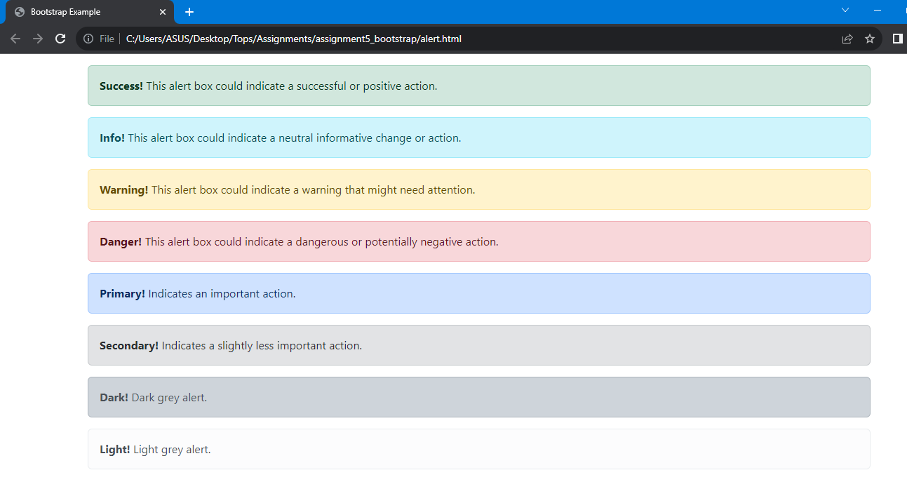

**• What is a bootstrap card and how would you create one?**

-> A Bootstrap card is a versatile content container that allows you to display various types of content, including text, images, links, and other HTML elements, in a structured and visually appealing manner. Cards are commonly used to present information, such as articles, products, user profiles, and more, in a consistent and organized format.

example:

code:

<!DOCTYPE html>

<html lang="en">

<head>

    <meta charset="UTF-8">

    <meta name="viewport" content="width=device-width, initial-scale=1.0">

    <title>Document</title>

    <link href="https://cdn.jsdelivr.net/npm/bootstrap@5.0.2/dist/css/bootstrap.min.css" rel="stylesheet" integrity="sha384-EVSTQN3/azprG1Anm3QDgpJLIm9Nao0Yz1ztcQTwFspd3yD65VohhpuuCOmLASjC" crossorigin="anonymous">

    <script src="https://cdn.jsdelivr.net/npm/bootstrap@5.0.2/dist/js/bootstrap.bundle.min.js" integrity="sha384-MrcW6ZMFYlzcLA8Nl+NtUVF0sA7MsXsP1UyJoMp4YLEuNSfAP+JcXn/tWtIaxVXM" crossorigin="anonymous"></script>

</head>

<body>

    <div class="card" style="width:400px">

        <img class="card-img-top" src="image/hyper2_02_1280.jpg" alt="Card image">

        <div class="card-body">

          <h4 class="card-title">John Doe</h4>

          <p class="card-text">Some example text.</p>

          <a href="#" class="btn btn-primary">See Profile</a>

        </div>

      </div>

</body>

</html>

output:

