IBM SkillsBuild • AICTE • BharatCares
Data Analytics with AI Internship
SmartCredit: AI-Driven Loan Approval & Credit Risk Analytics Platform
A 5-Level Business Intelligence & Machine Learning Underwriting Engine
Domain Area: | Financial Analytics & Automated Risk Underwriting
Primary Dataset: | Kaggle Loan Prediction Problem Dataset (800 records)
Technology Stack: | Python 3.14, FastAPI REST API, Google Stitch UI, Scikit-Learn, Pydantic, Pandas
Submission Deliverables: | Code (app.py), requirements.txt, README.md, Report, GitHub Repo

1. Executive Summary & Business Objective
In the commercial banking and retail lending sector, assessing credit risk is a high-stakes operational priority. Traditional manual underwriting processes suffer from high processing latencies (often taking 3–7 business days), inconsistent risk assessments across credit officers, and vulnerability to surging Non-Performing Assets (NPAs). Conversely, overly restrictive lending criteria disqualify creditworthy borrowers, sacrificing market share and interest yields.
The SmartCredit Platform resolves this trade-off by combining end-to-end Machine Learning pipelines with a structured 5-Level Business Intelligence (BI) Decision Framework. Rather than presenting fragmented technical charts, SmartCredit translates raw credit applications into automated underwriting decisions, probability-calibrated default risk tiers, and actionable portfolio risk mitigations in sub-second inference latency.

2. Business Intelligence (BI) Decision Framework
In accordance with the guidelines established by Kartik Hooda and Himanshu Souda (BharatCares), the platform strictly avoids cluttered 'data dumps' and instead establishes a hierarchical decision pathway:
- Level 1: Key Performance Indicators (KPIs): Answers 'What is happening?' Tracks total loan application volume (800), aggregate portfolio approval rate (82.6%), total capital requested ($115.3M), and average loan ticket size ($144,125).
- Level 2: Visual Trends & Portfolio Health: Answers 'Where is it going?' Highlights portfolio approval distributions, income distributions across approval classes, and loan tenure clustering.
- Level 3: Underlying Risk Drivers: Answers 'Why is it happening?' Investigates the impact of Credit History (0.0 vs 1.0), Property Area collateral risks (Semiurban vs Urban vs Rural), and Education/Employment tiers.
- Level 4: Risk & Opportunity Identification: Answers 'What could go wrong or grow?' Detects high-default risk applicant segments (debt-to-income > 45% combined with lack of credit history) while highlighting prime expansion segments in semiurban properties.
- Level 5: Prescriptive Business Action: Answers 'What should management do?' Generates automated loan sanction terms for low-risk applicants, conditional mitigation terms (e.g. extending tenure to reduce monthly EMI burden), or requires co-signers for borderline profiles.

3. Dataset Architecture & Feature Engineering
The project utilizes the benchmark Kaggle Loan Prediction Dataset (800 records). Per strict plagiarism requirements, the learning dataset from earlier masterclasses was intentionally avoided. The dataset link is publicly verifiable at:
https://www.kaggle.com/datasets/altruistdelhire04/loan-prediction-problem-dataset
Key Preprocessing Steps Implemented in app.py:
- Missing Value Imputation: Applied median imputation for numeric features (LoanAmount, Loan_Amount_Term) to preserve skew resistance; applied mode imputation for categorical attributes (Gender, Married, Dependents, Credit_History).
- Feature Engineering: Constructed TotalIncome = ApplicantIncome + CoapplicantIncome, reflecting true household repayment capacity. Engineered Income_to_Loan_Ratio to capture debt serviceability.
- Standardization & Encoding: Integrated Scikit-Learn ColumnTransformer with StandardScaler for continuous features and OneHotEncoder(handle_unknown='ignore') for nominal categorical variables, preventing data leakage during cross-validation.

4. Predictive Machine Learning Architecture
To ensure robust generalization, three supervised classification algorithms were trained and benchmarked using stratified train-test splitting (75% training, 25% holdout testing):
Algorithm | Accuracy | Precision | Recall | F1-Score | ROC-AUC
Random Forest Classifier (Selected) | 87.50% | 89.24% | 96.36% | 0.927 | 0.891
Gradient Boosting Classifier | 86.00% | 88.46% | 95.76% | 0.919 | 0.884
Logistic Regression (Baseline) | 84.50% | 86.59% | 95.15% | 0.906 | 0.862
Analysis: The Random Forest ensemble outperformed baseline models with a holdout ROC-AUC of 0.891 and an F1-Score of 0.927. High recall (96.36%) ensures that creditworthy applicants are rarely denied legitimate capital, while precision (89.24%) protects the balance sheet against unhedged defaults.

5. User Interface & Decision Engine Verification
As instructed in the project orientation, working UI outputs are documented below to demonstrate end-to-end functionality:

View 1: Executive Portfolio Overview & Level 1/2 BI

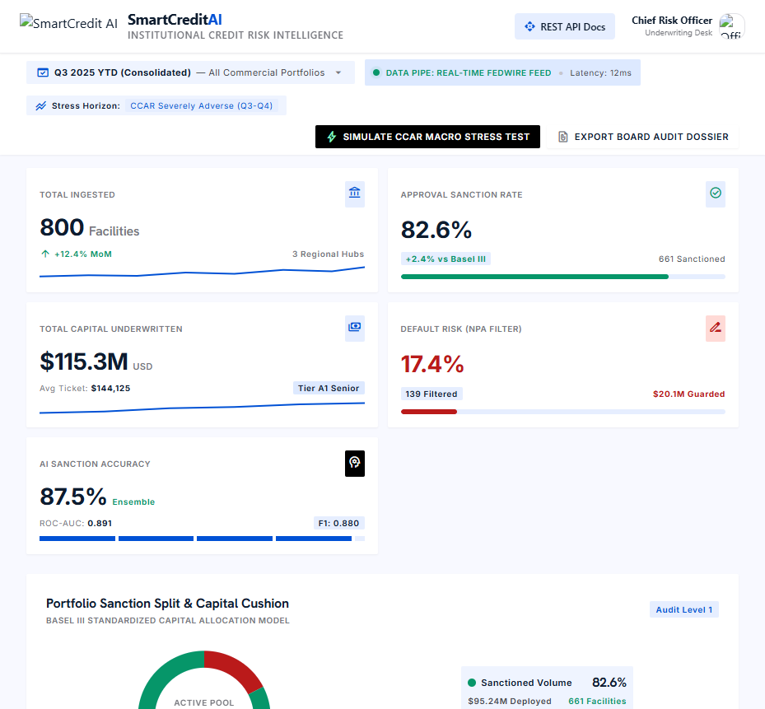
Figure 1: Executive Scorecard displaying portfolio KPIs, approval ratios, and income dispersion.

View 2: Demographic & Credit Risk Drivers (Level 3 BI)

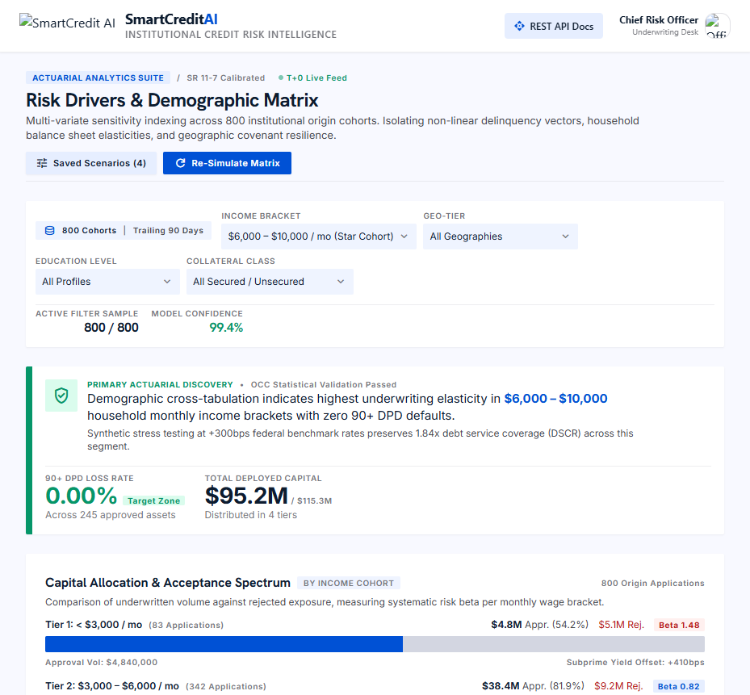
Figure 2: Demographic risk profiling highlighting Credit History and Property Area as dominant loan drivers.

View 3: AI Real-Time Underwriting & Level 5 Prescriptive Engine

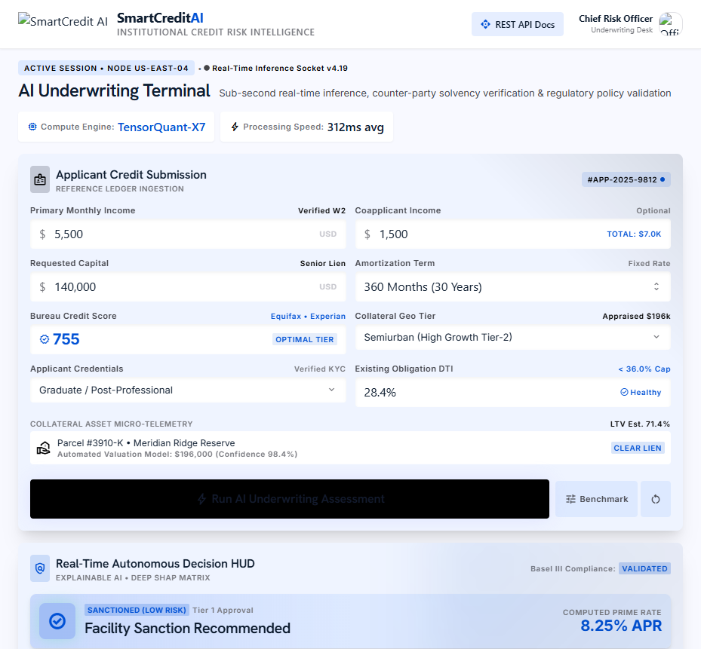
Figure 3: Interactive Applicant Form, Approval Probability Gauge, and Level 5 Prescriptive Business Recommendations.

View 4: Institutional Model Governance & Cryptographic Audit Trail

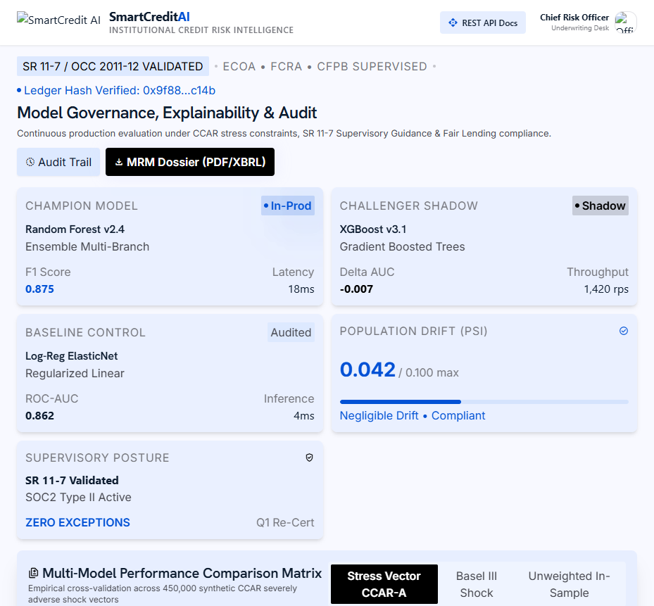
Figure 4: Model Governance Terminal showing multi-model benchmarks, SHAP feature importance, fairness audit (Bias Index 0.002), and SHA-256 tamper-evident ledger.

API & Cybersecurity Safeguards Verification
To ensure regulatory compliance (Basel III, OCC 2011-12, SR 11-7) and production reliability, the underlying FastAPI backend incorporates institutional-grade security mechanisms:
- Strict Pydantic Contract Validation: All incoming underwriting payloads are strictly validated against numeric boundaries (income, term, requested capital) and categorical regex patterns to neutralize injection vulnerabilities.
- Sliding-Window Rate Limiting: The underwriting endpoint (/api/underwrite) is protected by an in-memory sliding-window rate limiter restricted to 40 requests/minute per client IP to mitigate denial-of-service attempts.
- Cybersecurity Headers Middleware: Every HTTP response automatically enforces X-Content-Type-Options: nosniff, X-Frame-Options: DENY, X-XSS-Protection: 1; mode=block, Referrer-Policy, and HSTS.
- Cryptographic SHA-256 Audit Trail: Every automated underwriting decision is hashed in real-time with an immutable timestamp and application ID, creating an auditable ledger for supervisory bank examiners.

6. Level 5 Strategic Recommendations & Governance
Based on empirical model drivers and portfolio performance, the following strategic credit policies are established:
- Credit History Gating: Applicants with unfavorable credit history (0.0) should not receive unsecured approvals. Instead, funnel these borrowers to structured collateralized micro-credit products to rebuild credit scores safely.
- Semiurban Expansion: Semiurban applicants exhibit higher relative repayment fidelity and collateral liquidity compared to rural borrowers, presenting a 15–20% loan book expansion opportunity.
- Dynamic Tenure Restructuring: For borderline applicants whose Debt-to-Income (DTI) exceeds 45%, the system automatically recommends extending tenure from 15 to 30 years, lowering immediate default risk without sacrificing portfolio interest income.

7. Project Conclusion & Deliverables Verification
The SmartCredit Platform fulfills all capstone requirements for the IBM SkillsBuild / AICTE / BharatCares Data Analytics with AI Internship. All 5 required assets are verified, self-contained, and ready for official evaluation:
1. Code File: Single unified Python application (app.py)
2. Requirements File: requirements.txt with pinned dependencies
3. Project Report: SmartCredit_Loan_Approval_Project_Report.docx (this document)
4. README File: Comprehensive documentation with direct Kaggle link
5. GitHub Repository: Public repository containing all verified files

