# INTRODUCTION

**Problem Statement :-**

Nowadays everyone likes to spend some time in the beautiful places around the world. Everyone wants to get aside from the hectic schedule of their respective domains, like the students want to spend some time away from studies whereas the adults would want to free themselves from their respective work.

So there is a lot of rush of people to some of the common destinations around the world. Some of them are not able to book their respective tours due to heavy rush of tourists while some of them are not able to get proper hotels for their stay. This is the reason many people cancel their plans of their holiday visit and prefer staying at their homes, ruining the holidays of each and everyone.

# Problem Solution :-

To resolve all this issue we are going to work upon a project in which we are creating a website for all the people named as “**TRAVELO**”.

The website will contain multiple web pages which will provide information about the various tours and packages we give,the overall package information and the advance services for accommodation(booking of hotels).

People will be able to choose their preferred tour and book their holidays plan around the world, in a very easy way

# Webpages :-

* Homepage
* About Us
* Contact Us
* Sign Up
* Login
* Tours
* Blog
* Hotels

# Technologies will be use :-

* HTML
* CSS
* JAVASCRIPT
* JQUERY
* BOOTSTRAP
* ANGULAR

•

# Work Division :-

1. **Alisha Thakur**

* Homepage

# Nitin Chaudhary

* Login and Signup
* About us

# Jay Pathak

* Tour and Packages

# Aarushi

* Blog
* Contact us

Github link - <https://github.com/jaypathak14/Front_end_project>

Screen shots

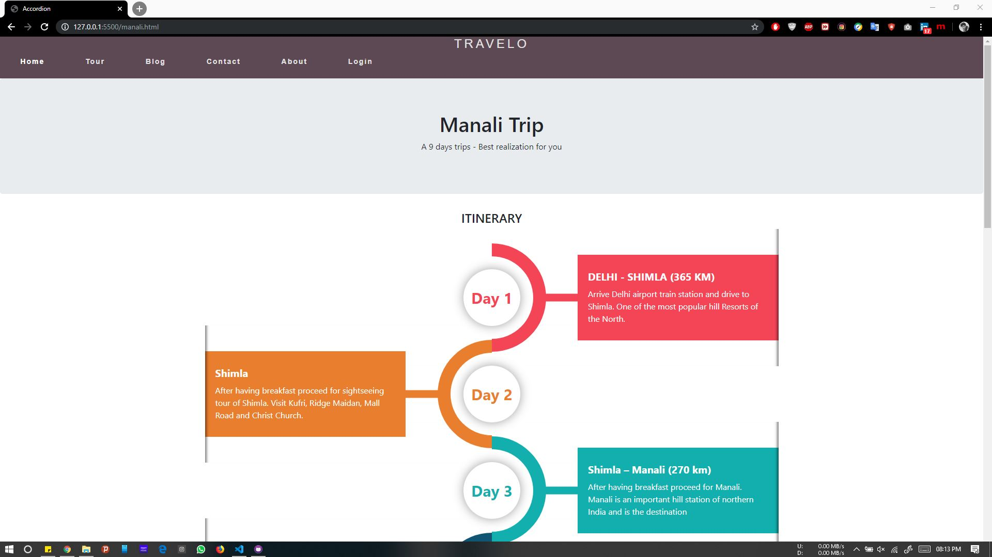

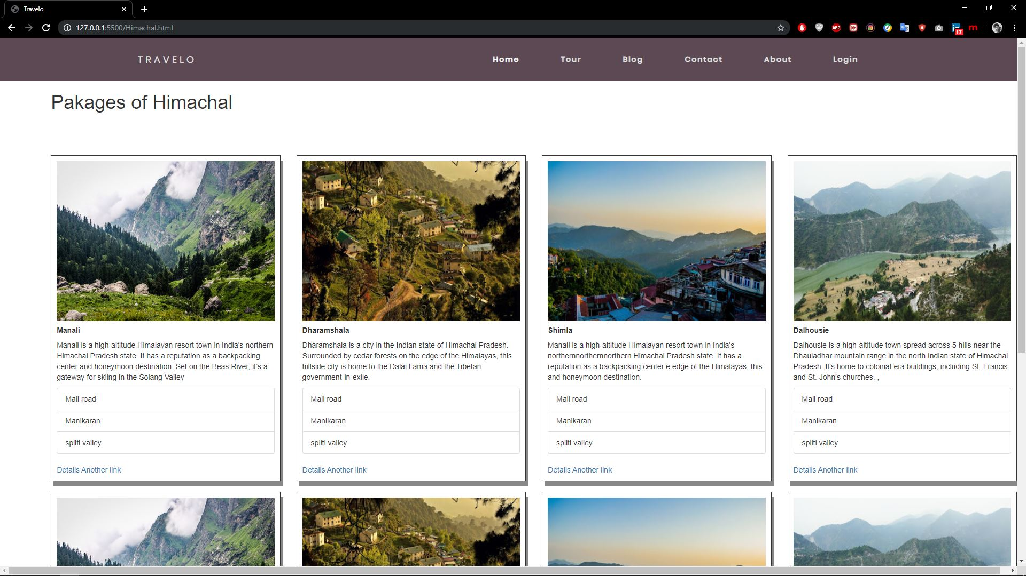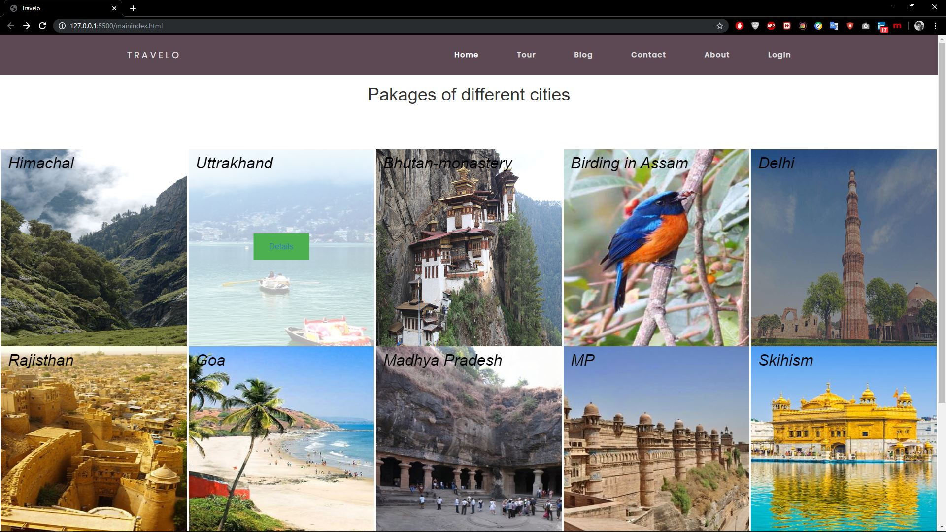

Code

Tour-

<div class="pakages">

<div class="container" id="sha">

<img src="images/Kullu-Valley-Himachal-Pradesh-India.jpg" alt="Kullu" class="image">

<div class="top-left">Himachal</div>

<div class="middle">

<div class="text"><a href="Himachal.html">Details</a></div>

</div>

</div>

<div class="container">

<img src="images/best-of-uttaranchal.jpg" alt="Uttrakhand" class="image">

<div class="top-left">Uttrakhand</div>

<div class="middle">

<div class="text"><a href="Himachal.html">Details</a></div>

</div>

</div>

<div class="container">

<img src="images/bhutan-monastery.jpg" alt="bhutan-monastery" class="image">

<div class="top-left">Bhutan-monastery</div>

<div class="middle">

<div class="text"><a href="Himachal.html">Details</a></div>

</div>

</div>

**Single city –**

<div class="row">

<div class="col-sm-3">

<div class="card" style="width: 100%;">

<img class="card-img-top" src="images/H1.jpg" alt="Manali">

<div class="card-body">

<h5 class="card-title"><strong>Manali</strong></h5>

<p class="card-text">Manali is a high-altitude Himalayan resort town in India’s northern Himachal Pradesh state. It has a reputation as a backpacking center and honeymoon destination. Set on the Beas River, it’s a gateway for skiing in the Solang Valley

</p>

</div>

<ul class="list-group list-group-flush">

<li class="list-group-item">Mall road</li>

<li class="list-group-item">Manikaran</li>

<li class="list-group-item">spliti valley</li>

</ul>

<div class="card-body">

<a href="manali.html" class="card-link">Details</a>

<a href="manali.html" class="card-link">Another link</a>

</div>

</div>

</div>

<div class="col-sm-3">

<div class="card" style="width: 100%;">

<img class="card-img-top" src="images/dharamshala.jpg" alt="dharamshala">

<div class="card-body">

<h5 class="card-title"><strong>Dharamshala</strong></h5>

<p class="card-text">Dharamshala is a city in the Indian state of Himachal Pradesh. Surrounded by cedar forests on the edge of the Himalayas, this hillside city is home to the Dalai Lama and the Tibetan government-in-exile. </p>

</div>

<ul class="list-group list-group-flush">

<li class="list-group-item">Mall road</li>

<li class="list-group-item">Manikaran</li>

<li class="list-group-item">spliti valley</li>

</ul>

<div class="card-body">

<a href="manali.html" class="card-link">Details</a>

<a href="manali.html" class="card-link">Another link</a>

</div>

</div>

</div>

**Single pakage –**

<h4> ITINERARY</h4>

<div class="row">

<div class="col-md-12">

<div class="main-timeline5">

<div class="timeline">

<div class="timeline-icon"><span class="year">Day 1</span></div>

<div class="timeline-content">

<h3 class="title">DELHI - SHIMLA (365 KM)</h3>

<p class="description">

Arrive Delhi airport train station and drive to Shimla. One of the most popular hill Resorts of the North. </p>

</div>

</div>

<div class="timeline">

<div class="timeline-icon"><span class="year">Day 2</span></div>

<div class="timeline-content">

<h3 class="title">Shimla </h3>

<p class="description">

After having breakfast proceed for sightseeing tour of Shimla. Visit Kufri, Ridge Maidan, Mall Road and Christ Church.

</p>

</div>

</div>

<div class="timeline">

<div class="timeline-icon"><span class="year">Day 3</span></div>

<div class="timeline-content">

<h3 class="title">Shimla – Manali (270 km)</h3>

<p class="description">

After having breakfast proceed for Manali. Manali is an important hill station of northern India and is the destination

</p>

</div>

</div>

<div class="timeline">

<div class="timeline-icon"><span class="year">Day 4</span></div>

<div class="timeline-content">

<h3 class="title">Manali - Rohtang Pass - Manali</h3>

<p class="description">

Today full day excursion visiting Kothi Gorge, Gulaba, Marhi, Rohtang Pass (Upto Snow Line in case Rohtang is closed </p>

</div>

</div>

<div class="timeline">

<div class="timeline-icon"><span class="year">Day 5</span></div>

<div class="timeline-content">

<h3 class="title">Manali – Chamunda – Dharamshala (260 km)</h3>

<p class="description">

After breakfast, proceed for Dharamshala. En-route visit Chamunda Devi Temple. Check in to the hotel. Evening at leisure.</p>

</div>

</div>

<div class="timeline">

<div class="timeline-icon"><span class="year">Day 6</span></div>

<div class="timeline-content">

<h3 class="title">Dharamshala – Dalhousie. (140 kms)</h3>

<p class="description">

After breakfast visit Bhudhist Monastery, Bhagsunag Temple. Enjoy the scenic beauty of Dharamshala. Later drive to Dalhousie. </p>

</div>

</div>

<div class="timeline">

<div class="timeline-icon"><span class="year">Day 7</span></div>

<div class="timeline-content">

<h3 class="title">Dalhousie - Khajjiar - Dalhousie</h3>

<p class="description">

Afte Hving breakfast, visit Khajjiar (Khajjiar is closed some time in Dec-Jan due to heavy snow) the mini Switzerland, </p>

</div>

</div>

<div class="timeline">

<div class="timeline-icon"><span class="year">Day 8</span></div>

<div class="timeline-content">

<h3 class="title"> Dalhousie- Chandigarh (300 kms)</h3>

<p class="description">

After breakfast proceed to Chandigarh. On arrival check in to the hotel. Evening free to explore the local markets.</p>

</div>

</div>

<div class="timeline">

<div class="timeline-icon"><span class="year">Day 9</span></div>

<div class="timeline-content">

<h3 class="title">Chandigarh to Delhi (250 kms)</h3>

<p class="description">

After having breakfast, sightseeing of Chandigarh visit Rockgarden. Rose Garden and Sukhna Lake and transfer to Delhi.

</p>

</div>

</div>

</div>