Name – Jay Pathak
Roll No. – 38
Reg. No. – 11702074
Section - CS

GitHub link - https://github.com/jaypathak14/OS-project-Roll-No.-38-Jay-Pathak-K17CS

Q3.
Gives error when zero is entered as arrival time-
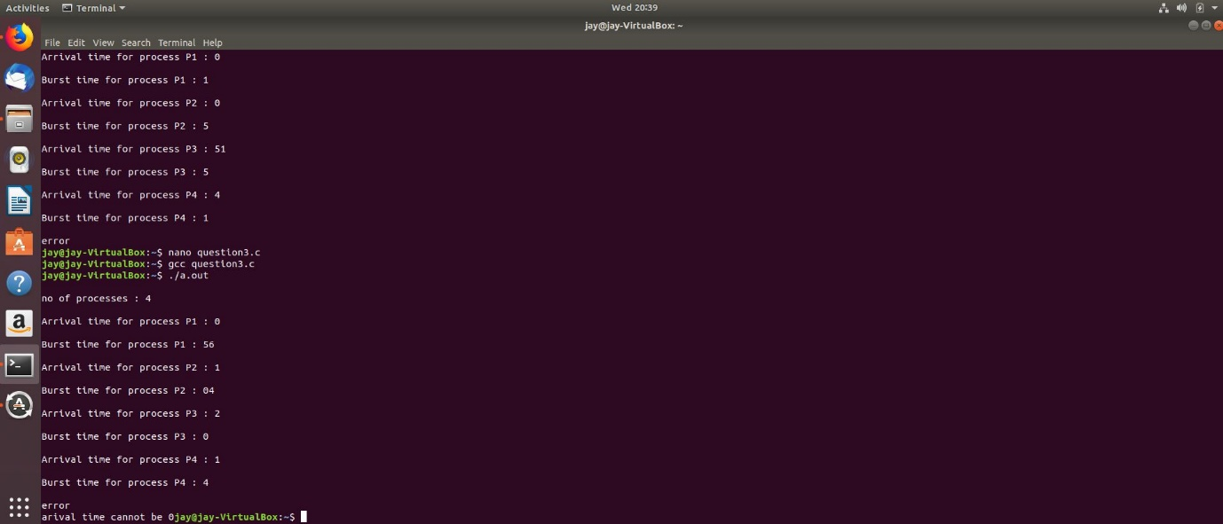
Normal run -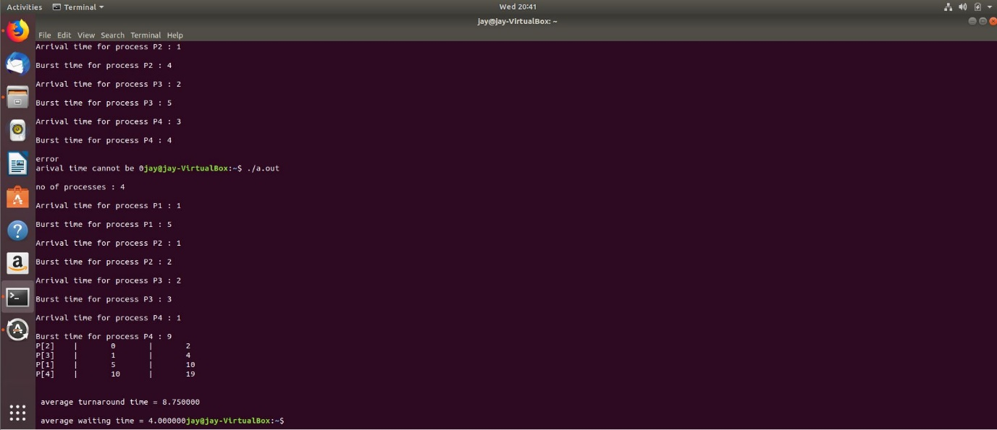

Q14.
