___________________

Software Requirements
Specification

For

API Cost Leak Profiler

Prepared by Pranav Gadge,
Shrey Sawant
and Jay Patil
Sardar Patel Institute Of Technology

15 September 2026

DOCUMENT CONTROL
This page records the revision history of the specification, the approvals required before it is treated as baselined, and the parties to whom it is issued. Once baselined, changes to this document are made by raising the version and recording the change below; requirement identifiers are never reused (Section 1.2).
Version | Date | Author | Summary of change
0.1 | 28 Aug 2026 | Project team | Initial outline; section structure fixed against IEEE 830-1998.
0.2 | 04 Sep 2026 | Project team | Functional requirements FR-100 to FR-800 drafted and identified; use case model added.
0.3 | 08 Sep 2026 | Project team | Non-functional requirements aligned to the measurable targets of P1 §8; traceability matrix added.
1.0 | 11 Sep 2026 | Project team | Interfaces, data model and verification plan completed. Baselined for implementation.

Approval
Role | Name | Signature | Date
Project Guide | Dr. Sudhir Dhage
Project Co-Guide | Prof. Ameya Nile
Team representative | Shrey Sawant
Team member | Jay Patil
Team member | Pranav Gadge

Distribution
Project Guide and Co-Guide; the Semester V mini-project evaluation panel, Department of Computer Engineering; and the project team. This document accompanies P1, P2, P3 and P4 as the fifth deliverable of the project sequence.

TABLE OF CONTENTS

1. INTRODUCTION 5
1.1 Purpose 5
1.2 Document Conventions 5
1.3 Intended Audience and Reading Suggestions 6
1.4 Product Scope 6
1.5 Definitions, Acronyms and Abbreviations 7
1.6 References 7
1.7 Overview of this Document 8
2. OVERALL DESCRIPTION 9
2.1 Product Perspective 9
2.2 System Architecture Overview 10
2.3 Data Flow Overview 12
2.4 Product Functions 14
2.5 User Classes and Characteristics 16
2.6 Operating Environment 16
2.7 Design and Implementation Constraints 16
2.8 User Documentation 17
2.9 Assumptions and Dependencies 17
2.10 Apportioning of Requirements 18
3. EXTERNAL INTERFACE REQUIREMENTS 18
3.1 User Interfaces 18
3.2 Hardware Interfaces 18
3.3 Software Interfaces 19
3.4 Communications Interfaces 19
3.5 Programmatic Interface — the Instrumentation SDK 20
4. SYSTEM FEATURES 22
4.1 FR-100 Metadata Capture and Emission 22
4.2 FR-200 Asynchronous Ingestion and Persistence 23
4.3 FR-300 Cost Computation and Attribution 24
4.4 FR-400 Rule-Based Leak Detection 26
4.5 FR-500 Statistical and Semantic Analytics 28
4.6 FR-600 Alert Generation and Notification 30
4.7 FR-700 Dashboard, Visualisation and Reporting 31
4.8 FR-800 Configuration and Administration 32
5. OTHER NONFUNCTIONAL REQUIREMENTS 33
5.1 Performance Requirements 33
5.2 Safety Requirements 33
5.3 Security Requirements 34
5.4 Software Quality Attributes 34
5.5 Business Rules 35
5.6 Data Management Requirements 35
6. USE CASE SPECIFICATIONS 36
6.1 Actors 36
6.2 Use Case Diagram 36
6.3 Use Case Index 37
6.4 Detailed Use Case Specifications 37
7. OTHER REQUIREMENTS 41
7.1 Database Requirements 41
7.2 Logging and Auditing 42
7.3 Installation and Deployment Requirements 42
7.4 Licensing and Compliance 42
7.5 Internationalisation 42
8. VERIFICATION AND ACCEPTANCE 43
8.1 Verification Approach 43
8.2 Acceptance Criteria 43
8.3 Leak-Injection Test Suite 43
8.4 Requirement Coverage by Milestone 44
APPENDIX A — REQUIREMENTS TRACEABILITY MATRIX 45
APPENDIX B — MESSAGE SCHEMAS 46
APPENDIX C — OPEN ISSUES 47

LIST OF FIGURES

Figure 1 — System context (Data Flow Diagram, Level 0) 9
Figure 2 — Layered system architecture 10
Figure 3 — Component diagram 11
Figure 4 — Process decomposition (Data Flow Diagram, Level 1) 12
Figure 5 — Sequence diagram 1: instrumentation, ingestion and cost attribution (UC-01 → UC-03) 13
Figure 6 — Sequence diagram 2: leak detection, alerting and triage (UC-04, UC-05, UC-07, UC-08) 14
Figure 7 — Use case diagram 36

LIST OF TABLES

Table 1 — Requirement identifier scheme 5
Table 2 — Priority levels 5
Table 3 — Reading guide by audience 6
Table 4 — Definitions and acronyms 7
Table 5 — Positioning against existing categories of tool 9
Table 6 — Architectural tiers and their responsibilities 10
Table 7 — Process catalogue 12
Table 8 — Data store catalogue 13
Table 9 — Major function groups 14
Table 10 — User classes 16
Table 11 — Operating environment 16
Table 12 — Design and implementation constraints 16
Table 13 — Assumptions 16
Table 14 — External dependencies 18
Table 15 — Requirements apportioned to future releases 18
Table 16 — Dashboard screens 18
Table 17 — Software interfaces 19
Table 18 — Instrumentation SDK interface requirements 20
Table 19 — FR-100 — metadata capture requirements 22
Table 20 — FR-200 — ingestion and persistence requirements 23
Table 21 — FR-300 — cost computation and attribution requirements 25
Table 22 — FR-400 — common rule engine requirements 26
Table 23 — FR-410 — duplicate prompt detection 26
Table 24 — FR-420 — retry loop detection 27
Table 25 — FR-430 — unbounded context detection 27
Table 26 — FR-440 — oversized prompt detection 28
Table 27 — FR-450 — spend spike detection 28
Table 28 — FR-500 — analytics microservice requirements 29
Table 29 — FR-600 — alert generation and notification requirements 30
Table 30 — FR-700 — dashboard and reporting requirements 31
Table 31 — FR-800 — configuration and administration requirements 32
Table 32 — Performance requirements 33
Table 33 — Safety requirements 33
Table 34 — Security requirements 34
Table 35 — Software quality attributes 34
Table 36 — Business rules 35
Table 37 — Data management requirements 35
Table 38 — Actor catalogue 36
Table 39 — Use case index 37
Table 40 — Collection `usage_records` 41
Table 41 — Collection `alerts` 41
Table 42 — Supporting collections 42
Table 43 — Acceptance criteria and verification methods 43
Table 44 — Leak-injection test suite requirements 43
Table 45 — Requirement coverage by milestone 44
Table 46 — Requirements traceability matrix 45
Table 47 — Open issues 47

1. INTRODUCTION

1.1 Purpose
This Software Requirements Specification (SRS) describes the functional and non-functional requirements of the API Cost Leak Profiler (ACLP), release 1.0 — an observability and analytics platform that attributes Large Language Model (LLM) API spend to the application feature, end user and model that caused it, and that automatically identifies the specific inefficiencies responsible for wasted spend.
The document has four objectives. First, it establishes a single, unambiguous statement of what release 1.0 must do, so that the development team, the project guide and the evaluation panel share one interpretation of scope. Second, it converts the qualitative problem statement and success criteria agreed in the Problem Definition (P1) into individually identified, individually verifiable requirements. Third, it fixes the external interfaces — the instrumentation SDK, the REST and WebSocket contracts, and the provider integrations — early enough that the four parallel workstreams defined in the Project Plan (P4) can proceed without blocking one another. Fourth, it supplies the baseline against which the test and evaluation plan of P4 will be executed and the project will be accepted.
This SRS covers release 1.0 only. Capabilities identified in the project roadmap but deliberately excluded from this release are recorded in Section 2.10 so that their absence is understood as a scoping decision rather than an omission.

1.2 Document Conventions
Every requirement in this document carries a unique, permanent identifier. Identifiers are never reused, even if a requirement is withdrawn; a withdrawn requirement is marked as such and its identifier is retired. The prefix families are as follows.
Table 1 — Requirement identifier scheme
Prefix | Applies to | Example
FR-nnn | Functional requirement. The hundreds digit denotes the feature group defined in Section 4 (for example, FR-4nn are leak-detection requirements). | FR-412
NFR-x-nn | Non-functional requirement. The middle letter denotes the category: P performance, SF safety, S security, Q quality attribute, D data management. | NFR-P-03
UC-nn | Use case, specified in Section 6. | UC-04
CON-nn | Design or implementation constraint (Section 2.7). | CON-02
ASM-nn / DEP-nn | Assumption and external dependency (Section 2.9). | ASM-05
BR-nn | Business rule (Section 5.5). | BR-03
UI-nn / SI-nn /  CI-nn / SDK-nn | User, software, communications and programmatic interface requirements (Section 3). | SDK-07

Requirement statements use the modal verbs of IEEE Std 830-1998. Shall denotes a mandatory requirement whose absence constitutes a failure of the release. Should denotes a desirable requirement that may be traded away under schedule pressure, with the guide's agreement. May denotes an optional capability. Descriptive text that contains none of these verbs is explanatory background and is not itself binding.
Each requirement is assigned one of four priorities. Priority governs implementation order within the sprint plan and determines what is demonstrated at each milestone.
Table 2 — Priority levels
Priority | Meaning | Consequence if not delivered
Critical | Core to the project's central claim. Must be present in the final demonstration. | The project does not meet its stated objective.
High | Required for a complete and credible release. | A significant advertised capability is missing.
Medium | Adds substantive value; expected but not load-bearing. | The release is usable but noticeably thinner.
Low | Convenience or polish. First candidate for descoping. | No material impact on evaluation.

Typographically, monospaced text denotes an identifier, field name, endpoint, file name or literal value. Italics mark defined terms on first use. Cross-references are given as section numbers. Monetary values are in United States dollars, which is the currency in which both supported providers publish their prices.

1.3 Intended Audience and Reading Suggestions
The document is written for five readerships. No reader is expected to read it linearly from beginning to end; the following guide indicates the shortest useful path through it for each.
Table 3 — Reading guide by audience
Reader | Interest | Suggested reading order
Project guide and evaluation panel | Whether the stated scope is coherent, adequately justified and verifiable. | 1.4, 2.1-2.4, 4 (descriptions only), 5.1, 8, Appendix A
Development team — backend | Ingestion, cost computation, rule engine, persistence. | 2.2, 2.3, 3.3-3.5, 4.1-4.4, 4.6, 5.1, 7.1
Development team — analytics | The FastAPI microservice, its contract and its degradation behaviour. | 2.2, 3.4, 4.5, 5.1, 5.4, 7.1
Development team — frontend | Dashboard screens, live alerting, report export. | 3.1, 3.4, 4.6-4.7, 5.4, 6
Future maintainer or extender | What was deliberately deferred and why, and where the extension points are. | 2.7, 2.10, 5.4, 7.3, Appendix C

1.4 Product Scope
Organisations that build products on top of commercial LLM APIs are billed per token consumed. The provider's invoice, and the usage console behind it, report that consumption at the granularity of the API key: a single aggregate figure for the month, perhaps broken down by model. Neither answers the question an engineering team actually needs to ask, which is not how much did we spend but which part of our product spent it, and how much of that was avoidable. In the absence of an answer, teams respond to rising bills with blunt instruments — downgrading models, truncating context, imposing rate limits — that degrade product quality without necessarily removing the waste.
The API Cost Leak Profiler closes that gap. A thin instrumentation SDK wraps the application's existing LLM client and emits, asynchronously and out of the request path, the metadata of every call: model, prompt and completion token counts, latency, outcome, and the feature, user and session tags supplied by the developer. The backend prices each call against a maintained provider rate table, attributes the resulting cost along every tag dimension, and evaluates the stream against a set of leak detectors. Detected leaks are surfaced as alerts that name the category, quantify the recoverable spend and cite the specific requests that constitute the evidence.
Release 1.0 therefore delivers the following.
- Attribution. Per-request cost computation and roll-up by feature, end user, model and time window, replacing a single monthly aggregate with a queryable breakdown.
- Leak detection. Five detectors covering the waste patterns that recur in production LLM workloads: duplicate and near-duplicate prompts, retry storms, conversation context that grows without bound, prompts that are disproportionately large for the value they return, and spend that departs from its own rolling baseline.
- Explainability. Every alert is accompanied by the evidence that produced it and an estimate of the spend that would be recovered by acting on it, so that the alert supports a decision rather than merely reporting a number.
- Latency neutrality. The profiler observes; it does not mediate. The instrumented application continues to call the provider directly with its own credentials, and instrumentation is required to add no measurable latency to that call.
- Live operation. A React dashboard presents attribution and trends, and receives alerts by server push as they are raised rather than on a refresh cycle.
The following are explicitly outside the scope of release 1.0.
- Acting on the provider call — the profiler never proxies, rewrites, caches, retries or blocks a request. It has no ability to change what the application sends.
- Automatic remediation. The system recommends and quantifies; a human decides and acts.
- Multi-tenant operation, organisational accounts, and role-based access control beyond the single shared dashboard credential described in Section 5.3.
- Providers other than OpenAI and Google Gemini, and modalities other than text completion and chat completion.
- Invoice reconciliation. Costs are computed from published rates and token counts, and are an accurate estimate rather than a billing-grade figure (see ASM-03).

1.5 Definitions, Acronyms and Abbreviations
Table 4 — Definitions and acronyms
Term | Definition
Attribution | The assignment of a computed cost to one or more dimensions — feature, end user, session, model — by means of tags carried on the usage record.
Baseline | A rolling statistical summary (mean and standard deviation over a trailing window) of a metric such as hourly spend, against which current values are compared to detect departure.
BullMQ | A Redis-backed job queue for Node.js, used optionally to buffer ingestion when the instantaneous event rate exceeds what the writer can absorb.
Context window | The maximum number of tokens a model will accept in a single request. Conversation histories are re-sent in full on each turn and therefore consume tokens repeatedly.
Cost leak | API spend that produces no corresponding product value and could be removed without degrading the user-visible behaviour of the application.
Embedding | A dense vector representation of text whose geometric proximity approximates semantic similarity; used here to identify near-duplicate prompts that are not byte-identical.
FinOps | The practice of managing cloud and API spend as an engineering concern with shared accountability between engineering and finance.
Isolation Forest | An unsupervised anomaly-detection algorithm that isolates outliers by random recursive partitioning; chosen because labelled examples of cost anomalies are not available.
Latency neutrality | The property that instrumenting a call does not measurably increase the latency observed by the calling application. Quantified by NFR-P-01.
LLM | Large Language Model.
MERN | The MongoDB, Express, React and Node.js stack.
ODM | Object-Document Mapper; Mongoose in this project.
p95 / p99 | The 95th and 99th percentiles of a measured distribution, used in preference to the mean when specifying latency requirements.
Retry storm | A burst of repeated calls arising from automatic retry logic reacting to errors, timeouts or rate limiting; each attempt is billed.
Token | The unit of text in which LLM providers meter and bill usage. Input (prompt) and output (completion) tokens are generally priced differently.
Usage record | The persisted document representing one observed LLM API call, comprising its metadata, its computed cost and its attribution tags.

1.6 References
[R1] P1 — API Cost Leak Profiler: Problem Definition, Semester V Mini Project, Department of Computer Engineering, Sardar Patel Institute of Technology.
[R2] P2 — API Cost Leak Profiler: Literature Survey and Competitive Analysis, ibid.
[R3] P3 — API Cost Leak Profiler: Project Presentation, ibid.
[R4] P4 — API Cost Leak Profiler: Project Planning and Methodology, ibid.
[R5] IEEE Std 830-1998, IEEE Recommended Practice for Software Requirements Specifications, IEEE Computer Society, 1998.
[R6] F. T. Liu, K. M. Ting and Z.-H. Zhou, "Isolation Forest," in Proc. 8th IEEE International Conference on Data Mining (ICDM), 2008, pp. 413-422.
[R7] L. Chen, M. Zaharia and J. Zou, "FrugalGPT: How to Use Large Language Models While Reducing Cost and Improving Performance," arXiv:2305.05176, 2023.
[R8] F. Bang, "GPTCache: An Open-Source Semantic Cache for LLM Applications," in Proc. 3rd Workshop for Natural Language Processing Open Source Software, 2023.
[R9] OpenAI, API Pricing and API Reference — Usage Object, platform.openai.com (consulted for the token accounting and rate structure assumed in Section 4.3).
[R10] Google, Gemini API Pricing and Token Counting, ai.google.dev (as above).
[R11] MongoDB Inc., MongoDB Manual — Time Series and Aggregation Pipeline, and Mongoose Documentation.
[R12] S. Ramírez, FastAPI Documentation, fastapi.tiangolo.com.
[R13] F. Pedregosa et al., "Scikit-learn: Machine Learning in Python," Journal of Machine Learning Research, vol. 12, pp. 2825-2830, 2011.

1.7 Overview of this Document
Section 2 describes the product in context: where it sits relative to the systems surveyed in P2, how it is structured internally, who uses it, and what constrains its construction. Section 3 specifies the external interfaces. Section 4 is the functional core of the document, organised as eight feature groups, each with a description, a stimulus-response summary and a table of numbered requirements. Section 5 specifies the non-functional requirements, including the performance targets inherited from P1. Section 6 presents the use-case model. Section 7 covers the data model, deployment, logging and licensing. Section 8 states how the requirements will be verified and what constitutes acceptance. Appendix A carries the traceability matrix, Appendix B the message schemas and Appendix C the open issues.

2. OVERALL DESCRIPTION

2.1 Product Perspective
The API Cost Leak Profiler is a new, self-contained product. It is not a replacement for, or an enhancement of, an existing system, and it does not inherit an installed base or a legacy data model. It does, however, occupy a position between three established categories of tool that were surveyed in P2, and its requirements are shaped by what those categories do and do not provide.
Provider consoles report authoritative spend but only at API-key granularity, with no concept of the application's internal structure. LLM observability platforms such as Langfuse, Helicone and LangSmith trace individual calls richly and often report cost per trace, but they are built to answer questions about correctness and latency; cost appears as a reported attribute, and the burden of deciding whether a given pattern of spend is wasteful remains with the engineer reading the trace. Cloud FinOps platforms reason about waste with real sophistication, but their unit of analysis is the provisioned resource — an idle instance, an unattached volume — and token consumption does not fit that model. Semantic caching libraries such as GPTCache directly remove one class of waste, but they act rather than diagnose, and they must sit in the request path to do so.
The profiler is positioned in the space those four leave empty: it treats cost as the primary object of analysis rather than a reported attribute, it reasons about token consumption rather than provisioned resources, and it diagnoses without intervening.
Table 5 — Positioning against existing categories of tool
Category | What it provides | What it leaves unanswered
Provider usage console | Authoritative billed spend; breakdown by API key and model. | Which feature, user or code path consumed it, and how much was avoidable.
LLM observability platforms | Per-call tracing, latency, prompt and response capture, cost per trace. | Automated judgement of whether an observed pattern is wasteful, and what it would cost to fix.
Cloud FinOps platforms | Mature waste detection, budgets, anomaly alerting, chargeback. | Token-denominated consumption; no model of prompts, retries or conversation context.
Semantic caching libraries | Direct elimination of repeated-prompt spend. | Diagnosis, attribution, and the other four leak categories; requires sitting in the request path.
API Cost Leak Profiler | Feature- and user-level attribution, five categories of automated leak detection with quantified recoverable spend, delivered out of the request path. | — (release 1.0 scope; see Section 2.10 for deferrals)

Figure 1 shows the system in its context. The instrumented application is both the source of all observed data and an independent actor that continues to call the provider directly; the profiler has no position on that path.
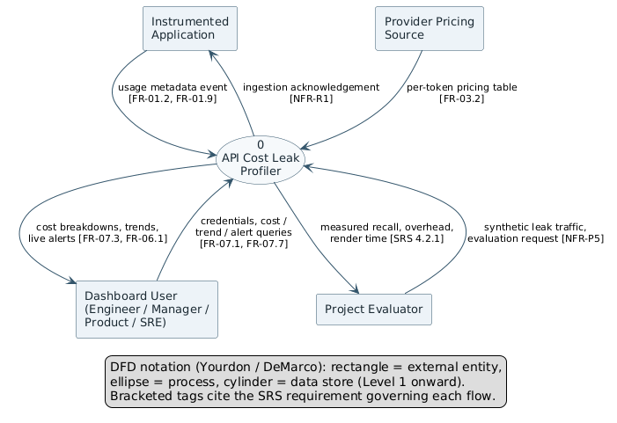
Figure 1 — System context (Data Flow Diagram, Level 0)

2.2 System Architecture Overview
The system is organised into six horizontal tiers. The separation is not merely presentational: it enforces the two properties the product depends on. Because the instrumentation tier communicates with the business-logic tier only by asynchronous emission, no profiler work can appear in the application's critical path; and because the analytics tier is reached over an internal HTTP contract rather than by direct invocation, the statistical and semantic detectors can be unavailable without the rule-based detectors ceasing to function.
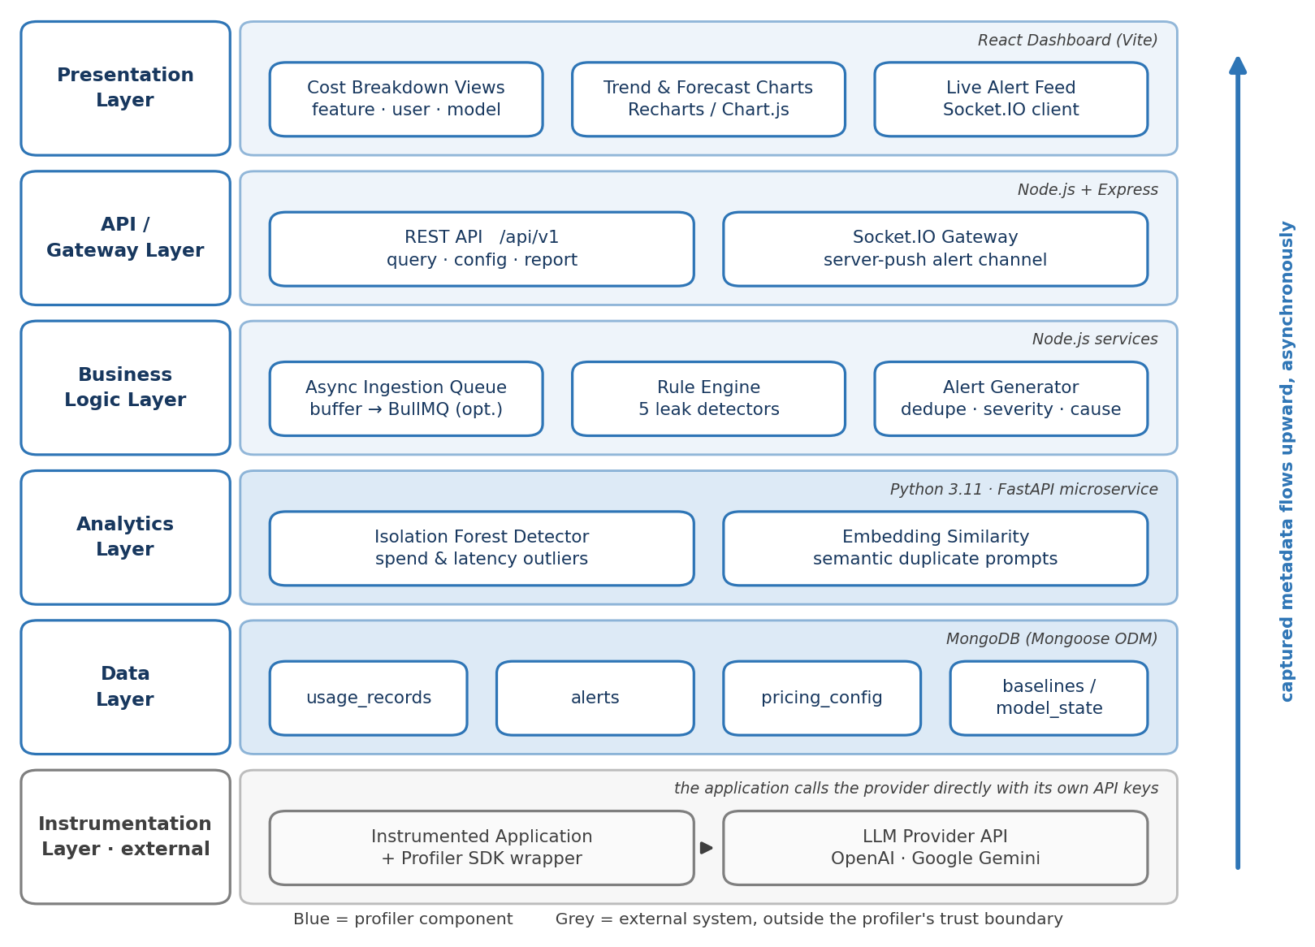
Figure 2 — Layered system architecture
Table 6 — Architectural tiers and their responsibilities
Tier | Technology | Responsibility
Presentation | React 18 (Vite), Recharts / Chart.js, Socket.IO client | Cost breakdown by feature, user and model; trend and comparison charts; live alert feed; alert detail with root-cause evidence; configuration screens.
API / Gateway | Node.js LTS, Express | Versioned REST surface under /api/v1 for ingestion, query, configuration and report export; Socket.IO gateway for server-pushed alerts.
Business logic | Node.js services | Asynchronous ingestion queue and validation; cost computation and attribution; the five-detector rule engine; alert generation with deduplication, severity assignment and root-cause assembly.
Analytics | Python 3.11, FastAPI, scikit-learn, sentence embeddings | Isolation Forest scoring of spend and latency feature vectors; embedding-based semantic similarity for near-duplicate prompt detection; periodic model refit.
Data | MongoDB 7.x with Mongoose | Collections usage_records, alerts, pricing_config and baselines; indexes supporting the time-window and tag-dimension queries the dashboard issues.
Instrumentation  (external) | Node.js SDK wrapper | Wraps the application's provider client, captures metadata after the call returns, and emits it asynchronously. Resident in the customer application, outside the profiler's trust boundary.

Figure 3 refines the layered view into components and the interfaces through which they collaborate. Each component is labelled with the requirement group that it realises, and the interfaces are those specified in Section 3: the API gateway offers IUsageIngest (CI-02), IQuery (CI-03) and IAlertStream (CI-04), and the analytics service is reached only through IAnalytics (SI-04).
Two properties of the structure follow directly from the figure. First, the instrumentation SDK only observes: the host application calls the LLM provider directly with its own credentials, and the profiler never proxies, retries or blocks that call and never handles provider credentials (NFR-SF-03, NFR-S-01). Second, the Analytics Client in the business-logic tier places the analytics service behind a circuit breaker: if the service is unreachable, the breaker opens and the rule engine continues alone (FR-405, FR-505), with the degraded state shown on the dashboard (FR-708).
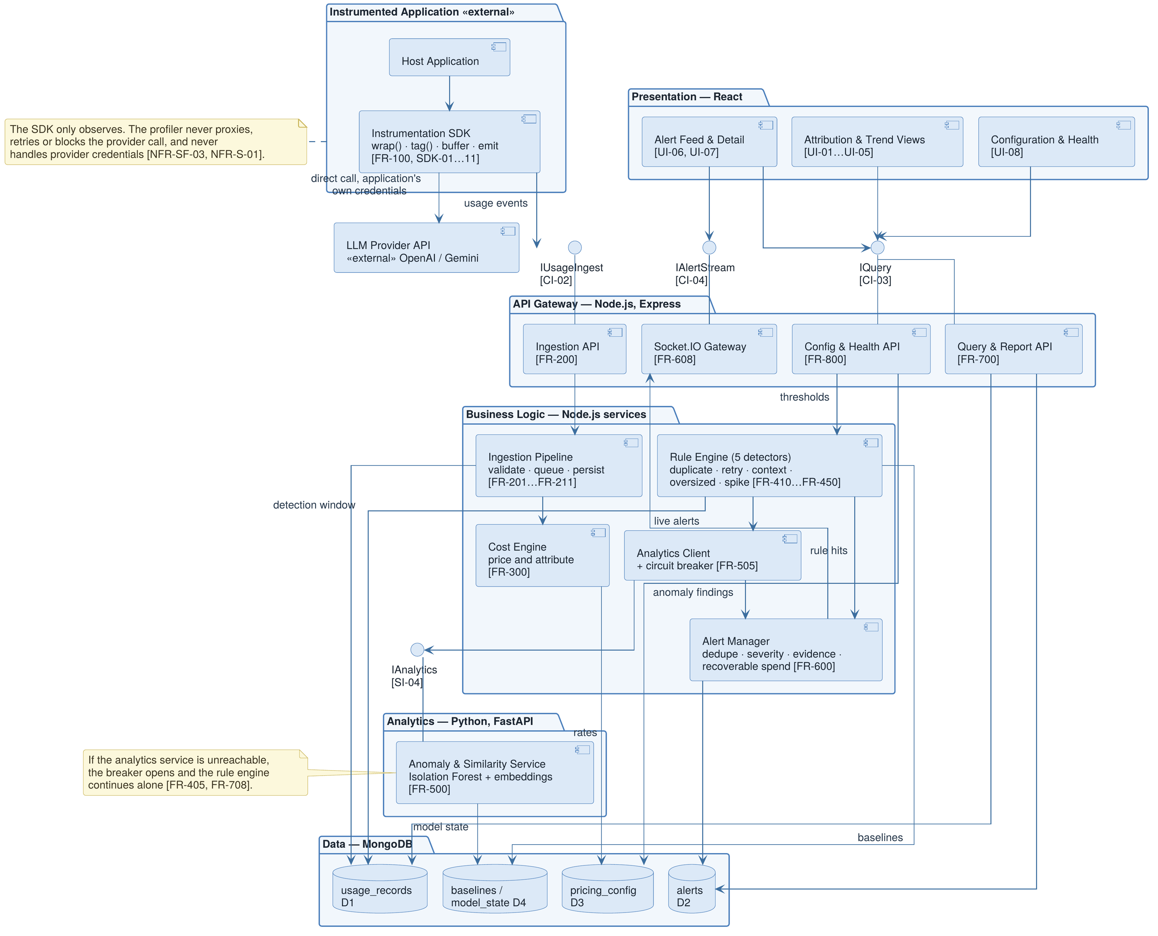
Figure 3 — Component diagram

2.3 Data Flow Overview
Figure 4 decomposes the system into six processes and four data stores. Two paths through it are worth stating explicitly. The ingestion path (1.0 → 2.0 → D1) runs on every observed call and is the only part of the system whose throughput is driven by the instrumented application's traffic; it is therefore the path against which the performance requirements of Section 5.1 are written. The detection path (3.0 and 4.0 → 5.0 → D2 → 6.0) runs on windows of accumulated records rather than on individual calls, which is what allows the statistical detectors to be comparatively expensive without affecting ingestion.
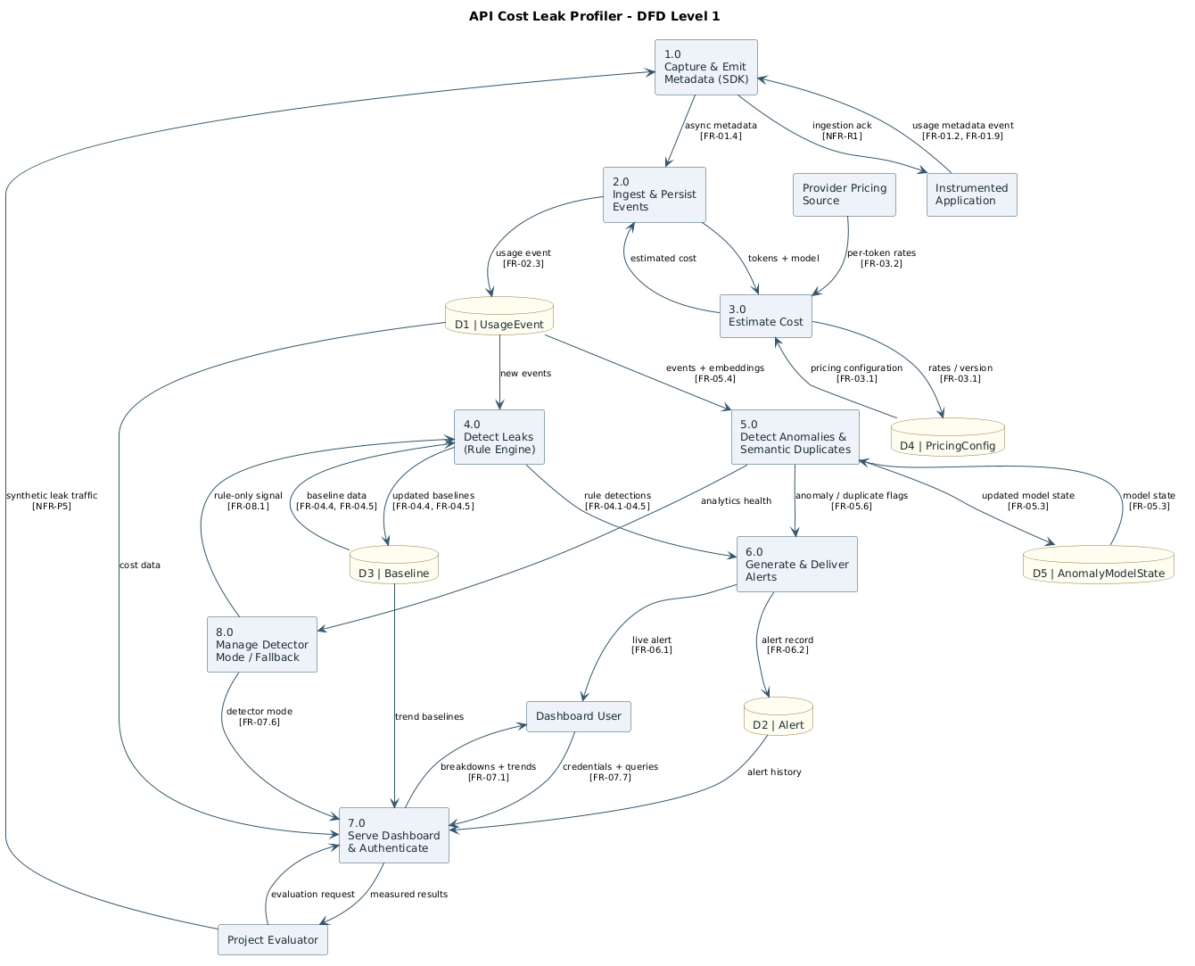
Figure 4 — Process decomposition (Data Flow Diagram, Level 1)
Table 7 — Process catalogue
Process | Name | Function
1.0 | Capture and Validate Metadata | Accepts emitted events, validates them against the usage-event schema, rejects or quarantines malformed records, and applies redaction policy.
2.0 | Compute Cost and Attribute | Prices input and output tokens against the active rate entry for the model, and writes the priced, tagged record to D1.
3.0 | Rule-Based Leak Detection | Evaluates the five deterministic detectors over recent windows of D1 and emits rule hits with category and evidence.
4.0 | Statistical and Semantic Analysis | Scores feature vectors with the Isolation Forest, computes embedding similarity for near-duplicate detection, and maintains rolling baselines in D4.
5.0 | Generate and Dispatch Alerts | Merges rule hits and anomaly scores, deduplicates against open alerts, assigns severity, estimates recoverable spend, and persists to D2.
6.0 | Serve Queries and Reports | Answers dashboard queries over D1 and D2, streams new alerts over the Socket.IO channel, and produces exported reports.

Table 8 — Data store catalogue
Store | Collection | Contents and retention
D1 | usage_records | One document per observed call: metadata, computed cost, attribution tags. The system of record for all attribution. Retained per the configured window (NFR-D-01).
D2 | alerts | Raised leaks with category, severity, evidence references, estimated recoverable spend and lifecycle state.
D3 | pricing_config | Provider rate table, versioned with effective-from timestamps so that historical records remain priced at the rate in force when they were observed.
D4 | baselines / model_state | Rolling statistics per dimension and the serialised Isolation Forest, refit on schedule.

Figures 5 and 6 trace the two paths described above as message sequences. Figure 5 follows a single call from the instrumented application through capture, ingestion and cost attribution (UC-01 to UC-03); Figure 6 follows a detection cycle through analysis, alert generation and triage (UC-04, UC-05, UC-07 and UC-08). The identifiers in square brackets give the requirement that governs each message.
In Figure 5 the sequence divides at the point where the SDK returns the provider's response. Everything before that point runs inside the application's request path and adds less than 5 ms (NFR-P-01); building the event, applying redaction, buffering and posting to the ingestion endpoint all happen off the request path. The endpoint acknowledges with 202 Accepted without waiting for the write (FR-204); if the queue is full or the event is invalid it answers 429 with Retry-After or a 4xx error, and the SDK backs off and then discards, counting the loss (FR-207, FR-208, SDK-09). The pipeline discards an event whose requestId has already been seen, so that cost is counted once (FR-206); a new event is priced at the rate in force at its timestamp (FR-302) and written to usage_records, the system of record for all attribution (FR-306).
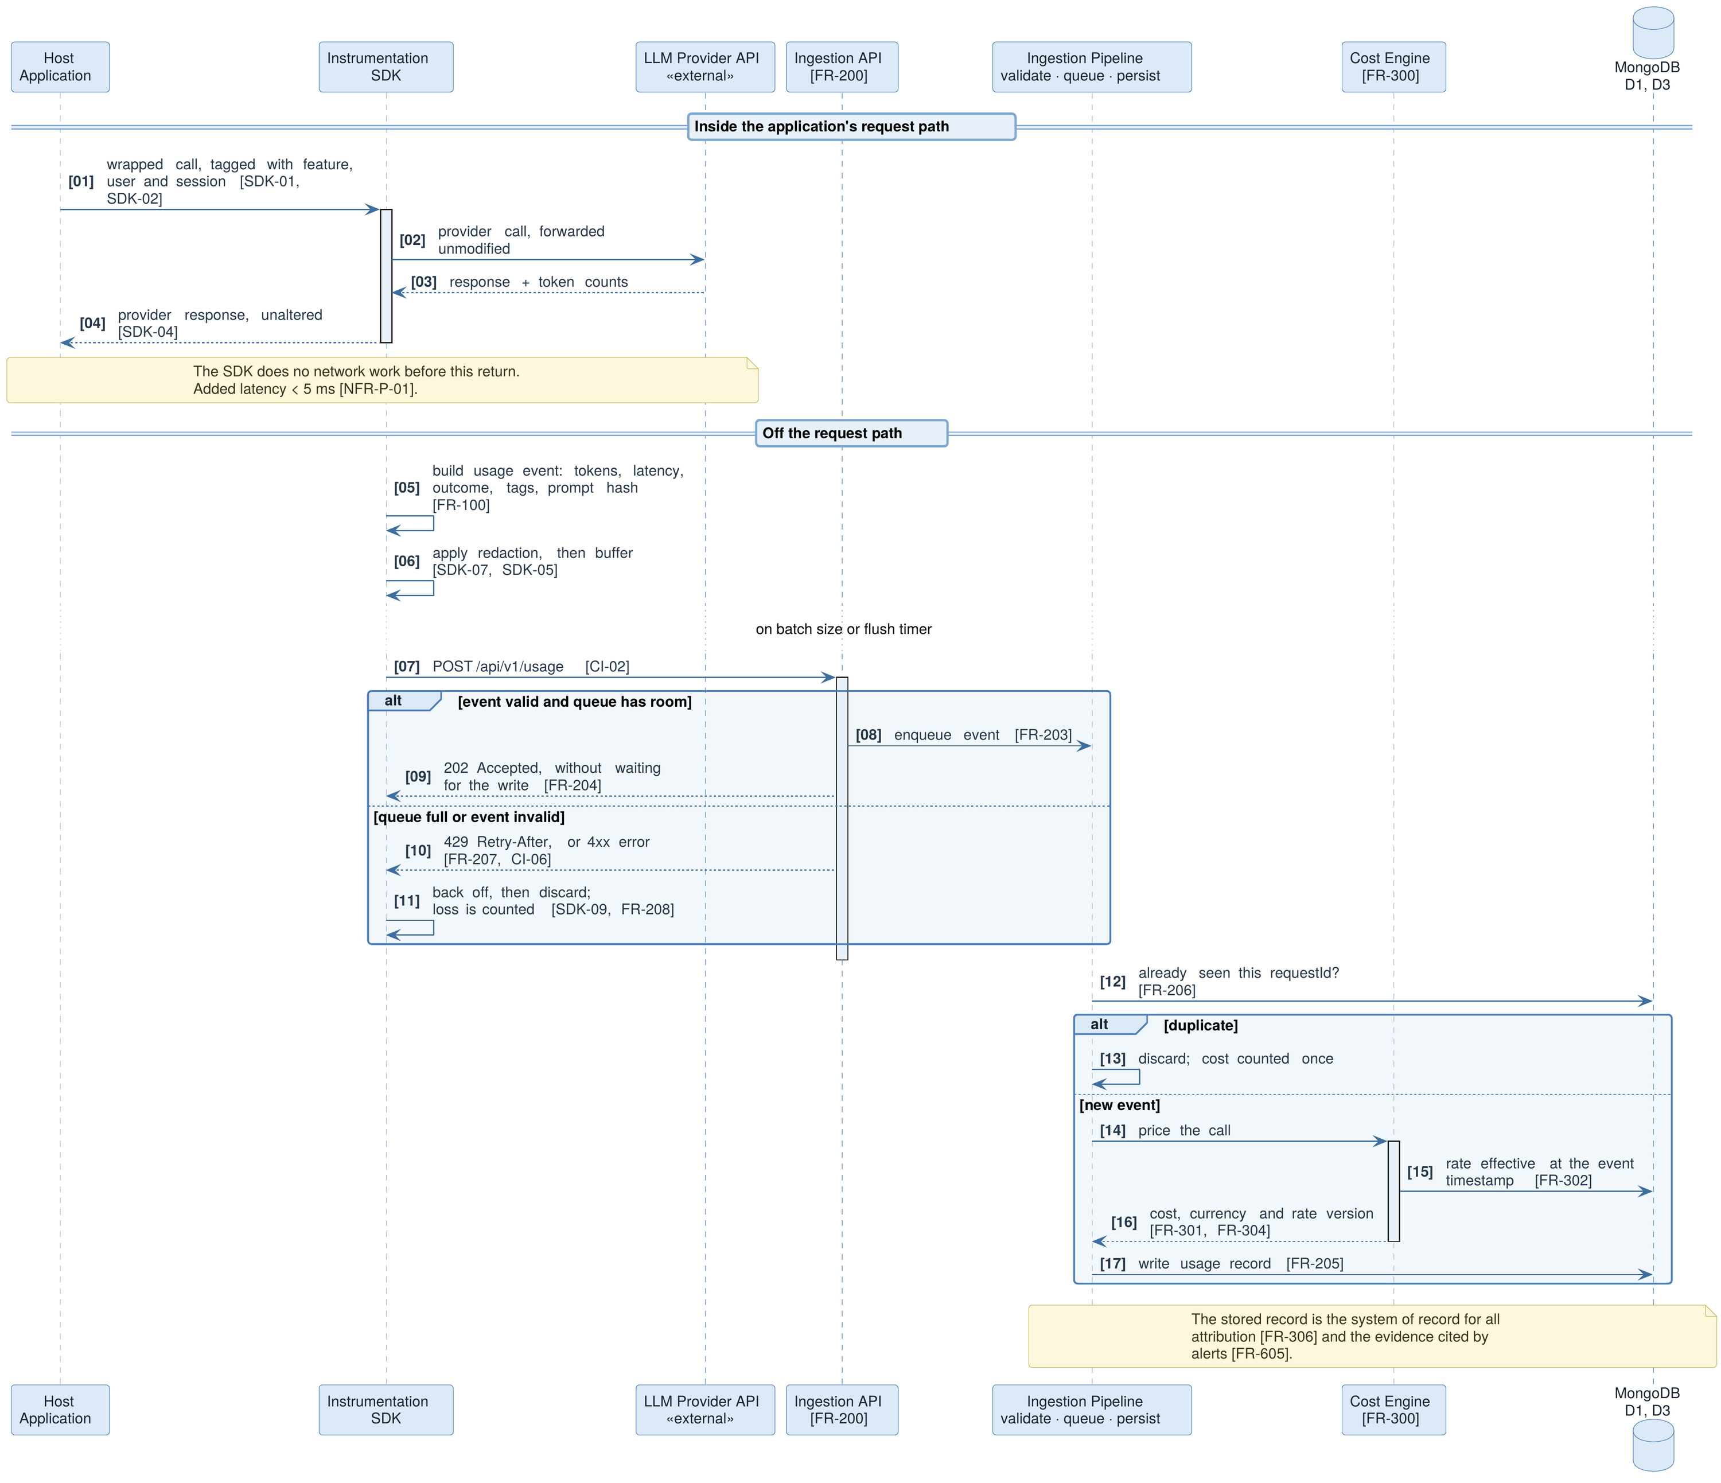
Figure 5 — Sequence diagram 1: instrumentation, ingestion and cost attribution (UC-01 → UC-03)
In Figure 6 a detection cycle begins on the scheduler's trigger (FR-401). The rule engine reads the recent window and the rolling baselines, runs the five detectors and updates the baselines (FR-410 to FR-450, FR-451). It then calls the analytics service for Isolation Forest scoring and embedding similarity (FR-501, FR-502); if the service is unavailable or times out, the circuit breaker opens and the cycle continues with rule hits alone (FR-405, FR-505). The Alert Manager then checks whether an alert is already open for the category and dimension: if so it updates the evidence and recoverable spend, otherwise it sets severity and recoverable spend, writes the root cause and recommendation, and saves the alert (FR-601 to FR-607). Each new alert is pushed over Socket.IO (FR-608) within 2 s (NFR-P-03) and remains retrievable by query (FR-611). In triage (UC-08) the engineer opens the alert, sees the usage records cited as evidence (FR-704) and acknowledges it; alerts are dismissed, never deleted (FR-609, BR-03).
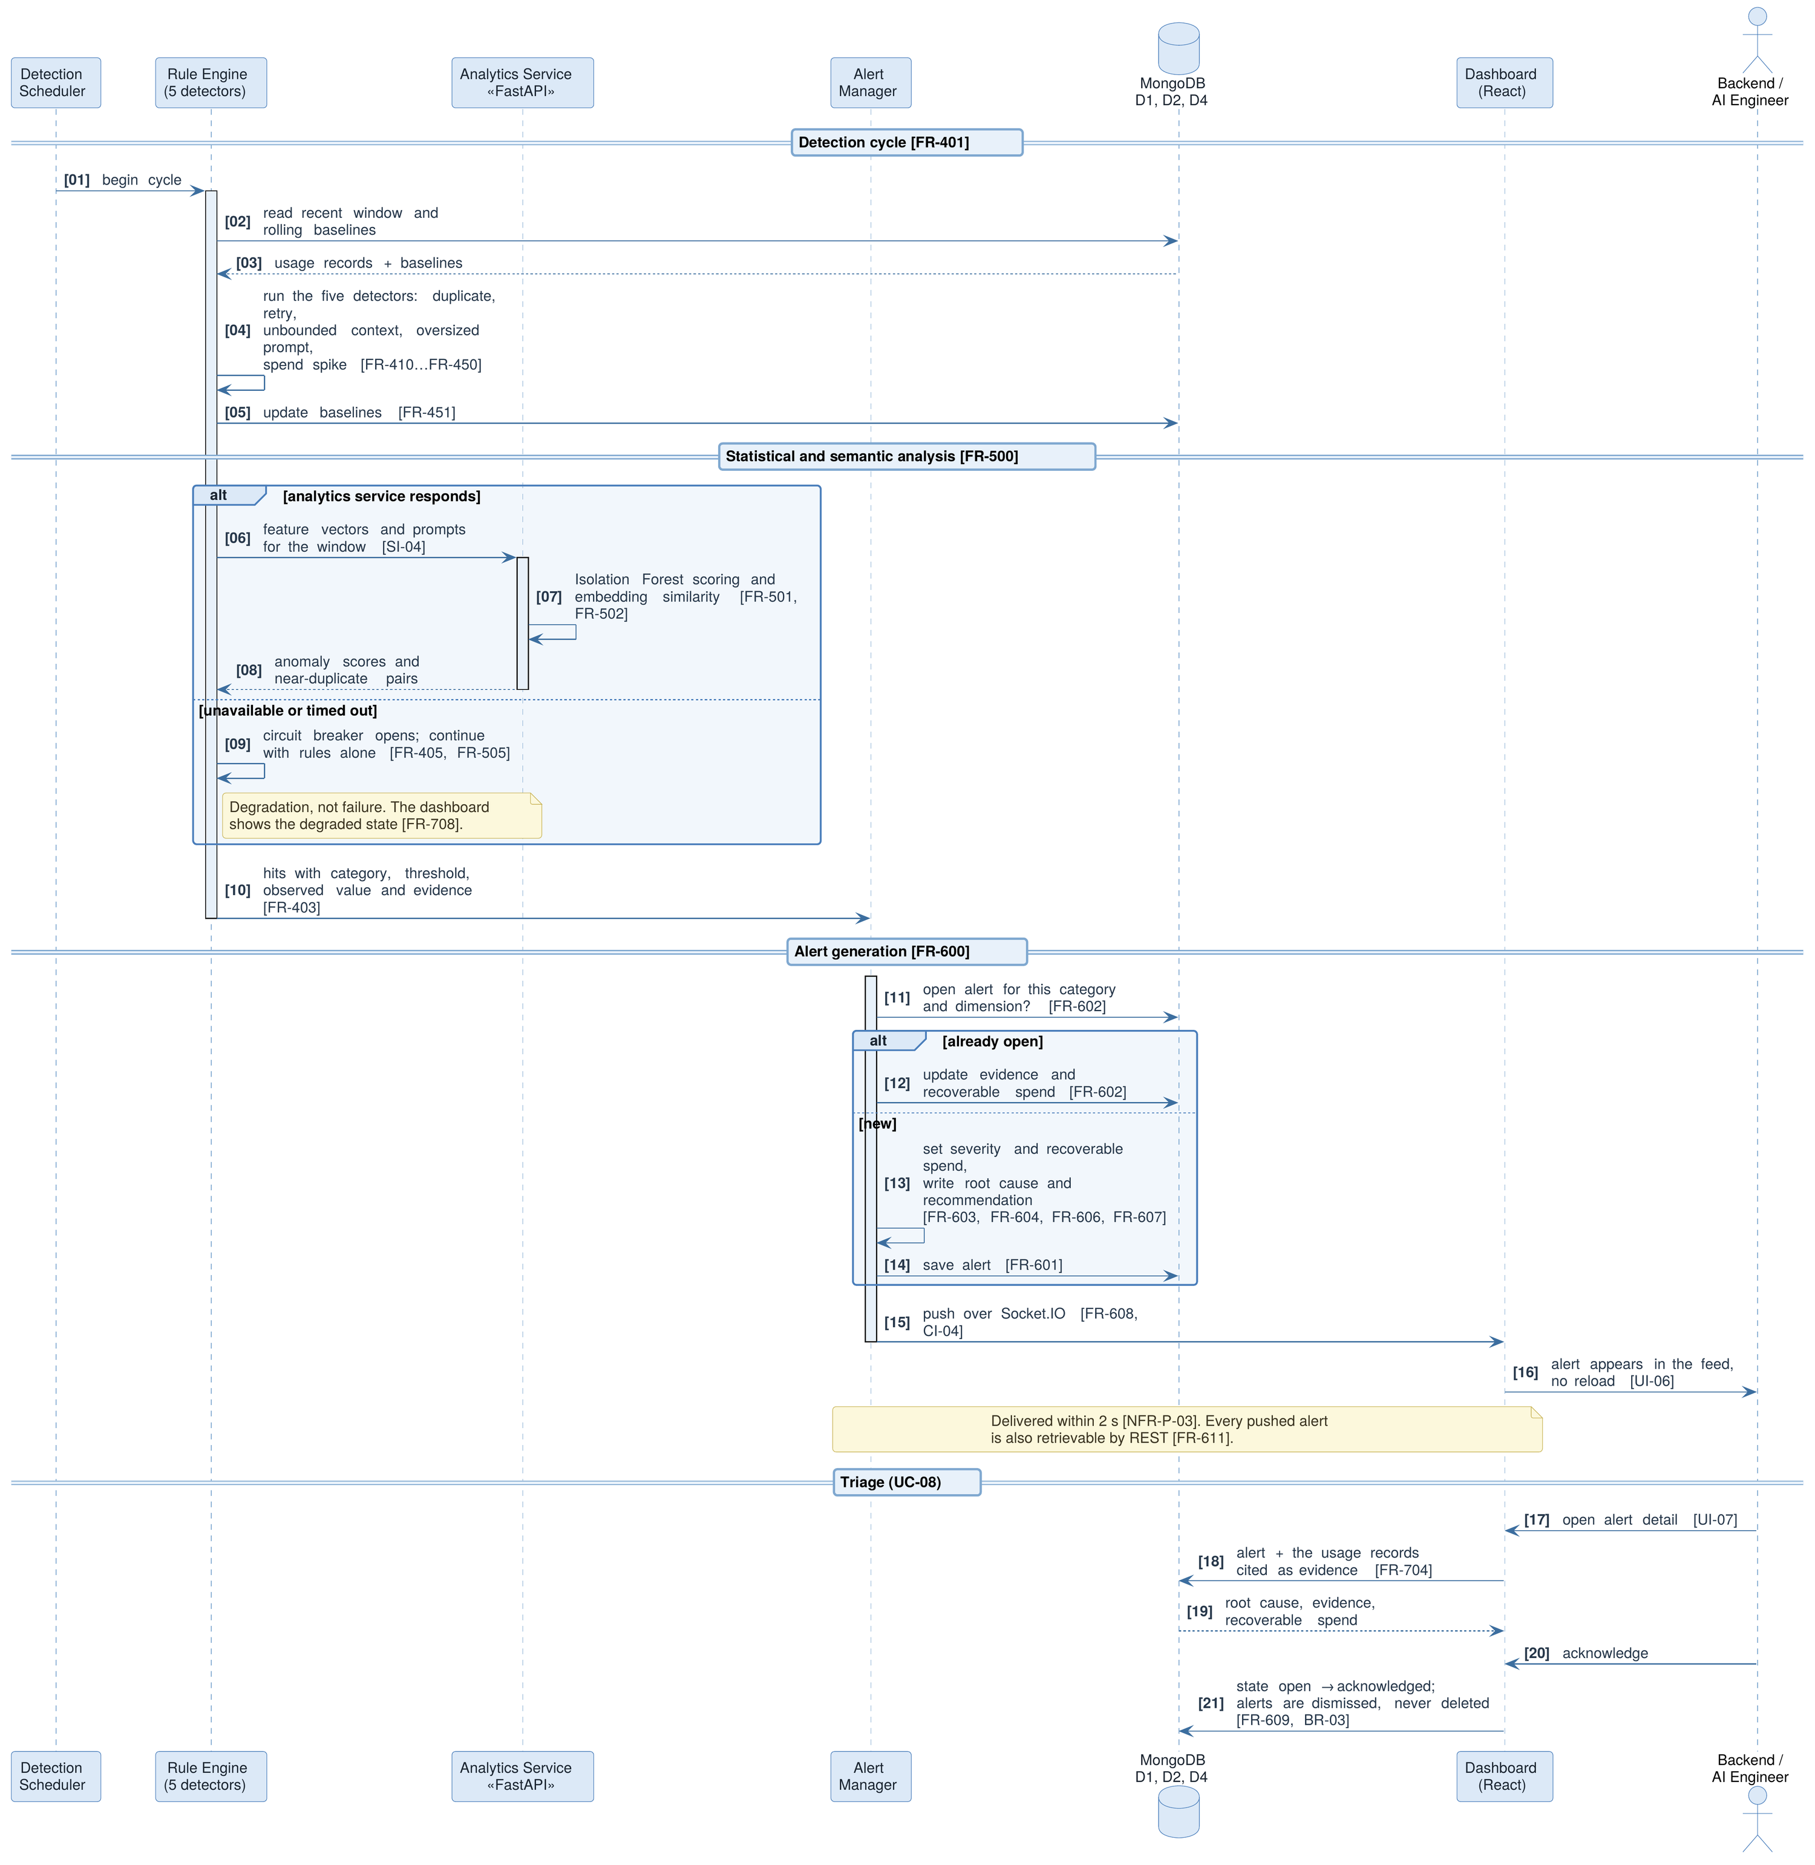
Figure 6 — Sequence diagram 2: leak detection, alerting and triage (UC-04, UC-05, UC-07, UC-08)

2.4 Product Functions
The functional requirements of Section 4 are organised into eight groups. The table below summarises them and gives the group priority; individual requirements within a group may carry a lower priority than the group as a whole.
Table 9 — Major function groups
Group | Function | Summary | Priority
FR-100 | SDK instrumentation and metadata capture | Wrap the provider client; capture token counts, model, latency and outcome; carry developer-supplied feature, user and session tags; emit asynchronously without blocking. | Critical
FR-200 | Asynchronous ingestion and persistence | Accept, validate, buffer and durably store emitted events; apply back-pressure and bounded loss policy under overload. | Critical
FR-300 | Cost computation and attribution | Price each call from the versioned rate table; roll costs up by feature, user, model and time window. | Critical
FR-400 | Rule-based leak detection | Five deterministic detectors: duplicate prompts, retry loops, unbounded context, oversized prompts, spend spikes. | Critical
FR-500 | Statistical and semantic analytics | Isolation Forest anomaly scoring and embedding-based near-duplicate detection in a separate Python service, with graceful degradation. | High
FR-600 | Alert generation and notification | Deduplicate, prioritise, quantify recoverable spend, attach evidence, and push live to connected clients. | Critical
FR-700 | Dashboard, visualisation and reporting | Attribution views, trends, alert feed and detail, and report export. | High
FR-800 | Configuration and administration | Detection thresholds, rate table maintenance, retention policy, health status. | Medium

2.5 User Classes and Characteristics
Table 10 — User classes
User class | Profile and frequency of use | Primary needs
Backend / AI engineer  (primary) | Builds and maintains the LLM-backed features. Fluent in the codebase; installs and configures the SDK. Uses the dashboard several times a week, and immediately after receiving an alert. | Attribution precise enough to identify the offending code path; alerts that cite concrete requests; confidence that instrumentation is not degrading the product.
Engineering manager / FinOps  (primary) | Accountable for the API budget. Not necessarily fluent in the codebase. Uses the dashboard weekly and at month end. | Spend by feature over time; early warning of budget departure; an exportable figure and a defensible explanation of it.
DevOps / SRE  (secondary) | Operates the deployment. Configures thresholds and retention; watches system health. Occasional use. | Reliable operation under load; visibility into ingestion lag and analytics availability; threshold tuning without redeployment.
Instrumented application  (system actor) | The customer application itself, emitting metadata on every LLM call. Continuous. | An SDK that never throws into the caller, never blocks, and bounds its own memory use.

Release 1.0 does not distinguish these classes by privilege — the dashboard is protected by a single shared credential (NFR-S-04). The distinction is nonetheless recorded here because it drives the information architecture of Section 3.1 and is the basis on which role-based access control would be added (Section 2.10).

2.6 Operating Environment
Table 11 — Operating environment
Element | Requirement
Client | Current versions of Chrome, Edge or Firefox, with JavaScript and WebSocket support enabled. Minimum viewport 1280 x 720 for the full dashboard layout.
Application server | Node.js 20 LTS or later, on Linux, macOS or Windows. The reference deployment is Linux.
Analytics service | Python 3.11 or later with FastAPI, scikit-learn and a sentence-embedding model; runs as a separate process, co-located with the application server in the reference deployment.
Database | MongoDB 7.x, either local or MongoDB Atlas. The evaluation deployment uses the Atlas free tier, whose limits are the basis of ASM-06.
Optional queue | Redis 7.x, required only when BullMQ buffering is enabled (FR-203).
Reference hardware | A development-class machine with 4 or more cores, 8 GB RAM and 10 GB free disk is sufficient for the demonstration workload of 10,000 usage records.
Instrumented application | Any Node.js application using the official OpenAI or Google Gemini client libraries. Network egress to the profiler ingestion endpoint is required; the profiler requires no inbound access to the application.

2.7 Design and Implementation Constraints
Table 12 — Design and implementation constraints
ID | Constraint | Rationale
CON-01 | The profiler shall not be positioned as a proxy or gateway on the provider call path. | A proxy adds a network hop and a failure mode to a revenue path; the product's core claim of latency neutrality would be forfeited.
CON-02 | The profiler shall never receive, store or require the application's provider API credentials. | Eliminates the most damaging possible breach of the profiler and removes a major barrier to adoption.
CON-03 | All metadata transfer from the SDK shall be asynchronous with respect to the instrumented call. | Synchronous emission would put profiler availability on the application's critical path.
CON-04 | Costs shall be derived from published provider rates held in pricing_config, not from a billing API. | Neither provider exposes a per-request billing feed; this is the only tractable approach and is the source of ASM-03.
CON-05 | The implementation shall use the MERN stack with a Python FastAPI analytics microservice. | Fixed by the project plan (P4) and by the course competencies the project is required to demonstrate.
CON-06 | Rule-based detection shall not depend on the availability of the analytics microservice. | Preserves a useful product when the Python service is down, and keeps the two workstreams independently deliverable.
CON-07 | The reference deployment is single-instance; horizontal scaling is not a requirement of release 1.0. | Academic scope. The queue-based ingestion design does not preclude later scale-out.
CON-08 | Anomaly models shall be trained per deployment on that deployment's own history; no pre-trained or cross-tenant model is used. | No labelled corpus of LLM cost anomalies exists, and spend profiles are highly application-specific. Implies the cold-start behaviour of FR-504.
CON-09 | Provider support in release 1.0 is limited to OpenAI and Google Gemini, text and chat completions only. | Bounded integration and testing effort within a 16-week schedule.
CON-10 | Prompt text shall not be persisted in full by default; detection operating on prompt content shall use hashes or embeddings. | Prompts routinely contain user data. Avoids making the profiler a secondary store of sensitive content (NFR-S-02).

2.8 User Documentation
The following shall be delivered with release 1.0. Documentation is treated as a deliverable rather than a by-product because the SDK integration step is the point at which an evaluator or adopter first encounters the system.
- SDK integration guide — installation, the minimal three-line wrapping example, the tagging API, configuration options, and the failure semantics the SDK guarantees.
- Dashboard user guide — a walkthrough of each screen, an explanation of each leak category and how to read its evidence, and guidance on interpreting severity.
- Configuration reference — every threshold, its default, its units and the effect of changing it.
- Deployment and operations note — prerequisites, environment variables, start-up order, health endpoints, and the procedure for updating the provider rate table.
- Demonstration script — the scripted leak-injection scenario used for the final evaluation, with expected outputs.

2.9 Assumptions and Dependencies
Table 13 — Assumptions
ID | Assumption | Effect if false
ASM-01 | Providers continue to return token counts in the API response usage object. | Cost computation would require client-side tokenisation, reducing accuracy and adding CPU cost to the SDK.
ASM-02 | Developers are willing to add feature and user tags at call sites. | Attribution degrades to model-level only, which is the granularity the provider console already offers.
ASM-03 | Published per-token rates, applied to reported token counts, approximate the billed amount closely enough to support decisions. | Computed costs would be indicative only; the recoverable-spend estimates on alerts would lose credibility.
ASM-04 | Real deployments contain enough traffic for statistical baselines to be meaningful within the observation window. | Anomaly detection would be noise-dominated; the rule detectors would carry the product.
ASM-05 | The five chosen leak categories cover the majority of avoidable spend in typical LLM applications. | The system would report correctly but miss the dominant source of waste in a given application.
ASM-06 | The MongoDB Atlas free tier is adequate for the evaluation dataset. | The demonstration would need a local MongoDB instance; no design change.
ASM-07 | Clocks on the instrumented application and the profiler host are synchronised to within a few seconds. | Time-window detectors, particularly retry-loop detection, would produce false results.

Table 14 — External dependencies
ID | External dependency | Criticality
DEP-01 | OpenAI and Google Gemini client libraries, and the stability of their response shapes. | Critical
DEP-02 | Published provider price lists, and notification of changes to them. | High
DEP-03 | MongoDB / Mongoose, and MongoDB Atlas for the evaluation deployment. | Critical
DEP-04 | scikit-learn and the chosen sentence-embedding model. | High
DEP-05 | Socket.IO for the server-push channel. | High
DEP-06 | Redis, only when BullMQ buffering is enabled. | Low
DEP-07 | Availability of a representative instrumented sample application for evaluation. | High

2.10 Apportioning of Requirements
The following capabilities are recognised as valuable and are excluded from release 1.0 by deliberate decision. They are recorded so that the boundary of this SRS is understood as a plan rather than an oversight, and so that the extension points noted in Section 5.4 can be designed for.
Table 15 — Requirements apportioned to future releases
Deferred capability | Reason for deferral | Target
Predictive cost forecasting (for example, gradient-boosted monthly projection) | Requires a longer history than the project window provides, and depends on the attribution pipeline being stable first. | Release 2.0
Additional providers (Anthropic, Azure OpenAI, self-hosted models) and non-text modalities | Each provider adds an integration and a distinct rate structure; CON-09 bounds the effort. | Release 2.0
Automatic remediation — cache insertion, prompt compression, model downgrade | Requires the profiler to act on the request path, which CON-01 forbids for release 1.0. | Under evaluation
Deep learning anomaly detectors (autoencoder or LSTM over spend series) | The literature (P2) indicates these outperform Isolation Forest only with substantially more data than will be available. | Release 2.0
Role-based access control and multi-tenancy | Not required for single-team evaluation; adds an authentication and data-isolation surface disproportionate to the academic scope. | Release 2.0
Metrics export to Prometheus and Grafana dashboards | Valuable for operational adoption; not needed to demonstrate the central claim. | Release 1.1
Native CI integration that fails a build on projected cost regression | Depends on a stable public API and a longer baseline period. | Release 2.0

3. EXTERNAL INTERFACE REQUIREMENTS

3.1 User Interfaces
The user interface is a single-page React application. Its information architecture follows the two questions the product exists to answer, in order: where is the money going, and what of it is being wasted. Attribution views therefore precede alert views in the navigation, and every alert links back into the attribution view filtered to the evidence behind it.
Table 16 — Dashboard screens
ID | Screen | Required content
UI-01 | Overview | Total spend for the selected window; change against the preceding equivalent window; count of open alerts by severity; sparkline of spend over the window; the three most expensive features.
UI-02 | Cost by feature | Ranked table and chart of spend per feature tag, with call count, mean cost per call and token totals; drill-down to the underlying records.
UI-03 | Cost by user | Ranked spend per end-user identifier over the window, with the same drill-down.
UI-04 | Cost by model | Spend and call volume per model, with input and output token split, supporting the model-mix question directly.
UI-05 | Trends | Time series of spend at a selectable granularity, overlaid with the rolling baseline and with markers where alerts were raised.
UI-06 | Alert feed | Reverse-chronological list of alerts with category, severity, estimated recoverable spend and state; filterable by category and severity; updates live without reload.
UI-07 | Alert detail | The full root-cause explanation: which rule or model fired, the threshold or score, the contributing requests as evidence, the recoverable-spend estimate and its basis, and the recommended action.
UI-08 | Configuration and health | Detection thresholds with their defaults; rate table view and edit; retention setting; ingestion lag and analytics-service availability indicators.

The following apply across all screens. UI-09: the interface shall be usable at a viewport width of 1280 px and shall remain legible down to 1024 px. UI-10: every monetary value shall be displayed with its currency and the window it covers, so that no figure on screen is ambiguous when read in isolation or in a screenshot. UI-11: any view whose data is not yet available shall render a skeleton or explanatory empty state rather than an indefinite spinner, and shall never block interaction with the rest of the page. UI-12: text and background combinations shall meet a contrast ratio of at least 4.5:1, and severity shall be conveyed by label as well as by colour.

3.2 Hardware Interfaces
The system has no direct hardware interfaces. It neither reads from nor writes to sensors, peripherals or specialised devices, and it requires no GPU: the embedding model specified in FR-502 is small enough to run acceptably on CPU for the volumes in scope. Hardware enters the specification only as the reference deployment profile recorded in Section 2.6, which establishes the platform on which the performance requirements of Section 5.1 are to be measured.

3.3 Software Interfaces
Table 17 — Software interfaces
ID | Interface | Direction and contract
SI-01 | OpenAI Node client library | The SDK shall wrap the client's chat and text completion methods, read the prompt_tokens, completion_tokens and model fields from the response usage object, and return the provider response to the caller unmodified.
SI-02 | Google Gemini client library | As SI-01, mapping the equivalent usageMetadata fields. The SDK shall normalise both providers onto the single internal usage-event schema of Appendix B.
SI-03 | MongoDB via Mongoose | All persistence. Schemas shall be declared with validation, and the indexes required by FR-702 shall be created at start-up if absent.
SI-04 | Analytics microservice (FastAPI) | Node.js is the client. Synchronous HTTP over the loopback or internal network, JSON request and response, with a configurable timeout and the fallback behaviour required by FR-505.
SI-05 | scikit-learn | Isolation Forest training and scoring inside the analytics service. The fitted model shall be serialised to D4 so that a service restart does not require a refit.
SI-06 | Sentence-embedding model | Loaded in-process by the analytics service. Prompt text shall be embedded and discarded within the request; only the vector or its similarity result leaves the function.
SI-07 | Redis with BullMQ (optional) | Ingestion buffering when enabled. The system shall start and operate correctly with this dependency absent.
SI-08 | Socket.IO | Server-to-client alert channel, namespaced, with automatic reconnection and a catch-up fetch of alerts raised while a client was disconnected.

3.4 Communications Interfaces
CI-01. All external communication shall use HTTP/1.1 or later, with JSON request and response bodies encoded in UTF-8. The reference deployment shall serve the dashboard and API over TLS; plain HTTP shall be permitted only for loopback development.
CI-02. The ingestion endpoint shall be POST /api/v1/usage, accepting either a single usage event or a batch array, and shall respond within the budget set by NFR-P-02 with an acknowledgement that does not await persistence.
CI-03. The query surface shall be versioned under /api/v1 and shall expose, at minimum, aggregate cost queries filterable by time window, feature, user and model; usage-record retrieval; alert listing and alert detail; configuration read and write; and report export. Breaking changes shall require a new version prefix.
CI-04. Live alerts shall be delivered over a Socket.IO channel. On connection a client shall receive the currently open alerts; thereafter it shall receive each new alert as an event. The channel shall be treated as an optimisation: every alert available by push shall also be retrievable by REST, so that a client that has lost the socket is never left with an incomplete picture.
CI-05. The internal Node-to-Python contract shall be a documented JSON schema in both directions, versioned independently of the public API, and shall be exercised by contract tests on both sides as required by Section 8.1.
CI-06. Requests to the ingestion endpoint shall be rejected with a 4xx status and a machine-readable error body if they fail schema validation; the SDK shall treat such rejections as non-retryable and shall record them for diagnostic reporting rather than resending indefinitely.

3.5 Programmatic Interface — the Instrumentation SDK
The SDK is the system's most important external interface. It is the only component that executes inside the user's application, and the point at which adoption succeeds or fails: integration that is not close to trivial will not be performed, and an SDK that can affect the host application will not be trusted in production.
const { profiler } = require('@aclp/sdk');

profiler.init({
endpoint: process.env.ACLP_ENDPOINT, // profiler ingestion URL
service: 'checkout-api', // logical service name
sampleRate: 1.0, // 0.0 - 1.0
redact: 'hash' // 'hash' | 'none' | 'drop'
});

// wrap the existing provider client - the only required change
const openai = profiler.wrap(new OpenAI({ apiKey: process.env.OPENAI_API_KEY }));

// tag the call so its cost can be attributed
const reply = await openai.chat.completions.create(
{ model: 'gpt-4o-mini', messages },
profiler.tag({ feature: 'support-summary', userId: user.id, sessionId: sid })
);

Table 18 — Instrumentation SDK interface requirements
ID | Requirement | Priority
SDK-01 | The SDK shall expose a wrap() function that accepts a provider client instance and returns an object presenting an identical interface, so that no call site requires modification other than the addition of tags. | Critical
SDK-02 | The SDK shall expose a tag() helper accepting at least feature, userId and sessionId, and shall permit arbitrary additional string-valued tags. | Critical
SDK-03 | The SDK shall capture metadata only after the provider response has been returned to the caller, and shall perform no network I/O of its own before that point. | Critical
SDK-04 | The SDK shall never propagate an exception into the calling application. Any internal failure shall be caught, counted and optionally logged; the provider response or error shall pass through unaltered. | Critical
SDK-05 | The SDK shall buffer events in memory up to a configurable bound and flush them in batches on a timer or when the batch size is reached. | High
SDK-06 | When the buffer is full the SDK shall discard the oldest events and increment a dropped-event counter, rather than growing without limit or blocking the caller. | Critical
SDK-07 | The SDK shall apply the configured redaction policy before transmission: hash sends a stable hash of the prompt, drop sends no prompt-derived field, none sends the prompt text and shall not be the default. | Critical
SDK-08 | The SDK shall support probabilistic sampling by sampleRate, and shall record the effective rate on each emitted event so that costs can be correctly extrapolated. | Medium
SDK-09 | The SDK shall degrade silently when the ingestion endpoint is unreachable: it shall retry with bounded exponential back-off, then discard, and shall surface the condition only through its counters. | High
SDK-10 | The SDK shall expose a flush() returning a promise, and shall register a process-exit handler, so that short-lived processes do not lose their final batch. | Medium
SDK-11 | The SDK shall record its own version and the detected provider library version on each event, to support diagnosis of schema drift (DEP-01). | Low

4. SYSTEM FEATURES
This section specifies the functional requirements of release 1.0, organised into the eight feature groups introduced in Section 2.4. Each group is presented as a short description with its group priority, a summary of the stimuli it responds to, and a table of individually identified requirements. Requirements are stated so that each can be verified independently; Appendix A traces every one of them to its source and to the method by which it will be verified.

4.1 FR-100 Metadata Capture and Emission

Description and priority
Everything the system knows originates here. The instrumentation SDK observes each LLM call made by the host application and produces a usage event describing it. The interface contract and the failure semantics of the SDK are specified in Section 3.5; this group specifies what must be observed. Group priority: Critical — no other capability has meaning without it.

Stimulus and response sequences
Stimulus and response sequences
Stimulus | System response
The instrumented application invokes a wrapped provider method. | The wrapper forwards the call unchanged, records a monotonic start time, and awaits the provider.
The provider returns a successful response. | The wrapper computes elapsed time, extracts token counts and model, assembles the usage event with the tags supplied at the call site, hands it to the emission buffer, and returns the untouched provider response to the caller.
The provider returns an error, or the call times out. | The wrapper records the outcome and error class, emits a usage event marked as a failure, and re-throws the provider error to the caller exactly as received.
The caller requests a streamed response. | The wrapper passes the stream through and finalises the usage event only when the stream terminates, using the token counts reported at completion.

Functional requirements
Table 19 — FR-100 — metadata capture requirements
ID | Requirement | Priority
FR-101 | The system shall capture, for every observed call, the provider name and the model identifier exactly as reported by the provider response. | Critical
FR-102 | The system shall capture input (prompt) and output (completion) token counts separately, taking them from the provider's reported usage object rather than estimating them. | Critical
FR-103 | The system shall capture the wall-clock duration of the provider call, measured immediately around the awaited call and excluding any profiler work. | High
FR-104 | The system shall capture the outcome of each call as one of success, provider error, timeout or rate-limited, together with the provider status code where one is available. | High
FR-105 | The system shall capture a UTC timestamp with millisecond resolution for each call, taken at call initiation. | Critical
FR-106 | The system shall assign each observed call a globally unique request identifier, generated by the SDK, which serves as the idempotency key for ingestion (FR-206) and as the evidence reference on alerts (FR-605). | Critical
FR-107 | The system shall carry the feature, userId and sessionId tags supplied at the call site. Where a tag is absent the event shall be recorded as explicitly untagged rather than silently omitted, so that attribution coverage can be measured against the 95% target of NFR-Q-01. | Critical
FR-108 | The system shall capture a stable fingerprint of the prompt — a cryptographic hash of its normalised text — together with the prompt length in characters and tokens. The prompt text itself shall be transmitted only under the redaction modes permitted by SDK-07. | Critical
FR-109 | Where a sessionId is present, the system shall capture the turn index within that session and the cumulative input tokens consumed by the session to that point, as the primary inputs to unbounded-context detection (FR-430). | High
FR-110 | The system shall record the SDK version, the detected provider client library version and the effective sampling rate on every event. | Medium
FR-111 | For streamed responses the system shall finalise the event only on stream completion, and shall mark the event as incomplete if the stream is abandoned before token counts are reported. | Medium
FR-112 | The system shall capture any retry attempt counter exposed by the provider client. Where the client does not expose one, retries shall be inferred at detection time by FR-420 rather than assumed to be absent. | Medium

4.2 FR-200 Asynchronous Ingestion and Persistence

Description and priority
The ingestion path accepts emitted events, validates them, and stores them durably. It is the only component whose load is set by the instrumented application rather than by the profiler's own schedule, so it is specified defensively: it must acknowledge quickly, absorb bursts, and behave predictably rather than unboundedly when overloaded. Group priority: Critical.

Stimulus and response sequences
Stimulus and response sequences
Stimulus | System response
A batch of usage events arrives at the ingestion endpoint. | The system validates each member against the schema, enqueues those that pass, and acknowledges with a per-member result without waiting for persistence.
The write path falls behind the arrival rate. | Queue depth rises; once the high-water mark is crossed the endpoint responds 429 with a Retry-After hint, and the SDK backs off.
The same request identifier arrives twice, for example after an SDK retry. | The duplicate is discarded at persistence and the cost is counted once.
The database is unreachable. | Events remain queued up to the queue bound; the health endpoint reports the condition; beyond the bound, events are dropped oldest-first and counted.

Functional requirements
Table 20 — FR-200 — ingestion and persistence requirements
ID | Requirement | Priority
FR-201 | The system shall accept usage events at POST /api/v1/usage, as either a single object or an array, up to a configurable maximum batch size. | Critical
FR-202 | The system shall validate every event against the usage-event schema of Appendix B, and shall process a partially valid batch by accepting the valid members and returning the indices and reasons of those rejected. | High
FR-203 | The system shall place accepted events on an asynchronous queue for persistence. The queue shall be in-process by default and shall use BullMQ on Redis when that backend is configured, with no change to the calling contract. | Critical
FR-204 | The system shall acknowledge an ingestion request as soon as the events are accepted onto the queue, without awaiting the database write, within the budget of NFR-P-02. | Critical
FR-205 | The system shall persist each accepted event to usage_records with an acknowledged write, and shall retry a failed write with bounded back-off before declaring the event lost. | Critical
FR-206 | The system shall be idempotent with respect to the request identifier of FR-106: a second event bearing an identifier already persisted shall be discarded and counted, never stored twice. | Critical
FR-207 | The system shall expose back-pressure by responding with HTTP 429 and a Retry-After value once queue depth exceeds the configured high-water mark, rather than accepting work it cannot absorb. | High
FR-208 | When the queue is full the system shall discard the oldest queued events and increment a dropped-event counter. Loss shall be bounded, counted and reported; it shall never be silent. | High
FR-209 | The system shall continuously measure ingestion lag — the interval between an event's captured timestamp and its persistence — and expose it on the health endpoint (FR-804) and in the dashboard (FR-708). | Medium
FR-210 | The system shall reject events whose timestamp lies more than a configurable tolerance in the future, and shall flag as suspect those arriving with an implausibly large backdating, to limit the damage of the clock skew contemplated by ASM-07. | Medium
FR-211 | The system shall apply the configured retention policy (FR-803) as a scheduled purge, and shall never delete a usage record that is currently cited as evidence by an open alert. | Medium

4.3 FR-300 Cost Computation and Attribution

Description and priority
This group converts token counts into money and money into answers. It is the feature that distinguishes the product from a tracing tool: the unit of analysis is cost, carried on every record and aggregable along every tag dimension. Group priority: Critical.

Stimulus and response sequences
Stimulus and response sequences
Stimulus | System response
A validated usage event reaches the pricing stage. | The system selects the rate entry for that provider and model effective at the event timestamp, computes input and output cost separately, sums them, and stores the result with the rate version used.
An event names a model absent from the rate table. | The record is persisted with a null cost and a pricing_missing flag; an administrative notice is raised; attribution totals disclose the excluded volume rather than under-reporting silently.
A user requests spend by feature for a time window. | The system aggregates matching records along the feature dimension and returns totals, call counts, mean cost per call and the input/output token split.

Functional requirements
Table 21 — FR-300 — cost computation and attribution requirements
ID | Requirement | Priority
FR-301 | The system shall compute the cost of each call as the sum of input tokens multiplied by the input rate and output tokens multiplied by the output rate for the model concerned. | Critical
FR-302 | The system shall select the rate entry whose effective-from timestamp is the latest not later than the event timestamp, so that historical records remain priced at the rate in force when they were observed. | High
FR-303 | Where no rate entry exists for a model, the system shall persist the record with a null cost and a pricing_missing flag, raise an administrative notice, and exclude the record from monetary aggregates while reporting the excluded call count alongside them. | High
FR-304 | The system shall store, with each computed cost, the currency and the identifier of the rate-table version used, so that any figure can be reconstructed and audited. | High
FR-305 | Where sampling is in effect the system shall record both the observed cost and the extrapolated cost obtained by dividing by the effective sampling rate, and shall label which is displayed wherever an extrapolated figure is shown. | Medium
FR-306 | The system shall aggregate cost by feature, by end user, by model, by session and by time bucket, over an arbitrary window, and shall support combining these as filters. | Critical
FR-307 | The system shall report untagged spend as an explicit category in every breakdown. Unattributable cost shall be visible, never distributed across tagged categories or omitted. | High
FR-308 | Aggregation queries shall be served within the budget of NFR-P-04 at the dataset sizes stated there, using pre-declared indexes and, where necessary, pre-aggregated time buckets. | High
FR-309 | A change to the rate table shall not retroactively alter the stored cost of records already priced. Historical figures shall be immutable. | High
FR-310 | The system shall report, for each aggregation dimension, total cost, call count, mean cost per call, total input and output tokens, and the change against the preceding equivalent window. | High

4.4 FR-400 Rule-Based Leak Detection

Description and priority
The rule engine is the product's central claim: the assertion that a meaningful share of avoidable LLM spend follows a small number of recognisable patterns that can be detected deterministically, explained in plain language and quantified in money. Five detectors are specified. They are deterministic by design — each fires on a stated condition against a stated threshold, so that every alert can be explained by naming the rule, the threshold and the observed value. Per CON-06 the engine shall not depend on the analytics microservice. Group priority: Critical.

Common engine requirements
Table 22 — FR-400 — common rule engine requirements
ID | Requirement | Priority
FR-401 | The system shall evaluate all enabled detectors on a configurable polling cycle over a sliding window of recent usage records, and shall complete a cycle before the next is due. | Critical
FR-402 | Each detector shall be independently enabled or disabled and independently configured, without redeployment (FR-801). | High
FR-403 | Each detector shall emit, for every hit, the category, the dimension on which it fired, the threshold applied, the observed value, the identifiers of the contributing records and the wasted spend attributable to the pattern. | Critical
FR-404 | A detector shall not re-report a pattern already covered by an open alert for the same category and dimension; it shall instead update that alert (FR-602). | High
FR-405 | The engine shall continue to operate at full function when the analytics microservice is unavailable, degrading only in that semantic and statistical findings are absent. | Critical
FR-406 | Every detector shall be accompanied by unit fixtures containing hand-crafted positive and negative cases, as required by the test plan of Section 8.1. | High

FR-410 Duplicate prompt detection
Identical or near-identical prompts issued repeatedly within a short window indicate a missing cache, a re-render loop, or a retried computation whose result was already available. The recoverable spend is the cost of every occurrence after the first.
Table 23 — FR-410 — duplicate prompt detection
ID | Requirement | Priority
FR-411 | The system shall group usage records within the detection window by prompt fingerprint (FR-108) and shall raise a hit where the number of occurrences exceeds the configured threshold. | Critical
FR-412 | The system shall additionally treat as duplicates those prompts whose embedding similarity exceeds the configured threshold, when the analytics service provides that finding (FR-502). | High
FR-413 | The system shall estimate recoverable spend as the summed cost of all occurrences beyond the first within the window, and shall state that basis on the alert. | Critical
FR-414 | Where only exact-match detection is available because the redaction mode precludes embedding (SDK-07), the alert and the dashboard shall disclose that near-duplicates are not being detected. | Medium

FR-420 Retry loop detection
Automatic retry logic reacting to errors, timeouts or rate limiting can multiply the cost of a single logical operation several times over, and is billed on every attempt. Retries are identified by repetition of the same prompt fingerprint within a very short interval, correlated with error or rate-limit outcomes.
Table 24 — FR-420 — retry loop detection
ID | Requirement | Priority
FR-421 | The system shall raise a hit where the same prompt fingerprint recurs more than the configured number of times within the configured short interval, and at least one of the attempts carries an error, timeout or rate-limited outcome. | Critical
FR-422 | Where the provider client exposes a retry counter (FR-112) the system shall use it in preference to inference, and shall mark the finding as directly observed rather than inferred. | Medium
FR-423 | The system shall estimate recoverable spend as the cost of all attempts beyond the first in each identified retry cluster. | Critical
FR-424 | The system shall distinguish retry clusters from legitimate high-frequency repetition by requiring the error-outcome correlation of FR-421, so that a genuinely repeated successful call is reported as a duplicate rather than a retry. | High

FR-430 Unbounded conversation context detection
Conversational applications resend the accumulated history on every turn. Without truncation or summarisation, input tokens grow with the length of the conversation and cost grows superlinearly with the number of turns, often for history that no longer affects the answer.
Table 25 — FR-430 — unbounded context detection
ID | Requirement | Priority
FR-431 | The system shall track, per session, the input token count per turn and shall raise a hit where it grows monotonically beyond the configured absolute ceiling or growth-rate threshold across the configured minimum number of turns. | Critical
FR-432 | The system shall report the session identifier, the turn at which the threshold was crossed and the input-token trajectory, as the evidence for the finding. | High
FR-433 | The system shall estimate recoverable spend as the cost of input tokens above the configured reasonable-context ceiling, summed across the affected turns. | High
FR-434 | The system shall not raise this finding for sessions shorter than the configured minimum turn count, to avoid reporting on conversations that have not yet established a trend. | Medium

FR-440 Oversized prompt detection
A prompt that is large relative to the output it elicits, or relative to its peers serving the same feature, frequently indicates embedded boilerplate, an unnecessarily large retrieved context, or a system prompt that has accreted over time.
Table 26 — FR-440 — oversized prompt detection
ID | Requirement | Priority
FR-441 | The system shall raise a hit where a call's input-to-output token ratio exceeds the configured threshold and its absolute input token count exceeds the configured floor. | High
FR-442 | The system shall additionally raise a hit where a call's input token count exceeds the configured multiple of the median for the same feature tag over the window, so that the detector adapts to features whose prompts are legitimately large. | High
FR-443 | The system shall estimate recoverable spend as the cost of the input tokens in excess of the feature median, aggregated over the matching calls. | High
FR-444 | The system shall group its findings by feature rather than reporting each oversized call individually, so that the alert identifies a code path rather than an event. | Medium

FR-450 Spend spike detection
The remaining category is the one that cannot be described by a per-call rule: spend that departs sharply from the pattern the deployment has established for itself. This detector is the deterministic counterpart of the Isolation Forest of FR-501, and ensures that spike detection survives the unavailability of the analytics service.
Table 27 — FR-450 — spend spike detection
ID | Requirement | Priority
FR-451 | The system shall maintain a rolling baseline of spend per unit time, overall and per feature, over a configurable trailing window. | Critical
FR-452 | The system shall raise a hit where current-period spend exceeds the baseline by more than the configured number of standard deviations or the configured percentage, whichever the deployment has selected. | Critical
FR-453 | The system shall flag a spike no later than one polling cycle after the contributing traffic has been ingested, as required by NFR-P-05. | Critical
FR-454 | The system shall attribute a spike to the dimension contributing most of the excess, and shall name that dimension in the alert rather than reporting only the aggregate. | High
FR-455 | The system shall suppress spike alerts while the baseline window holds less than the configured minimum history, and shall report that state as "establishing baseline". | Medium

4.5 FR-500 Statistical and Semantic Analytics

Description and priority
The analytics microservice supplies the two findings that deterministic rules cannot produce: multivariate anomalies that no single threshold describes, and semantic similarity between prompts that are not byte-identical. It is deliberately separated from the Node backend so that its absence degrades the product rather than stopping it. Group priority: High.

Stimulus and response sequences
Stimulus and response sequences
Stimulus | System response
The scheduled analysis cycle begins. | The backend assembles feature vectors for the window and posts them to the analytics service, which returns an anomaly score per vector.
The analytics service does not respond within its timeout. | The backend abandons the call, records the failure, opens the circuit breaker after repeated failures, and continues with rule-based detection alone; the dashboard shows a degraded-mode indicator.
The deployment has too little history to fit a model. | The service reports a warming-up state; no statistical findings are produced and the dashboard says so, rather than presenting an untrained model's output as a result.

Functional requirements
Table 28 — FR-500 — analytics microservice requirements
ID | Requirement | Priority
FR-501 | The analytics service shall score windowed feature vectors — spend per interval, tokens per call, cost per call, call rate, error rate and mean latency — with an Isolation Forest, and shall return a normalised anomaly score for each. | High
FR-502 | The analytics service shall compute embeddings of prompt text and shall report pairs whose cosine similarity within the window exceeds the configured threshold, as the near-duplicate input to FR-412. | High
FR-503 | The analytics service shall refit its model on a configurable schedule, shall serialise the fitted model and its fitting metadata to model_state, and shall load that state on start-up rather than refitting. | Medium
FR-504 | The analytics service shall not produce scores until the configured minimum history is available, and shall report a warming-up state until then (consistent with the per-deployment training constraint CON-08). | High
FR-505 | The backend shall treat unavailability of the analytics service as a non-fatal, expected condition: it shall apply a timeout, retry within bounds, open a circuit breaker on repeated failure, continue with rule-based detection, and surface the degraded state through FR-708. | Critical
FR-506 | The analytics service shall not persist prompt text. Text received for embedding shall exist only for the duration of the request, and only the resulting vector or similarity verdict shall leave the function (NFR-S-02). | Critical
FR-507 | The system shall map normalised anomaly scores onto the same severity scale used by rule findings, so that a user reading the alert feed is not required to interpret two scales. | Medium
FR-508 | Where the active redaction mode denies the service access to prompt text or embeddings, the system shall disable semantic near-duplicate detection, continue with exact-fingerprint detection, and disclose the reduced coverage (FR-414). | High
FR-509 | The analytics service shall expose a health endpoint reporting model age, training sample count and readiness, consumed by FR-804. | Medium

4.6 FR-600 Alert Generation and Notification

Description and priority
An alert is the product's output. The requirements in this group exist to ensure that an alert is a decision-support artefact rather than a notification: it must say what was found, on what evidence, what it is costing, and what to do about it — and it must not arrive so often that it is ignored. Group priority: Critical.

Stimulus and response sequences
Stimulus and response sequences
Stimulus | System response
A detector emits a hit. | The system checks for an open alert covering the same category and dimension; it either updates that alert or creates a new one with severity, evidence, recoverable spend and a recommended action.
A new alert is created. | It is persisted, then pushed to every connected dashboard client within the budget of NFR-P-03.
A user acknowledges or dismisses an alert. | Its state and the time of the transition are recorded; it leaves the open set and ceases to suppress future alerts of that category.
A client connects after a period offline. | It receives the current open alert set, so that nothing raised during the disconnection is missed.

Functional requirements
Table 29 — FR-600 — alert generation and notification requirements
ID | Requirement | Priority
FR-601 | The system shall create an alert record carrying category, severity, detecting rule or model, dimension and value, first-seen and last-seen timestamps, evidence references, estimated recoverable spend, recommended action and lifecycle state. | Critical
FR-602 | The system shall deduplicate: where an open alert already covers the same category and dimension, the system shall update its last-seen time, evidence and recoverable-spend estimate rather than creating a second alert. | Critical
FR-603 | The system shall assign severity from the estimated recoverable spend and, where applicable, the anomaly score, against configurable bands. | High
FR-604 | Every alert shall carry an estimated recoverable spend together with a plain statement of how it was derived. An alert without a quantified estimate shall state that explicitly rather than omitting the field. | Critical
FR-605 | Every alert shall reference the usage records constituting its evidence, capped at a configurable number for display, with the full contributing count reported alongside. | Critical
FR-606 | Every alert shall carry a human-readable root-cause statement naming the rule or model that fired, the threshold applied and the observed value. | Critical
FR-607 | Every alert shall carry a recommended action appropriate to its category — for example, introducing a cache for duplicates, bounding retries, truncating or summarising context, or trimming a system prompt. | High
FR-608 | The system shall push each new or materially updated alert to connected clients over the Socket.IO channel within the budget of NFR-P-03. | Critical
FR-609 | The system shall support the lifecycle open → acknowledged → resolved or dismissed, recording the transition time, and shall retain resolved alerts for historical review. | High
FR-610 | The system shall cap the number of alerts raised per category per hour at a configurable limit, aggregating further findings into the existing alert, so that a pathological workload cannot render the feed unusable. | High
FR-611 | Alert persistence shall be independent of client connectivity: every alert delivered by push shall also be retrievable by query (CI-04). | Critical

4.7 FR-700 Dashboard, Visualisation and Reporting

Description and priority
The dashboard is where attribution becomes usable. Its requirements are stated here; the screens themselves and their required content are specified as UI-01 to UI-12 in Section 3.1. Group priority: High.

Functional requirements
Table 30 — FR-700 — dashboard and reporting requirements
ID | Requirement | Priority
FR-701 | The system shall implement the screens UI-01 to UI-08 with the content specified for each in Section 3.1. | High
FR-702 | The system shall declare and, if absent, create at start-up the indexes required to serve time-window and tag-dimension queries within NFR-P-04 — at minimum on timestamp, and compound on timestamp with each of feature, user and model. | High
FR-703 | The system shall offer preset time windows of 24 hours, 7 days and 30 days, and an arbitrary custom range, applying consistently across every view. | High
FR-704 | Every aggregate figure shall support drill-down to the contributing usage records, and every alert shall link into the attribution view filtered to its evidence. | High
FR-705 | The alert feed shall update on server push without requiring a page reload or a client polling loop. | High
FR-706 | The system shall export the current view as CSV, and shall produce a printable summary report covering spend by dimension, trend and open alerts for a chosen window. | Medium
FR-707 | Every view shall render a meaningful state when data is absent, insufficient or still warming up, and shall never present an indefinite loading indicator as a terminal state. | Medium
FR-708 | The dashboard shall display a persistent indicator when the system is degraded — analytics unavailable, ingestion lag above threshold, events being dropped, or pricing entries missing — naming the specific condition. | High
FR-709 | Trend charts shall overlay the rolling baseline and mark the points at which alerts were raised, so that a spike and its alert are read together. | Medium
FR-710 | The 30-day trend view shall render within the budget of NFR-P-04, which is the criterion carried forward from P1. | High

4.8 FR-800 Configuration and Administration

Description and priority
Detection thresholds are workload-specific; a deployment that cannot tune them will either miss leaks or drown in false positives. This group makes the system adjustable without redeployment and observable enough to operate. Group priority: Medium.

Functional requirements
Table 31 — FR-800 — configuration and administration requirements
ID | Requirement | Priority
FR-801 | The system shall allow every detection threshold to be read and changed at runtime, taking effect on the next detection cycle without a restart. | High
FR-802 | The system shall support creating, viewing and superseding rate-table entries with an effective-from timestamp, preserving prior entries as required by FR-302 and FR-309. | High
FR-803 | The system shall allow the retention window for usage records and resolved alerts to be configured, and shall enforce it by scheduled purge (FR-211). | Medium
FR-804 | The system shall expose a health endpoint reporting ingestion lag, queue depth, dropped-event count, database reachability, analytics-service reachability, model age and the count of records with missing pricing. | High
FR-805 | The system shall record an audit entry for every configuration change, capturing what changed, from what value, to what value and when. | Medium
FR-806 | The system shall validate configuration values against declared types and ranges and shall reject invalid input with a specific message, never accepting a value that would disable detection silently. | High
FR-807 | The system shall seed documented default thresholds and a current rate table on first run, so that a fresh deployment detects leaks without prior configuration. | High

5. OTHER NONFUNCTIONAL REQUIREMENTS

5.1 Performance Requirements
Five of the requirements below restate, as binding requirements, the measurable targets fixed in P1 §8; they are marked accordingly. The remainder derive from the load model of the reference deployment. All targets are to be measured on the reference hardware of Section 2.6 and verified by the methods of Section 8.
Table 32 — Performance requirements
ID | Requirement | Target
NFR-P-01 | Latency added to the instrumented application's request path by SDK instrumentation, measured as the difference in p95 call duration between wrapped and unwrapped calls. (P1 §8) | < 5 ms
NFR-P-02 | Server-side acknowledgement time for an ingestion request at the nominal sustained event rate, measured at the p95. | < 50 ms
NFR-P-03 | Interval between an alert being generated and its delivery to a connected dashboard client. | < 2 s
NFR-P-04 | Render time of the 30-day trend view over a seeded 30-day dataset, measured by browser performance timing. (P1 §8) | < 2 s
NFR-P-05 | Interval between the ingestion of traffic constituting a spend spike and the raising of the corresponding alert. (P1 §8) | ≤ 1 polling  cycle
NFR-P-06 | Sustained ingestion rate absorbed without back-pressure on the reference deployment, with queue depth returning to baseline within 60 s of the burst ending. | ≥ 100 events/s
NFR-P-07 | Resident memory added to the host application by the SDK at maximum buffer occupancy. | < 20 MB
NFR-P-08 | Time for the analytics service to score one detection window of 1,000 records, excluding model fitting. | < 5 s
NFR-P-09 | Time for a scheduled model refit, during which scoring may be served from the previous model but shall not fail. | < 60 s

5.2 Safety Requirements
The profiler is not a safety-critical system in the conventional sense, but it executes inside a third party's production application. The requirements below exist to bound the harm the profiler can do to its host — the property on which the product's adoptability rests.
Table 33 — Safety requirements
ID | Requirement
NFR-SF-01 | No failure of the profiler — SDK, ingestion endpoint, backend, analytics service or database — shall cause a failure, an exception or a measurable slowdown in the instrumented application.
NFR-SF-02 | The SDK shall bound every resource it consumes in the host process: buffer size, memory, in-flight requests and retry attempts shall each have a configured ceiling.
NFR-SF-03 | The profiler shall never modify, delay, suppress, duplicate or retry an LLM API call. Its relationship to the call path is strictly observational (CON-01).
NFR-SF-04 | Data loss under overload shall be bounded, counted and visible. The system shall not silently discard usage events (FR-208).
NFR-SF-05 | Cost figures presented to users shall be labelled as estimates derived from published rates, so that no user mistakes them for billed amounts (ASM-03).

5.3 Security Requirements
Table 34 — Security requirements
ID | Requirement
NFR-S-01 | The system shall neither require nor accept the instrumented application's provider API credentials at any point (CON-02). No code path shall exist that would store one.
NFR-S-02 | Prompt text shall not be persisted by default. The default redaction mode shall be hash; the none mode, which transmits prompt text, shall require explicit configuration and shall be documented as carrying data-protection implications (CON-10, FR-506).
NFR-S-03 | All traffic between the SDK and the ingestion endpoint, and between the browser and the backend, shall be carried over TLS in any deployment beyond loopback development.
NFR-S-04 | The dashboard and the write surface of the API shall require authentication. Release 1.0 uses a single shared credential; the credential shall not be stored in plaintext and shall not have a default value that works out of the box.
NFR-S-05 | The ingestion endpoint shall authenticate its callers by a per-deployment ingestion key, distinct from the dashboard credential and revocable independently.
NFR-S-06 | All input received over any interface shall be validated against a declared schema before use, and rejected on failure. No input shall reach a database query or a template unvalidated.
NFR-S-07 | End-user identifiers received as attribution tags shall be treated as opaque. The system shall not require, and the documentation shall advise against supplying, personally identifying values.
NFR-S-08 | Third-party dependencies shall be pinned and audited for known vulnerabilities before the final release build.

5.4 Software Quality Attributes
Table 35 — Software quality attributes
ID | Attribute | Requirement and measure
NFR-Q-01 | Correctness of  attribution | At least 95% of logged requests shall carry a valid feature and user attribution when replayed from a labelled traffic sample. (P1 §8)
NFR-Q-02 | Detection recall | At least 90% recall against the ground truth of the synthetic leak-injection suite, measured over duplicate-prompt and retry-loop cases. (P1 §8)
NFR-Q-03 | Detection precision | No more than 10% of alerts raised on the clean control workload shall be false positives, measured over the same suite. A detector exceeding this shall have its default threshold revised rather than being disabled.
NFR-Q-04 | Reliability | The backend shall run the demonstration workload for 24 hours without manual intervention, unrecovered error or monotonic memory growth.
NFR-Q-05 | Availability and  graceful degradation | Loss of the analytics service, of Redis, or of dashboard connectivity shall each reduce function without stopping the system, and each degraded state shall be visible (FR-505, FR-708).
NFR-Q-06 | Maintainability | Adding a sixth detector shall require changes only within the rule-engine module and its configuration schema; adding a provider shall require changes only within the SDK adapter and the rate table. Both extension points shall be documented.
NFR-Q-07 | Testability | Each detector shall be executable in isolation against fixture data without a running database, and the Node ↔ FastAPI contract shall be exercisable from either side independently.
NFR-Q-08 | Portability | The backend and analytics service shall run unmodified on Linux, macOS and Windows, with environment-variable configuration and no host-specific paths.
NFR-Q-09 | Usability | A developer unfamiliar with the system shall be able to instrument an existing application and see attributed cost in the dashboard within 15 minutes, using the integration guide alone.
NFR-Q-10 | Interoperability | Exported CSV shall open without transformation in standard spreadsheet software, and the REST surface shall be consumable by any HTTP client without a proprietary SDK.

5.5 Business Rules
Table 36 — Business rules
ID | Rule
BR-01 | Only a user authenticated to the dashboard may alter detection thresholds, the rate table or the retention policy. Ingestion credentials confer no configuration rights.
BR-02 | Rate-table entries are superseded, never edited in place. Every historical cost remains reconstructible from the entry that produced it (FR-302, FR-309).
BR-03 | An alert may be dismissed but not deleted. The record of what was detected, and of the decision taken on it, is retained for the configured period.
BR-04 | Spend that cannot be attributed is reported as unattributed. It is never apportioned across tagged dimensions, and never excluded from totals.
BR-05 | Every monetary figure the system displays is an estimate derived from published rates and reported token counts, and is labelled as such wherever it appears.
BR-06 | A usage record cited as evidence by an open alert is exempt from retention purge until that alert is resolved (FR-211).

5.6 Data Management Requirements
Table 37 — Data management requirements
ID | Requirement
NFR-D-01 | The default retention window for usage records shall be 90 days, configurable, with purge executed on a schedule and logged.
NFR-D-02 | The system shall remain within the storage limits of the MongoDB Atlas free tier for the evaluation dataset of 100,000 usage records (ASM-06), which bounds the permissible per-record document size.
NFR-D-03 | Usage records shall be immutable once written, except for the addition of derived analytical fields. Correction, if ever required, shall be by compensating record rather than in-place edit.
NFR-D-04 | The system shall provide a documented procedure for exporting the full usage-record set, so that a deployment is not locked in to the profiler's own store.
NFR-D-05 | Indexes required by FR-702 shall be verified at start-up, and their absence reported as a degraded condition rather than allowed to manifest as slow queries.

6. USE CASE SPECIFICATIONS
The use-case model presents the same requirements from the perspective of the actors who exercise them. It is included because two of the system's behaviours — the automated ingestion-to-alert chain, and the human investigation that follows an alert — are sequences whose correctness depends on their ordering and their failure paths, and these are not visible in a list of atomic requirements.

6.1 Actors
Table 38 — Actor catalogue
Actor | Type | Description
Backend / AI Engineer | Primary, human | Integrates the SDK, tags call sites, investigates alerts and tunes thresholds. The actor who acts on what the system finds.
Engineering Manager / FinOps | Primary, human | Consumes attribution and trend information and exports it for budget reporting. Does not modify configuration in normal operation.
DevOps / SRE | Secondary, human | Operates the deployment: maintains the provider rate table, adjusts retention, monitors health, and receives operational alerts.
Instrumented Application | Primary, system | The host application, which emits a usage event on every LLM call. It initiates the system's highest-volume use case and never reads from the system.
LLM Provider API | External, system | OpenAI or Google Gemini. Not an actor of the profiler: it is called by the instrumented application and has no interaction with the profiler at all. Shown in Figure 2 only to make that separation explicit.

6.2 Use Case Diagram
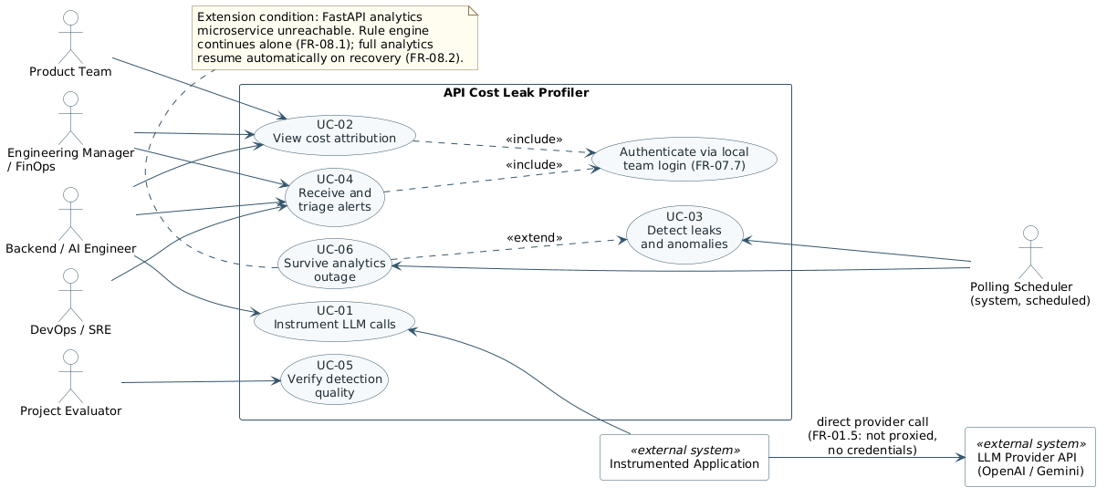
Figure 7 — Use case diagram

6.3 Use Case Index
Table 39 — Use case index
ID | Use case | Primary actor | Pri. | Requirements
UC-01 | Instrument an LLM call via the SDK wrapper | Backend / AI Engineer | Crit. | SDK-01…11, FR-101…112
UC-02 | Capture and ingest request metadata | Instrumented Application | Crit. | FR-101…112, FR-201…211
UC-03 | Compute and attribute per-request cost | Instrumented Application  («include» of UC-02) | Crit. | FR-301…310
UC-04 | Detect a rule-based cost leak | Instrumented Application  («include» of UC-03) | Crit. | FR-401…406, FR-410…455
UC-05 | Detect a statistical or semantic anomaly | («extend» of UC-04) | High | FR-501…509
UC-06 | View the cost attribution dashboard | Backend Engineer;  Eng. Manager | Crit. | FR-306, FR-701…710, UI-01…12
UC-07 | Receive a live leak alert | Backend Engineer;  DevOps / SRE | Crit. | FR-601…611, CI-04
UC-08 | Inspect root cause and drill down to evidence | Backend / AI Engineer | Crit. | FR-604…607, FR-704
UC-09 | Configure detection thresholds | Backend Engineer;  DevOps / SRE | High | FR-801, FR-805, FR-806
UC-10 | Export a cost or spend report | Engineering Manager | Med. | FR-706
UC-11 | Maintain the provider pricing table | DevOps / SRE | High | FR-802, FR-303, BR-02

Six use cases are specified in full below: the two that establish the data (UC-01, UC-02), the one that embodies the central claim (UC-04), and the three through which a human derives value from it (UC-06, UC-07, UC-09). The remainder are adequately specified by the functional requirements they reference.

6.4 Detailed Use Case Specifications

UC-01 — Instrument an LLM call via the SDK wrapper
Field | Specification
Primary actor | Backend / AI Engineer
Trigger | The engineer decides to bring an application, or a newly added feature, under cost observation.
Preconditions | The profiler backend is reachable. The engineer holds a valid ingestion key. The application uses a supported provider client (CON-09).
Main success  scenario | 1. The engineer installs the SDK package into the application.  2. The engineer calls profiler.init() with the ingestion endpoint, service name and redaction mode.  3. The engineer replaces the provider client instance with profiler.wrap(client).  4. The engineer adds profiler.tag({feature, userId, sessionId}) at each call site.  5. The application runs; the SDK emits usage events without altering behaviour.  6. The engineer opens the dashboard and observes attributed cost for the new feature.
Alternate flows | 4a. The engineer omits tags. The calls are still recorded and priced, but appear under the untagged category (FR-107), and the dashboard shows attribution coverage below the NFR-Q-01 target.  2a. The engineer selects redaction mode hash (the default). Near-duplicate detection is disabled and the dashboard discloses the reduced coverage (FR-508).
Exception flows | 5a. The ingestion endpoint is unreachable. The SDK buffers, retries with back-off, and ultimately discards while incrementing its dropped counter. The application is unaffected (SDK-09, NFR-SF-01).  5b. The provider returns an unexpected response shape. The SDK records the event as incomplete and continues; the application receives the provider response unchanged (SDK-04).
Postconditions | Every LLM call made through the wrapped client is observed, and tagged calls are attributable.
Frequency | Once per application or feature, at integration time.

UC-02 — Capture and ingest request metadata
Field | Specification
Primary actor | Instrumented Application (system actor)
Trigger | The application makes an LLM API call through the wrapped client.
Preconditions | The SDK is initialised. The ingestion endpoint is configured.
Main success scenario | 1. The wrapper records a start time and forwards the call to the provider unchanged.  2. The provider responds; the wrapper returns that response to the caller immediately.  3. After returning, the wrapper assembles the usage event: model, token counts, latency, outcome, timestamp, request identifier, prompt fingerprint and tags.  4. The event is placed in the SDK buffer and flushed with its batch on the next timer or size trigger.  5. The ingestion endpoint validates the batch, enqueues the valid members and acknowledges within the NFR-P-02 budget.  6. The persistence worker prices each event («include» UC-03) and writes it to usage_records.
Alternate flows | 4a. Sampling is in effect and the event is not selected. It is discarded at the SDK; the effective rate is recorded on the events that are sent so that costs can be extrapolated (FR-305).  5a. Part of the batch fails validation. The valid members are accepted and the rejected indices returned with reasons (FR-202).  6a. The request identifier is already present. The duplicate is discarded and counted (FR-206).
Exception flows | 4b. The SDK buffer is full. The oldest events are discarded and the dropped counter incremented; the application is not blocked (SDK-06).  5b. Queue depth is above the high-water mark. The endpoint responds 429 with Retry-After and the SDK backs off (FR-207).  6b. The database is unreachable. Events remain queued to the queue bound; the condition appears on the health endpoint and as a dashboard banner (FR-708).
Postconditions | A priced, attributed, immutable usage record exists for the call, or the loss has been counted and made visible.
Frequency | Once per LLM API call — the system's highest-volume path.

UC-04 — Detect a rule-based cost leak
Field | Specification
Primary actor | Instrumented Application (system actor); no human participates
Trigger | The detection polling cycle elapses.
Preconditions | Usage records exist for the detection window. At least one detector is enabled.
Main success  scenario | 1. The rule engine loads the current thresholds and the window of records since the previous cycle.  2. Each enabled detector evaluates its condition: duplicate fingerprints (FR-410), retry clusters (FR-420), session token growth (FR-430), input-to-output ratio and feature-relative size (FR-440), and spend against rolling baseline (FR-450).  3. For each hit the detector emits the category, dimension, threshold, observed value, contributing record identifiers and estimated recoverable spend (FR-403).  4. Where the analytics service is available, anomaly scores and semantic near-duplicate findings are merged in («extend» UC-05).  5. The alert generator deduplicates against open alerts, assigns severity, composes the root-cause statement and the recommended action, and persists the alert (UC-07 follows).  6. The cycle completes before the next is due (FR-401).
Alternate flows | 2a. A detector is disabled. It is skipped without affecting the others (FR-402).  4a. The analytics service is unavailable or its circuit breaker is open. The cycle proceeds on rule findings alone and the degraded state is surfaced (FR-505, FR-708).  5a. An open alert already covers the same category and dimension. It is updated rather than duplicated (FR-602).  5b. The per-category hourly alert cap has been reached. Further findings are aggregated into the existing alert (FR-610).
Exception flows | 1a. The baseline window holds insufficient history. Spike detection is suppressed and reported as "establishing baseline" (FR-455).  2b. A detector throws. The failure is logged and counted, the remaining detectors complete, and the cycle is not abandoned.  6a. The cycle overruns its interval. The next cycle is skipped rather than run concurrently, and the overrun is recorded on the health endpoint.
Postconditions | Every leak present in the window and above threshold is represented by exactly one open alert carrying evidence and a quantified estimate.
Frequency | Every polling cycle, continuously.

UC-06 — View the cost attribution dashboard
Field | Specification
Primary actor | Backend / AI Engineer; Engineering Manager / FinOps
Trigger | The user opens the dashboard, or changes the window or a filter.
Preconditions | The user is authenticated (NFR-S-04). Usage records exist.
Main success  scenario | 1. The user opens the dashboard and is presented with the overview: total spend for the window, change against the preceding window, and open alerts by severity (UI-01).  2. The user selects a time window from the presets or specifies a custom range (FR-703).  3. The user opens the breakdown by feature, by user or by model and reads spend, call count, mean cost per call and the token split (UI-02 to UI-04).  4. The user opens the trend view; spend over time is drawn with the rolling baseline overlaid and alert markers in place (UI-05, FR-709), rendering within the NFR-P-04 budget.  5. The user drills from any aggregate into the contributing usage records (FR-704).
Alternate flows | 3a. A material share of spend is untagged. It is shown as its own category so the gap is visible rather than implicit (FR-307, BR-04).  3b. Records exist whose model is absent from the rate table. Monetary totals exclude them and the excluded call count is displayed alongside (FR-303).  4a. Sampling was in effect. Extrapolated figures are labelled as such (FR-305).
Exception flows | 1a. No data exists for the window. An explanatory empty state is rendered, not a spinner (FR-707).  1b. The system is degraded — analytics down, ingestion lagging, events dropped. A banner names the specific condition (FR-708).
Postconditions | The user can state where spend is going, at feature, user and model granularity, for the selected window.
Frequency | Several times weekly per engineer; weekly and at month end per manager.

UC-07 — Receive a live leak alert
Field | Specification
Primary actor | Backend / AI Engineer; DevOps / SRE
Trigger | The alert generator persists a new or materially updated alert (UC-04 step 5).
Preconditions | The alert exists in alerts. Zero or more dashboard clients are connected.
Main success  scenario | 1. The backend emits the alert on the Socket.IO channel within the NFR-P-03 budget (FR-608).  2. Each connected client inserts it at the head of the alert feed without a page reload (FR-705).  3. The user reads the category, severity and estimated recoverable spend in the feed (UI-06).  4. The user opens the alert detail and reads the root-cause statement, the threshold and observed value, the contributing requests and the recommended action (UI-07, UC-08).  5. The user acknowledges the alert, or dismisses it; the transition and its time are recorded (FR-609).
Alternate flows | 2a. No client is connected. The alert is persisted regardless and appears when a client next connects (FR-611).  2b. A client reconnects after an outage. It receives the current open alert set on connection, so nothing raised meanwhile is missed (CI-04).  5a. The user dismisses the alert. It is retained as dismissed, never deleted (BR-03).
Exception flows | 1a. The Socket.IO channel is unavailable. Delivery falls back to the REST alert listing on the client's next query; no alert is lost (CI-04, FR-611).  3a. Alerts are arriving at the per-category cap. Further findings are folded into the existing alert rather than flooding the feed (FR-610).
Postconditions | The alert has been delivered and its lifecycle state reflects the user's decision.
Frequency | Event-driven; expected to be low-volume by design (FR-610).

UC-09 — Configure detection thresholds
Field | Specification
Primary actor | Backend / AI Engineer; DevOps / SRE
Trigger | A detector is producing findings judged too frequent or too sparse for the workload.
Preconditions | The user is authenticated (BR-01).
Main success  scenario | 1. The user opens the configuration screen and reads the current value, default and permitted range of each threshold (UI-08).  2. The user changes one or more values and submits.  3. The system validates each against its declared type and range (FR-806).  4. The system persists the change, writes an audit entry recording the previous and new values (FR-805), and applies it from the next detection cycle without a restart (FR-801).  5. The user observes the effect on the next cycle and iterates if required.
Alternate flows | 2a. The user disables a detector entirely. It is skipped on subsequent cycles (FR-402) and the dashboard indicates that the category is not being monitored.  2b. The user restores defaults. The seeded values of FR-807 are reinstated and the restoration is itself audited.
Exception flows | 3a. A value is outside its permitted range. The change is rejected with a specific message; no partial application occurs, and detection is never silently disabled by an invalid value (FR-806).  4a. The configuration store is unwritable. The change is rejected and the prior configuration remains in force.
Postconditions | The new thresholds are in force and the change is auditable.
Frequency | Occasional — during tuning after deployment, and when workload changes.

7. OTHER REQUIREMENTS

7.1 Database Requirements
MongoDB is used as a document store rather than a relational database because a usage record is naturally a single self-contained document, because the attribution tag set is intentionally open-ended, and because the dominant query shape — a time range filtered by one or two tag dimensions and aggregated — is served well by a compound index and an aggregation pipeline. The field sets below are requirements on the schemas, not a final Mongoose definition.
Table 40 — Collection `usage_records`
Field | Type | Notes
requestId | string | SDK-generated, globally unique. Unique index; the idempotency key of FR-206.
timestamp | date | UTC, millisecond resolution, taken at call initiation. Indexed; compound with each tag dimension.
provider, model | string | As reported by the provider (FR-101).
inputTokens,  outputTokens | int | From the provider usage object (FR-102).
latencyMs | int | Provider call duration, excluding profiler work (FR-103).
outcome, statusCode | string, int | success | provider_error | timeout | rate_limited (FR-104).
feature, userId,  sessionId | string | Attribution tags; explicitly null where untagged (FR-107). Indexed.
turnIndex,  sessionInputTokens | int | Present when a session tag is supplied; inputs to FR-430.
promptHash | string | Stable hash of the normalised prompt (FR-108). Indexed — the grouping key for FR-410 and FR-420.
promptChars,  promptTokens | int | Prompt size, retained even when text is not.
cost, currency,  pricingVersion | decimal, string | Computed cost with the rate version that produced it (FR-301, FR-304). Null with a pricingMissing flag where the model is unknown (FR-303).
sampleRate,  extrapolatedCost | float, decimal | Present when sampling is in effect (FR-305).
sdkVersion,  clientVersion | string | Diagnostic provenance (FR-110).

Table 41 — Collection `alerts`
Field | Type | Notes
alertId | string | Unique.
category | string | duplicate_prompt | retry_loop | unbounded_context | oversized_prompt | spend_spike | statistical_anomaly.
severity | string | Derived from recoverable spend and anomaly score (FR-603).
dimension, value | string | What the alert is about — for example feature = "support-summary".
detector, threshold,  observed | string, number | The rule or model that fired, the threshold applied and the value observed — the basis of the root-cause statement (FR-606).
recoverableSpend,  estimationBasis | decimal, string | The quantified estimate and a plain statement of how it was derived (FR-604).
evidenceIds,  contributingCount | array, int | Capped list of requestId values with the full count (FR-605).
recommendedAction | string | Category-appropriate remediation guidance (FR-607).
firstSeen, lastSeen | date | Updated in place on deduplication (FR-602).
state, stateChangedAt | string, date | open | acknowledged | resolved | dismissed (FR-609). Records are never deleted (BR-03).

Table 42 — Supporting collections
Collection | Purpose and key fields
pricing_config | Versioned provider rate table. provider, model, inputRatePerMTok, outputRatePerMTok, currency, effectiveFrom, version. Entries are superseded, never edited (BR-02); selection is by latest effectiveFrom not later than the event timestamp (FR-302).
baselines | Rolling statistics per dimension: dimension, value, windowStart, mean, stdDev, sampleCount. Consumed by FR-451 and displayed as the trend overlay (FR-709).
model_state | Serialised Isolation Forest with fittedAt, sampleCount, featureSchemaVersion, loaded on analytics start-up in preference to refitting (FR-503).
config_audit | One entry per configuration change: key, previousValue, newValue, changedAt, actor (FR-805).

7.2 Logging and Auditing
LOG-01. The backend and the analytics service shall emit structured, level-tagged logs to standard output, so that a deployment may route them without the profiler imposing a logging destination. LOG-02. Logs shall never contain prompt text, credentials or ingestion keys; where a prompt must be identified in a log line, its fingerprint shall be used. LOG-03. Every detection cycle shall log its duration, the number of records examined and the number of hits per detector, so that detector behaviour can be reconstructed after the fact. LOG-04. Configuration changes shall additionally be recorded in config_audit as a durable, queryable record (FR-805). LOG-05. Dropped events, rejected ingestion batches and analytics-service failures shall be logged with enough context to distinguish a transient condition from a systematic one.

7.3 Installation and Deployment Requirements
DEP-R-01. The system shall be startable from a documented sequence of commands with no manual database preparation: required collections and indexes shall be created on first run (FR-702), and default thresholds and a rate table seeded (FR-807). DEP-R-02. All deployment-specific values — database URI, ingestion key, dashboard credential, analytics service URL, optional Redis URL — shall be supplied by environment variable, with no secret committed to the repository. DEP-R-03. The backend and the analytics service shall start independently and in any order; neither shall fail to start because the other is absent (FR-505). DEP-R-04. The system shall run correctly against both a local MongoDB instance and MongoDB Atlas without code change. DEP-R-05. A seeded demonstration dataset and the leak-injection generator of Section 8.3 shall be provided so that the system can be evaluated without access to a production application.

7.4 Licensing and Compliance
LIC-01. All third-party dependencies shall carry licences compatible with academic use and redistribution of the project source; the licence set shall be enumerated in the final report. LIC-02. The system shall not store or transmit provider credentials (NFR-S-01) and shall not proxy provider traffic (CON-01), so that its use does not implicate the providers' terms of service. LIC-03. Published rate data held in pricing_config shall record its source and the date on which it was captured. LIC-04. Because prompts may contain personal data, the default configuration shall not transmit prompt text (NFR-S-02), and the documentation shall state plainly what each redaction mode causes to leave the host application.

7.5 Internationalisation
Release 1.0 presents its interface in English and reports monetary values in United States dollars, the currency in which both supported providers publish their rates. I18N-01: all monetary values shall be stored with an explicit currency field so that multi-currency support can be added without migrating stored data. I18N-02: all timestamps shall be stored in UTC and rendered in the viewer's local time zone, with the zone stated. I18N-03: user-facing strings should be held separately from component logic to permit later translation; this is a should and may be traded away under schedule pressure.

8. VERIFICATION AND ACCEPTANCE

8.1 Verification Approach
Verification is organised in four layers, each answering a different question. Unit tests answer whether a detector implements its stated rule: each of the five detectors is exercised in isolation against hand-crafted positive and negative fixtures, without a running database, as required by NFR-Q-07. Contract tests answer whether the Node and Python halves agree: the boundary of SI-04 is exercised from both sides independently, including the timeout, circuit-breaker and rule-only fallback paths of FR-505, since that path is the one least likely to be exercised by ordinary use and the most damaging if wrong. Integration tests answer whether the end-to-end chain holds: a wrapped call produces a persisted record, a priced attribution, a detected leak and a delivered alert. Measurement harnesses answer whether the quantified targets are met, and are described in Section 8.2. Manual dashboard QA against the seeded demonstration dataset precedes the final review.

8.2 Acceptance Criteria
The system is accepted when every criterion below is met on the demonstration dataset and the leak-injection suite. Each criterion is carried forward unchanged from P1 §8 and is paired here with the requirement that implements it and the method that verifies it.
Table 43 — Acceptance criteria and verification methods
Criterion | Target | Requirement | Verification method
Ingestion overhead added to the application's request path | < 5 ms  (async emit only) | NFR-P-01  SDK-03, CON-03 | A timing harness wraps 10,000 SDK calls and measures added latency against an unwrapped baseline call, comparing p95 values.
Logged requests attributable to a feature and user | ≥ 95% | NFR-Q-01  FR-107 | A labelled traffic sample is replayed through the SDK; the proportion of logged documents carrying a valid feature and user tag is computed.
Recall on injected duplicate-prompt and retry-loop cases | ≥ 90% | NFR-Q-02  FR-410, FR-420 | The synthetic leak-injection generator seeds known duplicate and retry patterns into test traffic; recall is computed against the injected ground truth.
Dashboard render time for a 30-day trend view | < 2 s | NFR-P-04  FR-710, FR-702 | Browser performance timing on a seeded 30-day dataset, measured on the demonstration hardware of Section 2.6.
Time to flag an injected synthetic spend spike | ≤ 1 polling  cycle | NFR-P-05  FR-450, FR-453 | Injected spike traffic is timestamped; the alert-generation timestamp is compared against the next scheduled polling cycle.

Two further criteria are added by this SRS and are not drawn from P1: NFR-Q-03 (no more than 10% false positives on the clean control workload) and NFR-Q-04 (24 hours of unattended operation without unrecovered error or memory growth). Recall without a precision counterpart can be achieved by lowering thresholds until everything alerts, so the two are specified and measured together.

8.3 Leak-Injection Test Suite
The suite is the primary instrument for verifying detection quality, and is therefore itself a requirement rather than an implementation detail.
Table 44 — Leak-injection test suite requirements
ID | Requirement
TST-01 | The generator shall synthesise traffic containing each of the five leak categories, with a recorded ground truth identifying every injected instance and its wasted spend.
TST-02 | The generator shall also produce a clean control workload containing no injected leaks, against which the false-positive rate of NFR-Q-03 is measured.
TST-03 | Injected volume, leak density and workload shape shall be parameterised, so that detector behaviour can be examined across a range of conditions rather than at a single operating point.
TST-04 | The suite shall be re-runnable in a single command and shall emit recall and precision per detector, so that it can be executed at every phase-end review from Phase 2 onward rather than only at Phase 5.
TST-05 | The near-duplicate cases shall include prompts that are semantically equivalent but not byte-identical, so that FR-412 is distinguished from FR-411 by the results.

8.4 Requirement Coverage by Milestone
The milestones below are those of P4 §6. The mapping states which requirements each milestone is expected to demonstrate, so that progress can be assessed against this SRS rather than against a subjective sense of completeness.
Table 45 — Requirement coverage by milestone
ID | Milestone | Requirements demonstrated
M1 | Environment and schema ready | DEP-R-01, DEP-R-02, FR-702, FR-807, Section 7.1 schemas
M2 | SDK and ingestion | SDK-01…11, FR-101…112, FR-201…211, FR-301…310, NFR-P-01, NFR-P-02
M3 | Rule engine and dashboard MVP (Mid-Term Review) | FR-401…406, FR-410…455, FR-601…611, FR-701…705, UI-01…07, NFR-P-03, NFR-P-05
M4 | Analytics microservice integrated | FR-501…509, SI-04, CI-05, FR-505 fallback path, NFR-P-08, NFR-Q-05
M5 | Dashboard analytics complete | FR-706…710, UI-08, FR-801…807, NFR-P-04, NFR-Q-09
M6 | Success criteria validated | TST-01…05, NFR-P-01, NFR-P-04, NFR-P-05, NFR-Q-01…04 — the full Section 8.2 table
M7 | Final submission and demonstration | Section 2.8 documentation set, DEP-R-05, end-to-end demonstration script

APPENDIX A — REQUIREMENTS TRACEABILITY MATRIX
Every functional group and every quantified non-functional requirement is traced backward to the source that motivates it and forward to the use case that exercises it, the milestone at which it is demonstrated and the method by which it is verified. Verification methods are abbreviated: T test, D demonstration, A analysis or measurement, I inspection.
Table 46 — Requirements traceability matrix
Requirement | Source | Use case | M | V
FR-101 – FR-112 Metadata capture | P1 §5.1; P3 architecture | UC-01, UC-02 | M2 | T, A
FR-201 – FR-211 Ingestion and persistence | P1 §5.3; P4 Phase 2 | UC-02 | M2 | T, A
FR-301 – FR-310 Cost and attribution | P1 §5.1; P1 §8 (95%) | UC-02, UC-03, UC-06 | M2 | T, A
FR-401 – FR-406 Rule engine core | P1 §5.2; P2 §6 gap | UC-04 | M3 | T
FR-410 – FR-414 Duplicate prompts | P1 §5.2; P2 (GPTCache) | UC-04 | M3 | T, A
FR-420 – FR-424 Retry loops | P1 §5.2 | UC-04 | M3 | T, A
FR-430 – FR-434 Unbounded context | P1 §5.2 | UC-04 | M3 | T
FR-440 – FR-444 Oversized prompts | P1 §5.2; P2 (FrugalGPT) | UC-04 | M3 | T
FR-450 – FR-455 Spend spikes | P1 §5.2, §8 | UC-04 | M3 | T, D
FR-501 – FR-509 Analytics microservice | P2 (Isolation Forest); P4 Phase 3 | UC-05 | M4 | T, A
FR-601 – FR-611 Alerting | P1 §5.4; P1 §8 | UC-07 | M3 | T, D
FR-701 – FR-710 Dashboard and reporting | P1 §6; P3 UI | UC-06, UC-08, UC-10 | M5 | D, A
FR-801 – FR-807 Configuration and admin | P4 §8 tuning | UC-09, UC-11 | M5 | T, I
SDK-01 – SDK-11 SDK interface | P1 §5.3, §9 | UC-01 | M2 | T, I
UI-01 – UI-12 User interface | P1 §6; P3 slides | UC-06, UC-07, UC-08 | M5 | D, I
CI-01 – CI-06, SI-01 – SI-08 Interfaces | P4 §9 stack | UC-02, UC-05 | M2, M4 | T, I
NFR-P-01 < 5 ms added latency | P1 §8 | UC-01, UC-02 | M2, M6 | A
NFR-P-04 < 2 s trend render | P1 §8 | UC-06 | M5, M6 | A
NFR-P-05 ≤ 1 cycle to flag a spike | P1 §8 | UC-04, UC-07 | M3, M6 | A
NFR-Q-01 ≥ 95% attribution | P1 §8 | UC-01, UC-02 | M2, M6 | A
NFR-Q-02 ≥ 90% recall | P1 §8 | UC-04 | M3, M6 | A
NFR-Q-03 ≤ 10% false positives | This SRS §8.2 | UC-04 | M6 | A
NFR-S-01 – S-08 Security | P1 §9; CON-02, CON-10 | UC-01, UC-09 | M2, M5 | I, T
NFR-SF-01 – SF-05 Safety | P1 §5.3 | UC-01, UC-02 | M2, M6 | T, A
TST-01 – TST-05 Test suite | P4 §8 | UC-04 | M6 | D

APPENDIX B — MESSAGE SCHEMAS
The two messages below are the system's principal data contracts. The usage event is the payload of CI-02 and the normalised form onto which both provider integrations map (SI-02). The alert is the payload of the Socket.IO channel of CI-04 and of the REST alert endpoints. Both are illustrative of the required content; field names are normative, formatting is not.

B.1 Usage event (SDK → ingestion endpoint)
{
"requestId": "0f3c9a2e-7b41-4d8e-9c11-2a6f5d3b8e07",
"timestamp": "2026-09-11T09:42:17.318Z",
"service": "checkout-api",
"provider": "openai",
"model": "gpt-4o-mini",
"inputTokens": 2841,
"outputTokens": 196,
"latencyMs": 1327,
"outcome": "success",
"statusCode": 200,
"tags": { "feature": "support-summary",
"userId": "u_84213",
"sessionId":"s_19f2c8" },
"turnIndex": 7,
"sessionInputTokens": 18420,
"promptHash": "sha256:9d1b...c4a7",
"promptChars": 11364,
"promptTokens": 2841,
"redactMode": "hash",
"sampleRate": 1.0,
"sdkVersion": "1.0.0",
"clientVersion": "openai-node/4.57.0"
}

B.2 Alert (backend → dashboard)
{
"alertId": "alr_2f81c4",
"category": "duplicate_prompt",
"severity": "high",
"dimension": "feature",
"value": "support-summary",
"detector": "FR-410 duplicate fingerprint",
"threshold": { "occurrences": 5, "windowMinutes": 60 },
"observed": { "occurrences": 43, "distinctPrompts": 3 },
"rootCause": "3 prompt fingerprints in feature 'support-summary' recurred 43 times
in 60 minutes; 40 calls after the first occurrence of each returned a
response already computed within the window.",
"recoverableSpend": { "amount": 4.12, "currency": "USD",
"basis": "summed cost of all occurrences beyond the first" },
"recommendedAction": "Introduce a response cache keyed on the normalised prompt for
this feature, or deduplicate upstream of the call site.",
"evidenceIds": ["0f3c9a2e-...", "7b41-...", "..."],
"contributingCount": 43,
"firstSeen": "2026-09-11T08:05:02.441Z",
"lastSeen": "2026-09-11T09:04:55.702Z",
"state": "open"
}

APPENDIX C — OPEN ISSUES
The following are known to be unresolved at issue of this baseline. Each is recorded with the point at which it must be closed; none blocks the commencement of implementation.
Table 47 — Open issues
ID | Issue | Resolve by
OI-01 | Default threshold values for all five detectors are stated as configurable but their seeded defaults (FR-807) are not yet fixed. They will be set empirically from the first leak-injection runs rather than guessed now. | M3
OI-02 | The polling cycle length, on which NFR-P-05 depends, has not been fixed. It trades detection latency against database load and will be chosen once ingestion throughput has been measured. | M3
OI-03 | The specific sentence-embedding model for FR-502 is not yet selected; the choice is between embedding quality and CPU cost on the reference hardware. | M4
OI-04 | Whether the SDK should offer a local-embedding redaction mode — computing the vector in the host process so that near-duplicate detection survives the hash default — is undecided. It would resolve the coverage gap disclosed by FR-414 at the cost of loading a model into the customer process. | M4
OI-05 | The severity bands of FR-603 are specified as configurable but their default monetary boundaries are not yet set. | M5
OI-06 | The procedure for updating pricing_config when a provider changes published rates is manual (CON-04). Whether to add a scheduled reminder or a rate-staleness warning on the dashboard is open. | M5
OI-07 | Attribution of cost for streamed responses abandoned before completion (FR-111) is recorded as incomplete; whether such calls should be priced on partial token counts is unresolved. | M4

— End of document —

