SARDAR PATEL INSTITUTE OF TECHNOLOGY
Department of Computer Engineering
DESIGN OF ALGORITHMS
for
API Cost Leak Profiler (ACLP)
Release 1.0
P3 — Mini Project Phase 2: Architecture and Design
Subject: Mini Project — Semester V, Academic Year 2026-27
Role | Name
Project Guide | Dr. Sudhir Dhage
Project Co-Guide | Prof. Ameya Nile
Team Representative | Shrey Sawant
Team Member | Jay Patil
Team Member | Pranav Gadge

Prepared for the Semester V Mini-Project Evaluation Panel
16 September 2026

TABLE OF CONTENTS
1. Introduction 3
2. Input Data and Data Representation 4
3. Cost Calculation Algorithm 5
4. Cost Attribution Algorithm 6
5. Duplicate Prompt Detection Algorithm 7
6. Retry Loop Detection Algorithm 8
7. Unbounded Conversation Context Detection 9
8. Oversized Prompt Detection 10
9. Spend Spike Detection 11
10. Isolation Forest Anomaly Detection 12
11. Semantic Duplicate Detection 14
12. Alert Generation Algorithm 15
13. Overall End-to-End Algorithm 16
14. Algorithm Flowcharts and Process Diagrams 17
15. Complexity Analysis 27
16. Configurable Parameters and Thresholds 28
17. Algorithm Validation and Test Cases 29
18. Traceability to SRS 30
19. Conclusion 31
20. References 32

1. INTRODUCTION

1.1 Purpose
This document specifies the algorithmic design of Release 1.0 of the API Cost Leak Profiler (ACLP), as the Phase 2 (P3) deliverable of the Semester V mini-project sequence. Where the Software Requirements Specification (SRS) states what the system must do, this document states how the system processes an observed LLM call into a priced, attributed record and, over accumulated windows of such records, into an explained, quantified alert. Every algorithm described below is derived from, and traceable to, the functional requirements, data flow and interfaces fixed in the SRS; none introduces functionality outside the Release 1.0 scope defined there.

1.2 Scope
The scope of this document is confined to the processing logic internal to the six architectural tiers described in SRS Section 2.2: the instrumentation SDK's metadata capture, the cost computation and attribution pipeline, the five rule-based leak detectors of FR-400, the statistical and semantic analytics of FR-500, and the alert-generation logic of FR-600. Interface contracts, schema definitions, screen layouts and project-management concerns are not repeated here except where needed to state an algorithm's input or output precisely; the reader is referred to the SRS Sections 3, 4 and 7 for those.

1.3 Role of Algorithms in the Proposed System
The product's central claim, stated in SRS Section 2.1, is that a meaningful share of avoidable LLM spend follows a small number of recognisable patterns that can be detected deterministically, explained in plain language, and quantified in money. That claim is carried entirely by the algorithms in this document. Two design properties, both constraints in the SRS (CON-06, CON-08), shape every algorithm described: rule-based detection must remain fully functional with the analytics microservice unavailable, and every statistical or learned model is fitted only on the deployment's own history, never on a pre-trained or cross-tenant corpus. Consequently the algorithms are organised into two tiers of the same pipeline — deterministic, threshold-based detectors that run unconditionally, and statistical/semantic detectors that augment them when available.

2. INPUT DATA AND DATA REPRESENTATION
Every algorithm in this document operates on the usage record, the persisted document representing one observed LLM API call (SRS Section 1.5, Appendix B.1). The usage record is the single input from which cost, attribution and every leak category are derived; no algorithm reads any other primary source. Table 1 lists the fields consumed by the algorithms of this document, restricted to those the SRS specifies as captured by the instrumentation SDK (FR-101 to FR-112).
Field | Populated by | Consumed by
requestId | FR-106 (SDK, globally unique) | Idempotent ingestion (FR-206); alert evidence (FR-605)
timestamp (UTC, ms) | FR-105 | Rate selection (FR-302); windowing; retention (FR-211)
provider, model | FR-101 | Cost calculation (Section 4); rate lookup
inputTokens, outputTokens | FR-102 (from provider usage object) | Cost calculation; oversized-prompt ratio (Section 9)
latencyMs | FR-103 | Isolation Forest feature vector (Section 11)
outcome, statusCode | FR-104 | Retry-loop correlation (Section 7)
tags: feature, userId, sessionId | FR-107 (or explicitly "untagged") | Cost attribution (Section 5); alert dimension
promptHash, promptChars, promptTokens | FR-108 | Duplicate/retry grouping (Sections 6, 7)
turnIndex, sessionInputTokens | FR-109 (session calls only) | Unbounded-context detection (Section 8)
retryAttempt (if exposed) | FR-112 | Retry-loop detection, direct-observation path (Section 7)
sampleRate, sdkVersion | FR-110, SDK-08 | Cost extrapolation (FR-305)

Preprocessing and windowing
Two distinct windowing regimes are used, matching the two paths identified in SRS Section 2.3. The ingestion path (FR-201 to FR-211) processes one usage event at a time, in arrival order, and is not windowed: it validates, prices and persists each record independently. The detection path (FR-401) operates on a sliding window of recently persisted usage_records, re-evaluated on a configurable polling cycle; the window length and the polling-cycle length are both configuration values (FR-801) rather than values fixed by this design. Within the detection path, three further groupings recur across detectors and are defined once here rather than per detector:
- Fingerprint grouping — records sharing the same promptHash, used by duplicate-prompt (Section 6) and retry-loop (Section 7) detection.
- Session grouping — records sharing the same sessionId, ordered by turnIndex, used by unbounded-context detection (Section 8).
- Feature grouping — records sharing the same feature tag, used by oversized-prompt detection (Section 9) and as one of the dimensions of spend-spike attribution (Section 10).
Where a record's feature, userId or sessionId tag is absent, FR-107 requires it to be recorded as explicitly untagged rather than omitted; the algorithms of this document treat "untagged" as an ordinary, distinct value of the corresponding dimension (BR-04) so that it participates in grouping and is visible in aggregates rather than silently dropped.

3. COST CALCULATION ALGORITHM
FR-301 to FR-304 require that each call's cost be computed as the sum of its input-token cost and output-token cost, priced at the rate entry for the model concerned that was in force at the time the call was observed. Rates in pricing_config are published per million tokens (Appendix B.2 supporting collections), and are versioned by an effective-from timestamp so that a later change to the rate table never alters the stored cost of a record already priced (FR-309, BR-02).
cost = (inputTokens ÷ 1,000,000) × inputRatePerMTok + (outputTokens ÷ 1,000,000) × outputRatePerMTok
Rate selection is itself a small algorithm, since FR-302 requires the latest rate entry not later than the event timestamp:
rateEntry = argmax { entry.effectiveFrom : entry.provider = event.provider ∧ entry.model = event.model ∧ entry.effectiveFrom ≤ event.timestamp }
FUNCTION computeCost(event, pricingConfig):
candidates ← FILTER pricingConfig WHERE
provider = event.provider AND model = event.model
AND effectiveFrom <= event.timestamp
IF candidates IS EMPTY:
event.cost <- NULL
event.pricingMissing <- TRUE
RAISE administrativeNotice(event.provider, event.model) // FR-303
RETURN event

rateEntry <- candidates ordered by effectiveFrom DESC, first item // FR-302

inputCost <- (event.inputTokens / 1_000_000) * rateEntry.inputRatePerMTok
outputCost <- (event.outputTokens / 1_000_000) * rateEntry.outputRatePerMTok
event.cost <- inputCost + outputCost // FR-301
event.currency <- rateEntry.currency
event.rateVersion <- rateEntry.version // FR-304

IF event.sampleRate < 1.0:
event.extrapolatedCost <- event.cost / event.sampleRate // FR-305
event.costIsExtrapolated <- TRUE

RETURN event

Worked example
Using the illustrative usage event of SRS Appendix B.1 (model gpt-4o-mini, inputTokens = 2,841, outputTokens = 196, sampleRate = 1.0), and denoting the rate-table entry's rates for that model as r_in and r_out (per million tokens, in force at the event timestamp), the algorithm above computes cost = (2,841 ⁄ 1,000,000) × r_in + (196 ⁄ 1,000,000) × r_out. The SRS does not fix a numeric rate for any model — rates are held in pricing_config and are maintained operationally (FR-802, CON-04) — so no specific rate value is asserted here; the substitution above is illustrative of the computation only.

4. COST ATTRIBUTION ALGORITHM
FR-306 requires cost to be aggregated by feature, end user, model, session and time bucket, individually and in combination, over an arbitrary window; FR-307 requires untagged spend to be reported as its own explicit category, never redistributed across tagged categories or omitted (BR-04); FR-310 requires each aggregate to report total cost, call count, mean cost per call, token totals and the change against the preceding equivalent window.
FUNCTION attributeCost(records, dimension, window):
buckets <- EMPTY MAP keyed by dimension value // e.g. feature name, or "untagged"
FOR EACH record IN records WHERE record.timestamp IN window:
key <- record.tags[dimension] IF PRESENT ELSE "untagged" // FR-107, BR-04
IF record.pricingMissing:
buckets[key].excludedCallCount += 1 // FR-303 — visible, not silent
CONTINUE
buckets[key].totalCost += record.cost
buckets[key].callCount += 1
buckets[key].inputTokens += record.inputTokens
buckets[key].outputTokens += record.outputTokens

FOR EACH key IN buckets:
buckets[key].meanCostPerCall <- buckets[key].totalCost / buckets[key].callCount

previous <- attributeCost(records, dimension, precedingEquivalentWindow(window)) // FR-310
FOR EACH key IN buckets:
buckets[key].changeVsPrevious <- buckets[key].totalCost - previous[key].totalCost

RETURN buckets

The same routine, applied once per dimension (feature, userId, model, sessionId) and once with a time-bucket key, produces the four breakdown views and the trend view of UI-02 to UI-05 without a distinct algorithm per screen. Applying it with a compound key (for example, feature and time-bucket together) supports the drill-down and filter combinations required by FR-306 and FR-704.

5. DUPLICATE PROMPT DETECTION ALGORITHM
Identical prompts issued repeatedly within a short window indicate a missing cache, a re-render loop, or a retried computation whose result was already available (SRS Section 4.4, FR-410). Detection groups the records of the sliding detection window by prompt fingerprint (FR-108) — a cryptographic hash of the normalised prompt text, present regardless of the redaction mode in force (SDK-07) — and raises a hit where the number of occurrences in a group exceeds the configured occurrence threshold.
recoverableSpend = Σ cost(r) for each occurrence r beyond the first in a fingerprint group whose size exceeds the threshold
FUNCTION detectDuplicatePrompts(records, window, occurrenceThreshold):
groups <- GROUP records WHERE timestamp IN window BY promptHash
hits <- EMPTY LIST
FOR EACH (fingerprint, group) IN groups:
IF |group| > occurrenceThreshold: // FR-411
occurrences <- SORT group BY timestamp ASC
recoverable <- SUM(cost(r) FOR r IN occurrences[1:]) // all but the first, FR-413
hits.ADD({
category: "duplicate_prompt", dimension: occurrences[0].feature,
observed: |group|, threshold: occurrenceThreshold,
recoverableSpend: recoverable, evidenceIds: occurrences.requestId
})
RETURN hits

Relationship to semantic near-duplicate detection
This algorithm performs exact-match detection only: two prompts are grouped solely because they share the same fingerprint, i.e. are byte-identical after normalisation. FR-412 additionally treats as duplicates those prompts whose embedding similarity exceeds a configured threshold, but only when the analytics microservice supplies that finding (Section 12); the two are deliberately separate algorithms; the exact-match algorithm above never computes or depends on a similarity score, which is what allows it to run whether or not the analytics service, or an embedding-permitting redaction mode, is available. Where only exact-match detection is possible — because the active redaction mode is hash or drop (SDK-07) and no embedding can be computed — FR-414 requires the alert and dashboard to disclose that near-duplicates are not being detected, rather than presenting the exact-match count as complete coverage.

6. RETRY LOOP DETECTION ALGORITHM
Automatic retry logic reacting to errors, timeouts or rate limiting can multiply the cost of one logical operation several times over, since every attempt is billed (SRS Section 4.4, FR-420). Structurally this detector reuses the fingerprint grouping of Section 5, but over a much shorter interval, and adds the condition that at least one attempt in the group carries a non-success outcome (FR-104); this correlation with outcome is exactly what FR-424 uses to distinguish a retry cluster from a genuinely repeated successful call, which is left to Section 5's duplicate detector instead.
recoverableSpend = Σ cost(r) for each attempt r beyond the first in a fingerprint cluster satisfying the recurrence and error-correlation conditions
FUNCTION detectRetryLoops(records, shortInterval, recurrenceThreshold):
groups <- GROUP records WHERE timestamp IN shortInterval BY promptHash
hits <- EMPTY LIST
FOR EACH (fingerprint, group) IN groups:
IF |group| > recurrenceThreshold // FR-421
AND EXISTS r IN group WHERE r.outcome IN {error, timeout, rate_limited}:
attempts <- SORT group BY timestamp ASC
IF attempts[0].retryAttempt IS PRESENT: // FR-112, FR-422
basis <- "directly observed"
ELSE:
basis <- "inferred from fingerprint + outcome correlation"
recoverable <- SUM(cost(r) FOR r IN attempts[1:]) // FR-423
hits.ADD({
category: "retry_loop", basis: basis,
observed: |group|, threshold: recurrenceThreshold,
recoverableSpend: recoverable, evidenceIds: attempts.requestId
})
// ELSE: recurring fingerprint with only successful outcomes is left
// to detectDuplicatePrompts (Section 5) — FR-424
RETURN hits

7. UNBOUNDED CONVERSATION CONTEXT DETECTION
Conversational applications resend accumulated history on every turn; without truncation or summarisation, input tokens grow with conversation length and cost grows superlinearly with the number of turns (SRS Section 4.4, FR-430). This detector tracks, per session, the input-token count reported at each turn (FR-109) and raises a hit where that count grows monotonically beyond a configured absolute ceiling or growth-rate threshold, once the session has reached a configured minimum number of turns (FR-434) — short sessions are excluded because they have not yet established a trend.
recoverableSpend = Σ over affected turns t of: (inputTokens(t) − ceiling) × inputRate(t), for turns where inputTokens(t) > ceiling
FUNCTION detectUnboundedContext(session, minTurns, ceiling, growthRateThreshold):
turns <- SORT session.records BY turnIndex ASC
IF |turns| < minTurns: RETURN NO_HIT // FR-434

trajectory <- [t.sessionInputTokens FOR t IN turns] // FR-109
monotonic <- IS_NONDECREASING(trajectory)
exceeds <- EXISTS i WHERE trajectory[i] > ceiling
OR growthRate(trajectory) > growthRateThreshold

IF monotonic AND exceeds: // FR-431
crossingTurn <- FIRST i WHERE trajectory[i] > ceiling
recoverable <- 0
FOR EACH t IN turns[crossingTurn:]:
excessTokens <- MAX(0, t.sessionInputTokens - ceiling)
recoverable += excessTokens * inputRateFor(t) / 1_000_000 // FR-433
RETURN {
category: "unbounded_context", sessionId: session.id,
crossingTurn: crossingTurn, trajectory: trajectory, // FR-432
recoverableSpend: recoverable
}
RETURN NO_HIT

Worked example
Consider a session whose input-token count rises 1,200 → 2,050 → 3,400 → 5,100 → 7,300 over five turns against a configured ceiling of 3,000 tokens and a minimum-turn requirement of three. The sequence is monotonically increasing and crosses the ceiling at the third turn; the detector reports the crossing turn and the full trajectory as evidence, and estimates recoverable spend from the sum of (inputTokens − 3,000) at turns three through five, priced at the input rate in force for each turn.

8. OVERSIZED PROMPT DETECTION
A prompt large relative to the output it elicits, or relative to its peers on the same feature, frequently indicates embedded boilerplate, an over-large retrieved context, or a system prompt that has accreted over time (SRS Section 4.4, FR-440). Two independent conditions are specified, and either is sufficient to raise a hit; they exist because a single fixed ratio cannot distinguish a legitimately prompt-heavy feature (for example, a document-summarisation feature) from an anomaly within a lighter-weight feature, whereas the feature-relative comparison adapts to each feature's own baseline (FR-442).

Approach A — input/output ratio with an absolute floor
hit(call) ⇐ (inputTokens ÷ outputTokens) > ratioThreshold AND inputTokens > inputFloor

Approach B — feature-relative baseline
hit(call) ⇐ inputTokens > medianMultiplier × median(inputTokens for calls sharing the same feature, within the window)
FUNCTION detectOversizedPrompts(records, window, ratioThreshold, inputFloor, medianMultiplier):
byFeature <- GROUP records WHERE timestamp IN window BY feature
flagged <- EMPTY LIST
FOR EACH (feature, calls) IN byFeature:
featureMedian <- MEDIAN(c.inputTokens FOR c IN calls)
FOR EACH call IN calls:
approachA <- (call.inputTokens / MAX(call.outputTokens, 1)) > ratioThreshold
AND call.inputTokens > inputFloor // FR-441
approachB <- call.inputTokens > medianMultiplier * featureMedian // FR-442
IF approachA OR approachB:
flagged.ADD((feature, call, featureMedian))

hits <- EMPTY LIST
FOR EACH (feature, group) IN GROUP flagged BY feature: // FR-444
recoverable <- SUM(
MAX(0, call.inputTokens - featureMedian) * inputRateFor(call) / 1_000_000
FOR (call, featureMedian) IN group // FR-443
)
hits.ADD({ category: "oversized_prompt", dimension: feature,
recoverableSpend: recoverable, evidenceIds: group.requestId })
RETURN hits

9. SPEND SPIKE DETECTION
The remaining rule-based category is the one no per-call rule can express: spend that departs sharply from the pattern a deployment has established for itself (SRS Section 4.4, FR-450). This detector is the deterministic counterpart of the Isolation Forest of Section 11 and, per CON-06, ensures that spike detection survives the analytics microservice being unreachable. A rolling baseline of spend per unit time is maintained overall and per feature over a configurable trailing window (FR-451); a hit is raised when current-period spend departs from the baseline by more than a configured number of standard deviations or a configured percentage, whichever the deployment has selected (FR-452).
z = (currentSpend − μ) ⁄ σ ; hit ⇐ z > kThreshold OR currentSpend > μ × (1 + pctThreshold)
FUNCTION detectSpendSpike(dimensionSeries, kThreshold, pctThreshold, minHistory):
IF dimensionSeries.sampleCount < minHistory:
RETURN { state: "establishing_baseline" } // FR-455

(mu, sigma) <- rollingMeanAndStdDev(dimensionSeries) // FR-451, Welford's method
current <- currentPeriodSpend(dimensionSeries)
z <- (sigma > 0) ? (current - mu) / sigma : INFINITY IF current > mu ELSE 0

IF z > kThreshold OR current > mu * (1 + pctThreshold): // FR-452
contributions <- spendByDimensionValue(current.window)
topContributor <- ARGMAX(contributions, excessOverBaselineShare) // FR-454
RETURN {
category: "spend_spike", dimension: topContributor,
observed: current, baseline: mu, stdDev: sigma,
threshold: {k: kThreshold, pct: pctThreshold}
}
RETURN NO_HIT

The baseline update itself uses an incremental (Welford) formulation of mean and standard deviation so that each polling cycle updates μ and σ in O(1) per new observation rather than rescanning the trailing window, which is what allows the spike to be flagged within the single polling cycle required by NFR-P-05 and FR-453.

10. ISOLATION FOREST ANOMALY DETECTION
The five rule-based detectors each test one named, univariate condition. Some cost anomalies, by contrast, are multivariate — an unremarkable spend total produced by an unusual combination of call rate, latency and error rate, for instance — and are not well described by any single threshold. FR-501 addresses this with an Isolation Forest [R6], chosen because no labelled corpus of LLM cost anomalies exists (CON-08): Isolation Forest is unsupervised, isolates outliers by random recursive partitioning rather than by distance or density, and is inexpensive to fit and score, which suits the per-deployment training constraint of CON-08 and the analytics-service performance budget of NFR-P-08.

Feature set
Per FR-501, each windowed observation is represented by exactly the six features specified in the SRS — no additional feature is introduced by this design:
- spend per interval
- tokens per call
- cost per call
- call rate
- error rate
- mean latency

Training and scoring, at the level relevant to this design
An Isolation Forest is an ensemble of t isolation trees, each built over a random sub-sample of ψ observations by recursively choosing a random feature and a random split value until every observation is isolated in its own leaf or a height limit is reached. Because anomalous points are, on average, isolated in fewer splits than normal points (they differ enough from the bulk of the data that a random split separates them early), the mean path length across the trees to a given point is a serviceable measure of how anomalous it is. FR-501 requires this path-length measure to be reported as a normalised anomaly score per feature vector, and FR-503 requires the fitted forest to be refit on a configurable schedule against the deployment's own accumulated history and serialised to model_state so that scoring can resume after a service restart without an immediate refit.
FUNCTION scoreAnomalies(featureVectors, forest, threshold):
IF trainingHistory(forest) < minimumHistory: // CON-08, FR-504
RETURN { state: "warming_up", scores: [] }

scores <- EMPTY LIST
FOR EACH v IN featureVectors:
pathLengths <- [ pathLength(tree, v) FOR tree IN forest.trees ]
avgPathLength <- MEAN(pathLengths)
rawScore <- 2 ^ ( -avgPathLength / c(forest.subsampleSize) ) // Liu, Ting & Zhou, 2008
normalisedScore <- mapToSeverityScale(rawScore) // FR-507
IF normalisedScore > threshold:
scores.ADD({ vector: v, score: normalisedScore,
contributingDimension: dominantFeature(v, forest) })
RETURN { state: "scored", scores: scores }

PROCEDURE refitOnSchedule(history, forest): // FR-503
newForest <- fitIsolationForest(history, numTrees=t, subsampleSize=psi)
persist(newForest, model_state, fittedAt=NOW(), sampleCount=|history|)
RETURN newForest // scoring continues on the previous forest until this completes (NFR-P-09)
c(ψ) above is the standard normalisation term used in the original Isolation Forest formulation — the expected path length of an unsuccessful search in a binary search tree of ψ nodes — and is not a project-specific value; it is included only to indicate where normalisation enters the scoring step. Per FR-505, if the analytics microservice does not respond within its configured timeout, the Node backend treats this as an expected condition rather than a failure: it opens a circuit breaker after repeated failures and continues with the five rule-based detectors alone, and FR-708 requires the dashboard to disclose the degraded state explicitly rather than silently omitting anomaly findings.

11. SEMANTIC DUPLICATE DETECTION
Section 5's duplicate-prompt detector groups only prompts that are byte-identical after normalisation. Many real duplicate-spend patterns are near-identical rather than identical — the same user question rephrased, or the same template populated with cosmetically different values — and are invisible to fingerprint matching. FR-502 addresses this by having the analytics microservice compute a dense vector embedding of each prompt and report pairs whose cosine similarity exceeds a configured threshold, which FR-412 then folds into duplicate-prompt detection as an additional, embedding-based source of grouping alongside the exact-fingerprint groups of Section 5.
similarity(a, b) = (a · b) ⁄ (‖a‖ × ‖b‖) — cosine similarity of embedding vectors a and b
FUNCTION detectSemanticDuplicates(promptsInWindow, similarityThreshold, redactionMode):
IF redactionMode = "drop" OR embeddingDenied(redactionMode): // FR-508
RETURN { state: "disabled", reason: "redaction mode precludes embedding" } // FR-414

pairs <- EMPTY LIST
FOR EACH prompt IN promptsInWindow:
vector <- embed(prompt.text) // FR-502
DISCARD prompt.text // FR-506, NFR-S-02 — text never leaves the function
prompt.vector <- vector

FOR EACH (p1, p2) IN DISTINCT_PAIRS(promptsInWindow):
sim <- similarity(p1.vector, p2.vector)
IF sim > similarityThreshold:
pairs.ADD({ requestIdA: p1.requestId, requestIdB: p2.requestId, similarity: sim })

RETURN { state: "scored", nearDuplicatePairs: pairs } // consumed by FR-412

Two points distinguish this algorithm from Section 5's. First, it never has access to a stable, reusable identifier for a prompt's content in the way a fingerprint is: two calls are related only through a continuous similarity score, so "duplicate" here means "similarity above threshold", not "identical key", and the merge into FR-412 treats a near-duplicate pair as evidence to be added to the nearest existing fingerprint group rather than as a group key in its own right. Second, per FR-506 the prompt text supplied for embedding exists only for the duration of the request; only the vector, or the similarity verdict derived from it, is retained, so that the semantic detector does not become a secondary store of prompt content the SRS otherwise avoids persisting (CON-10, NFR-S-02).

12. ALERT GENERATION ALGORITHM
An alert is the system's output artefact (SRS Section 4.6): it must name what was found, on what evidence, what it is costing, and what to do about it (FR-601, FR-606, FR-607), and it must not repeat itself so often that it becomes noise (FR-602, FR-610). Alert generation is therefore a merge-and-decide step that runs after every detector — rule-based and, when available, statistical/semantic — has produced its findings for the current cycle.
FUNCTION generateAlerts(findings, openAlerts, severityBands, capPerCategoryPerHour):
// findings: the combined output of Sections 5-11 for this detection cycle
FOR EACH finding IN findings:
key <- (finding.category, finding.dimension) // FR-602, FR-404
existing <- openAlerts.LOOKUP(key)

IF existing IS PRESENT:
existing.lastSeen <- NOW()
existing.evidenceIds <- MERGE(existing.evidenceIds, finding.evidenceIds) // FR-605
existing.contributingCount <- existing.contributingCount + finding.newCount
existing.recoverableSpend <- recompute(existing, finding) // FR-604
CONTINUE // no new alert created — FR-602

IF countRaisedThisHour(finding.category) >= capPerCategoryPerHour: // FR-610
mergeIntoNearestOpenAlertOfSameCategory(finding)
CONTINUE

severity <- assignSeverity(finding.recoverableSpend, finding.anomalyScore, severityBands) // FR-603
alert <- {
category: finding.category, dimension: finding.dimension,
severity: severity,
rootCause: describe(finding.detector, finding.threshold, finding.observed), // FR-606
recommendedAction: recommendationFor(finding.category), // FR-607
recoverableSpend: finding.recoverableSpend, // FR-604
evidenceIds: CAP(finding.evidenceIds, displayLimit),
contributingCount: |finding.evidenceIds|, // FR-605
firstSeen: NOW(), lastSeen: NOW(), state: "open"
}
PERSIST(alert) // FR-611 — independent of client connectivity
PUSH(alert, socketChannel) // FR-608, within NFR-P-03
RETURN

Deduplication (FR-404, FR-602) is the property that keeps a persistent leak from generating a new alert on every cycle: the lookup key is the (category, dimension) pair, so a second finding of the same category on the same feature updates the existing open alert's evidence, last-seen time and recoverable-spend estimate rather than creating a duplicate. The per-category-per-hour cap (FR-610) provides a second layer of the same protection against a pathological workload that would otherwise flood the feed with distinct dimensions in a single category.

13. OVERALL END-TO-END ALGORITHM
The algorithms of Sections 3 to 12 are stages of one pipeline. The master algorithm below states their composition, matching the process decomposition of SRS Figure 3 and Table 7: capture and validation (process 1.0), cost computation and attribution (2.0), rule-based detection (3.0), statistical and semantic analysis (4.0), alert generation (5.0), and serving (6.0).
// Per-call path — runs once for every observed LLM call, on the ingestion path (FR-201..211)
ON llmCallReturns(event):
metadata <- captureMetadata(event) // Section 2; FR-101..112, SDK-03
emitAsync(metadata) // CON-03 — never blocks the caller
IF NOT validate(metadata, usageEventSchema): // FR-202
reject(metadata); RETURN
IF alreadyPersisted(metadata.requestId): // FR-206 — idempotency
discard(metadata); RETURN
priced <- computeCost(metadata, pricingConfig) // Section 3; FR-301..305
tagged <- attributeCost(priced) // Section 4; FR-306..310
persist(tagged, usage_records) // FR-205

// Detection cycle — runs on the configurable polling cycle (FR-401), independent of call volume
ON detectionCycleDue():
window <- slidingWindow(usage_records)
ruleFindings <- []
ruleFindings += detectDuplicatePrompts(window) // Section 5
ruleFindings += detectRetryLoops(window) // Section 6
ruleFindings += detectUnboundedContext(window) // Section 7
ruleFindings += detectOversizedPrompts(window) // Section 8
ruleFindings += detectSpendSpike(window) // Section 9
// CON-06 — the above never depend on the analytics service
analyticsFindings <- []
IF analyticsServiceReachable(): // FR-505
analyticsFindings += scoreAnomalies(window) // Section 10
analyticsFindings += detectSemanticDuplicates(window) // Section 11
ELSE:
markDegraded("analytics_unavailable") // FR-708

allFindings <- MERGE(ruleFindings, analyticsFindings)
generateAlerts(allFindings, openAlerts) // Section 12; FR-601..611

// Continuously, independent of both paths above
ON dashboardQuery(request): serveFromUsageRecordsAndAlerts(request) // FR-701..710

The two ON-handlers above are independent and run at different cadences, which is the property SRS Section 2.3 identifies as what allows the statistical detectors to be comparatively expensive without affecting ingestion: the per-call path is driven by the instrumented application's own traffic and must complete inside the latency and acknowledgement budgets of NFR-P-01 and NFR-P-02, while the detection cycle runs on a fixed schedule over already-persisted data and its cost is bounded by the polling-cycle interval, not by request volume.

14. ALGORITHM FLOWCHARTS AND PROCESS DIAGRAMS
The diagrams below use standard flowchart notation: an ellipse marks start/end, a rectangle a processing step, a diamond a decision, and a parallelogram an input/output (transmission or persistence) step. Each diagram corresponds to one algorithm of Sections 9 to 13.

14.1 Overall end-to-end pipeline
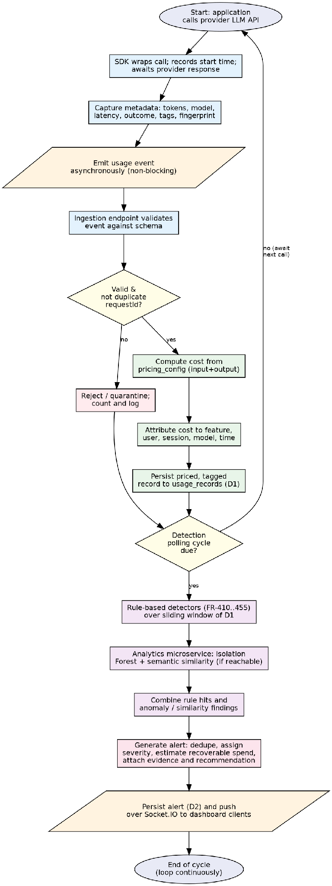
Figure 5 — Overall system algorithm (per-call path and detection cycle)

14.2 Duplicate prompt detection
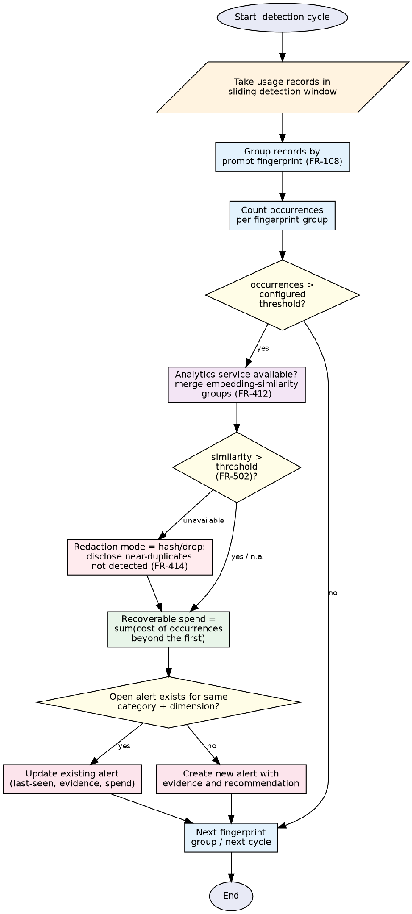
Figure 6 — Duplicate prompt detection

14.3 Retry loop detection
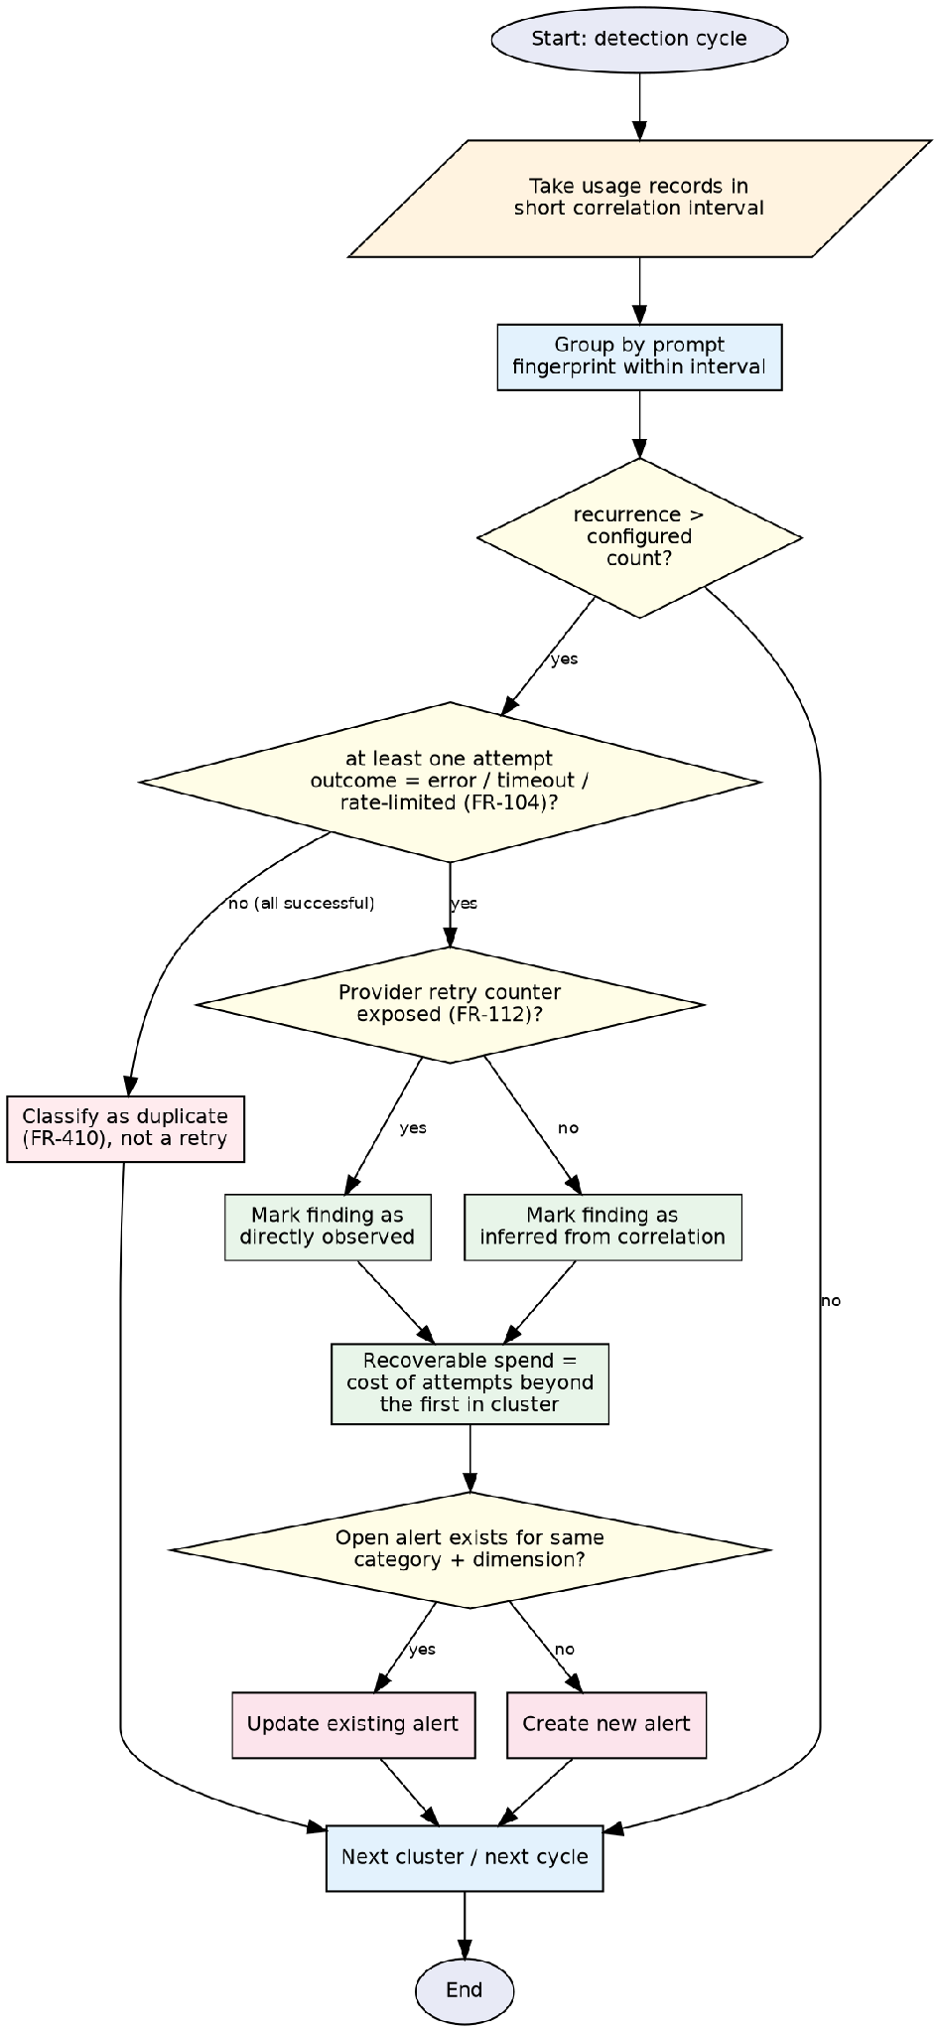
Figure 7 — Retry loop detection

14.4 Unbounded conversation context detection
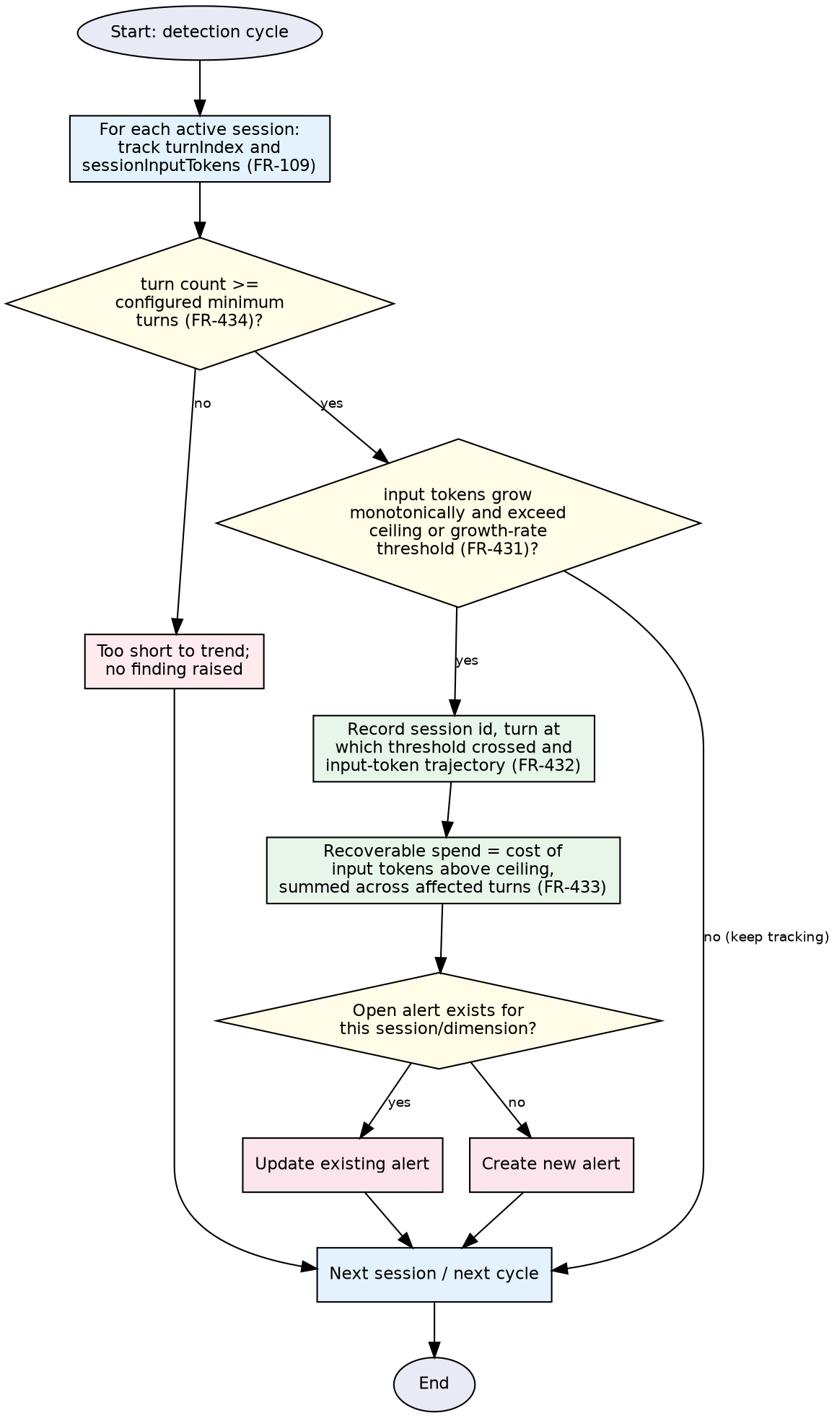
Figure 8 — Unbounded conversation context detection

14.5 Oversized prompt detection
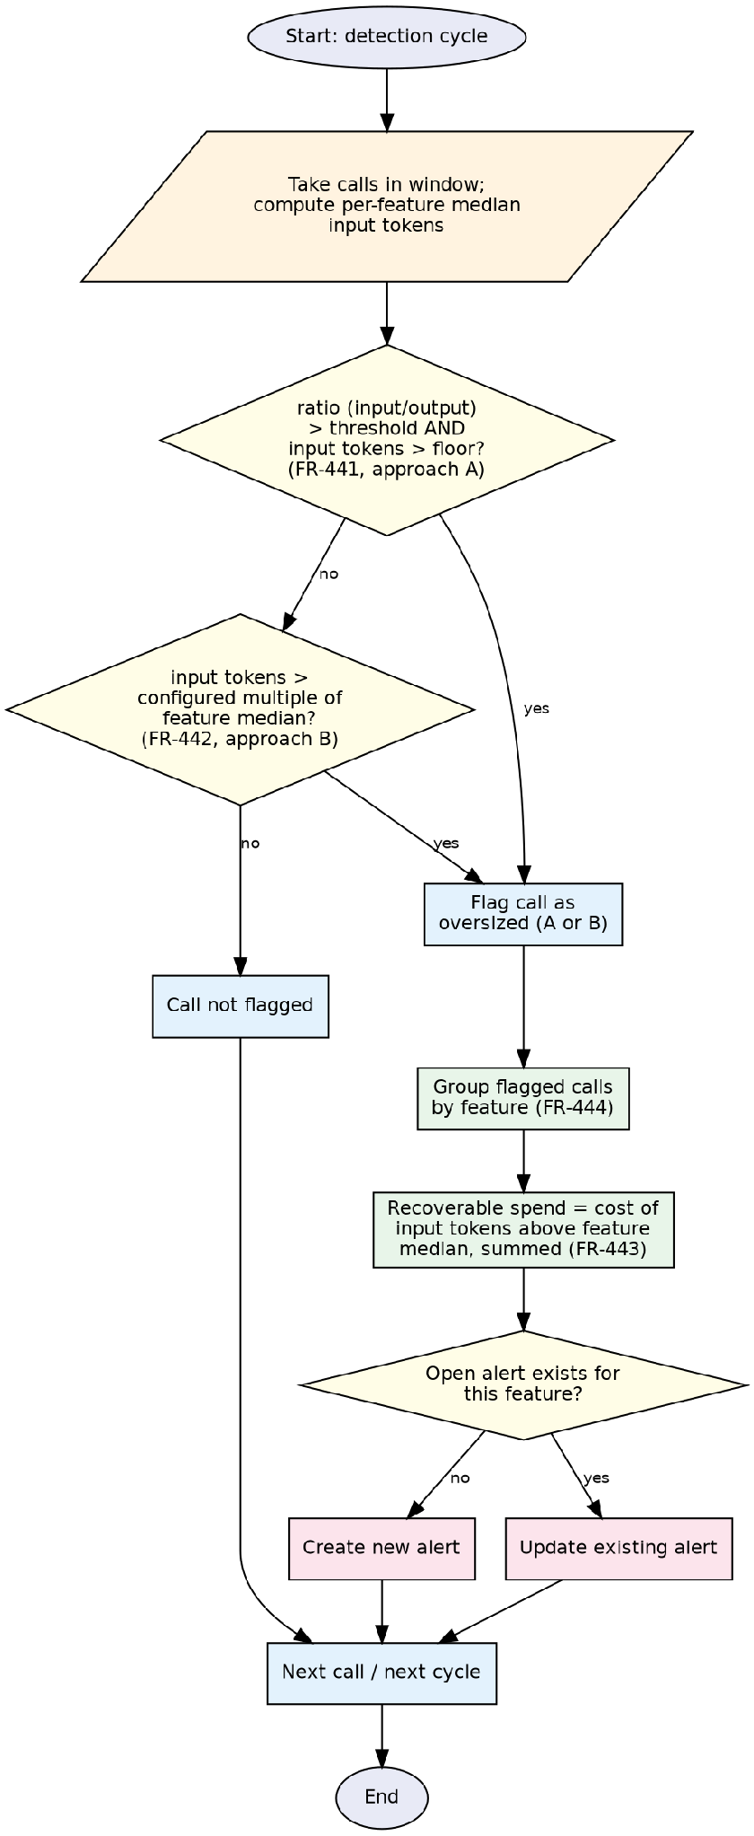
Figure 9 — Oversized prompt detection (approaches A and B)

14.6 Spend spike detection
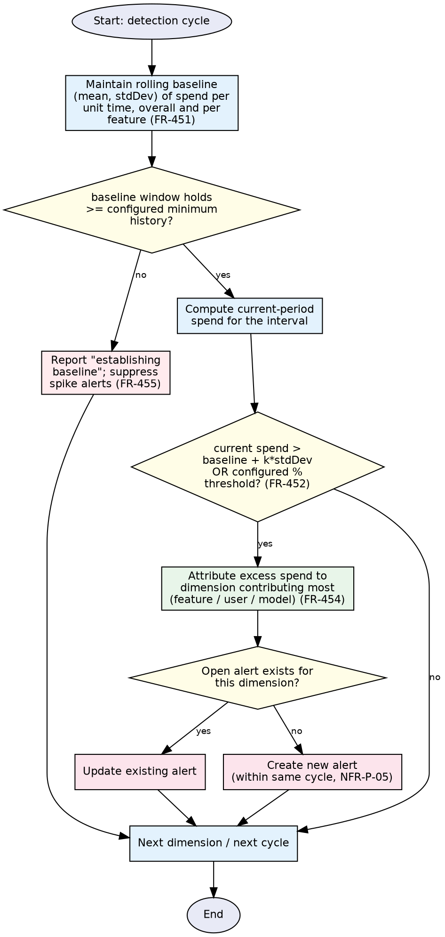
Figure 10 — Spend spike detection

14.7 Isolation Forest anomaly detection
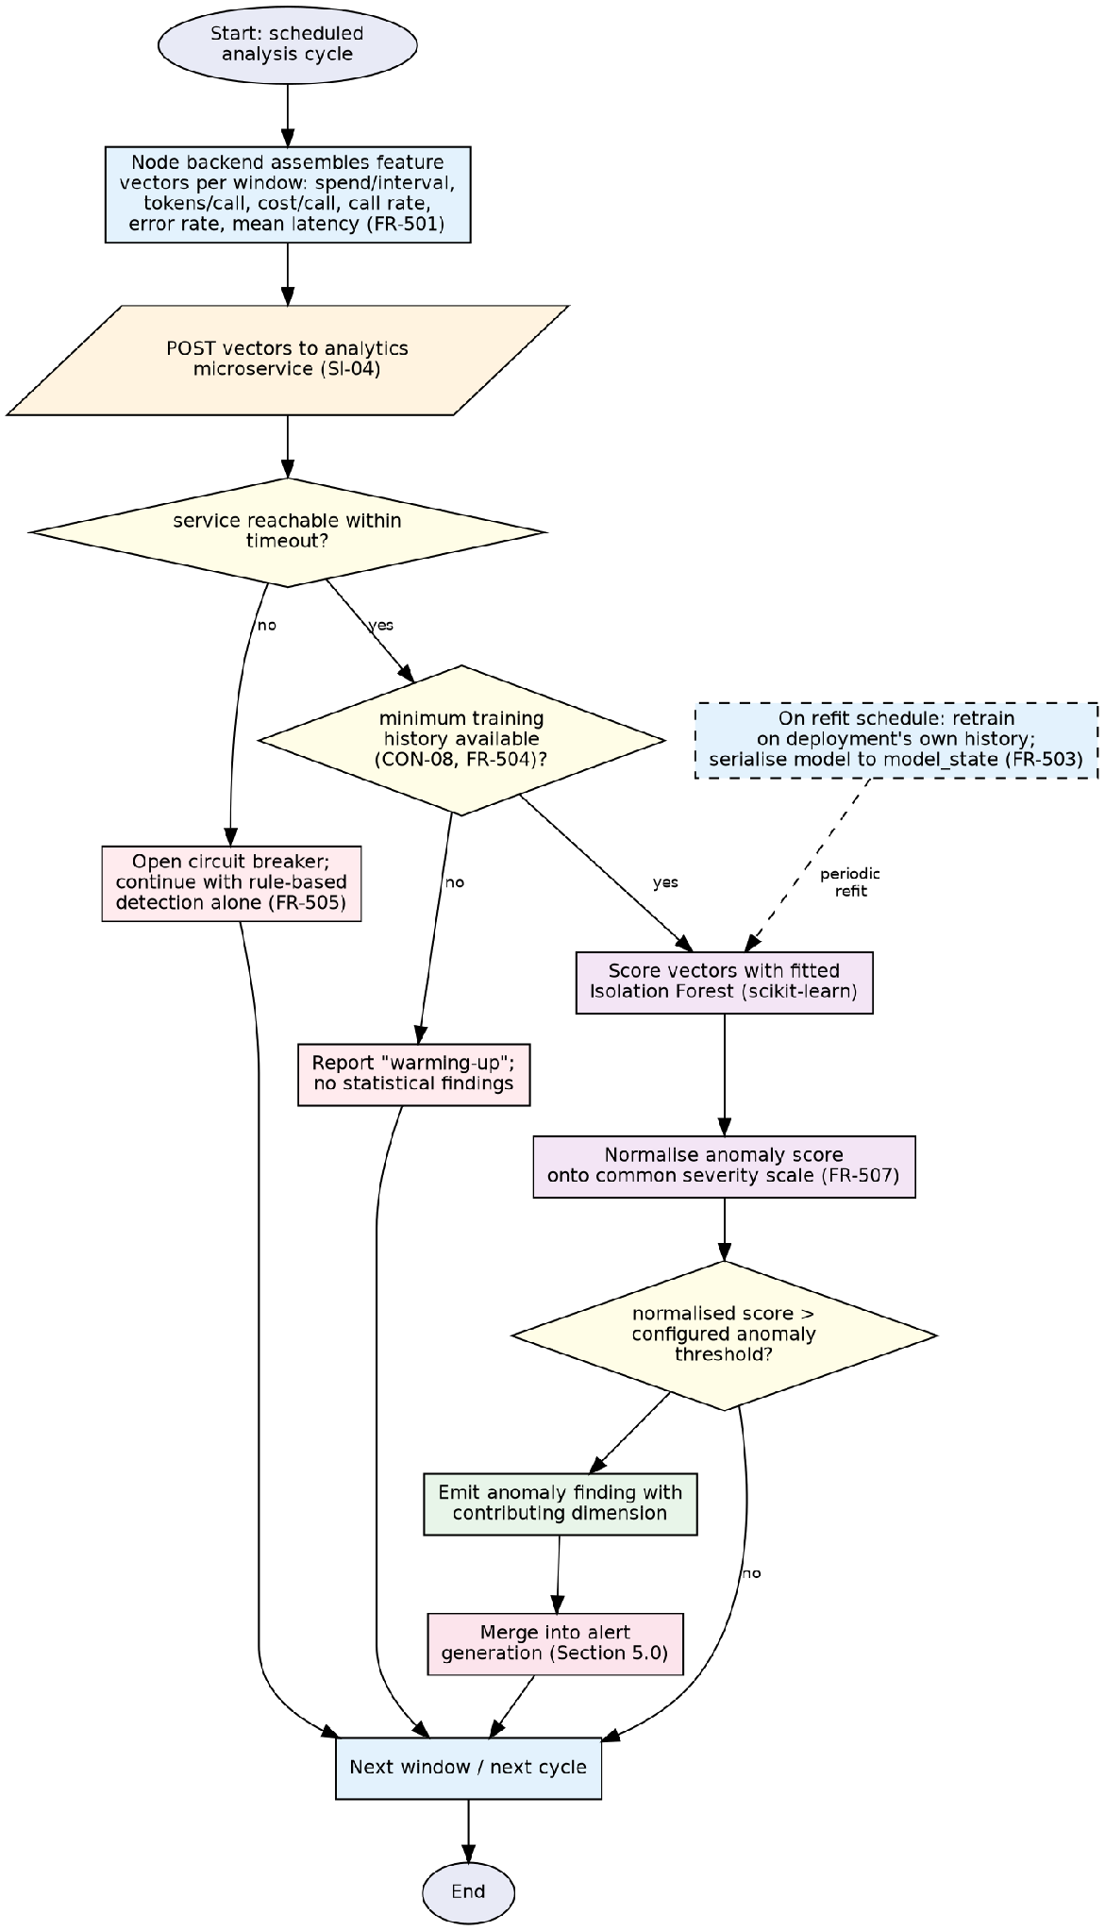
Figure 11 — Isolation Forest anomaly detection

14.8 Semantic duplicate detection
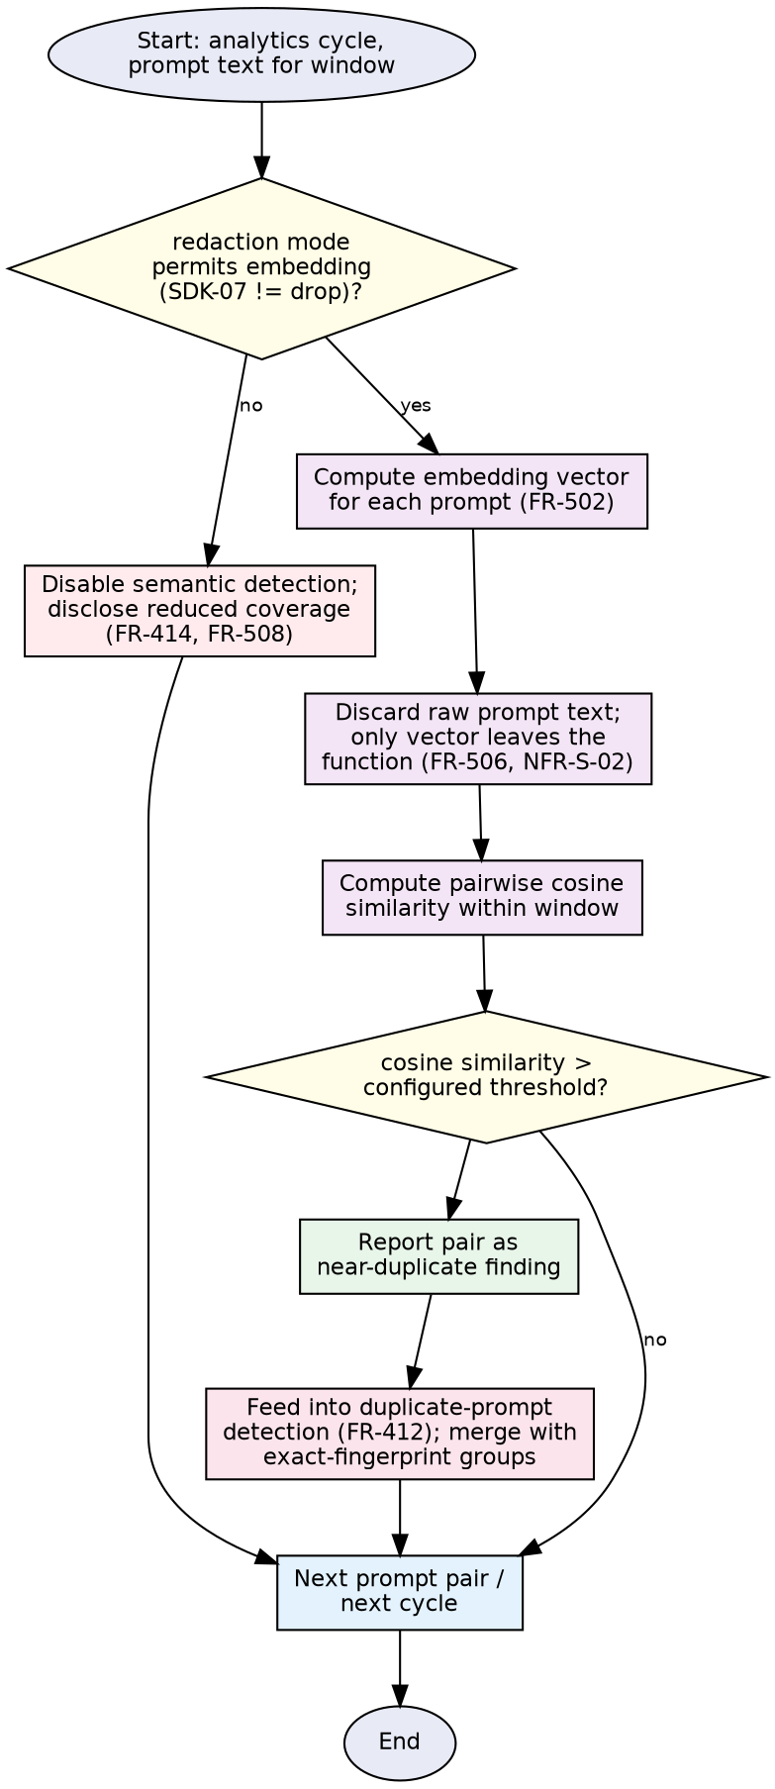
Figure 12 — Semantic (embedding-based) duplicate detection

15. COMPLEXITY ANALYSIS
The complexities below assume n usage records in the active detection window, s active sessions, f distinct feature tags, d distinct values of the dimension being aggregated, and, for the Isolation Forest, t trees each fitted on a sub-sample of ψ observations. All grouping operations are implemented with hash maps keyed by the grouping field (fingerprint, sessionId or feature), which is what keeps them linear rather than quadratic in n.
Algorithm | Time complexity | Space complexity | Notes / assumptions
Cost calculation (Sec. 3) | O(n log k) | O(1) per record | k = rate entries for the model; binary/ordered search on effectiveFrom per record.
Cost attribution (Sec. 4) | O(n) | O(d) | Single hash-map pass per dimension; previous-window comparison repeats the same pass once more.
Duplicate prompt detection (Sec. 5) | O(n) | O(n) | Hash-map grouping by promptHash; one pass to group, one to sum recoverable spend.
Retry loop detection (Sec. 6) | O(n) | O(n) | Structurally identical to duplicate detection, over a shorter interval.
Unbounded context detection (Sec. 7) | O(n) | O(s) | One pass per session over its ordered turns; trajectory stored per session.
Oversized prompt detection (Sec. 8) | O(n log n) | O(n) | Dominated by the per-feature median (Approach B), computed by sorting each feature group.
Spend spike detection (Sec. 9) | O(n) | O(d) | Rolling mean/standard deviation updated incrementally (Welford's method) per dimension.
Isolation Forest scoring (Sec. 10) | O(t log ψ) per scored vector | O(t · ψ) | Standard isolation-tree complexity [R6]; refitting is O(t · ψ log ψ) and runs off the scoring path.
Semantic duplicate detection (Sec. 11) | O(n · e + n²) | O(n) | e = per-prompt embedding cost (model-dependent); n² from naive pairwise cosine similarity over the window, acceptable at the window sizes CON-08/NFR-P-08 target.
Alert generation (Sec. 12) | O(m) | O(a) | m = number of findings in the cycle; a = number of open alerts; dedup lookup is O(1) via hash map on (category, dimension).
Detection cycle, overall (Sec. 13) | O(n log n) | O(n) | Dominated by oversized-prompt median computation; all other detectors are linear in n.

16. CONFIGURABLE PARAMETERS AND THRESHOLDS
FR-801 requires every detection threshold to be readable and changeable at runtime, taking effect on the next detection cycle without a restart. Per Appendix C (OI-01) of the SRS, the seeded default values for these thresholds are not yet fixed at the time of this baseline; they are to be set empirically from the first leak-injection runs (Milestone M3) rather than assumed here. The table below therefore states the parameters this design's algorithms consume and the requirement that makes each configurable, without asserting numeric defaults the SRS does not specify.
Parameter | Consumed by | Configurability requirement | Default
Duplicate occurrence threshold | Sec. 5 | FR-411, FR-801 | Not yet fixed (SRS Appendix C, OI-01)
Retry recurrence threshold / short interval | Sec. 6 | FR-421, FR-801 | Not yet fixed (OI-01)
Context ceiling / growth-rate threshold | Sec. 7 | FR-431, FR-801 | Not yet fixed (OI-01)
Minimum turn count | Sec. 7 | FR-434, FR-801 | Not yet fixed (OI-01)
Oversized-prompt ratio threshold and input floor | Sec. 8 (Approach A) | FR-441, FR-801 | Not yet fixed (OI-01)
Feature-median multiplier | Sec. 8 (Approach B) | FR-442, FR-801 | Not yet fixed (OI-01)
Spend-spike standard-deviation / percentage threshold | Sec. 9 | FR-452, FR-801 | Not yet fixed (OI-01)
Minimum baseline history | Sec. 9 | FR-455, FR-801 | Not yet fixed (OI-01)
Embedding similarity threshold | Sec. 11 | FR-502, FR-801 | Not yet fixed (OI-01)
Isolation Forest anomaly threshold | Sec. 10 | FR-501, FR-801 | Not yet fixed (OI-01)
Detection window length / polling-cycle length | Secs. 5-13 | FR-401, FR-801 | Not yet fixed (SRS Appendix C, OI-02)
Alert cap per category per hour | Sec. 12 | FR-610, FR-801 | Not yet fixed (OI-01)
Severity band boundaries | Sec. 12 | FR-603, FR-801 | Not yet fixed (SRS Appendix C, OI-05)
Usage-record / resolved-alert retention window | Sec. 2 (windowing) | FR-803, NFR-D-01 | 90 days

17. ALGORITHM VALIDATION AND TEST CASES
Detection quality is verified against the leak-injection test suite required by SRS Section 8.3 (TST-01 to TST-05): a generator synthesises traffic containing each of the five rule-based leak categories with a recorded ground truth (TST-01), plus a clean control workload containing no injected leaks (TST-02), against which the acceptance targets of NFR-Q-02 (≥ 90% recall on duplicate-prompt and retry-loop cases) and NFR-Q-03 (≤ 10% false positives on the clean workload) are measured. Representative cases for each algorithm are given below; exact expected values depend on the injected parameters and the threshold configuration in force (Section 16) and are established at test-execution time, not asserted here.
Input / scenario | Expected detection | Expected evidence / output
Same prompt fingerprint replayed N times within the detection window, N above the configured occurrence threshold | Duplicate-prompt hit (Sec. 5) | Alert with category duplicate_prompt, occurrence count, recoverable spend = cost of the N−1 repeats, evidence = contributing requestIds
Same prompt fingerprint recurs rapidly, correlated with error/timeout/rate-limited outcomes | Retry-loop hit (Sec. 6), not a duplicate hit | Alert with category retry_loop, basis (observed or inferred per FR-422), recoverable spend = cost of attempts beyond the first
Session input-token count grows monotonically past the configured ceiling over ≥ minimum turns | Unbounded-context hit (Sec. 7) | Alert with sessionId, crossing turn, token trajectory, recoverable spend from excess tokens
Calls with high input/output ratio and input tokens above the floor, or above the feature median multiple | Oversized-prompt hit (Sec. 8), grouped by feature | Alert per feature with recoverable spend from tokens above the feature median
Spend for a window departs from the rolling baseline by more than the configured standard-deviation or percentage threshold | Spend-spike hit (Sec. 9), flagged within one polling cycle | Alert naming the dimension contributing most of the excess (FR-454), observed value and baseline
Prompts that are semantically equivalent but not byte-identical (paraphrases, template variants) | Semantic near-duplicate finding (Sec. 11), merged into duplicate-prompt alert via FR-412 | Similarity score above threshold; distinguished from Sec. 5 results by TST-05
Feature vectors reflecting an unusual combination of call rate, latency and error rate with no single threshold breached | Isolation Forest anomaly finding (Sec. 10) | Normalised anomaly score above threshold, contributing dimension named
Clean control workload with no injected leaks | No hits, or hits within the NFR-Q-03 false-positive budget (≤ 10%) | No alert raised, or an alert correctly reflecting genuine (non-injected) workload behaviour

18. TRACEABILITY TO SRS
Algorithm | Relevant SRS requirements | Purpose
Cost calculation (Sec. 3) | FR-301, FR-302, FR-303, FR-304, FR-305, FR-309 | Convert token counts into a versioned, immutable, auditable cost per call
Cost attribution (Sec. 4) | FR-306, FR-307, FR-310, BR-04 | Roll priced records up by feature, user, model, session and time, with untagged spend explicit
Duplicate prompt detection (Sec. 5) | FR-108, FR-411, FR-412, FR-413, FR-414 | Identify repeated computation of an already-available result
Retry loop detection (Sec. 6) | FR-104, FR-112, FR-421, FR-422, FR-423, FR-424 | Identify billed repetition caused by error/timeout/rate-limit retries
Unbounded context detection (Sec. 7) | FR-109, FR-431, FR-432, FR-433, FR-434 | Identify superlinear cost growth from unbounded conversation history
Oversized prompt detection (Sec. 8) | FR-441, FR-442, FR-443, FR-444 | Identify prompts large in absolute terms or relative to their feature's baseline
Spend spike detection (Sec. 9) | FR-451, FR-452, FR-453, FR-454, FR-455, NFR-P-05 | Identify aggregate spend departing from a deployment's own established pattern
Isolation Forest anomaly detection (Sec. 10) | FR-501, FR-503, FR-504, FR-505, FR-507, CON-08, NFR-P-08 | Identify multivariate anomalies no single rule expresses
Semantic duplicate detection (Sec. 11) | FR-412, FR-502, FR-506, FR-508, NFR-S-02 | Identify near-duplicate (not byte-identical) prompts
Alert generation (Sec. 12) | FR-601 to FR-611 | Convert detector findings into deduplicated, evidenced, actionable alerts
Overall end-to-end algorithm (Sec. 13) | FR-201-211, FR-401-406, CON-06, NFR-P-01, NFR-P-02 | Compose the per-call and detection-cycle paths into one pipeline

19. CONCLUSION
This document has set out the algorithmic design by which the API Cost Leak Profiler converts an observed LLM call into a priced, attributed record and, over accumulated windows of such records, into an explained and quantified alert. Two deterministic pricing and attribution algorithms establish cost as the unit of analysis; five deterministic rule-based detectors — duplicate prompts, retry loops, unbounded context, oversized prompts and spend spikes — cover the leak categories the SRS specifies, and are designed to run unconditionally regardless of the availability of any other component; and two statistical/semantic algorithms, Isolation Forest anomaly scoring and embedding-based semantic similarity, extend detection to patterns no fixed threshold can express, while degrading gracefully rather than compromising the deterministic tier when unavailable. A common alert-generation algorithm merges the output of all seven detectors into a single, deduplicated, evidenced artefact. Taken together, the combination of deterministic rules and statistical/semantic algorithms is what allows the system to attribute cost precisely, detect the five specified categories of waste, and explain every alert it raises in terms of the rule or model that fired, the threshold applied and the evidence observed.

20. REFERENCES
SRS — API Cost Leak Profiler: Software Requirements Specification, Release 1.0 (baselined 11 September 2026), Department of Computer Engineering, Sardar Patel Institute of Technology (the source document for this design).
[R1] P1 — API Cost Leak Profiler: Problem Definition, Semester V Mini Project, Department of Computer Engineering, Sardar Patel Institute of Technology.
[R2] P2 — API Cost Leak Profiler: Literature Survey and Competitive Analysis, ibid.
[R3] P3 — API Cost Leak Profiler: Project Presentation, ibid.
[R4] P4 — API Cost Leak Profiler: Project Planning and Methodology, ibid.
[R6] F. T. Liu, K. M. Ting and Z.-H. Zhou, "Isolation Forest," in Proc. 8th IEEE International Conference on Data Mining (ICDM), 2008, pp. 413-422.
[R7] L. Chen, M. Zaharia and J. Zou, "FrugalGPT: How to Use Large Language Models While Reducing Cost and Improving Performance," arXiv:2305.05176, 2023.
[R8] F. Bang, "GPTCache: An Open-Source Semantic Cache for LLM Applications," in Proc. 3rd Workshop for Natural Language Processing Open Source Software, 2023.
[R9] OpenAI, API Pricing and API Reference — Usage Object, platform.openai.com.
[R10] Google, Gemini API Pricing and Token Counting, ai.google.dev.
[R11] MongoDB Inc., MongoDB Manual — Time Series and Aggregation Pipeline, and Mongoose Documentation.
[R13] F. Pedregosa et al., "Scikit-learn: Machine Learning in Python," Journal of Machine Learning Research, vol. 12, pp. 2825-2830, 2011.

