P4 — PROJECT PLANNING
API Cost Leak Profiler
Work Breakdown, Timeline, Risk Register & Evaluation Plan
Submitted by: Shrey Sawant, Jay Patil, Pranav Gadge
Department: Computer Engineering
Institution: Sardar Patel Institute of Technology (S.P.I.T.), Mumbai
Guide: Dr. Sudhir Dhage
Co-Guide: Prof. Ameya Nile
Proposed Stack: MERN (MongoDB, Express.js, React.js, Node.js) + Python (FastAPI) for the analytics layer
Project Window: 11 August 2026 – 28 November 2026 (Semester V, A.Y. 2026–27)
Date: 12 August 2026

1. Purpose and Planning Approach
P1 fixed the problem, and P2 confirmed the gap against real tooling and grounded the technical design in citable literature. This document, P4, turns that scope into an executable plan: a work breakdown structure, a week-wise timeline against the Semester V academic calendar, a risk register, and an evaluation plan mapped directly to the measurable success criteria already fixed in P1 §6.
The plan is deliberately sequenced so that the riskiest and most architecturally load-bearing pieces — the SDK capture layer and the Node.js ↔ Python FastAPI integration — are built and de-risked early, while the analytics layer and dashboard polish, which depend on that foundation being stable, are scheduled later. This mirrors the Working Methodology phases already defined in the original proposal (Request Monitoring → Analysis → Dashboard) but expands each phase into weekly, trackable units of work.

2. Development Methodology
The project follows a phased-Agile approach: six sequential phases (Section 3), each broken into weekly iterations with a working, demoable increment at the end of every phase rather than at the end of the semester alone. This keeps the project reviewable at the College's Mid-Term and Final evaluation checkpoints without a last-minute integration crunch.

Guiding Principles
- Build the observational SDK and data path first — every later phase (rules, analytics, dashboard) depends on trustworthy captured data.
- Keep the rule-based detector and the Python analytics layer decoupled behind a clean internal API, so either can be developed, tested, and demoed independently.
- Treat the P1 Non-Goals as hard scope boundaries for every phase review, not just a one-time note — proxying, multi-tenant auth, and auto-remediation stay out of v1.
- Validate continuously against the P1 Success Criteria table (Section 8) rather than only at the final demo.

2A. System Architecture (Reference Diagram)
Added for reference alongside the work breakdown below: a layered view of the MERN + FastAPI stack proposed in this document, shown top to bottom in the conventional N-tier order — presentation, API/gateway, business logic, and analytics sitting above the data layer, with the instrumented application and the LLM provider it calls directly shown as the external, bottom-most layer. The side arrow marks the direction captured data actually travels: up from instrumentation through storage, analytics, and business logic to the API and dashboard.
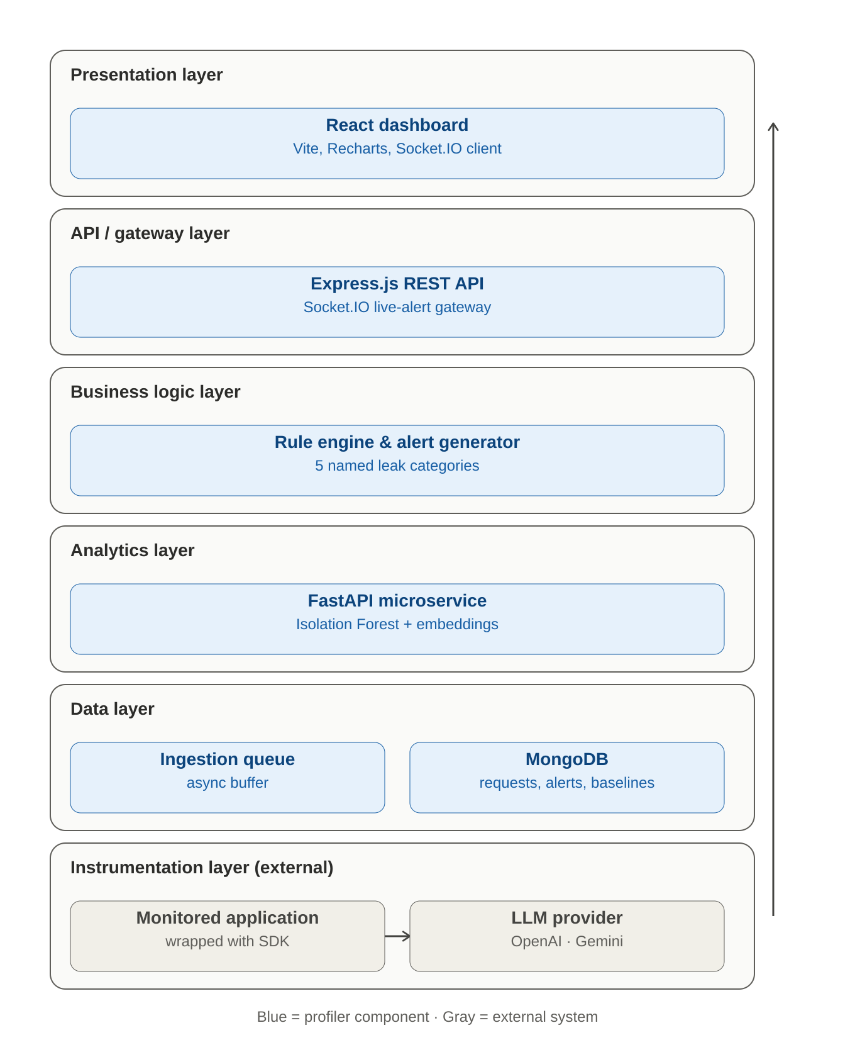
Figure: six-tier layered architecture — presentation, API/gateway, business logic, analytics, data, and instrumentation (external) layers. Blue = profiler component, gray = external system.

3. Work Breakdown Structure
The v1 scope from P1 §6 decomposes into seven phases. Phase numbering starts at 0 because environment setup and document finalisation are already partly underway alongside P1–P3.
Phase | Focus | Scope Covered
Phase 0 | Planning & Environment Setup | Repo scaffolding for MERN + FastAPI, MongoDB schema design, versioned provider-pricing config table, finalised P1–P4 documents.
Phase 1 | SDK & Ingestion Layer | Thin Node.js SDK wrapper around OpenAI / Gemini calls, async metadata emit, ingestion queue, MongoDB persistence, base Express REST API.
Phase 2 | Rule Engine & Dashboard MVP | Five canonical rule-based leak detectors, alert generator, React dashboard skeleton, Socket.IO live-alert channel.
Phase 3 | Python FastAPI Analytics Microservice | Isolation Forest anomaly-detection service, embedding-based semantic duplicate-prompt detector, Node ↔ FastAPI integration contract.
Phase 4 | Dashboard Analytics & Polish | Feature-wise / user-wise cost breakdowns, trend charts, cost-leak explanations surfaced in the UI.
Phase 5 | Testing & Evaluation | Synthetic leak-injection test suite, measurement against every row of the P1 Success Criteria table, bug fixing.
Phase 6 | Documentation, Demo & Final Review | Final report, demo script / recording, viva preparation, submission packaging.

4. Team and Workstreams
The project is executed individually by Shrey under the guidance of Dr. Aman Yadav. To keep a single-contributor timeline realistic, the work is organised into four workstreams rather than calendar-parallel tracks — each is completed and stabilised before the next depends on it, though minor cross-workstream polishing (e.g. dashboard styling) can run alongside later back-end work.
Workstream | Covers | Mapped Phase(s)
A — Ingestion & SDK | Node.js SDK wrapper, async ingestion queue, MongoDB schema & persistence | Phases 0–1
B — Detection & Dashboard MVP | Rule engine, alert generator, Express REST API, React dashboard skeleton, Socket.IO | Phase 2
C — Analytics Microservice | Python FastAPI service: Isolation Forest, embedding similarity, Node integration | Phase 3
D — Analytics, Testing & Docs | Dashboard analytics, leak-injection test suite, evaluation, final report & demo | Phases 4–6

5. Week-Wise Timeline
Sixteen weeks across Semester V (11 August – 28 November 2026), aligned to the College's Mid-Term Review (≈ Week 8) and Final Review (Week 16).
Wk | Dates | Phase | Focus / Deliverable
1 | 11–17 Aug | Phase 0 | Repo scaffolding (MERN + FastAPI); MongoDB schema draft; P1–P3 finalised.
2 | 18–24 Aug | Phase 0 | Versioned provider cost-config table; dev environment & CI hygiene; P4 finalised.
3 | 25–31 Aug | Phase 1 | Node.js SDK wrapper for OpenAI calls; capture timestamp, tokens, model, latency.
4 | 1–7 Sep | Phase 1 | Extend SDK to Gemini; async metadata emit; ingestion queue (in-memory → buffered).
5 | 8–14 Sep | Phase 1 | MongoDB persistence layer; base Express REST API; SDK integration test app. — M2
6 | 15–21 Sep | Phase 2 | Rule detectors: duplicate prompts, retry loops (exact / correlated).
7 | 22–28 Sep | Phase 2 | Rule detectors: unbounded context, oversized prompts, spend-spike baseline; alert generator.
8 | 29 Sep – 5 Oct | Phase 2 | React dashboard skeleton; Socket.IO live alerts. — M3 / Mid-Term Review
9 | 6–12 Oct | Phase 3 | FastAPI service scaffold; Isolation Forest training pipeline on seeded traffic.
10 | 13–19 Oct | Phase 3 | Embedding-based semantic duplicate detector; similarity-threshold tuning.
11 | 20–26 Oct | Phase 3 | Node ↔ FastAPI integration contract; graceful fallback to rule-only mode. — M4
12 | 27 Oct – 2 Nov | Phase 4 | Feature-wise & user-wise cost breakdown views; trend charts (Recharts).
13 | 3–9 Nov | Phase 4 | Alert UI, root-cause explanations in-dashboard, daily/monthly reports. — M5
14 | 10–16 Nov | Phase 5 | Synthetic leak-injection test suite build-out (duplicate / retry / spike generators).
15 | 17–23 Nov | Phase 5 | Full run against P1 Success Criteria table; bug fixing; performance tuning. — M6
16 | 24–28 Nov | Phase 6 | Final report, demo script & recording, viva preparation, submission. — M7

6. Milestones and Deliverables
ID | When | Milestone | Definition of Done
M1 | End Wk 2 | Environment & Schema Ready | Working MERN + FastAPI scaffold; MongoDB schema; cost-config table.
M2 | End Wk 5 | SDK & Ingestion | Working SDK wraps OpenAI + Gemini calls; metadata persisted asynchronously to MongoDB.
M3 | End Wk 8 | Rule Engine + Dashboard MVP | 5 rule detectors live; alerts fire; dashboard skeleton renders real data. Mid-Term Review.
M4 | End Wk 11 | Analytics Microservice Integrated | FastAPI service reachable from Node; Isolation Forest + semantic duplicate detection live.
M5 | End Wk 13 | Dashboard Analytics Complete | Feature/user cost breakdowns, trend charts, and alert explanations fully wired.
M6 | End Wk 15 | Success Criteria Validated | Leak-injection suite run; results measured against every P1 §8 target.
M7 | Wk 16 | Final Submission & Demo | Final report, live/recorded demo, viva-ready walkthrough.

7. Sprint Cadence and Review Cycle
Work is tracked in two-week sprints nested inside the phases above, each closing with a short self-review against that sprint's target deliverable before the next sprint opens.
- Sprint length: 2 weeks, aligned to the week-wise timeline in Section 5 (8 sprints total).
- End-of-sprint check: does the increment run end-to-end, even if incomplete — a partially-featured but working path is prioritised over a fully-featured but broken one.
- Phase-end check: re-validate against the relevant P1 Non-Goals so scope does not silently expand (e.g. Phase 3 must not grow into a hosted, multi-tenant analytics platform).
- Guide check-ins: aligned to the College's Mid-Term (≈ Week 8) and Final (Week 16) review slots, with the Working Methodology phases from the original proposal used as the shared reference points with Dr. Sudhir Dhage and Prof. Ameya Nile.

8. Testing and Evaluation Plan
Every row below reproduces a target already fixed in P1 §8 (Success Criteria) and pairs it with the concrete test method used to validate it, executed in Phase 5 and re-checked at every phase-end review from Phase 2 onward.
Success Criterion (P1 §8) | Target | Test Method
Ingestion overhead added to the request path | < 5 ms (async emit only) | Timing harness wraps 10,000 SDK calls; measures added latency vs. an unwrapped baseline call.
Logged requests attributable to a feature / user | ≥ 95% | Replay a labelled traffic sample through the SDK; compute the % of logged documents carrying a valid feature/user tag.
Recall on injected duplicate-prompt / retry-loop cases | ≥ 90% | Synthetic leak-injection generator seeds known duplicate and retry patterns into test traffic; recall computed against the injected ground truth.
Dashboard render time for a 30-day trend view | < 2 s | Browser performance timing on a seeded 30-day dataset, measured on the target demo hardware.
Time to flag an injected synthetic spend spike | ≤ 1 polling cycle | Injected spike traffic timestamped; alert-generation timestamp compared against the next scheduled polling cycle.

Additional Test Layers
- Unit tests on the rule engine's five detectors, each with hand-crafted positive and negative fixtures.
- Contract tests on the Node ↔ FastAPI boundary, including the fallback path when the analytics microservice is unreachable.
- Manual dashboard QA against the College's demo dataset before the Final Review.

9. Tools, Environment and Technology Setup
Layer | Tools / Technologies
Backend | Node.js (LTS) + Express, Mongoose ODM
Analytics Service | Python 3.11, FastAPI, scikit-learn (Isolation Forest), sentence embeddings for semantic similarity
Frontend | React.js (Vite), Chart.js / Recharts, Socket.IO client
Database | MongoDB (local for dev, Atlas free tier for demo)
Async / Scale-out (optional) | Redis + BullMQ for ingestion buffering beyond the single-worker reference deployment
APIs Profiled | OpenAI API, Google Gemini API
Dev & Test Tooling | Git & GitHub, Postman, npm, VS Code, pytest (FastAPI service), Jest (Node)

10. Risk Register
Risk | Likelihood | Impact | Mitigation
Node ↔ Python integration adds latency or a new failure mode | Med | High | Define a thin REST contract early (Phase 3, Week 9); rule engine keeps functioning stand-alone if the analytics service is unreachable.
Isolation Forest cold-start — no historical baseline for a fresh deployment | High | Med | Ship a synthetic seed dataset for demo purposes; analytics layer activates only past a minimum-data threshold, rule-based detection covers the gap until then.
Real OpenAI / Gemini API cost during development and load testing | Med | Low | Use a mock / replay traffic generator for the bulk of testing; cap and monitor spend on real-API test runs.
Semantic duplicate-detector accuracy sensitive to similarity threshold | Med | Med | Benchmark against the reported GPTCache / GPT Semantic Cache figures (P2 §6.4–6.5); tune on the leak-injection suite before Phase 5 sign-off.
Single-contributor bottleneck across a full-stack + analytics scope | Med | High | Strict WBS sequencing (Section 3); reuse of MERN boilerplate; time-boxed spikes capped at 2 days before escalating to the guide.
Scope creep beyond P1 §7 Non-Goals | Low | High | Every phase-end review explicitly re-checks the Non-Goals list (Section 7); no proxying, multi-tenant auth, or auto-remediation enters v1.
Academic-calendar compression alongside other Semester V coursework | Med | Med | Two-week sprint buffers already built into the 16-week timeline; Phase 6 reserved solely for documentation, not new features.

11. Deliverables Checklist
Consolidated against the APNI Leap — Foundation Integration Course framework's mini-project documentation requirements.
- P1 — Problem Definition (complete)
- P2 — Study of Existing / Related Systems, with literature survey (complete)
- P3 — Presentation deck (complete)
- P4 — Project Planning (this document)
- Working prototype: SDK, rule engine, FastAPI analytics microservice, React dashboard
- Synthetic leak-injection test suite and evaluation results against P1 §8
- Final report consolidating P1–P4 and the evaluation outcomes
- Live or recorded demo walkthrough for the Final Review

12. Conclusion
This plan converts the v1 scope fixed in P1 into sixteen weekly, trackable units of work across six phases, with the architecturally riskiest integration — the Node.js SDK and the Python FastAPI analytics boundary — sequenced early enough to be de-risked before the dashboard and evaluation work depend on it. Every milestone in Section 6 and every test in Section 8 traces back to a specific line in P1 or P2, so progress against this plan is also, directly, progress against the problem and the research gap already established for this project.

