**Flask Application**

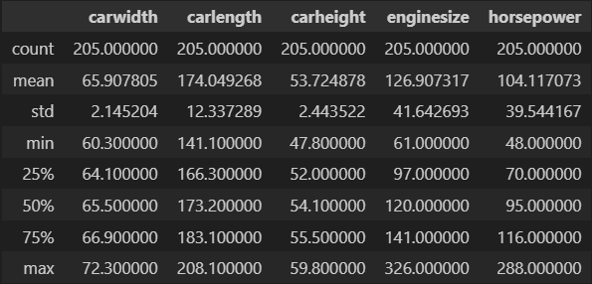**The Dataset and Model**



*Fig 1. Dataset Description Fig 2. Model Accuracy*

The dataset used in this application is a multivariate dataset from UCI Machine Learning Repositories called "Automobile." It consists of 25 features and 205 instances, although only 5 of them were used to train the model. These features, notably 'carwidth', 'carlength', 'carheight', 'enginesize', and 'horsepower', were the most relevant features to include in training a linear regression model. The data used to train the model was neither preprocessed nor scaled for simpler implementation in the Flask application inputs.

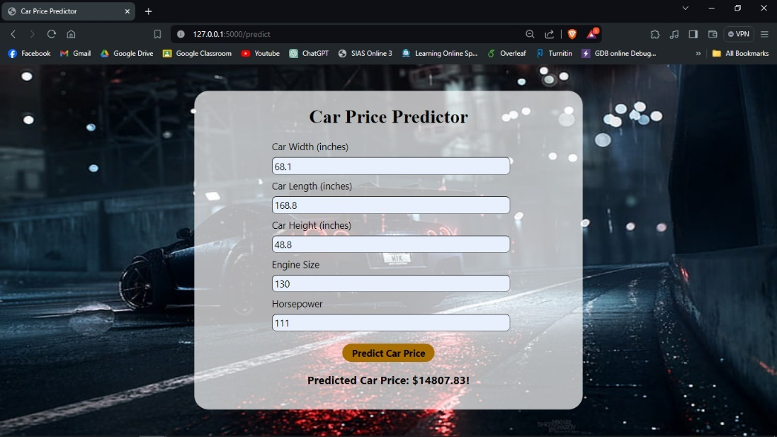**The Output**

*Fig 3. Flask Application Output*

To implement the model with Flask, a basic html form was developed. The form prompts the user to provide the five input features applied in the Linear Regression model. Because the input in the form is not scaled, the model was also trained using the raw dataset. The model predicts that increasing horsepower and engine capacity will result in a large rise in car price when compared to other features. Overall, the model performs according to expectations and is acceptable.