**Store data from IoT sensor to MySQL using**

**Arduino IDE and Processing IDE v2.2.1**

**Overview**

The main purpose of this system is to store the data that is generate by IoT sensor through the Arduino Mega to MySQL directly.

For this system, we use ultrasonic sensor (HC-SR04) as the example of IoT sensor.

**Libraries**

This system is required to import 3 packages for Processing IDE including:

1. de.bezier.data.sql.mapper.* - this package is used to map database names to instance names.
2. de.bezier.data.sql.* - this package is used to import MySQL library
3. processing.serial.* - this package allows communicating using the serial communication protocol.

**Materials**

1. Arduino Mega

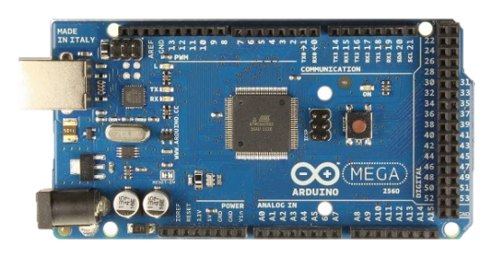

Figure 1: Arduino Mega

1. Ultrasonic sensor (HC-SR04)

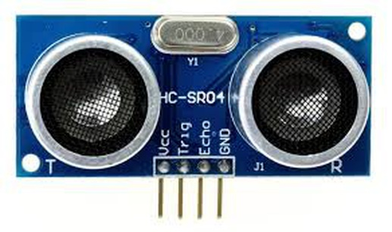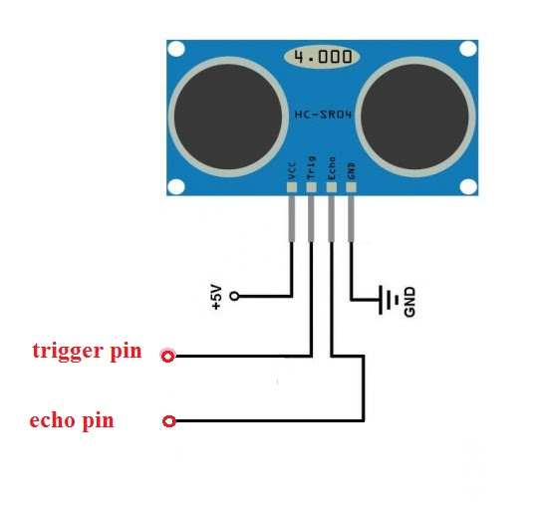

Figure 2: HC-SR04

Figure 3: HC-SR04 Pinout

1. Arduino IDE
2. Processing IDE v2.2.1
3. Wamp OR Xampp Server

**Installation**

How to install Arduino IDE?

For Linux: https://www.arduino.cc/en/Guide/Linux (see also the Arduino playground page https://playground.arduino.cc/Learning/Linux)

For macOS X: <https://www.arduino.cc/en/Guide/MacOSX>

For Windows: <https://www.arduino.cc/en/Guide/Windows>

How to install Processing IDE v2.2.1?

Download from <https://processing.org/download/>

How to install Wamp?

Download from <https://sourceforge.net/projects/wampserver/>

How to install Xampp?

Download from https://xampp-windows.en.softonic.com/

How to install and import BezierSQLib-0.2.0 library for Processing IDE?

Download from <https://cdn.instructables.com/ORIG/F9V/ZSGC/IUKESD09/F9VZSGCIUKESD09.zip>

Then import BezierSQLib as shown on the figure below

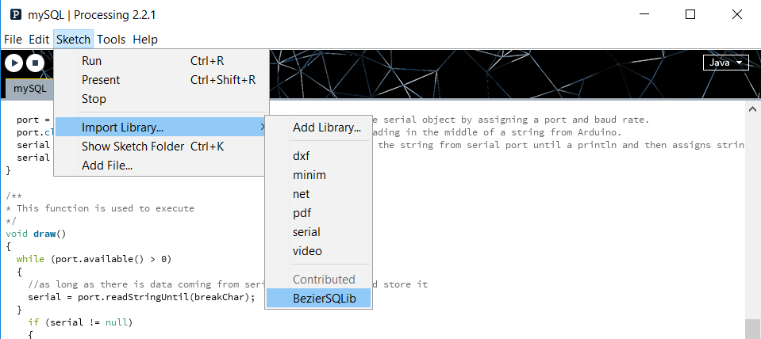

Figure 4: How to install and import BezierSQLib-0.2.0 library for Processing IDE

How to install IoT devices?

* Arduino Mega and HC-SR04 Ultrasonic sensor

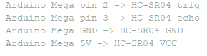

Figure 5: Connection between Arduino Mega and HC-SR04 Ultrasonic sensor

**Description of code**

* For Arduino IDE, the code is separated into 2 parts including:

1. Setup part (setup()) – this is the part to set the trigger pin and echo pin of Ultrasonic sensor. Moreover it is used to set mode of pin.
2. Execution part (loop()) - used to calculate the actual distance by applying the raw data that stems from HC-SR04 with this formula; distance = time x speed of sound.

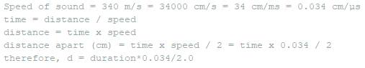

Figure 6: Distance Formula's Proof

* For Processing IDE, the code is separated into 4 parts including:

1. Packages’ import and variable’s declaration part – importing 3 packages that is stated above. Moreover, declaring and initializing the variable that will be used later.
2. Setup part (setup()) – this is the main part to initialize MySQL object to create the connection and initialize serial object by assigning a port and baud rate.
3. Execution part (draw()) – this is used to store the data coming from serial port in the MySQL database by calling the external function named exeQuery().
4. Additional function part

* exeQuery() is used to send the query to insert the data into table in MySQL database by using “msql.query()”.

**Instruction**

Step 1: Uploading Arduino code to Arduino Mega

Step 2: Setting up MySQL

* To create the table in MySQL database in Wamp OR Xampp server

Step 3: Executing the program on Processing IDE

IMPORTANT: Don't open serial monitor on Arduino while running processing IDE because port conflict will occur as both have to use the same port.