**D. Y. PATIL COLLEGE OF ENGINEERING & TECHNOLOGY,**

**KASABA BAWADA, KOLHAPUR.**

DEPARTMENT OF COMPUTER SCIENCE & ENGINEERING



**A**

**Mini Project Synopsis on**

**“T.S.I. (Teacher Student Interface)”**

**Submitted by:**

**Roll No.**    **Name**

38. Tejas Deepak Pandit.

39. Jay Avinash Powar.

51. Ajay Avinash Powar.

Under the guidance of

**Prof. A. S. Yadav.**

**Class : SE(CSE) Div : A Batch : S3 Group : G1**

**(Academic Year : 2019-20)**

**TSI – TEACHER STUDENT INTERFACE**

* **ABSTRACT :**

Practical sessions always play a very important role in School, University Etc. If the we consider fields such as Engineering then the practicals must be taken very carefully, because practical knowledge always leads to better understanding of that subject and if there is not better understanding between speaker and listener i.e. student and teacher then student may get some difficulties while doing given practical work.

In Today’s world we can observe that students are tending towards social network learning / E – Learning and digital medium for studying So the concept of TSI **Teacher Student Interface** is digital (computer-based communication) medium basically created for practicals related to computer i.e. computer based practicals. TSI will help to improvise the communication between student and teacher, the interface will be computer so it will become a lot easier for teachers to give attention to every needy student within time. If this kind of interaction is generated then overall workload to learn the concepts in practicals will gets reduced.

TSI can be created through local network by using SOCKET PROGRAMMING. It can be used in several computers to create connection between them.TSI also includes different features such as admin passkey, Add-Remove client, Send-Receive Files (program code). It is going to be very suitable solution for teaching method in practicals.

* **INTRODUCTION :**

This software can be used to make simple Interface between students and teacher so that the interaction can be done between them while performing live activities such as programming practicals, problem solving sessions. In Schools / Colleges, Computer based practicals always requires timely guidance by respective practical teachers. Teachers must make sure that every student is understanding the session. But due to time restrictions, student personal problems, etc some students do not understand that session.

* **PROBLEM STATEMENT:**

Implementing the socket programming (TCP) techniques to reduce the difficulties generating while practical sessions (related to computer practicals only).

* **PROPOSED SOLUTION:**

Socket programming can be used and, in that socket programming using client and server concept, teacher does not need to go to particular student but by using server it can easily interact (chat/communicate) with each and every student. It will not only save Time but also make interaction more practical friendly.

* **OBJECTIVES :**
  + **INTERFACE** - Create two ways interface between Students (client) and Teacher. (server)
  + **DISCUSSION** - Discussion is established between students and Teacher. (through Chats)
  + **QUERIES** - To solve problems in easy manner by understanding queries from students.
  + **SHARE** - Sharing of file resources to faculty. (server)
* **SCOPE OF PROJECT :**
  + Any Institutes or Universities.
  + Computer laboratories.
* **Proposed System Architecture**
  + Flowchart for Main System Software :

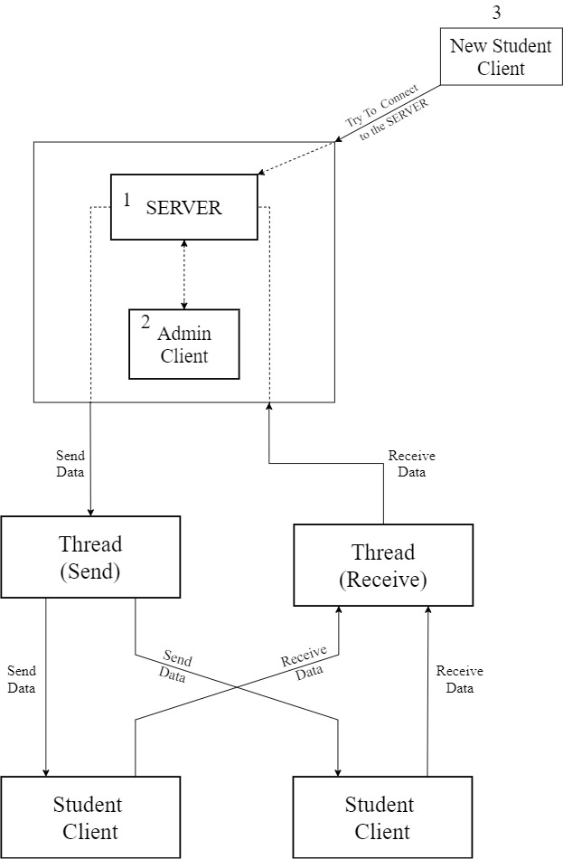

* + Flowchart for Process of sending file :

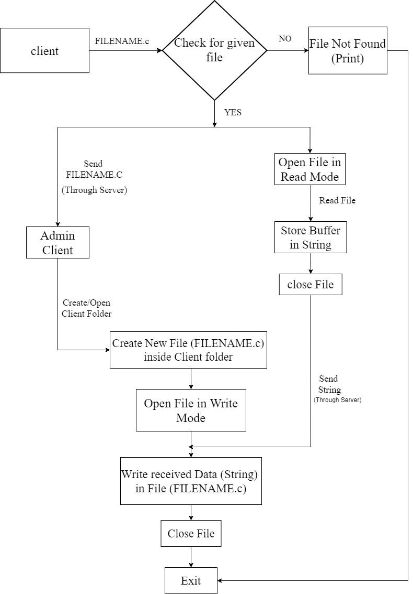

* **MODULES :**
  + **ADMIN LOGIN :**

When teacher connects to the TSI’s main server, it can declare itself as an admin to the server by giving a particular passkey. After which no one can become admin anymore, as this TSI’s server only supports one admin at a time

* + **ADD/REMOVE CLIENT :**

Students are clients , they can request to get connected or disconnect whenever they want. There is a queue in our server which can store the details of multiple clients (such as Name, Client ID, IP address details)

* + **SEND/RECEIVE DATA:**

Student(clients) can send either message or his/her program file to teacher(admin).

* **REQUIREMENTS:**

1. **Hardware:** Desktop machines/laptop, LAN connection.
2. **Software**: Any Version of Ubuntu (LINUX) with C / C++ compiler.

* **CONCLUSION:**

By using, TSI Interaction will becomes very smooth and fast, and Teacher can easily communicate and get access to each and every student easily.

* **REFERENCE:**

1.SOCKETS IN C - <https://www.geeksforgeeks.org/socket-programming-cc/>

2.Multithreading Concept - <https://www.geeksforgeeks.org/multithreading-c-2/>

3.Signals in C - <https://www.tutorialspoint.com/c_standard_library/c_function_signal.htm>

4.Commandline Concept - <https://www.javatpoint.com/command-line-arguments-in-c>

**Group Members:                                                                            Sign**

38.Tejas Deepak Pandit.

39***.*** Jay Avinash Powar.

51.Ajay Avinash Powar***.***

Date: / / 2020

Place: Kolhapur.

Sign of Guide Sign of Project Co-ordinate Sign of HOD

(Prof. Mr. A. S. Yadav) (Prof. Mrs. S. M. Surve) (Prof. Mr. B. D. Jitkar)