**PRADIP KUMAR SAHOO**

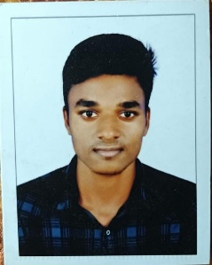

B.TECH(CSE)

AT/PO-Albaga,Bhadrak,Odisha-756124

Contact No: 7894159285

Mail Id: ps0616448@gmail.com

In:Pradip sahoo

**CAREER OBJECTIVE :**

Secure a responsible career opportunity to fully utilize my training and skills,while making a significant contribution to the success of the company.

**EDUCATIONAL QUALIFICATIONS :**

 B.TECH from Gandhi institute of technology and management, Bhubaneswar, affiliated to BPUT, Odisha

(2021-25)

10th from Robert High School, Narendrapur, affiliated to BSE,Odisha , 61%



Intermediate (Science) from Maa Bhavani Science Residential College K.VSquare, Balasore affiliated to CHSE (2019-2021) ,64% **SKILLS:**  Python



JavaScripts

MySQL

Html & Css

**INTERNSHIPS:**

 I have successfully completed 1 week training of internship on MySQL under the guidance of Neo Origin.

**PROJECTS:**

 Healthcare Management System

➢ A healthcare management system streamlines healthcare facility operations by integrating administrative and clinical functions. It enhances efficiency through automation, improves patient care quality, and reduces costs. Key features include electronic health records (EHR), appointment scheduling, billing, and telemedicine, facilitating better decision-making and health outcomes.

**STRENGTHS:**

Team Management



Leadership

Goal Oriented

Patience

**PERSONAL PROFILE:**

|  |  |  |
| --- | --- | --- |
| Father's Name | : | Rajanikanta Sahoo |
| Mother's Name | : | Janaki Sahoo |
| Date of Birth | : | January 14, 2004 |
| Gender  Hobbies | : : | Male  Playing Carrom |

***Declaration***

*I hereby declare that the above information is correct to the best of my knowledge and belief.*

Place: Pradip kumar Sahoo