User needs to be Authenticated if not already logged into LinekdIn:

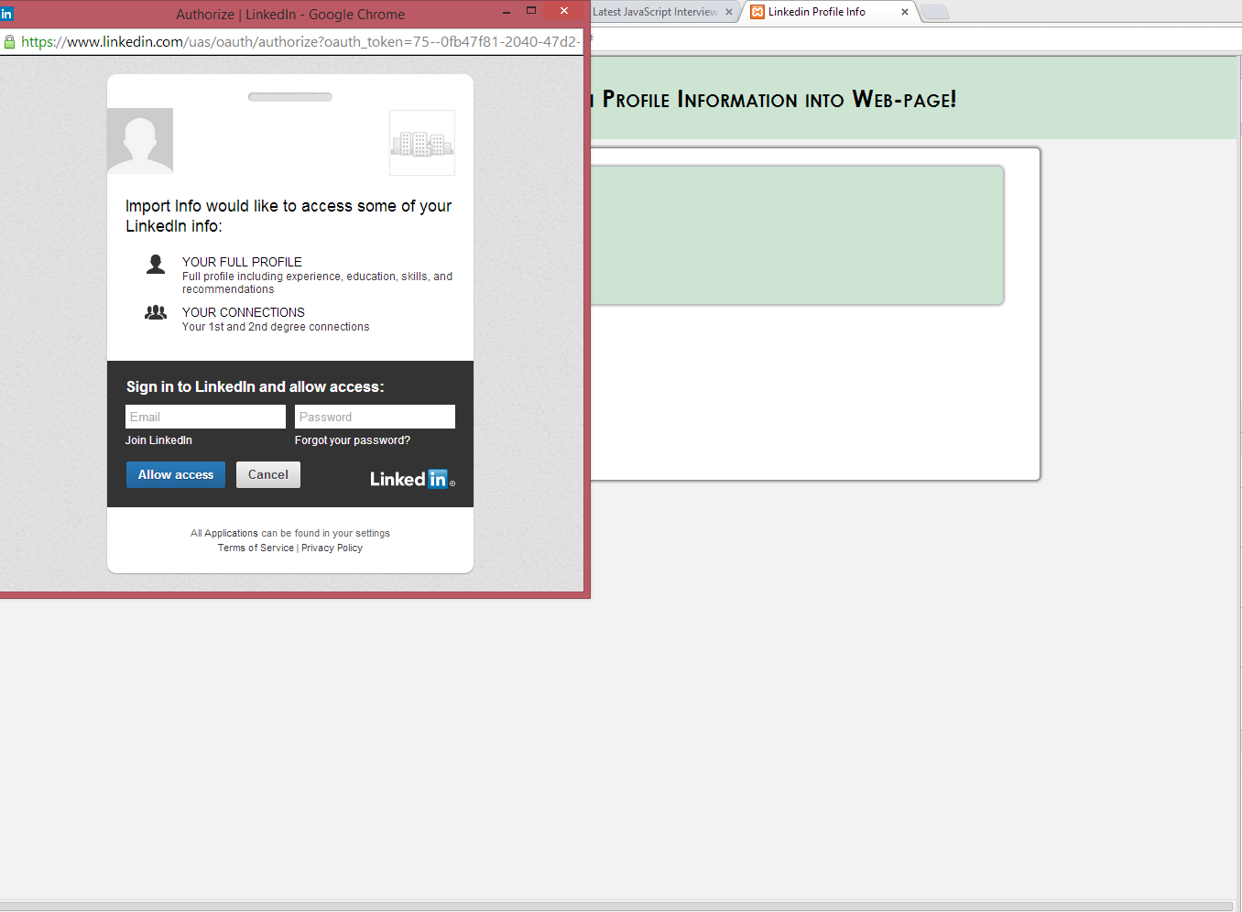

Once User has loggedIn, the api request with dev key returns user details, that are presented in beautiful way using CSS:

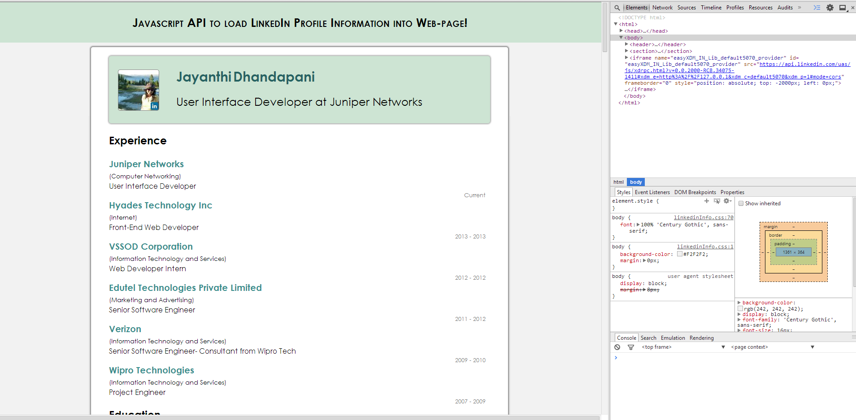

Also have the option of viewing User’s First Level Connections:

