PRODUCT ARCHITECTURE SPECIFICATION & BUSINESS REQUIREMENTS DOCUMENT
INFINIX MATH AI
Root of Infinity — Next-Generation AI Math Solver, Socratic Tutor, PDF Homework Helper & Graphing Workspace
Product Name / Codename | Infinix Math (Root of Infinity) — Web & Mobile Application Suite
Benchmark Reference Application | Mathos AI (formerly MathGPTPro) — https://www.mathos.ai & /app
Document Version / State | Version 2.0 (Comprehensive Feature BRD — Ready for Client Review)
Author / Architecture Lead | Principal AI Full-Stack Architect & Engineering Lead
Target Release Platforms | Cross-Platform Web App (Next.js PWA) + Native iOS & Android Apps

1. Executive Summary & Product Vision
Infinix Math (Brand: Root of Infinity) is a flagship, production-grade AI mathematical problem-solving, step-by-step tutoring, and document intelligence application suite designed to surpass reference benchmarks established by Mathos AI (formerly MathGPTPro). The application targets students, researchers, STEM educators, and lifelong learners across K-12, Advanced Placement (AP), undergraduate collegiate, and graduate academic tiers.
While traditional AI solutions (such as vanilla ChatGPT or Claude) frequently suffer from severe arithmetic and algebraic hallucinations, Infinix Math guarantees mathematical truth by decoupling cognitive reasoning from symbolic calculation. All mathematical operations are anchored in a high-speed Python Computer Algebra System (SymPy / CAS Engine), while advanced multimodal Large Language Models (Google Gemini 3.8-Flash) provide rich vision OCR, conversational Socratic tutoring, audio narration, and LaTeX derivation scaffolding.
Key Differentiators & Product Guarantee
CORE ARCHITECTURAL PILLARS:
1. Zero-Hallucination Symbolic Correctness: All solutions, step verifications, and alternative methods are computed and validated via Python SymPy.
2. Multi-Modal Accessibility: 5 seamless input modes (Text/LaTeX, Camera OCR, Drawing Canvas, Voice Recognition, and PDF Upload).
3. Interactive Socratic Tutor: Diagnoses exact student cognitive errors (sign errors, power rule, chain rule) in real-time.
4. PDF Homework Helper Workspace: Split-screen lasso crop, document annotation, and in-place problem resolution.
5. Unified Cross-Platform Ecosystem: Seamless synchronization across Desktop Web (PWA) and Mobile iOS/Android apps.

2. Competitive Benchmarking & Feature Matrix
A rigorous reverse-engineering and competitive analysis of Mathos AI (https://www.mathos.ai/app), Photomath, Symbolab, and Wolfram Alpha was conducted to map every user feature, input mechanism, and monetization workflow required for a category-defining market entrant.
Platform Capability | Mathos AI (Reference) | Photomath / Symbolab | Wolfram Alpha | Infinix Math (Target)
Symbolic Verification | Proprietary AI (occasional LLM hallucination) | Static rule-based algorithm | Authoritative CAS (Mathematica) | Decoupled SymPy CAS + LLM Bridge (Zero-Hallucination)
Photo / Camera OCR | Yes (Handwriting & Print) | Yes (Optimized print/mobile) | Limited image upload | Gemini 3.8 Vision OCR with Contrast Enhancement
Drawing Pad / Whiteboard | Yes (Web & iPad canvas) | No | No | Real-time stylus ink-to-LaTeX canvas with Bezier smoothing
Voice Input & Narration | Yes (Speech-to-math & Audio Tutor) | No | No | Multi-lingual speech-to-LaTeX + natural audio voice tutor
PDF Homework Helper | Yes (Lasso problem selector & notes) | No | No | Dual-pane PDF viewer, lasso crop, notes & annotated export
Socratic Step Verifier | Yes (Line-by-line verification) | Pre-computed fixed steps only | Step-by-step (read only) | Dynamic student input equivalence checking & error diagnosis
2D & 3D Graphing | Interactive 2D Desmos-style | Static 2D graphs | Static 2D/3D plots | Interactive 2D/3D dynamic canvas with tangent/integral sliders
Specialized Calculators | 40+ subject calculators | Basic calculators | Comprehensive domain tools | 45+ targeted calculators across Algebra, Calc, Stats & Physics
Quizzes & Flashcards | Yes (AI generated study aids) | No | Problem generator (paid) | Automated flashcards & adaptive diagnostic quiz engine
Cross-Device Sync | Web, iOS, Android, Chrome Extension | Mobile focused | Web & Mobile | Real-time Cloud Sync (Web PWA, iOS, Android)
Subscription Model | Weekly ($5.98 - $9.98/wk) | Monthly / Annual | Annual Pro subscription | Freemium + Pro Tiers ($4.99/wk or $14.99/mo) with 3-day trial

3. Target User Personas & User Lifecycle Journey
3.1 Target User Personas
- Persona A: High School / AP Student (Alex, 16): Struggles with AP Calculus and Algebra II homework. Needs immediate camera photo scanning, step-by-step visual explanations, and practice questions to prepare for AP exams without getting stuck.
- Persona B: STEM Collegiate Undergraduate (Priya, 20): Engineering major taking Multivariable Calculus, Linear Algebra, and Differential Equations. Works primarily on an iPad / Laptop, uploads multi-page textbook PDF problem sets, and requires 3D surface graphing and rigorous symbolic derivations.
- Persona C: Math Educator / Tutor (Marcus, 34): High school math teacher who prepares weekly quizzes, checks student derivations for common cognitive pitfalls (sign errors, algebraic distribution), and creates annotated PDF answer keys.
3.2 Complete End-to-End User Journey
The lifecycle journey encompasses 8 sequential stages from initial discovery through active daily study and retention:
- Stage 1: Discovery & Landing: User lands on Infinix Math web app or downloads mobile application from App Store/Google Play.
- Stage 2: Personalized Onboarding: Selects grade level (Middle School, High School, College, Professional), priority math subjects, and study goals (Homework Help, Exam Prep, Concept Mastery).
- Stage 3: Authentication & Workspace Creation: Signs in via Google OAuth, Apple ID, Email/Password, or begins an anonymous Guest Session with 5 free daily queries.
- Stage 4: Multi-Modal Problem Ingestion: Chooses preferred input: types in LaTeX via dynamic math keyboard, snaps a photo of notebook work, draws with stylus on whiteboard, speaks the problem aloud, or uploads a multi-page PDF homework assignment.
- Stage 5: Instant Solution & Socratic Derivation: Views instant final answer, verifies SymPy mathematical proof, explores alternative solution methods, and interacts with real-time 2D/3D graphs.
- Stage 6: Interactive Socratic AI Tutoring: Engages in step verification mode: student writes their next line of derivation; Infinix Math flags exact cognitive mistakes and offers tiered scaffolding hints.
- Stage 7: Homework Annotation & Export: In PDF Helper, annotates textbook pages with notes, attaches step-by-step solutions to questions, and exports an annotated PDF document.
- Stage 8: Knowledge Retention & Subscription: Reviews saved problem history, practices with AI-generated flashcards and adaptive quizzes, tracks streak metrics, and upgrades to Pro tier when daily free quota is reached.
4. Exhaustive Feature Specifications (Modules 1 to 10)
Below is the complete, granular functional specification covering every single feature from initial user authentication to advanced cloud synchronization, mirroring and elevating all capabilities found in Mathos AI.
Module 1: Authentication, Onboarding & User Profile Management
- F1.1 Omnichannel Authentication: Support for Google OAuth 2.0, Apple Sign-In (with private relay), Email/Password with email verification tokens, Phone OTP, and anonymous Guest Mode with frictionless upgrade paths.
- F1.2 Adaptive Onboarding Survey: Multi-step onboarding collecting: Academic Grade (Middle School, High School, AP/IB, Undergraduate, Graduate), Main Math Focus (Algebra, Geometry, Pre-Calc, Calculus, Linear Algebra, Stats), and Target Exam (SAT, ACT, AP Calc AB/BC, GRE).
- F1.3 User Profile & Gamification Dashboard: Personalized user avatar, daily study streak counter with streak freeze protection, total problems solved counter, mastery skill tree, and study time analytics.
- F1.4 Appearance & Preference Engine: Dark Mode, Light Mode, and OLED Black Mode; configurable math display settings (KaTeX render font size, angle unit degrees vs radians, decimal precision 2 to 10 digits).
Module 2: Multi-Modal Math Input Suite (5 Input Channels)
- F2.1 Mathematical Formula Editor (MathLive / LaTeX): WYSIWYG visual math editor supporting live LaTeX formatting, predictive syntax autocomplete, cursor navigation, and bracket pairing.
- F2.2 Dynamic Virtual Math Keyboard: Categorized keyboard palette tabs: Basic Arithmetic, Algebra (x, y, z, exponents, roots), Calculus (d/dx, integrals, limits, summation, partial derivatives), Trigonometry (sin, cos, tan, inverse trig, hyperbolic), Matrices (m x n grid generator), and Greek Symbols (alpha, beta, theta, pi, sigma, infinity).
- F2.3 Photo Math Camera OCR & Document Scanner: Live camera viewfinder with auto-capture, document boundary edge-detection, perspective deskewing, grayscale/contrast boost, and Gemini Vision multi-line mathematical OCR.
- F2.4 Whiteboard & Stylus Drawing Pad: Apple Pencil and pressure-sensitive stylus canvas with smooth Bezier ink interpolation, eraser, clear canvas, undo/redo, and stroke-to-LaTeX classification.
- F2.5 Voice Math Dictation: Natural language speech-to-math transcription using speech recognition models (e.g. converting 'integral of 3x squared plus 5x dx from zero to two' into LaTeX \int_{0}^{2} (3x^2+5x) dx).
- F2.6 PDF Document Drag-and-Drop Ingestion: Upload capability for single or multi-page PDF documents up to 50MB with instant background thumbnail generation.
Module 3: Core AI Math Solver & Derivation Workspace
- F3.1 Instant Verified Solution Card: Displays final exact symbolic answer (fractions, radicals, pi constants) alongside high-precision floating-point decimal approximations, with one-click LaTeX copy and image export.
- F3.2 Hierarchical Step-by-Step Derivations: Numbered primary steps with expandable substeps revealing every intermediate transformation, rule application (e.g. Product Rule, Integration by Parts), and algebraic simplification.
- F3.3 Multiple Alternative Solution Methods: Calculates and presents parallel solving strategies where applicable (e.g., Quadratic Equations: Method 1: Factoring; Method 2: Quadratic Formula; Method 3: Completing the Square; Method 4: Graphical Intersection).
- F3.4 Context-Aware Follow-Up AI Chat: Multi-turn conversational assistant linked directly to the solved problem (e.g. 'Can you explain step 3 in simpler terms?', 'What happens if x is negative?', 'Can you show this using substitution instead?').
- F3.5 Automated Practice Problem Generator: Dynamically generates 3 to 5 similar practice problems with matching mathematical difficulty, with hidden solutions for self-testing.
Module 4: Interactive AI Tutor Mode (Socratic Step Verifier & Voice Guidance)
- F4.1 Real-Time Line-by-Line Step Verification: Student enters their proposed next line of mathematical derivation; SymPy verifies mathematical equivalence against the problem state in under 300ms without hallucination.
- F4.2 Deep Cognitive Mistake Diagnosis: Identifies specific student error taxonomy: Sign Errors (+/- mismatch), Algebraic Distribution Errors, Power Rule Misapplication, Chain Rule Omission, Missing Constant of Integration (+ C), and Arithmetic Errors.
- F4.3 Tiered Socratic Scaffolding Hints: Level 1: Gentle nudge prompting student reflection; Level 2: Reminder of specific formula or theorem; Level 3: Concrete structural breakdown without revealing the final answer.
- F4.4 Voice Tutor Audio Narration: AI audio tutor that speaks out mathematical formulas naturally with pedagogical inflection, supporting playback speed adjustments (0.75x, 1.0x, 1.25x, 1.5x).
- F4.5 Problem Completion & Mastery Celebration: Celebration animation upon reaching the verified final step, awarding mastery points and updating the student's concept skill tree.
Module 5: PDF Homework Helper & Document Workspace
- F5.1 High-Performance PDF Document Viewer: Integrated PDF rendering engine with smooth pan, continuous scroll, thumbnail drawer, zoom from 50% to 400%, and jump-to-page navigation.
- F5.2 Lasso / Bounding-Box Problem Cropping Tool: Allows student to draw a selection rectangle over any formula, table, or word problem on the PDF page to extract and solve it immediately.
- F5.3 Split-Screen Dual-Pane Workspace: Side-by-side synchronized view: the source PDF remains interactive on the left, while the AI Solver and Tutor operate on the right panel without losing document context.
- F5.4 Rich In-Document Annotation Suite: Pen drawing, highlighter marker with multiple colors, sticky note callouts, text typing, and equation stamping directly onto the PDF.
- F5.5 Export Annotated PDF with Solution Keys: Exports the complete student PDF with highlighted regions, margin notes, and formatted step-by-step solutions appended at the end.
Module 6: Graphing Calculator & Visualization Suite (2D & 3D)
- F6.1 2D Interactive Function Plotter: Plots explicit functions y = f(x), implicit curves (e.g. circles, ellipses x^2 + y^2 = r^2), inequalities with shaded regions, parametric equations, and polar graphs r = f(theta).
- F6.2 Automatic Critical Points of Interest: Automatically computes and renders interactive coordinate tooltips for x-intercepts (roots), y-intercepts, local minima/maxima, and inflection points.
- F6.3 Dynamic Calculus Visualization Overlays: Interactive tangent line slider demonstrating instantaneous rate of change f'(x), secant lines, derivative curve overlay, and Riemann sum / definite integral shaded area under curves.
- F6.4 3D Multivariable Surface Plotter: WebGL 3D canvas plotting z = f(x,y) with rotational orbital controls, contour line overlays, and saddle point markers for multivariable calculus.
- F6.5 Parameter Sliders & Animation: Add dynamic sliders for constants (e.g. y = a*sin(b*x + c)) with play/pause animations to visualize parameter effects.
Module 7: Specialized Domain Calculators (45+ Dedicated Tools)
Comprehensive suite of 45+ specialized calculators with dedicated UI inputs, visual guides, and step-by-step walkthroughs:
Domain Category | Specialized Tools & Dedicated Calculators | Key Features & Outputs
Algebra & Polynomials | Fraction Calc, Quadratic Calc, Polynomial Factoring, System of Equations (2x2, 3x3), Logarithm & Exponent Calc, Rational Expression Simplifier | Roots, discriminant analysis, factoring tree, matrix elimination steps
Calculus & Analysis | Derivative Calc, Indefinite Integral Calc, Definite Integral Calc, Limit Calc (one-sided & infinity), Taylor/Maclaurin Series, Differential Equations (ODE) | Power/product/chain rule breakdowns, u-substitution, integration by parts, epsilon-delta
Trigonometry | Trig Identity Verifier, Unit Circle Explorer, Right Triangle Solver, Oblique Triangle (Law of Sines/Cosines), Inverse Trig Calc | Unit circle interactive coordinates, angle conversion (rad/deg), identity reduction
Linear Algebra | Matrix Operations (+, -, *), Determinant Calc, Matrix Inversion, Eigenvalues & Eigenvectors, Dot & Cross Product, Rank & Nullity | Row reduction (RREF) step-by-step, characteristic polynomials, geometric vector plots
Statistics & Probability | Descriptive Stats (Mean, Median, Mode, Std Dev), Normal Distribution (Z-score), Binomial & Poisson Calc, Permutations & Combinations, Linear Regression | Bell curve shading, cumulative probability tables, scatter plots with regression line
Physics & Geometry | Area & Volume 3D Calc, Vector Kinematics Calc, Projectile Motion Simulator, Ohm's Law & Circuit Calc, Thermodynamic Gas Laws | Geometric wireframe previews, trajectory parabolic plots, unit conversion

Module 8: Notebooks, Workspaces, Knowledge Retention & Study Tools
- F8.1 Subject Notebooks & Folder Hierarchy: Organize saved problems and derivations into custom folders (e.g. 'Calculus II - Fall 2026', 'SAT Math Prep', 'Physics Homework 4').
- F8.2 Automated Smart Flashcard Generator: One-click conversion of solved problem sets into digital flashcards (Front: equation/problem; Back: key formulas, identities, and step breakdown).
- F8.3 Adaptive Diagnostic Quiz Generator: Generates custom 5, 10, or 20-question practice quizzes based on topics the user struggled with in Tutor Mode, complete with timer, scoring, and explanation reviews.
- F8.4 Full Searchable Problem History: Search past solved problems by equation substring, topic keyword, domain tag, date range, or favorited star status.
- F8.5 Export & Collaboration Hub: Export notebooks to PDF, Markdown, LaTeX document (.tex), or generate shareable view-only web links for classmates and teachers.
Module 9: Cross-Platform Mobile Application Architecture (iOS & Android)
- F9.1 Native Camera & Document Capture Reticle: Hardware-accelerated camera capture with real-time bounding box guidance, torch/flashlight toggle, and auto-focus.
- F9.2 Mobile-Optimized Bottom Sheet UI: Gesture-driven bottom sheets for equation input, formula keyboard, step derivations, and tutor chat.
- F9.3 Offline Calculation & Caching Mode: Local SQLite / IndexedDB cache of previous calculations, formula sheets, and basic symbolic evaluation when offline.
- F9.4 Push Notification & Habit Engine: Configurable daily notifications (e.g. 'Streak at risk! Solve 1 problem to keep your 14-day streak alive', 'Weekly Calculus review ready').
Module 10: Monetization, Subscription Tiers & Quota Management
Structured freemium business model with clear progression triggers and high-value Pro capabilities:
Plan Tier | Pricing Model | Feature Quotas & Compute Limits | Target User Segment
Free Tier | $0 / Forever Free | 5 solves/day, Basic Step-by-Step, Standard 2D Graphing, Question History (last 30 days), Basic Calculator suite | Casual students, quick one-off problem checks
Basic Pro | $5.98 / week  (or $14.99 / mo) | Unlimited Solves, Unlimited Image Input, Full Step-by-Step Derivations, Alternative Methods, 20 PDF Helper pages/month, Ad-free | High school & introductory college students
Prime AI | $9.98 / week  (or $24.99 / mo) | Everything in Basic + Unlimited PDF Helper, Socratic Voice Tutor with Audio Narration, 3D Graphing, Quiz & Flashcard Generator, Priority GPU compute | Intensive STEM collegiate students & AP candidates
Institutional / Campus | Custom Annual License | Campus-wide SSO, LMS Integration (Canvas, Blackboard), Teacher grading dashboard, Student mastery analytics, Dedicated SLA | Schools, universities, and tutoring centers

5. UI/UX Design System & Visual Mockups
The Infinix Math design philosophy blends high-aesthetic dark mode ergonomics with zero cognitive clutter. The interface leverages deep slate surfaces (#0F172A, #1E293B), vibrant indigo and violet brand gradients (#4F46E5 to #7C3AED), emerald green verification cues (#10B981), and razor-sharp mathematical typography (KaTeX rendering with Computer Modern and Inter fonts).
5.1 Main AI Math Solver & Graphing Workspace
Figure 1 illustrates the primary desktop workspace. Key elements include the collapsible left navigation bar, the multi-modal formula input card with instant KaTeX preview, the verified step-by-step derivation container with alternative method tabs, and the synchronized real-time 2D graphing viewport.
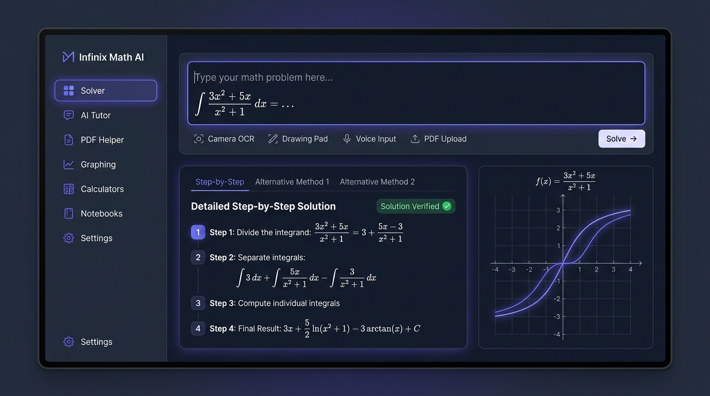
Figure 1: Infinix Math AI Solver — Multi-Modal Input, Verified Step Derivation & Synchronized 2D Graphing
5.2 PDF Homework Helper Dual-Pane Workspace
Figure 2 depicts the PDF Homework Helper. The left pane renders the uploaded textbook or assignment document with a glowing bounding-box lassoing problem 3. The right pane displays the active AI Math Assistant solving the extracted problem step-by-step, accompanied by the Voice Tutor audio waveform controller and top annotation tools.
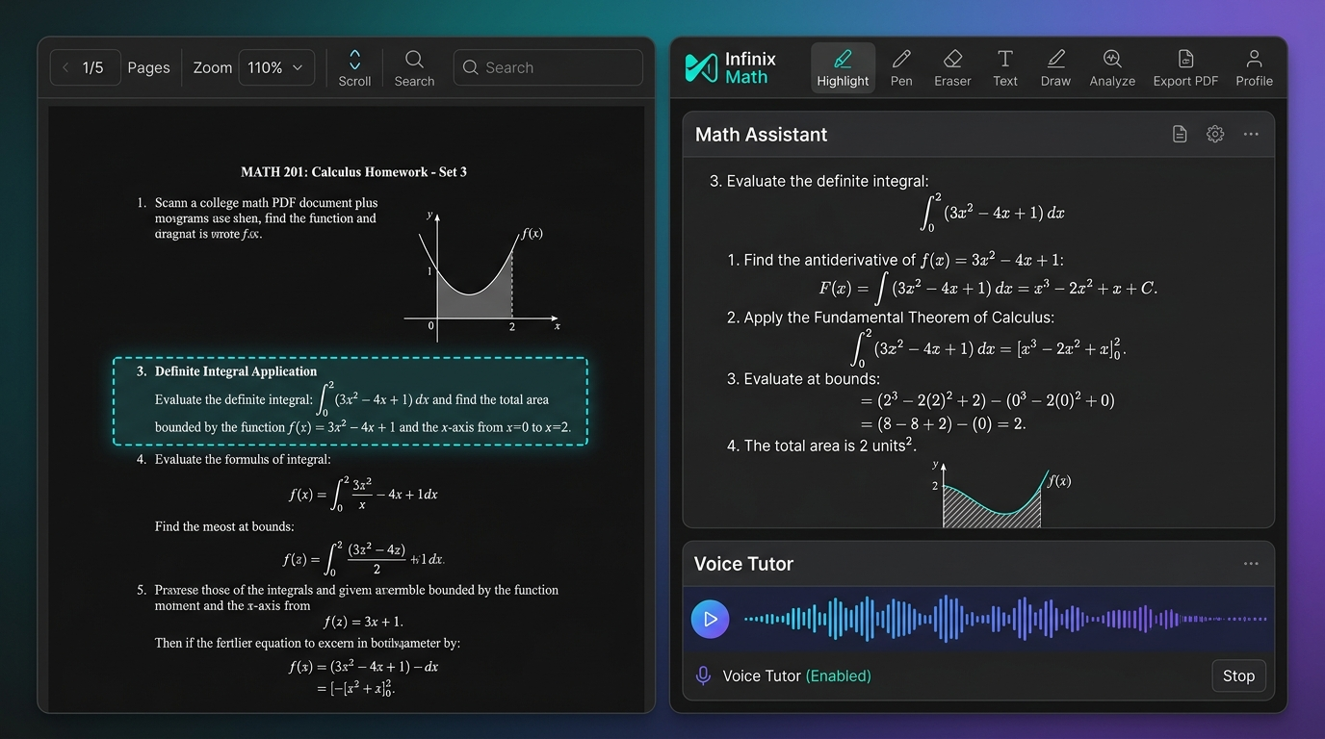
Figure 2: PDF Homework Helper — Split-Screen Document Viewer, Lasso Problem Crop & Voice Tutor Assistant
5.3 Interactive Socratic AI Tutor & Handwriting Verification Canvas
Figure 3 demonstrates the live AI Tutor Socratic Mode. A student writes their derivation steps directly on the digital canvas. Step 1 is symbolically validated with an emerald green SymPy checkmark badge. When an intentional sign error is introduced in Step 2, the tutor displays a non-punitive pedagogical diagnostic card with a Socratic hint button.
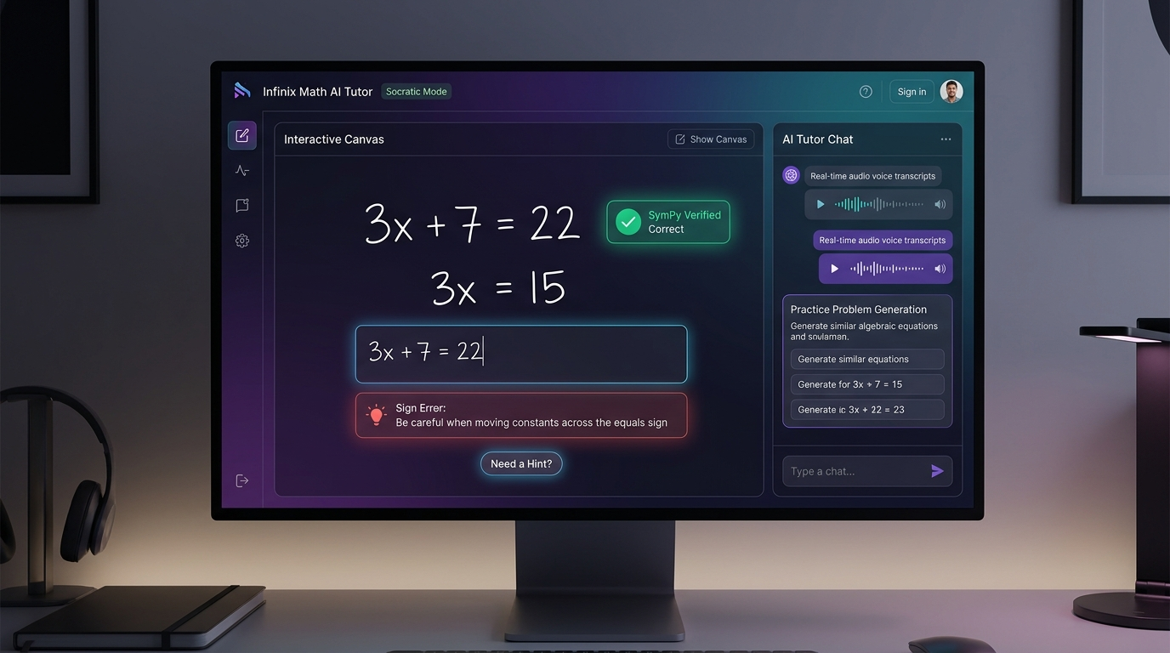
Figure 3: AI Tutor Socratic Mode — Interactive Handwriting Canvas, SymPy Step Verification & Error Diagnosis
5.4 Cross-Platform Mobile Application Experience (iOS & Android)
Figure 4 showcases the mobile smartphone user interface across three primary flows: (1) Camera Photo Math scanning reticle with real-time formula detection; (2) Detailed step-by-step card with KaTeX math rendering and inline graph; and (3) Dedicated mobile formula keyboard with bottom navigation bar.
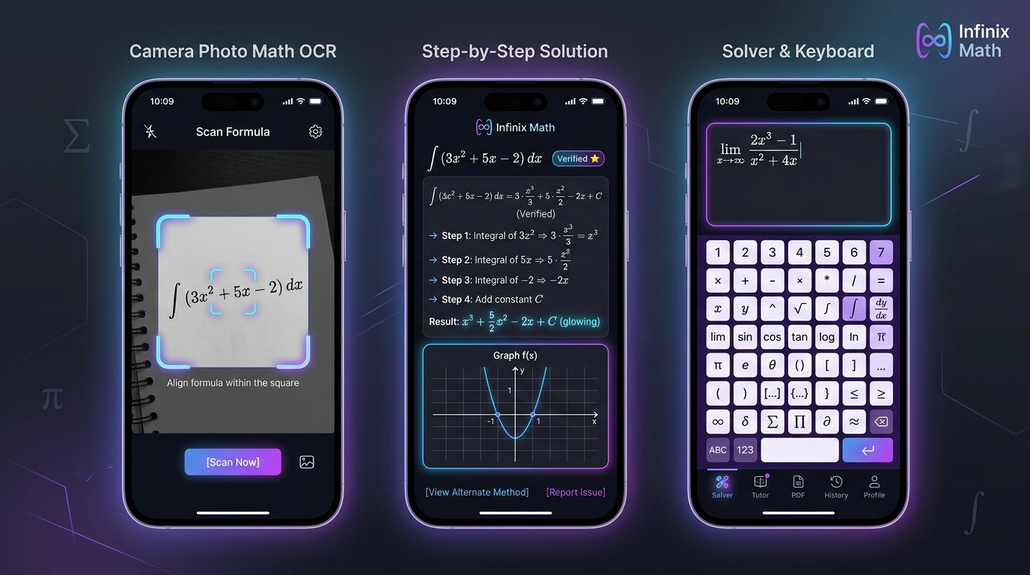
Figure 4: Infinix Math Mobile App Suite — Camera Photo Scan, Step Derivation & Virtual Math Keyboard
6. Technical Architecture & Non-Functional Requirements
6.1 Core System Architecture
The system employs a decoupled, multi-tiered microservices architecture designed for extreme reliability, sub-second symbolic verification, and elastic scalability:
- Frontend Layer: Next.js 16 (React 19, TypeScript, Tailwind CSS, Turbopack, KaTeX, MathLive, PDF.js, Three.js / WebGL for 3D graphs).
- Mobile Client Layer: React Native / Expo with shared TypeScript business logic, Native CameraKit, and Skia high-performance 2D canvas.
- API Gateway & Backend: FastAPI (Python 3.12+), asynchronous ASGI routing, Pydantic v2 data validation, structured JSON logging, and OAuth2 security.
- Symbolic Computation CAS: Python SymPy 1.13+ engine executing in worker pools with 5-second hard execution timeouts to guarantee zero infinite-loop stalls.
- Multimodal Vision & Audio: Google Gemini 3.8-Flash for sub-second image-to-LaTeX extraction, handwriting transcription, and natural conversational Socratic tutoring.
- Data Persistence & Cache: PostgreSQL (user profiles, history, notebooks, billing metadata) + Redis (session caching, rate-limiting, and OCR result deduplication).
6.2 Non-Functional Requirements (NFRs) & Performance SLAs
Metric / Requirement | Target SLA | Engineering Strategy / Enforcement Mechanism
Symbolic Verification Latency | < 300 ms (P95) | Local SymPy expression parsing with in-memory AST caching
Vision OCR Extraction Latency | < 2.5 seconds (P95) | Image downsampling, contrast pre-processing, and Gemini 3.8-Flash streaming
Mathematical Correctness | 100% Zero Hallucination | All mathematical answers, roots, and derivatives verified via SymPy CAS before rendering
System Availability & Uptime | 99.95% Availability | Multi-region cloud deployment (Cloud Run / AWS ECS) with health check probes
Data Privacy & Compliance | FERPA & COPPA Compliant | End-to-end encryption in transit (TLS 1.3) and at rest (AES-256); strict PII anonymization
Concurrent User Capacity | 10,000+ active sessions | Stateless ASGI backend with Redis horizontal pub/sub scaling

7. Phased Implementation Roadmap
To ensure disciplined, high-velocity delivery, development will proceed through 5 structured phases. Each phase delivers an independently verifiable, end-to-end functional milestone:
Phase | Milestone Name | Key Deliverables & Capabilities | Target Timeline
Phase 1 | Core Architecture & Solver Expansion | Upgrade FastAPI backend, multi-turn follow-up chat, alternative solution generators, and expanded SymPy domains (ODE, linear algebra). | Sprint 1 (Weeks 1 - 2)
Phase 2 | PDF Homework Helper Workspace | PDF.js split-screen viewer, bounding box crop tool, Gemini Vision multi-page OCR, and document annotation toolbar. | Sprint 2 (Weeks 3 - 4)
Phase 3 | 2D/3D Graphing & 45+ Calculators | Interactive 2D Desmos-style canvas, 3D WebGL plotter, critical point detection, and full suite of 45 specialized calculators. | Sprint 3 (Weeks 5 - 6)
Phase 4 | Voice Socratic Tutor & Study Tools | Speech-to-math voice input, natural voice audio tutor, automated flashcard generator, and adaptive diagnostic quiz engine. | Sprint 4 (Weeks 7 - 8)
Phase 5 | Mobile Apps & Monetization | iOS & Android mobile apps (React Native), offline caching, Stripe web billing, Apple/Google In-App Purchases, and quota meters. | Sprint 5 (Weeks 9 - 10)

8. Document Sign-Off & Stakeholder Approvals
By signing below, the project stakeholders confirm that this Business Requirements Document (BRD) accurately reflects all functional, technical, and aesthetic requirements for the Infinix Math AI application suite, benchmarked against Mathos AI. Upon formal approval, development of Phase 1 will commence.
Stakeholder Role | Printed Name | Signature | Date
Product Sponsor & Owner
Principal AI Full-Stack Architect | Lead AI Solutions Architect | Verified via Antigravity Engine | 2026-10-05
Lead Frontend / UI-UX Engineer
Lead DevOps & Cloud Engineer

