SYSTEM IMPLEMENTATION BLUEPRINT & EXECUTION PLAN
INFINIX MATH AI: STEP-BY-STEP BUILD PLAN
Starting from Static Login (admin/admin) to the Complete Mathos AI-Style Application Ecosystem
Project Codename | Infinix Math (Brand: Root of Infinity)
Benchmark Reference Application | Mathos AI (https://www.mathos.ai/app)
Starting Authentication Model | Static Developer Login: Username 'admin' / Password 'admin' (Production OAuth deferred to final phase)
UI/UX Design Standard | Exact 1:1 fidelity with approved high-tech dark mode mockups
Plan Version & Status | Version 2.0 (Phased Step-by-Step Implementation Specification)

1. Execution Strategy & Step-by-Step Methodology
To build Infinix Math into a market-leading application that rivals and exceeds Mathos AI, the development will follow a strictly phased, step-by-step approach starting directly from the entry point: the Login Page. Each phase introduces a dedicated, fully working module with its corresponding user interface, API endpoints, symbolic calculations, and interactive state.
Execution Rules & Project Constraints
KEY EXECUTION DIRECTIVES:
• Phase 1 Starts at the Login Page: Implement a sleek glassmorphic login screen where the user enters static credentials 'admin' and 'admin' to access the workspace. Full production OAuth (Google/Apple) will be integrated in the final phase.
• Exact Visual Fidelity: Every single screen must match the high-end dark mode aesthetics created in the design mockups (deep slate #0F172A, glowing indigo/violet gradients, KaTeX math symbols, and zero-clutter layouts).
• Strict Zero-Hallucination CAS: Every calculation, derivative, integral, and student step verification is grounded in Python SymPy.
• Independent Verifiable Milestones: Each phase concludes with functional browser verification and git checkpoints.

2. Master Phase Overview & Timeline
Phase | Milestone / Module Name | Core Capabilities & Deliverables | UI Mockup Reference
Phase 1 | Static Auth & Core App Shell | Login Page (admin/admin), Session Store, Collapsible Sidebar, Header, Route Protection | Figure 1: Login Page UI
Phase 2 | AI Math Solver & Input Workspace | MathLive LaTeX Keyboard, Camera OCR, Drawing Pad, Voice Input, Step Derivation, Inline Graph | Figure 2: Main AI Solver Workspace
Phase 3 | Interactive Socratic AI Tutor | Line-by-line SymPy step verifier, Mistake taxonomy cards, 3-tier scaffolding hints, Voice tutor audio | Figure 3: Socratic Tutor Mode
Phase 4 | PDF Homework Helper Workspace | PDF.js split viewer, Bounding box lasso crop, Side-by-side solver, In-document annotations, PDF export | Figure 4: PDF Homework Helper
Phase 5 | 2D/3D Graphing & 45+ Calculators | Desmos-style 2D plotter with tangent/integral sliders, WebGL 3D surface plotter, 45+ domain calculators | Figure 5: Graphing & Calculators
Phase 6 | Notebooks & Study Suite | Class/subject folders, Automated flashcard generator, Adaptive diagnostic quiz generator, History search | Study Suite Modules
Phase 7 | Mobile App & Production Launch | iOS & Android mobile apps, Replace admin/admin with Google/Apple OAuth, Stripe billing, CI/CD | Figure 6: Mobile App Experience

3. Detailed Phase-by-Phase Implementation Specifications
Phase 1: Foundation & Static Authentication (Login Page: admin / admin)
Phase 1 establishes the entry point of the entire application. The user will be greeted by a modern, glassmorphic login page. Per requirements, this initial version utilizes static credentials (username 'admin', password 'admin'), establishing an authenticated session before granting access to the main dashboard.
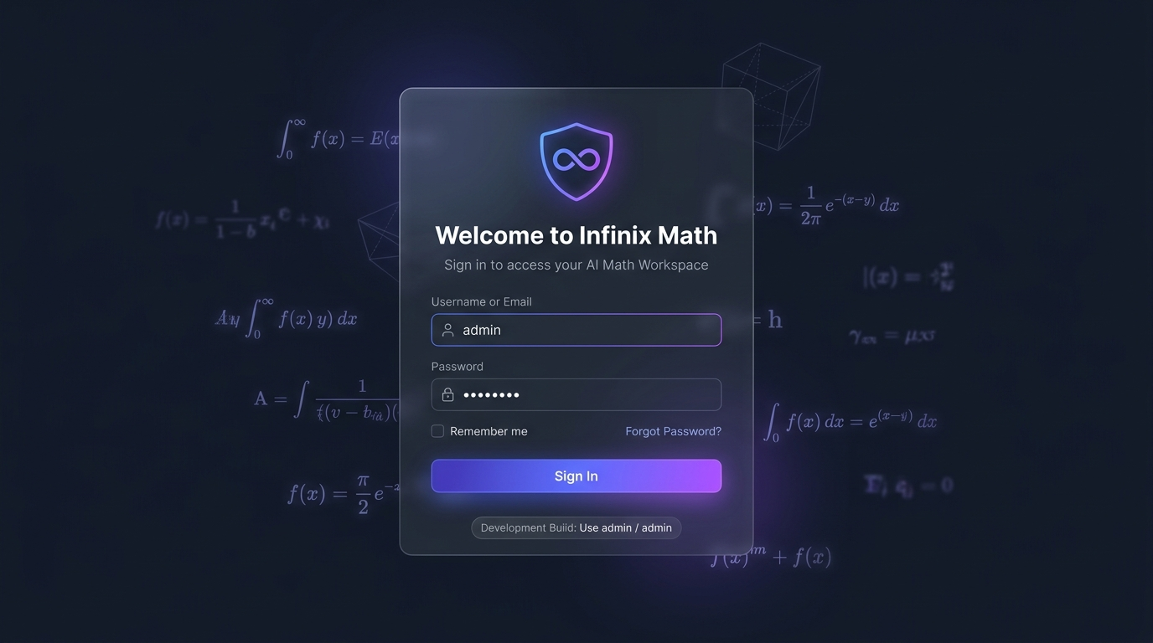
Figure 1: Phase 1 — Infinix Math Login Screen with Glassmorphic Card, Ambient Math Background & Static Credentials
- Task 1.1: Glassmorphic Login Page Component: Construct /login page with glowing brand shield (Infinity icon), 'Welcome to Infinix Math' title, and ambient mathematical formulas in the background. Provide input fields for 'Username or Email' and 'Password', with a 'Remember me' toggle and a subtle developer badge: 'Development Build: Use admin / admin'.
- Task 1.2: Static Authentication Engine: Implement client-side authentication validator checking username === 'admin' and password === 'admin'. On success, issue a session cookie/token (infinix_auth_session) and redirect to the application dashboard; on failure, display a red glowing error toast: 'Invalid credentials. Please use admin / admin'.
- Task 1.3: Protected Route Wrapper / Middleware: Implement a Next.js route guard that verifies active authentication. If an unauthenticated user visits / or /app, automatically redirect to /login; if an authenticated user visits /login, redirect directly to the workspace.
- Task 1.4: Modern Application Shell & Navigation: Build the persistent app shell matching the mockups: a collapsible left sidebar with navigation icons (Solver, AI Tutor, PDF Helper, Graphing, Calculators, Notebooks, Settings), a top header displaying backend health status, and user profile avatar with a 'Sign Out' action.
Phase 2: Core Solver & Multi-Modal Input Workspace (Main Dashboard)
Phase 2 delivers the central mathematical solving engine. It equips students with 5 multi-modal input channels (LaTeX keyboard, photo OCR, stylus whiteboard, voice dictation, and PDF ingestion), paired with instant SymPy solutions, step-by-step derivations, alternative methods, and inline 2D graph visualizations.
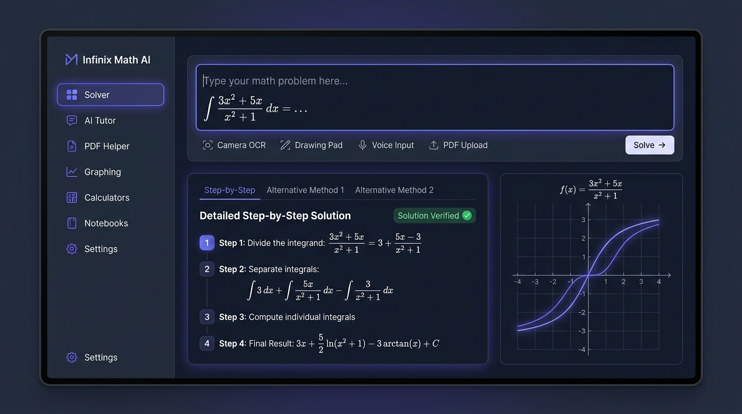
Figure 2: Phase 2 — Main AI Math Solver Workspace with Multi-Modal Input, Step Derivations & Synchronized 2D Graphing
- Task 2.1: Dynamic LaTeX Formula Bar (MathLive): Integrate a responsive WYSIWYG mathematical formula editor supporting live LaTeX formatting, bracket auto-pairing, and cursor navigation.
- Task 2.2: Categorized Virtual Math Keyboard: Build tabbed virtual keypad palettes: Basic, Algebra (variables, powers, radicals), Calculus (derivatives, integrals, limits), Trigonometry (sin, cos, tan, inverse), Matrices (m x n grid), and Greek symbols.
- Task 2.3: Camera Photo Math OCR Modal: Implement camera capture and file upload modal with image contrast boost and Google Gemini 3.8-Flash vision extraction to transcribe handwritten/printed equations to clean LaTeX.
- Task 2.4: Whiteboard Drawing Pad Canvas: Develop a digital ink drawing pad supporting stylus/Apple Pencil pressure sensitivity, Bezier stroke smoothing, undo/redo, and stroke-to-LaTeX conversion.
- Task 2.5: Voice Math Dictation: Incorporate speech-to-math transcription converting spoken phrases ('integral of 3x squared plus 5x') into syntactically valid LaTeX.
- Task 2.6: Detailed Step-by-Step Solution Card: Render exact symbolic solutions alongside decimal approximations, expandable substeps, and alternative method comparison tabs (e.g. Factoring vs. Quadratic Formula).
- Task 2.7: Inline Interactive 2D Graph Viewport: Synchronize the solved equation with a lightweight 2D coordinate plot displaying roots, intercepts, and function curves.
Phase 3: Interactive Socratic AI Tutor & Derivation Canvas
Phase 3 transforms Infinix Math from a passive calculator into an active, intelligent personal tutor. Students write their derivations line-by-line; the engine mathematically verifies each step in under 300ms, flags exact cognitive errors, and delivers tiered pedagogical hints.
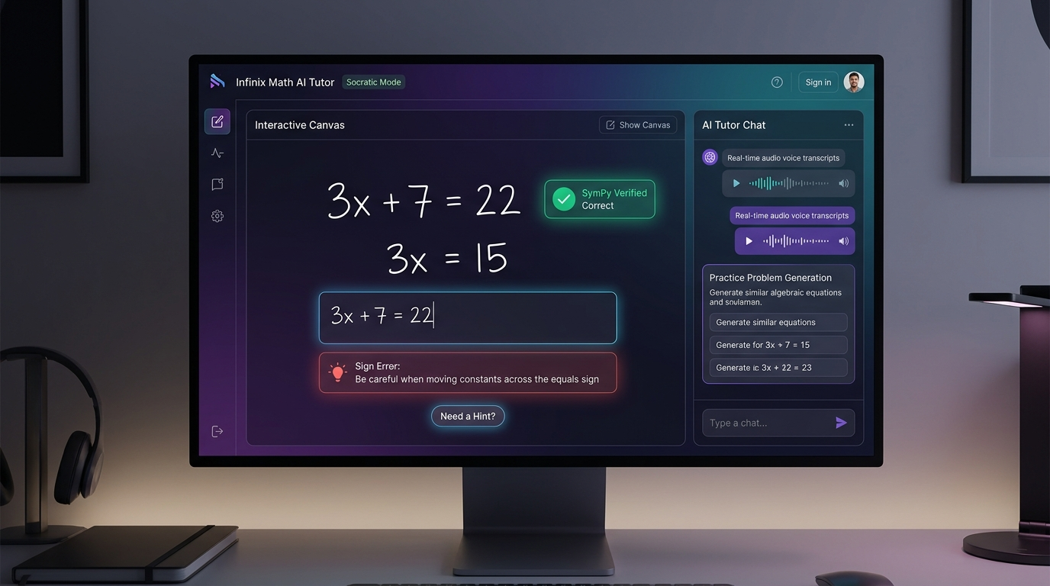
Figure 3: Phase 3 — Socratic AI Tutor Mode with Live Digital Ink Canvas, Step Verification & Mistake Diagnostics
- Task 3.1: Live Line-by-Line Step Verification Engine: Connect frontend derivation canvas to backend SymPy equivalence checking to evaluate intermediate steps without LLM hallucination.
- Task 3.2: Cognitive Mistake Taxonomy & Diagnostic Cards: Detect and visually flag student errors: Sign Errors (+/- mismatch), Distribution Errors, Power Rule slips, Chain Rule omissions, missing constant (+ C), and Arithmetic slips.
- Task 3.3: 3-Tier Socratic Hint System: Implement progressive hint delivery: Level 1 (reflective nudge) -> Level 2 (relevant formula/theorem reminder) -> Level 3 (structural breakdown).
- Task 3.4: Practice Problem Generator & Mastery Reward: Upon reaching the final step, trigger a completion animation, award mastery points, and generate 3 similar difficulty-adjusted practice problems.
- Task 3.5: Voice Tutor Audio Playback: Integrate text-to-speech audio narration providing conversational explanations of mathematical concepts with variable speed controls.
Phase 4: PDF Homework Helper (Split-Screen Document Workspace)
Phase 4 introduces the flagship PDF Homework Helper, mirroring Mathos AI's most popular study feature. Students upload multi-page homework assignments, lasso-crop specific problems on the page, annotate with highlighters, and receive step-by-step guidance side-by-side with the source document.
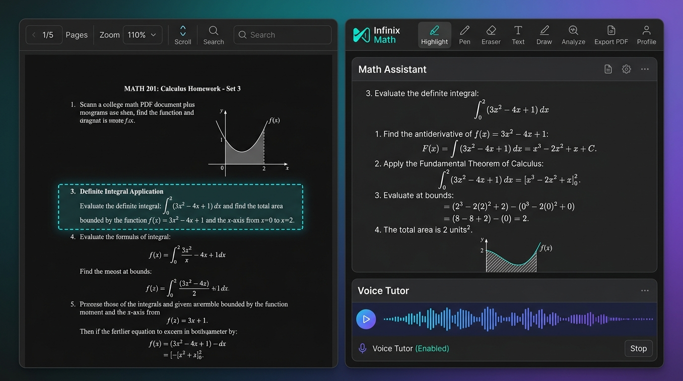
Figure 4: Phase 4 — PDF Homework Helper with Split-Screen Document Viewer, Lasso Problem Crop & Voice Assistant
- Task 4.1: High-Performance Multi-Page PDF Viewer: Integrate PDF.js rendering engine supporting continuous scroll, page thumbnail sidebar, zoom (50% to 400%), and jump-to-page navigation.
- Task 4.2: Bounding Box Lasso Selection Tool: Enable interactive drag-to-select rectangles on the PDF canvas to crop and isolate individual math problems, diagrams, or word problems.
- Task 4.3: Synchronized Dual-Pane Workspace Layout: Maintain document context on the left viewport while automatically feeding cropped problems into the AI Math Assistant on the right viewport.
- Task 4.4: In-Document Annotation Suite: Provide pen drawing, multi-color highlighters, text boxes, and sticky notes directly on the PDF pages.
- Task 4.5: Annotated PDF Export Engine: Export the complete homework document with highlighted annotations, margin notes, and formatted step-by-step solutions appended.
Phase 5: Graphing Calculator (2D & 3D) & 45+ Specialized Calculators
Phase 5 implements a full Desmos/GeoGebra-grade graphing environment alongside a modular suite of 45+ specialized domain calculators covering Algebra, Calculus, Linear Algebra, Trigonometry, Statistics, and Physics.
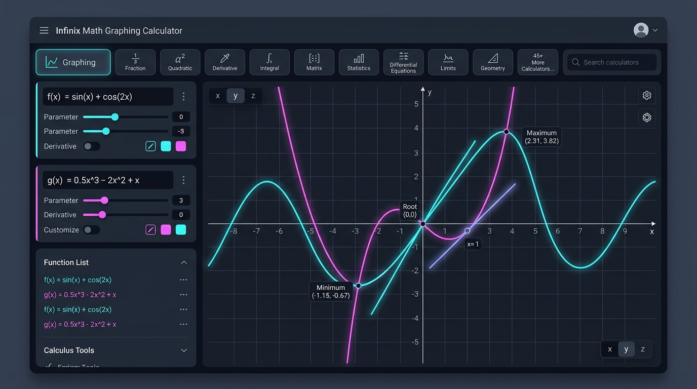
Figure 5: Phase 5 — Interactive Graphing Calculator Workspace & 45+ Specialized Subject Calculators
- Task 5.1: 2D Interactive Function Plotter: Plot explicit functions y = f(x), implicit curves (circles, ellipses), inequalities with shaded regions, polar coordinates, and parametric curves.
- Task 5.2: Automatic Critical Points Tooltips: Compute and render coordinate tooltips for roots, y-intercepts, local minima/maxima, and inflection points.
- Task 5.3: Dynamic Calculus Overlays & Parameter Sliders: Add interactive tangent line sliders for instantaneous rate of change f'(x), secant lines, derivative overlays, and shaded area under curve for definite integrals.
- Task 5.4: 3D Multivariable Surface Plotter (WebGL): Implement 3D surface plotting for z = f(x,y) with 360-degree orbital rotation and contour line slices.
- Task 5.5: Modular Suite of 45+ Specialized Calculators: Build dedicated UI screens and workflows for Fraction, Quadratic, Polynomial, Derivative, Integral, Limit, Matrix (RREF, eigenvalues), Statistics (normal distribution), and Physics tools.
Phase 6: Notebooks, Study Suite (Flashcards & Quizzes) & History Hub
Phase 6 adds knowledge retention tools that turn one-time solves into continuous learning. Students organize problems into subject folders, generate digital study flashcards, and take adaptive diagnostic quizzes.
- Task 6.1: Subject Notebooks & Folder Hierarchy: Create folders to organize problems by class or subject (e.g. 'Calculus II', 'SAT Math', 'Physics 101').
- Task 6.2: Automated Flashcard Generator: One-click conversion of solved problem sets into digital flashcards (Front: equation/problem; Back: key formulas, identities, and step breakdown).
- Task 6.3: Adaptive Diagnostic Quiz Generator: Generate custom 5, 10, or 20-question practice quizzes based on topics the user struggled with in Tutor Mode, complete with timer, scoring, and explanation reviews.
- Task 6.4: Full Searchable Problem History Hub: Search past solved problems by equation substring, topic keyword, domain tag, date range, or favorited star status.
- Task 6.5: Export & Sharing Hub: Export notebooks to PDF, Markdown, LaTeX (.tex), or generate shareable view-only web links.
Phase 7: Mobile App Deployment & Production Auth / Billing Launch
The final phase packages the application for mobile devices (iOS & Android) and transitions the temporary static login (admin/admin) into a full-scale, enterprise-ready authentication and monetization ecosystem.
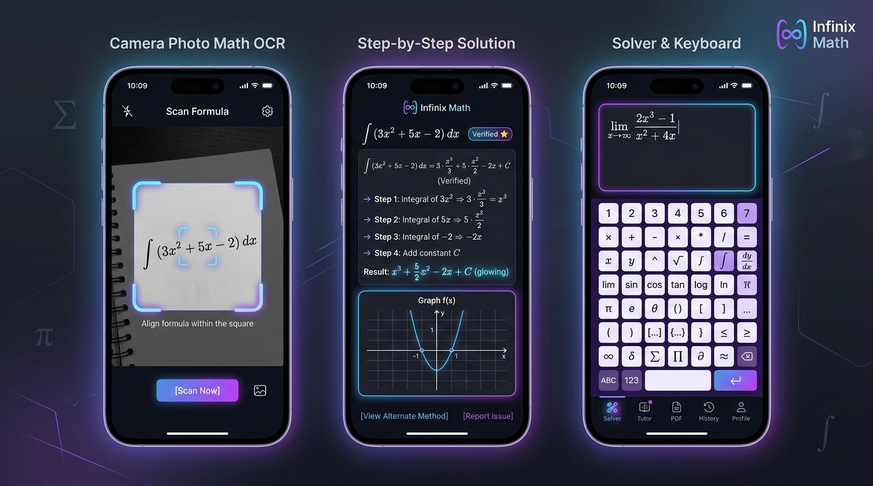
Figure 6: Phase 7 — Cross-Platform Mobile Experience: Camera Photo OCR, Step Solution & Virtual Math Keyboard
- Task 7.1: Cross-Platform Mobile App (iOS & Android): Package application using React Native / Capacitor with native camera reticle, gesture-driven bottom sheets, and offline caching.
- Task 7.2: Production Authentication Upgrade: Replace static 'admin/admin' with full production authentication: Google OAuth 2.0, Apple ID (private relay), Email OTP verification, and JWT session management.
- Task 7.3: Subscription Billing & Quota Engine: Integrate Stripe web checkout and Apple/Google In-App Purchases for Free ($0), Basic Pro ($5.98/wk), and Prime AI ($9.98/wk) tiers, complete with daily query meters and paywall modals.
- Task 7.4: CI/CD Pipeline & Cloud Deployment: Automate GitHub Actions CI/CD for automated linting, pytest suites, Next.js standalone builds, and multi-stage Docker deployment to Google Cloud Run / AWS ECS.
4. Sprints & Milestone Schedule
Sprint | Phase Focus | Key Verifiable Output | Sprint Target
Sprint 1 | Phase 1: Static Auth & App Shell | Working /login (admin/admin), session protection, sidebar navigation, dark theme | Days 1 - 3
Sprint 2 | Phase 2: Solver & Multi-Modal Input | MathLive editor, virtual keyboard, camera OCR, drawing pad, step solution & graph | Days 4 - 8
Sprint 3 | Phase 3: Socratic AI Tutor | Line-by-line step verifier, error taxonomy diagnosis cards, scaffolding hints, voice tutor | Days 9 - 13
Sprint 4 | Phase 4: PDF Homework Helper | PDF viewer, lasso crop tool, side-by-side solver, in-document annotations, PDF export | Days 14 - 18
Sprint 5 | Phase 5: Graphing & 45+ Calculators | 2D/3D interactive coordinate canvas, calculus overlays, full suite of 45 calculators | Days 19 - 24
Sprint 6 | Phase 6: Notebooks & Study Suite | Folder hierarchy, flashcards, adaptive quiz generator, searchable history hub | Days 25 - 28
Sprint 7 | Phase 7: Mobile & Production Auth | Mobile builds (iOS/Android), Google/Apple OAuth, Stripe subscriptions, Docker CI/CD | Days 29 - 34

Ready to Begin Phase 1 Execution
APPROVAL PROTOCOL:
By reviewing and approving this Step-by-Step Build Plan, engineering will immediately initiate Phase 1 (Task 1.1: Glassmorphic Login Page with static credentials 'admin'/'admin', followed by the persistent App Shell and protected route navigation).

