**EXPERIMENT NO:3**

**AIM:-.**To explore ‘select’ statement using various clauses like where, order by, between, like, group by, having and logical/relational operator. To implement various DML statements.

SQL:-

CREATE table student(id int,name varchar(10),marks int);

INSERT INTO student(id,name,marks)

VALUES(1,"alok",41),(2,"utsav",43),(3,"abc",46),(4,"ramesh",43),(5,"xyz",46);

SELECT* FROM student;

OUTPUT:-

### Student

| id | name | marks |
| --- | --- | --- |
| 1 | alok | 41 |
| 2 | utsav | 43 |
| 3 | abc | 46 |
| 4 | ramesh | 43 |
| 5 | xyz | 46 |

SQL:-

SELECT* FROM student

ORDER by marks;

OUTPUT:-

| id | name | marks |
| --- | --- | --- |
| 1 | alok | 41 |
| 2 | utsav | 43 |
| 4 | ramesh | 43 |
| 3 | abc | 46 |
| 5 | xyz | 46 |

SQL:-

SELECT* FROM student

WHERE marks BETWEEN 40 AND 45

OUTPUT:-

| id | name | marks |
| --- | --- | --- |
| 1 | alok | 41 |
| 2 | utsav | 43 |
| 4 | ramesh | 43 |

SQL:-

SELECT* FROM student

WHERE name LIKE 'a%';

OUTPUT:-

| id | name | marks |
| --- | --- | --- |
| 1 | alok | 41 |
| 3 | abc | 46 |

SQL:-

SELECT COUNT(id),name,marks

FROM student

GROUP BY marks;

OUTPUT:-

| COUNT(id) | name | marks |
| --- | --- | --- |
| 1 | alok | 41 |
| 2 | utsav | 43 |
| 2 | abc | 46 |

SQL:-

SELECT COUNT(id),name,marks

FROM student

GROUP BY marks

HAVING COUNT(id)>1;

OUTPUT:-

| COUNT(id) | name | marks |
| --- | --- | --- |
| 2 | utsav | 43 |
| 2 | abc | 46 |

SQL:-

SELECT * FROM student

WHERE name='abc' AND marks=46;

OUTPUT:-

| id | name | marks |
| --- | --- | --- |
| 3 | abc | 46 |

SQL:-

SELECT * FROM student

WHERE name='abc' OR marks=46;

OUTPUT:-

| id | name | marks |
| --- | --- | --- |
| 3 | abc | 46 |
| 5 | xyz | 46 |

SQL:-

SELECT * FROM student

WHERE name NOT LIKE 'a%';

OUTPUT:-

| id | name | marks |
| --- | --- | --- |
| 2 | utsav | 43 |
| 4 | ramesh | 43 |
| 5 | xyz | 46 |

**EXPERIMENT NO:4.1**

**AIM:-** Create the following table:

1. Table name DEPT:

| Column Name | Data Type | Size | Constraints |
| --- | --- | --- | --- |
| Dno | Number | 3 | Primary Key |
| Dname | Varchar | 10 |  |

SQL:-

CREATE TABLE DEPT(

Dno NUMBER(3) PRIMARY KEY,

Dname VARCHAR(10));

OUTPUT:-

### DEPT

| Dno | Dname |
| --- | --- |
| empty | |

(b)Table name EMP:

| Column Name | Data Type | Size | Constraints |
| --- | --- | --- | --- |
| ENo | Varchar | 5 | Primary Key and first number must be ‘E |
| Ename | Varchar | 10 | Not null |
| City | Char | 10 | Cities ‘delhi’,‘kolkata’,’chennai’,’mumbai’ |
| Salary | Integer |  |  |
| JoinDate | Date |  |  |
| Dno | Number | 3 | Foreign key reference DEPT Table |

SQL:-

CREATE TABLE Employee (

ENo VARCHAR(5) PRIMARY KEY CHECK (ENo LIKE 'E%'),

Ename VARCHAR(10) NOT NULL,

City CHAR(10) CHECK (City IN ('delhi', 'kolkata', 'chennai', 'mumbai')),

Salary INTEGER,

JoinDate DATE,

Dno NUMBER(3),

CONSTRAINT fk_Dno FOREIGN KEY (Dno) REFERENCES DEPT(Dno)

);

OUTPUT:-

### EMP

| ENo | Ename | City | Salary | JoinDate | Dno |
| --- | --- | --- | --- | --- | --- |
| empty | | | | | |

(c) Table Name:PROJECT

| Column Name | DataType | Size | Constraints |
| --- | --- | --- | --- |
| Pno | Varchar | 5 | Primary Key and First character must be ‘P’ |
| Eno | Varchar | 5 | Primary key and Foreign Key reference EMP |

SQL:-

CREATE TABLE PROJECT(

Pno VARCHAR(5) PRIMARY KEY CHECK (Pno LIKE 'P%'),

Eno VARCHAR(5),

CONSTRAINT fk_Eno FOREIGN KEY (Eno) REFERENCES EMP(Eno)

);

OUTPUT:-

### PROJECT

| Pno | Eno |
| --- | --- |
| empty | |

**Experiment No:4.2**

**Aim:**-Insert the following data into table:

(a)Table DEPT

| Dno | Dname |
| --- | --- |
| 1 | research |
| 2 | finance |

SQL;

INSERT INTO DEPT (Dno, Dname)

VALUES (1, 'research'),(2, 'finance');

OUTPUT:

### DEPT

| Dno | Dname |
| --- | --- |
| 1 | research |
| 2 | finance |

1. Table EMP

| Eno | Ename | City | Salary | JoinDate | Dno |
| --- | --- | --- | --- | --- | --- |
| E1 | ashima | kolkata | 18000 | 01-jan-14 | 1 |
| E2 | kamal | mumbai | 10000 | 01-jun-14 | 2 |
| E3 | tamal | chennai | 7000 | 01-jan-15 | 1 |
| E4 | asha | kolkata | 8000 | 01-jun-15 | 2 |
| E5 | timir | delhi | 7000 | 01-jan-16 | 1 |

SQL:-

INSERT INTO EMP (Eno, Ename, City, Salary, JoinDate, Dno)

VALUES

('E1', 'ashima', 'kolkata', 18000, TO_DATE('01-Jan-14', 'DD-Mon-YY'), 1),

('E2', 'kamal', 'mumbai', 10000, TO_DATE('01-Jun-14', 'DD-Mon-YY'), 2),

('E3', 'tamal', 'chennai', 7000, TO_DATE('01-Jan-15', 'DD-Mon-YY'), 1),

('E4', 'asha', 'kolkata', 8000, TO_DATE('01-Jun-15', 'DD-Mon-YY'), 2),

('E5', 'timir', 'delhi', 7000, TO_DATE('01-Jan-16', 'DD-Mon-YY'), 1);

OUTPUT:-

EMP

ENo Ename City Salary JoinDate Dno

E1 ashima kolkata 18000 01-Jan-14 1

E2 kamal mumbai 10000 01-Jun-14 2

E3 tamal chennai 7000 01-Jan-15 1

E4 asha kolkata 8000 01-Jun-15 2

E5 timir delhi 7000 01-Jan-16 1

(c) PROJECT

| Pno | Eno |
| --- | --- |
| P1 | E1 |
| P2 | E3 |
| P1 | E5 |
| P2 | E1 |

SQL:-

INSERT INTO PROJECT (Pno, Eno)

VALUES ('P1', 'E1'),('P2', 'E3'),('P3', 'E5'),('P4', 'E1');

OUTPUT:-

### PROJECT

| Pno | Eno |
| --- | --- |
| P1 | E1 |
| P2 | E3 |
| P3 | E5 |
| P4 | E1 |

**EXPERIMENT NO:5.1**

**AIM:-** Write sql for the following queries:

(a)Display the structure of table EMP

SQL:-

EXEC sp_columns 'EMP';

OUTPUT:-

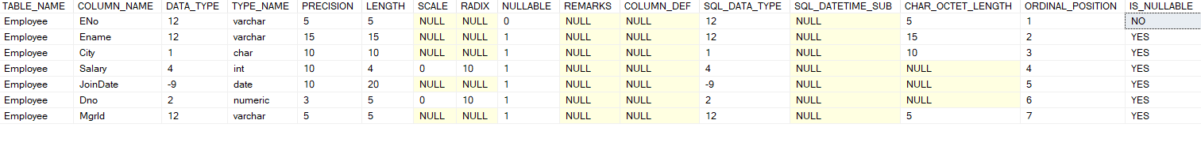

(b)Modify the dataType size of Ename of varchar 15

SQL:-

ALTER TABLE Employee

ALTER COLUMN Ename VARCHAR(15);

OUTPUT:-

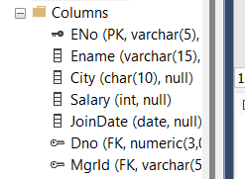

(c) Display the user constraints of table EMP

SQL:-

SELECT

tc.constraint_name,

ccu.column_name,

tc.constraint_type

FROM

INFORMATION_SCHEMA.CONSTRAINT_COLUMN_USAGE ccu

INNER JOIN

INFORMATION_SCHEMA.TABLE_CONSTRAINTS tc ON ccu.constraint_name = tc.constraint_name

WHERE

ccu.table_name = 'Employee';

OUTPUT:-

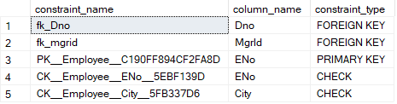

**Experiment No:5.2**

**Aim:-** Write the sql for following queries:

(a) Add a new column Mobileno which is unique (candidate key) of table EMP

SQL:-

ALTER TABLE EMP

ADD Mobileno VARCHAR(15);

OUTPUT:-

### 

### (b)add the constraint for Mobileno which is exactly of 10 digit.

SQL:-

ALTER TABLE EMP

ADD CONSTRAINT check_mobile_length

CHECK (LEN(Mobileno) = 10);

OUTPUT:-

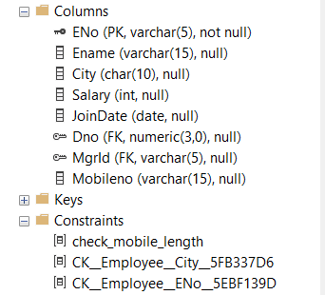

(c) Drop all constraints of Mobileno.

SQL:-

ALTER TABLE EMP

DROP CONSTRAINT check_mobile_length;

OUTPUT:-

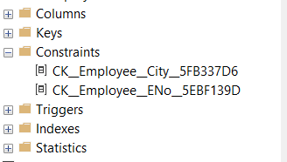

(d)Drop the column Mobileno of table EMP.

SQL:-

ALTER TABLE EMP

DROP COLUMN Mobileno;

OUTPUT:-

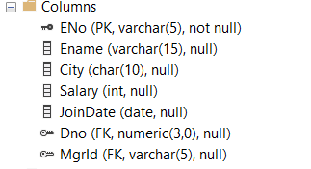

**Experiment No:5.3**

**Aim:-** Write sql for following queries.

(a) Add a new column MgrId of data size number 5 and MgrId should reference from Eno of table EMP.

SQL:-

ALTER TABLE EMP

ADD COLUMN MgrId VARCHAR(5),

ADD CONSTRAINT fk_mgrid

FOREIGN KEY (MgrId)

REFERENCES EMP(Eno);

OUTPUT:-



(b)Update the table EMP with following MgrId values:

| Eno | MgrId |
| --- | --- |
| E1 | E1 |
| E2 | E2 |
| E3 | E1 |
| E4 | E2 |
| E5 | E1 |

SQL:-

UPDATE EMP

SET MgrId = CASE

WHEN Eno = 'E1' THEN 'E1'

WHEN Eno = 'E2' THEN 'E2'

WHEN Eno = 'E3' THEN 'E1'

WHEN Eno = 'E4' THEN 'E2'

WHEN Eno = 'E5' THEN 'E1'

ELSE NULL

END;

select *

FROM EMP;

OUTPUT:-

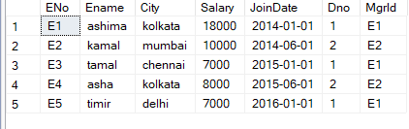

**Experiment No:5.4**

Aim:- Display the output of the queries.

(a) Display List of all employees in department no 2.

SQL:-

SELECT *

FROM EMP

WHERE Dno=2;

OUTPUT:-

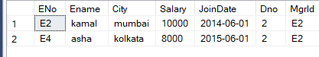

(b) Display name and salary of employees in dept number 1 and 2.

SQL:-

SELECT Ename,salary

FROM EMP

WHERE Dno=1 or Dno=2;

OUTPUT:-

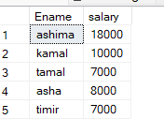

(c) Display the name of employees having ‘a’ as the second letter in their name.

SQL:-

SELECT Ename

FROM EMP

WHERE LEN(Ename)>=2 and SUBSTRING(Ename,2,1)='a'

OUTPUT:-

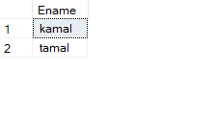

(d) Display list of all employees who have the name exactly four character.

SQL:-

SELECT *

FROM EMP

WHERE LEN(Ename)=4;

OUTPUT:-

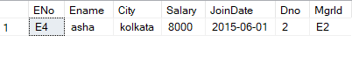

(e) Display employee name and department no for those who joined in the month june.

SQL:-

SELECT Ename, Dno

FROM EMP

WHERE MONTH(JoinDate) = 6;

OUTPUT:-

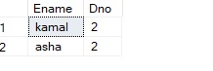

(f) Display list of all employee who were joined during 2015.

SQL:-

SELECT *

FROM EMP

WHERE YEAR(JoinDate) =2015

OUTPUT:-



(g).Display joining date of all employees in dd/mm/yy.

SQL:-

SELECT Ename, FORMAT(JoinDate, 'dd/MM/yy') AS FormattedJoinDate

FROM EMP;

OUTPUT:-

