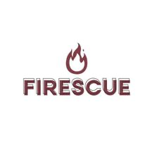**TITLE #1**

**FIRESCUE APPLICATION:** *A Reliable Fire Monitoring System Mobile Application regards to Disaster Risk Management in Municipality/Barangay .*

**TITLE #2**

**FIRESCUE APPLICATION:** *Approaches technical support for Fire Disaster Risk Reduction Management through Observation, Monitoring System in Municipality of .*

**TITLE #3**

**FIRESCUE APPLICATION:** *The Effectiveness in relation to Observation, Monitoring and Response in the Municipality of .*

A FAST application which is done to monitor reported fires and send alerts notifications to everyone in order to prevent damages and fatalities. Therefore, this application will help our Local Government Unit and BFP monitor real-time: the validity of reported fire, and give the community a reliable source of fire early warning, and preventive action that can be taken care of immediately.

**FEATURES:**

* *24/7 Live detection and Monitoring App via GPS*
* *Send alarm and status via text message or phone call*
* *Easy to install in mobile phones*
* *Flexible One-Tap options*
* *Designed with powerful and reliable features*
* *Can save history status/event logs*
* *Exclusive only for specific municipality/barangay*