create-react-app jay-amin-a-frame *# creates your new app*

cd jay-amin-a-frame *# navigate into the directory*

npm start *# run your app*

Go ahead and open this project in your favorite code editor. Open up src/App.jsso we can remove some code.

* Remove everything within the root div
* Clear out the import for the svg file and the css file

Your resulting code should look like this:

Setup Complete!

**A-Frame setup**

Now, we are going to install A-Frame as a dependency for our application. A-Frame uses a declarative way of writing code and feels very comfortable to anyone who has written JSX. It also has a handy debugging tool.

Back to the terminal:

npm install --save aframe

**Hello VR World**

We now need to import A-Frame into our React component and then add our first tag, the scene. The scene is the tag that all of other content will live in. Replace the div tags with the [<a-scene>](https://aframe.io/docs/0.5.0/core/scene.html) tag. The scene handles all of the three.js and WebVR boilerplate for us:

* Sets up the HTML canvas to hold our virtual reality world
* Creates the renderer
* Starts the render loop
* Adds a default camera
* Adds a directional light
* Adds an ambient light
* And a few other cool things too

import 'aframe'

import React, {Component} from 'react'

class App extends Component {

render () {

return (

<a-scene></a-scene>

);

}

}

export default App;

**Congratulations**, you officially made a VR world.

With your browser active, go ahead hit the following keys together: <ctrl> + <alt> + i.

This will open the visual inspector and dev tools. 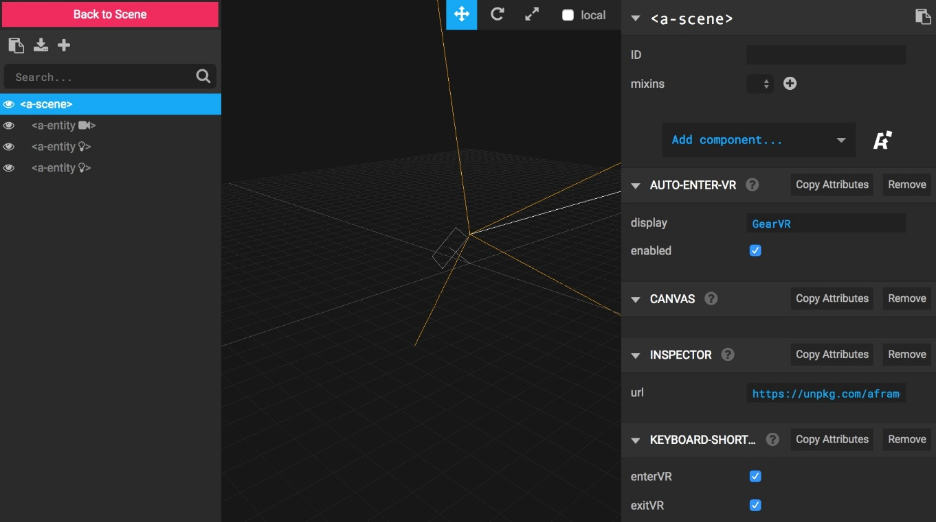

Click on the components on the left side and then check out the A-Frame component in the in

import 'aframe'

import React, {Component} from 'react'

class App extends Component {

render () {

return (

<a-scene>

<a-box

position="-1 0.5 -3"

rotation="0 45 0"

color="#4CC3D9" />

<a-sphere

position="0 1.25 -5"

radius="1.25"

color="#EF2D5E" />

<a-cylinder

position="1 0.75 -3"

radius="0.5"

height="1.5"

color="#FFC65D" />

<a-plane

position="0 0 -4"

rotation="-90 0 0"

width="4"

height="4"

color="#7BC8A4" />

<a-dodecahedron

color="#FF926B"

radius="5"

position="0 -1 -30"></a-dodecahedron>

<a-sky src={require('./imge.jpeg')} />

</a-scene>

);

}

}

export default App;