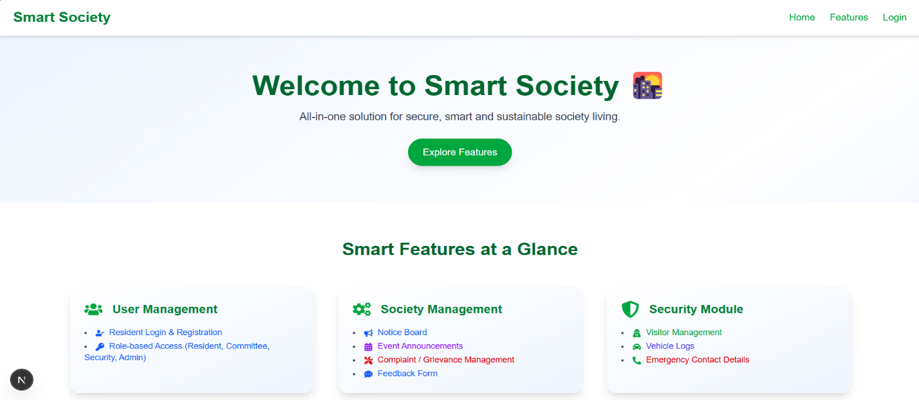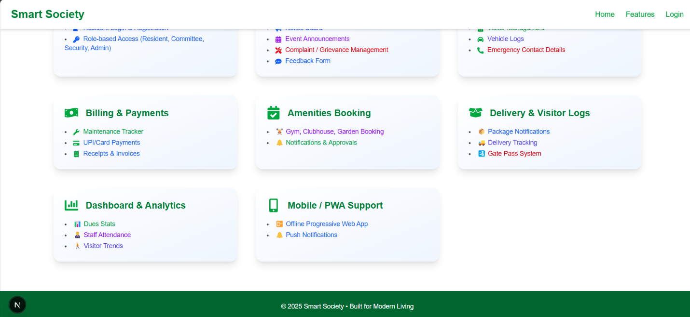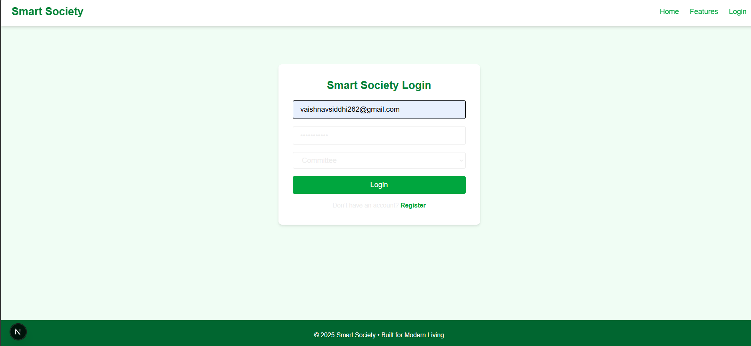

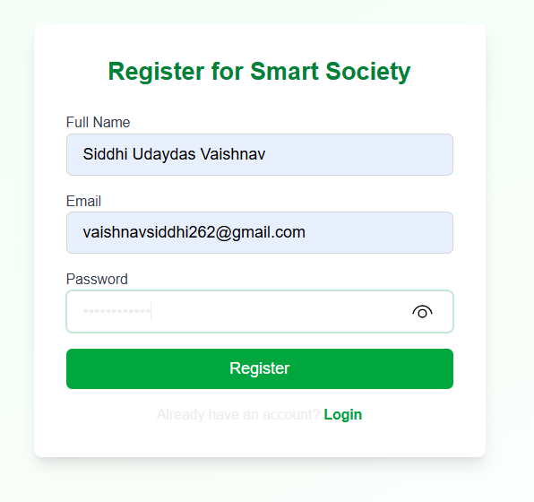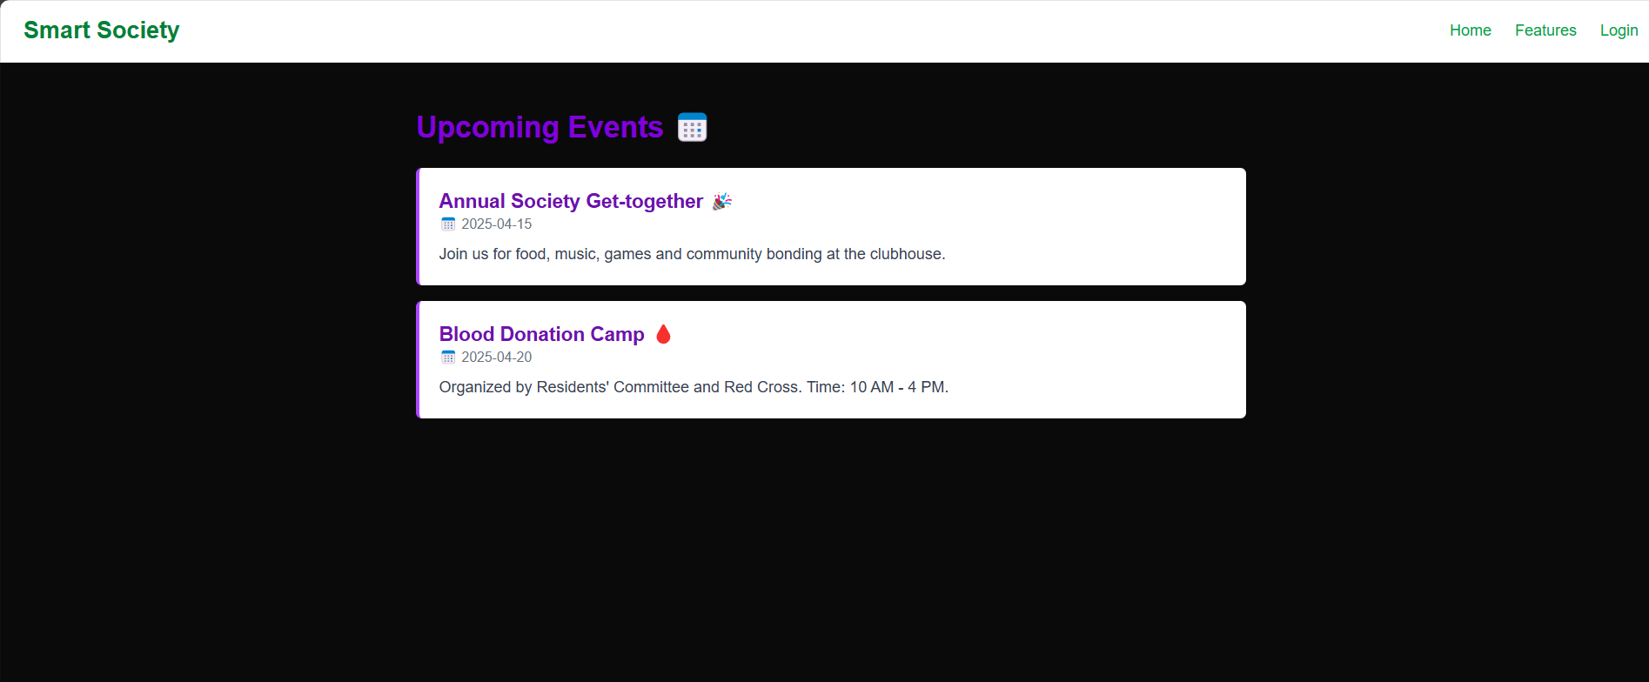

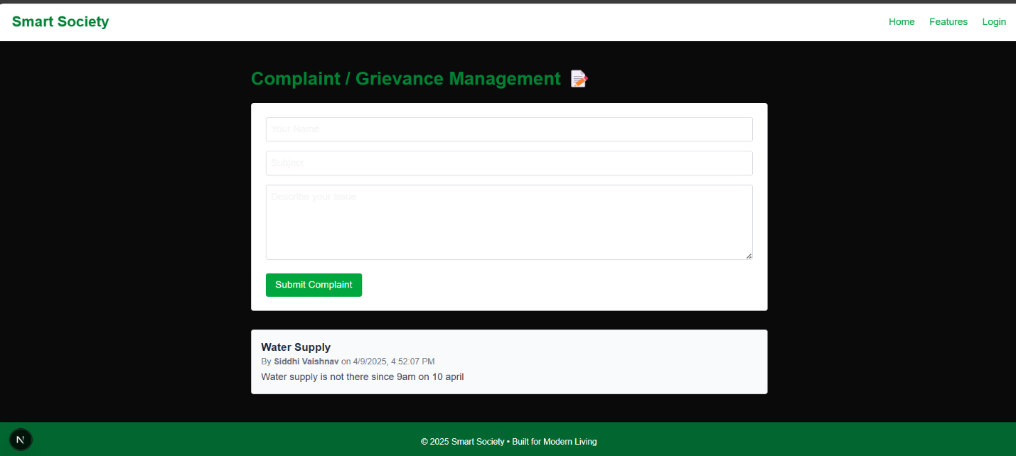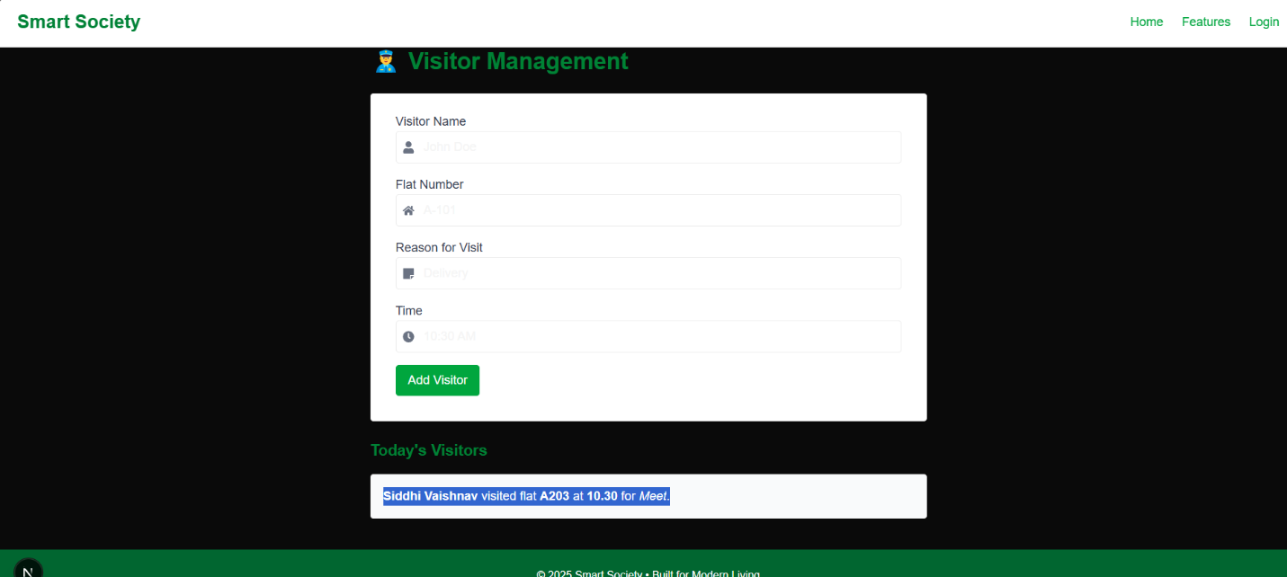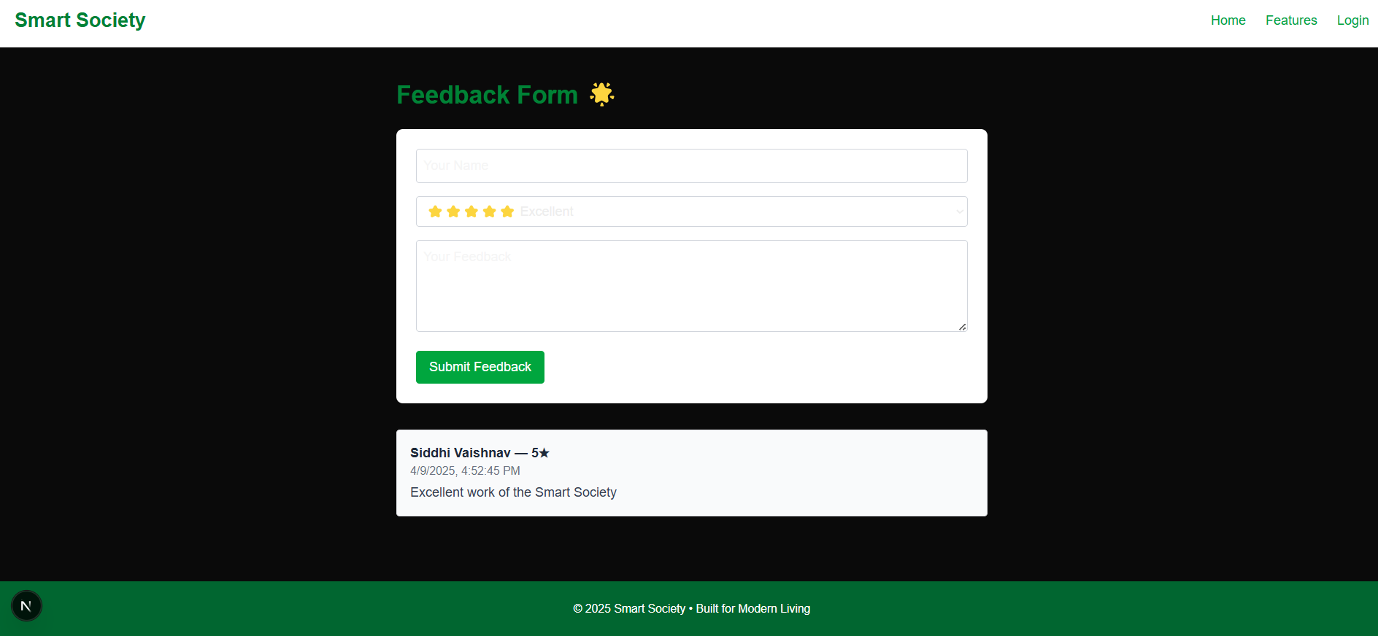

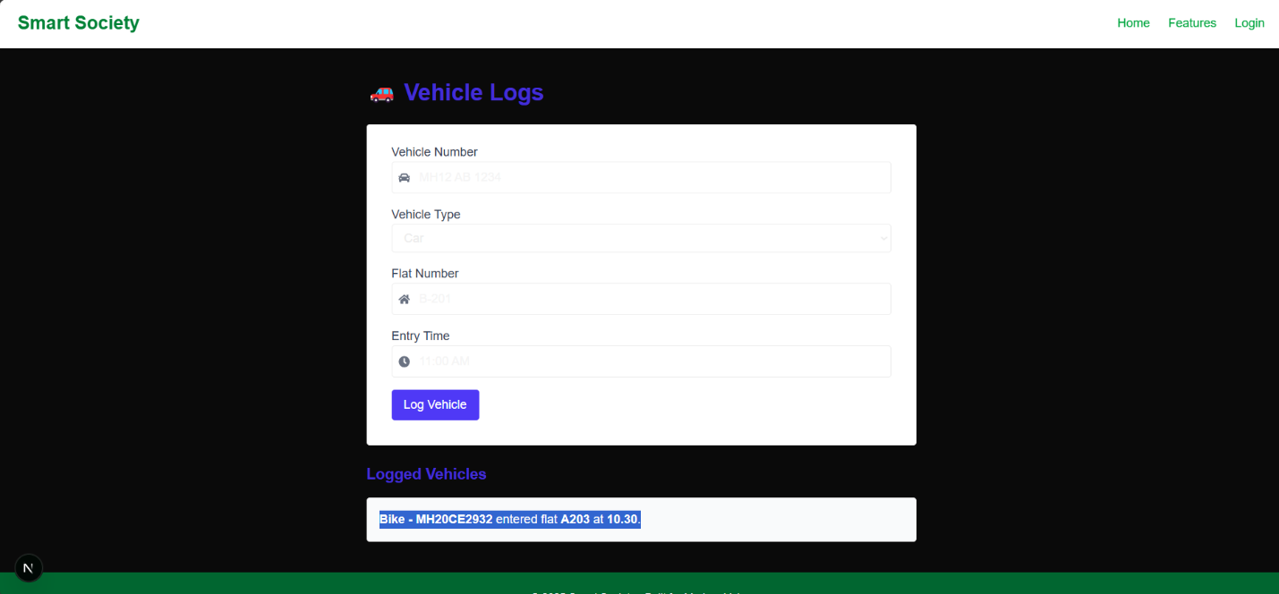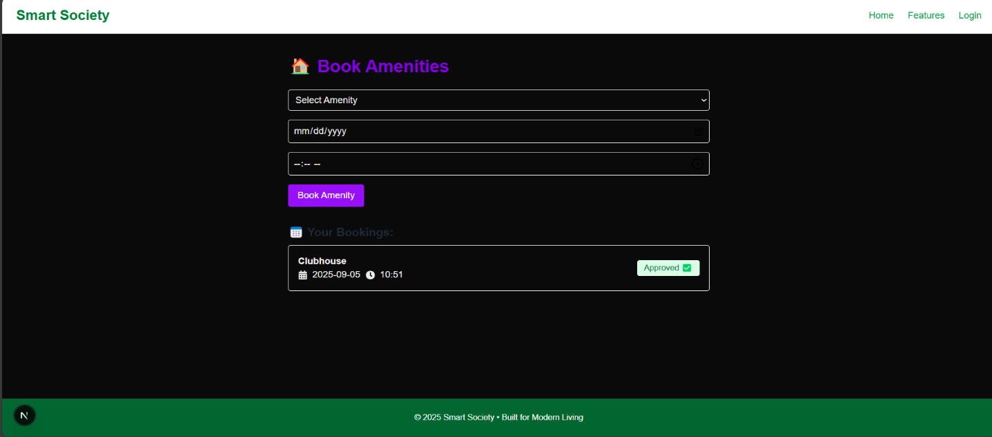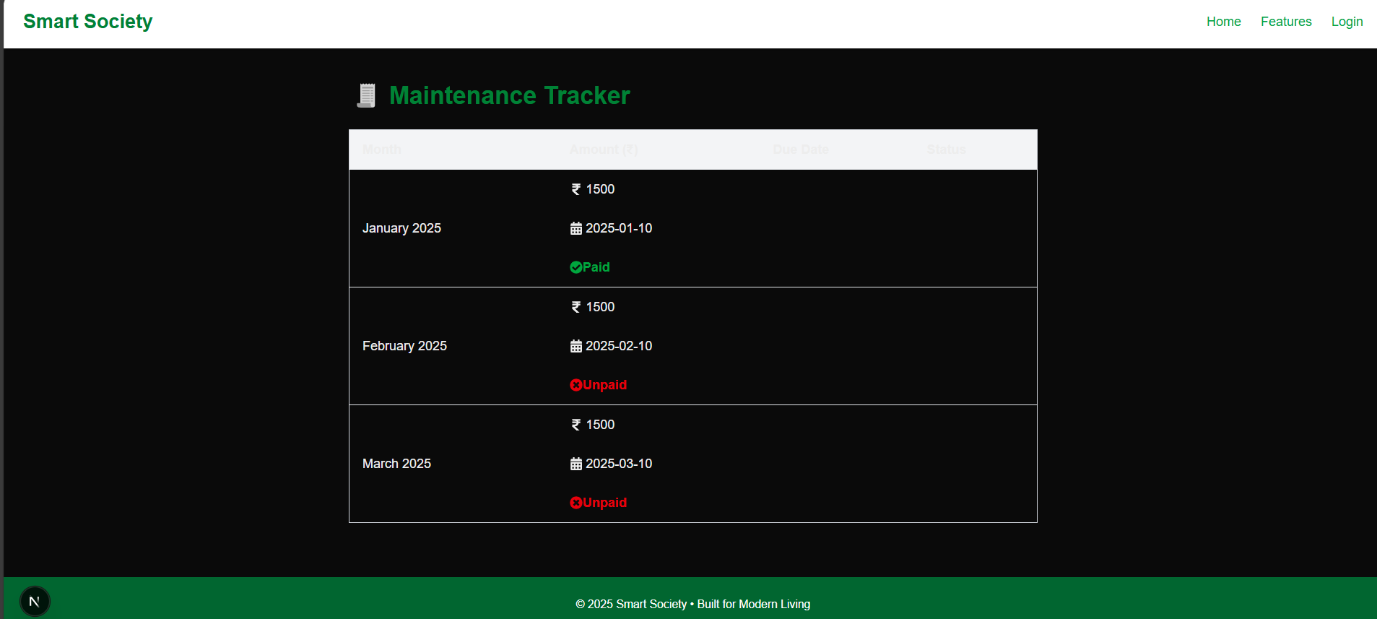

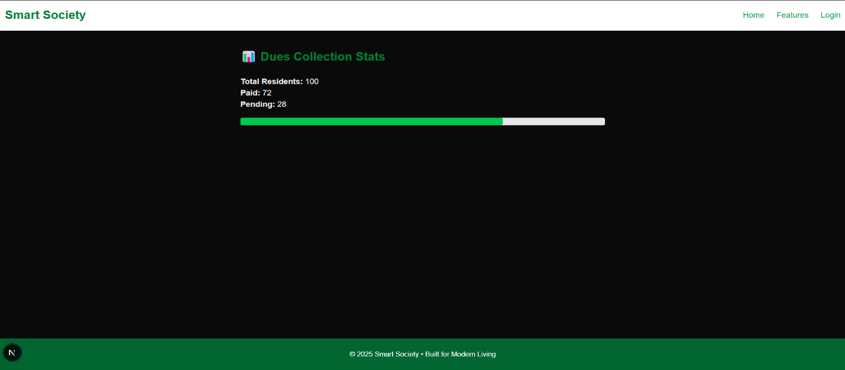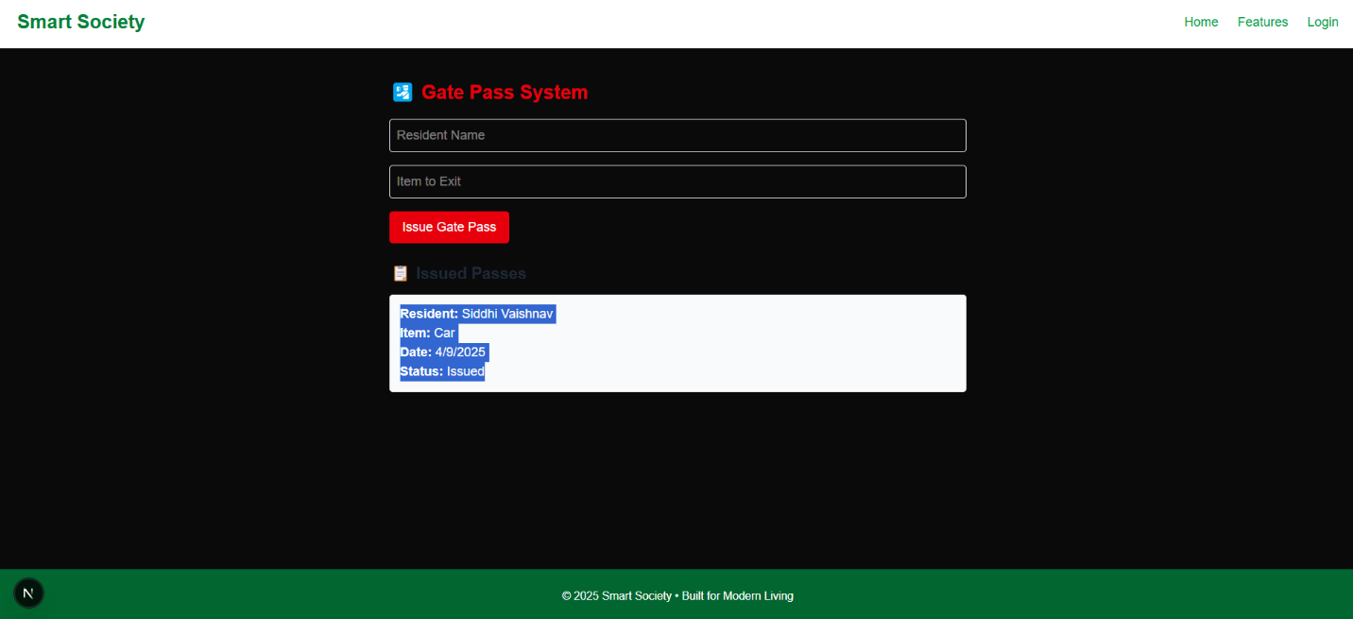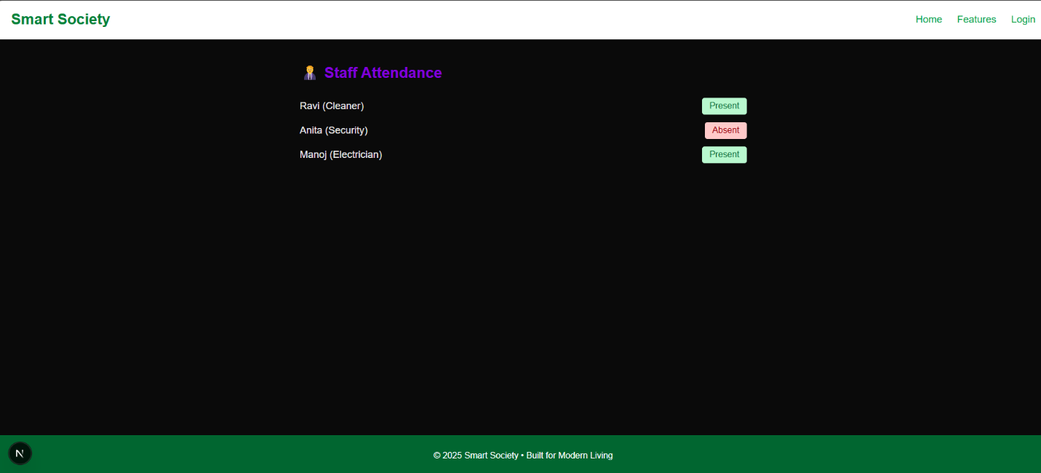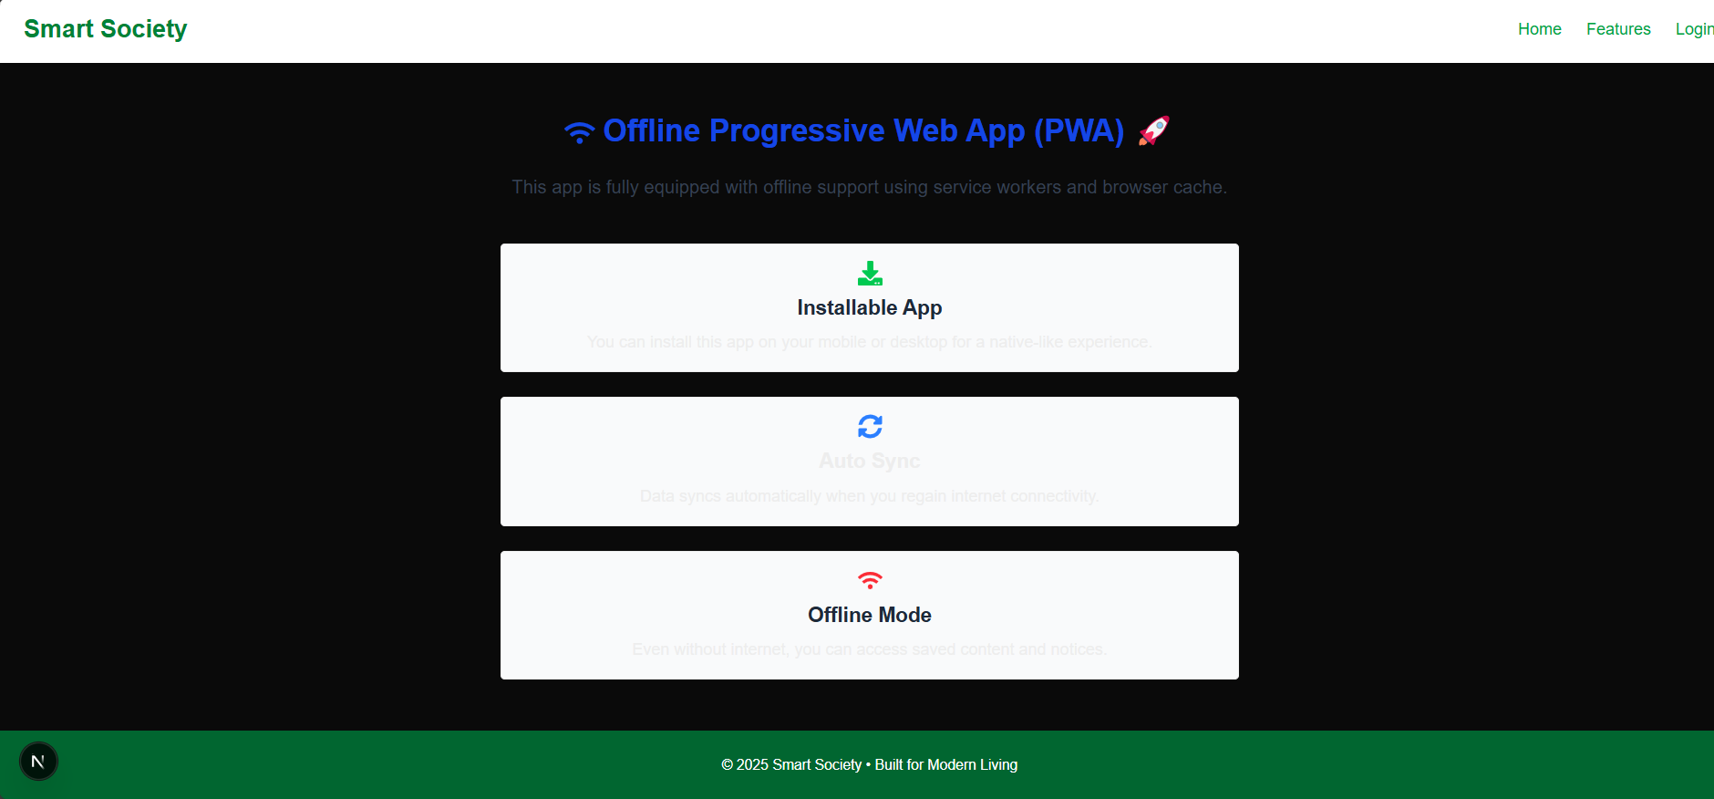

* users Table – Login & Role Management

CREATE TABLE users (

id INT PRIMARY KEY AUTO_INCREMENT,

name VARCHAR(100),

email VARCHAR(100) UNIQUE,

password_hash VARCHAR(255),

phone VARCHAR(15),

flat_number VARCHAR(10),

role ENUM('resident', 'committee', 'security', 'admin') DEFAULT 'resident',

created_at TIMESTAMP DEFAULT CURRENT_TIMESTAMP

);

* notices Table – Notice Board

CREATE TABLE notices (

id INT PRIMARY KEY AUTO_INCREMENT,

title VARCHAR(150),

content TEXT,

created_at DATE,

created_by INT,

FOREIGN KEY (created_by) REFERENCES users(id)

);

* **events Table – Event Announcements**

CREATE TABLE events (

id INT PRIMARY KEY AUTO_INCREMENT,

title VARCHAR(150),

description TEXT,

event_date DATE,

created_by INT,

FOREIGN KEY (created_by) REFERENCES users(id)

);

* **complaints Table – Grievance Management**

CREATE TABLE complaints (

id INT PRIMARY KEY AUTO_INCREMENT,

user_id INT,

title VARCHAR(100),

description TEXT,

status ENUM('pending', 'resolved') DEFAULT 'pending',

submitted_at TIMESTAMP DEFAULT CURRENT_TIMESTAMP,

FOREIGN KEY (user_id) REFERENCES users(id)

);

* **feedback Table – Feedback Form**

CREATE TABLE feedback (

id INT PRIMARY KEY AUTO_INCREMENT,

user_id INT,

feedback TEXT,

rating INT CHECK (rating BETWEEN 1 AND 5),

created_at TIMESTAMP DEFAULT CURRENT_TIMESTAMP,

FOREIGN KEY (user_id) REFERENCES users(id)

);

* **visitors Table – Visitor Management**

CREATE TABLE visitors (

id INT PRIMARY KEY AUTO_INCREMENT,

name VARCHAR(100),

flat_number VARCHAR(10),

purpose VARCHAR(100),

entry_time TIMESTAMP,

exit_time TIMESTAMP NULL,

entered_by INT,

FOREIGN KEY (entered_by) REFERENCES users(id)

);

* **vehicle_logs Table – Vehicle Entry/Exit**

CREATE TABLE vehicle_logs (

id INT PRIMARY KEY AUTO_INCREMENT,

vehicle_number VARCHAR(20),

owner_name VARCHAR(100),

entry_time TIMESTAMP,

exit_time TIMESTAMP NULL,

logged_by INT,

FOREIGN KEY (logged_by) REFERENCES users(id)

);

* **emergency_contacts Table**

CREATE TABLE emergency_contacts (

id INT PRIMARY KEY AUTO_INCREMENT,

name VARCHAR(100),

contact_number VARCHAR(15),

type ENUM('fire', 'ambulance', 'police', 'maintenance')

);

* **maintenance_payments Table – Billing**

CREATE TABLE maintenance_payments (

id INT PRIMARY KEY AUTO_INCREMENT,

user_id INT,

amount DECIMAL(10, 2),

paid_on DATE,

method ENUM('UPI', 'Card', 'Cash'),

receipt_url VARCHAR(255),

FOREIGN KEY (user_id) REFERENCES users(id)

);

* **invoices Table – Receipts**

CREATE TABLE invoices (

id INT PRIMARY KEY AUTO_INCREMENT,

user_id INT,

invoice_date DATE,

amount DECIMAL(10,2),

status ENUM('paid', 'unpaid'),

download_link VARCHAR(255),

FOREIGN KEY (user_id) REFERENCES users(id)

);

* **amenities_bookings Table**

CREATE TABLE amenities_bookings (

id INT PRIMARY KEY AUTO_INCREMENT,

user_id INT,

amenity ENUM('gym', 'clubhouse', 'garden'),

booking_date DATE,

slot_time VARCHAR(20),

status ENUM('pending', 'approved', 'rejected') DEFAULT 'pending',

FOREIGN KEY (user_id) REFERENCES users(id)

);

* **deliveries Table – Package Notifications**

CREATE TABLE deliveries (

id INT PRIMARY KEY AUTO_INCREMENT,

user_id INT,

package_details TEXT,

received_on TIMESTAMP DEFAULT CURRENT_TIMESTAMP,

collected_on TIMESTAMP NULL,

FOREIGN KEY (user_id) REFERENCES users(id)

);

* **gate_passes Table – Gate Pass Management**

CREATE TABLE gate_passes (

id INT PRIMARY KEY AUTO_INCREMENT,

user_id INT,

reason TEXT,

request_time TIMESTAMP DEFAULT CURRENT_TIMESTAMP,

status ENUM('pending', 'approved', 'rejected') DEFAULT 'pending',

FOREIGN KEY (user_id) REFERENCES users(id)

);

* **dashboard_stats View (optional)**

CREATE VIEW dashboard_stats AS

SELECT

(SELECT COUNT(*) FROM users WHERE role = 'resident') AS total_residents,

(SELECT COUNT(*) FROM complaints WHERE status = 'pending') AS pending_complaints,

(SELECT COUNT(*) FROM maintenance_payments) AS total_payments;