[Agile vs Waterfall | Which Software Development Approach Would You Choose? | Edureka - YouTube](https://www.youtube.com/watch?v=rvTejAg_fbY)

Waterfall:

* Software Development model
* Model is in sequential order; that is, it is top-down approach
* Phases of model👇

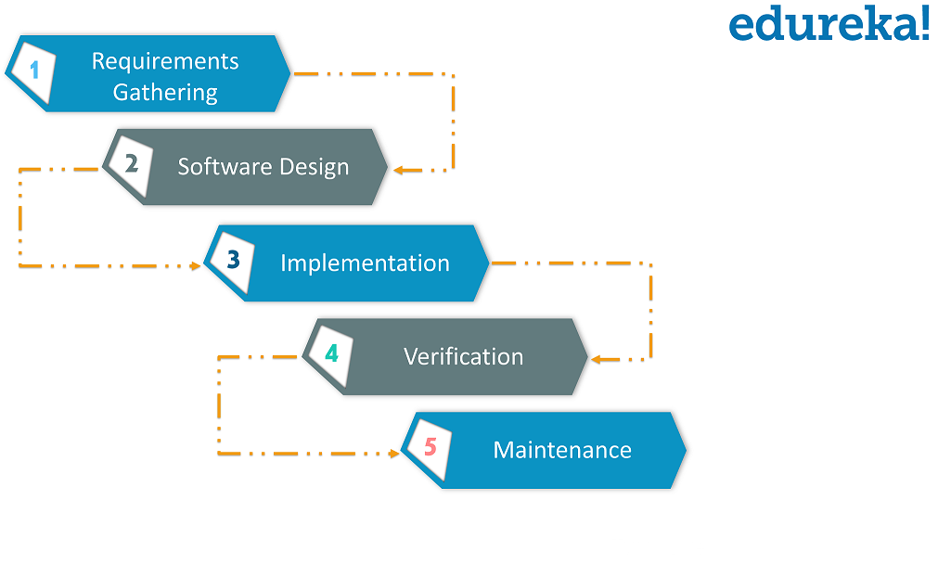

* Requirement gathering and analyzing of requirement
* Software Design: design a blueprint of software; how website will be looked.
* Implementation: here we begin with the coding part; team of developers works together on various components of application. After this
* Verification phase: in this various test conducted on the application i.e., integration testing, performance testing and so on.
* After all the test are done, application is deployed live on the production servers.
* Maintenance: In this phase application is monitored for performance and any issues related to the performance of app is resolved in this phase.

PROS:

* Planning and designing is straightforward and simple as whole team remain on the same phase.
* Easy of calculate progress of development of application.

CONS:

* Requirement gathering and analyzing of requirement at each page can be time consuming
* If customer wants to change or modify: it can be difficult, expensive to modify changes.

Agile:

* Software development model
* Model is iterative based and software can be broken down into various iterations.
* Every iteration has phases like Waterfall model

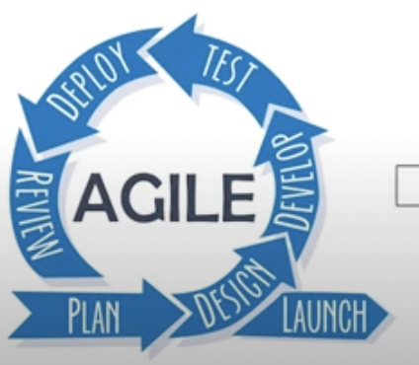

Plan->design->deploy->test->deploy->review

->Launch

* Duration of each iteration is usually 2-8weeks’

First Iteration:

* We release applications with some high priority features. End-Users and costumers give feedback about the performance of the application.

Second Iteration:

* Then necessary changes are made along with the new features and applications is again released.

This whole procedure repeats till we achieve actual requirements of the applications.

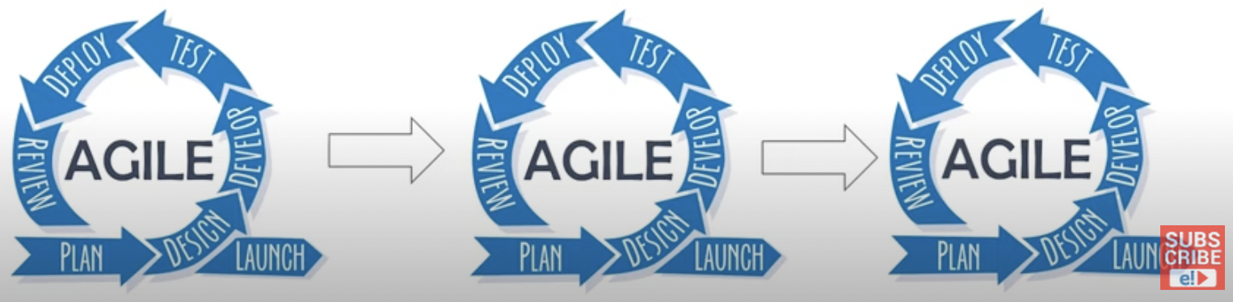

PROS:

* With high costumer Involvement, more feedback is received quickly.
* Our work is reviewed at every stage.
* Improved quality of application after every cycle.

CONS:

* Hard to execute
* Whole team is involved in each phase.
* Due to Continuous changes, Final product can be seemed different from what was planned initially