Agile vs Waterfall | Which Software Development Approach Would You Choose? | Edureka - YouTube
Waterfall:
- Software Development model
- Model is in sequential order; that is, it is top-down approach
- Phases of model👇
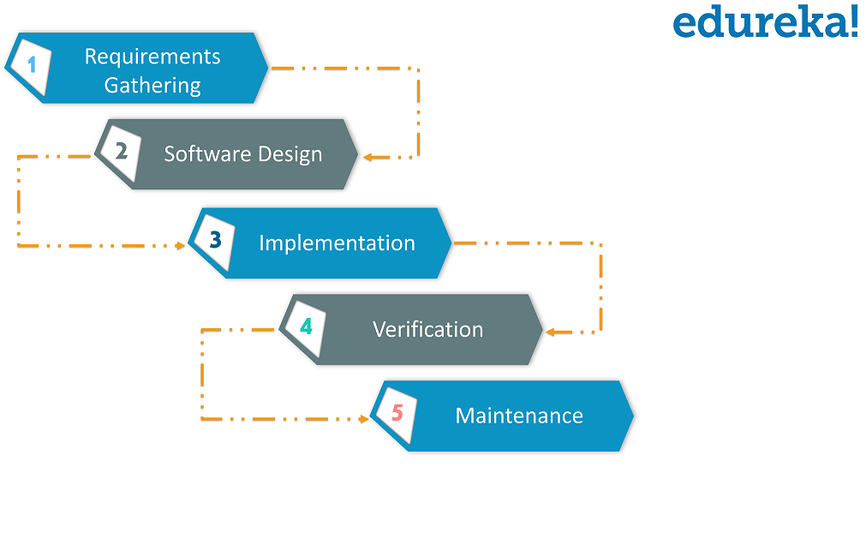
- Requirement gathering and analyzing of requirement
- Software Design: design a blueprint of software; how website will be looked.
- Implementation: here we begin with the coding part; team of developers works together on various components of application. After this
- Verification phase: in this various test conducted on the application i.e., integration testing, performance testing and so on.
- After all the test are done, application is deployed live on the production servers.
- Maintenance: In this phase application is monitored for performance and any issues related to the performance of app is resolved in this phase.

PROS:
- Planning and designing is straightforward and simple as whole team remain on the same phase.
- Easy of calculate progress of development of application.

CONS:
- Requirement gathering and analyzing of requirement at each page can be time consuming
- If customer wants to change or modify: it can be difficult, expensive to modify changes.

Agile:
- Software development model
- Model is iterative based and software can be broken down into various iterations.
- Every iteration has phases like Waterfall model
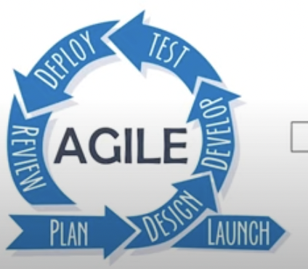
Plan->design->deploy->test->deploy->review
->Launch
- Duration of each iteration is usually 2-8weeks’
First Iteration:
- We release applications with some high priority features. End-Users and costumers give feedback about the performance of the application.
Second Iteration:
- Then necessary changes are made along with the new features and applications is again released.
This whole procedure repeats till we achieve actual requirements of the applications.
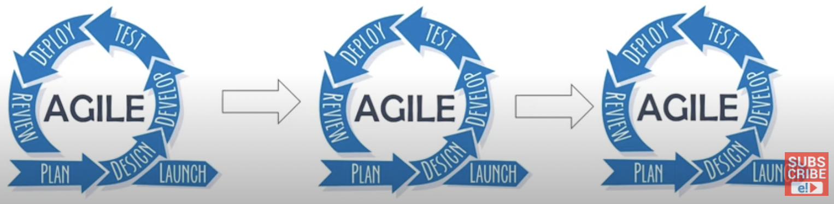
PROS:
- With high costumer Involvement, more feedback is received quickly.
- Our work is reviewed at every stage.
- Improved quality of application after every cycle.
CONS:
- Hard to execute
- Whole team is involved in each phase.
- Due to Continuous changes, Final product can be seemed different from what was planned initially

