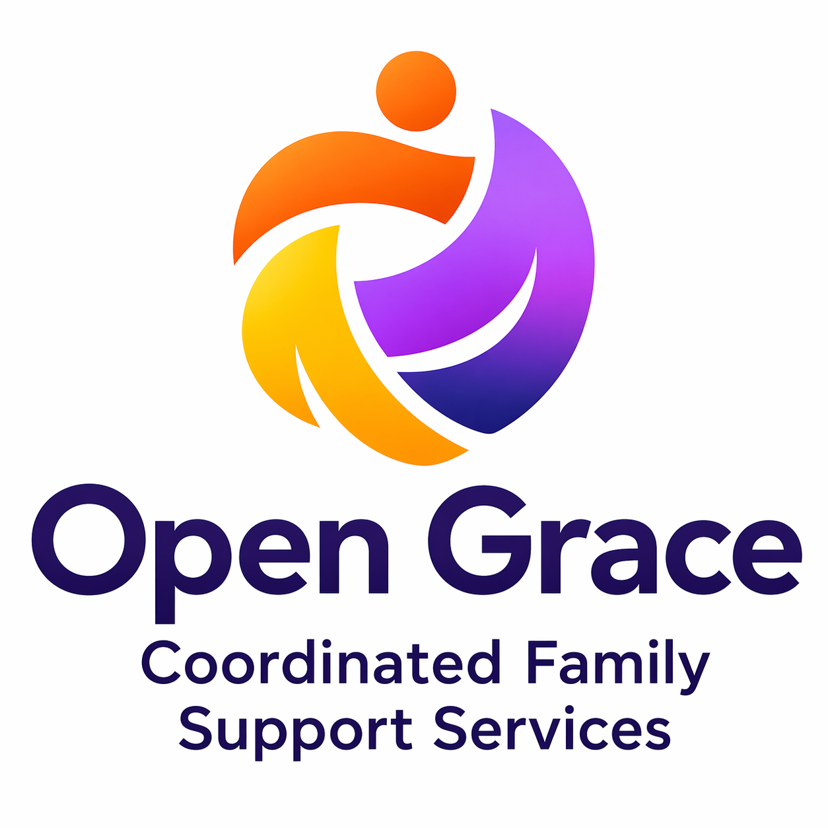
OPEN GRACE LLC
Coordinated Family Support Services • IRC Vendor PJ6208
951-880-4132 • joshua.kennedy@opengrace.org • opengrace.org

Date: [Offer Date]
[Candidate Full Name]
[Street Address]
[City, State ZIP]
RE: Offer of Employment — [Position Title]
Dear [Candidate Full Name],

Open Grace LLC is pleased to extend this conditional offer of employment for the position of [Position Title] within our Coordinated Family Support (CFS) program. We are confident that your skills, experience, and values are well-aligned with Open Grace’s mission to support families across Riverside and San Bernardino Counties.
Please review the terms of this offer carefully. This offer is conditional upon successful completion of all pre-employment requirements outlined below.
OFFER SUMMARY
Position Title | [Position Title]
Department | Coordinated Family Support (CFS)
Reports To | Joshua Kennedy, Director
Employment Status | Non-exempt (hourly) — at-will employment
FLSA Classification | Non-Exempt
Hours Per Week | Part-time / as scheduled — not to exceed 29 hours per week
Proposed Start Date | [Start Date]
Hourly Base Rate | $[XX.XX] per hour
COMPENSATION & PAY
Your base hourly rate has been determined using Open Grace’s Wage Rubric, which considers your years of relevant experience, educational background, and applicable certifications. This rate is effective upon your confirmed start date.
Payroll is processed [bi-weekly / semi-monthly] via [payroll platform]. Direct deposit enrollment is available and encouraged. Payroll details will be provided at onboarding.
PRE-EMPLOYMENT CONDITIONS
This offer is contingent upon your satisfactory completion of all of the following requirements prior to your start date. Failure to complete any requirement may result in withdrawal of this offer.

- Live Scan fingerprinting and DOJ/FBI background clearance (CORI access required for this role)
- Current CPR and First Aid certification
- Signed Employee Handbook Acknowledgement
- Completed Staff Onboarding Form (Jotform)
- Completion of all four Day 1 required training modules in the Open Grace Training Academy before first client contact
- Signed CORI Confidentiality Agreement
- Valid California driver’s license and proof of current auto insurance (if role involves transportation)

Open Grace LLC will reimburse the cost of Live Scan and CPR/First Aid certification upon successful completion of all pre-employment requirements and 30 days of active employment. Original receipts must be submitted within 60 days of your hire date.
AT-WILL EMPLOYMENT
Your employment with Open Grace LLC is at-will, meaning that either you or Open Grace may terminate the employment relationship at any time, with or without cause, and with or without advance notice. Nothing in this offer letter, the Employee Handbook, or any other communication constitutes a contract of employment for a specified term or guarantees continued employment.
CONFIDENTIALITY & CORI COMPLIANCE
As a condition of your employment, you will be required to sign and comply with Open Grace’s CORI Confidentiality Agreement. Your role may provide access to Criminal Offender Record Information (CORI) through the California DOJ. Unauthorized disclosure of CORI is a violation of California law and will result in immediate termination and potential criminal liability.
You are also required to comply at all times with HIPAA, Title 17, and Open Grace’s internal data security and confidentiality policies as described in the Employee Handbook.
ACCEPTANCE OF OFFER
To accept this offer, please sign and return this letter no later than [Acceptance Deadline]. If you have questions prior to signing, please contact Director Joshua Kennedy at 951-880-4132 or joshua.kennedy@opengrace.org.

We look forward to welcoming you to the Open Grace LLC team.

Sincerely,
Joshua Kennedy
Director, Open Grace LLC
IRC Vendor PJ6208 • 951-880-4132
joshua.kennedy@opengrace.org

CANDIDATE ACCEPTANCE
I, [Candidate Full Name], have read, understand, and agree to the terms and conditions of this offer of employment with Open Grace LLC.

Candidate Signature |  | Date

Open Grace LLC • Confidential Employment Document • IRC Vendor PJ6208

