Languages and Machines
Exercises Chap 9: 1, 2, 4, 7(a), 10

1
a
>E--B/BR-->0--B/aR-->1--B/aR-->2--B/aL-->f--
^ | a/a L
--
s
0
1
3
2
f
B/# R
a/B R
b/B R
a/B R
b/B R
B/B L
B/B L
#/B R
B/b L
B/a L
#/B R
(This is supposed to be a loop)
b

c
s
0
1
3
2
4
B/B R
B/B R
B/B R
a/a L
b/b L
a/a R
b/b R
a/B R
B/a L
b/B R
a/a R
b/b R
B/b L
a/a L
b/b L

d
This is my lt function from the final -- the greater than machine would use a similar design:
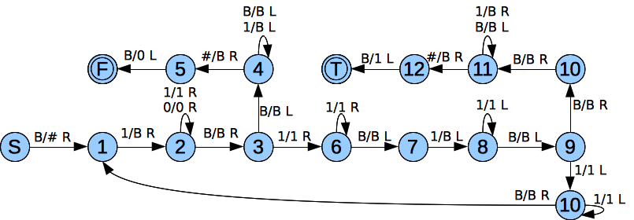
2
What is a “partial characteristic function”? If it means that it does not return 0/1 and we want it to return 0/1, then we simply check to see if there are blanks or u to the right.

4
a)
By the definition of recursive languages, all languages that are accepted by halting are recursive. Since X_{L} by definition prints a 1 or 0 and halts at the beginning for all strings w of L, then L is recursive.
b)
If L is recursive, then by definition we know that the TM halts for all input strings. We can convert the recursive TM to X_{L} by using the theorem to convert a halting TM to a final state TM. The failure state will erase all input and return a 0, while the final state will erase all input and return a 1.

7
a
Move right, write 111, Move left, MULT, move right, write 1111, move left, ADD

10
a
(NxN)->N
b
(NxN)->N
c
(NxNxN)->N
d
N->N

