SAP-1
User Manual
By J Bolton

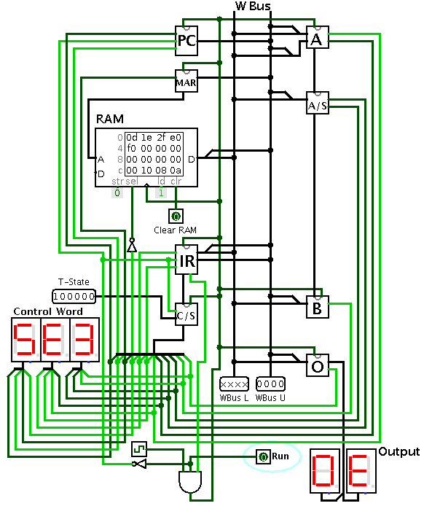

Introduction

The SAP-1 is a simple computer designed for the purposes of education. It can read a program and automatically execute it, accepting the following commands:
  - Load something into memory
  - Add two numbers
  - Subtract two numbers
  - Output our result
  - and Halt all processes
All inputs and outputs are in hexadecimal form. For example, you can create a program which adds A and 8 to output '12.'
There is only one control: the 'Run' switch. When switched on, your program is executed. When switched off, the computer is stopped and reset.

Your First Program

Our goal is to perform the following operation

16+8-10

To get started, we first need to know how to write a program. The SAP-1's programs are a sequential series of commands or instructions loaded into the RAM (see the diagram on the first page). Each of these instructions are represented by an abbreviation and a single, arbitrary hexadecimal number. The hexadecimal representation is what we are going to load into the RAM.

Instruction | Abbreviation | Hexadecimal representation
Load something into memory | LDA | 0
Add two numbers | ADD | 1
Subtract two numbers | SUB | 2
Output our result | OUT | E
Halt all processes | HLT | F

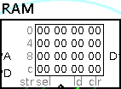
Take a look at the RAM component. It appears to contain a grid consisting of hexadecimal numbers. There are four rows and four columns, and each cell contains a two-digit hexadecimal number. Starting with the cell on the top left (labeled '0'), and ending with the bottom right cell (location 'F'). So, there are a total of 16 RAM locations, each containing two hex digits.

Each cell in the RAM either contains an instruction, a number, or nothing. The first digit in each two-digit location is where we put our instructions.
First, let's try loading our data into the RAM. Our data is the numbers we're dealing with. Remember, we're trying to do the following: 16+8-10, so our data is 16, 8, and 10. The very last locations are good places to put our data, because that gives us plenty of room in the rest of the RAM to give our instructions. So, select the last three locations and insert 16, 8, and 10 in hex form:
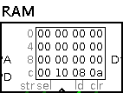

Before we add or subtract anything, we need to load an initial number. Let's try putting the Load instruction into the first location (location 0). Remember, the hex code for Load is '0', but it also needs the RAM location of the number its loading. We want to load our first number, 16, so we need to type '0D' or Load location D into memory.
Then, in location 1 and 2, we can insert our Add (1) and Subtract (2) instructions. Each are followed by the location of the number we want the operator to use. We want to Add the number at location E and then Subtract the number at location F.
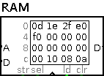
Finally give, the Output and Halt instructions, which are (EX) and (FX). It doesn't matter what the 'X' is because output and halt don't need to refer to any other memory location.

Now, make sure that “Simulate → Ticks Enabled” is checked and turn on the 'Run' switch. You'll see the different RAM locations being selected, and eventually it will get to the 'f0' instruction and it will stop.
Your output display should now read '0E,' which in decimal is 14.

How Does It Work?

To get a general idea of how it works, try any other variations of the program you wrote, and notice how the different wires go high and low and how both the 'control word' and 't-state' displays change together as the computer runs. Try setting the Ticks Frequency to a lower speed to see all the changes.
The instructions you put in the RAM tell the computer to go through a specific sequence of 'control words'. Each control word manipulates the various components – the registers, counters, and adder/subtracter – in different ways.
For example, the Add instruction will put two numbers into the adder component and then store the result, and it's able to do this in three steps, or three control words.
The best way to understand the tiny details of the computer's workings is to trace an instruction's control words to the individual components and observe exactly what is happening at each small step.

