**Take Home: Quiz 4 (15 pts) – Iteration and Loops**

Using Canvas <https://canvas.wsu.edu/>, please submit your solution to the correct quiz folder. Your solution should be a .pdf file with the name <your last name>_quiz4.pdf and uploaded. To upload your solution, please navigate to your correct Canvas ***lab*** course space. Select the “Assignments” link in the main left menu bar. Navigate to the correct quiz submission folder. Click the “Start Assignment” button. Click the “Upload File” button. Choose the appropriate .pdf file with your solution. Finally, click the “Submit Assignment” button.

1. (5 pts) Draw a flowchart for an algorithm that finds the sum of the digits in a 0 or positive integer number. For example, if the given integer is 4237, then the sum of the digits is 16. If the given integer is 106, then the sum of the digits is 7.

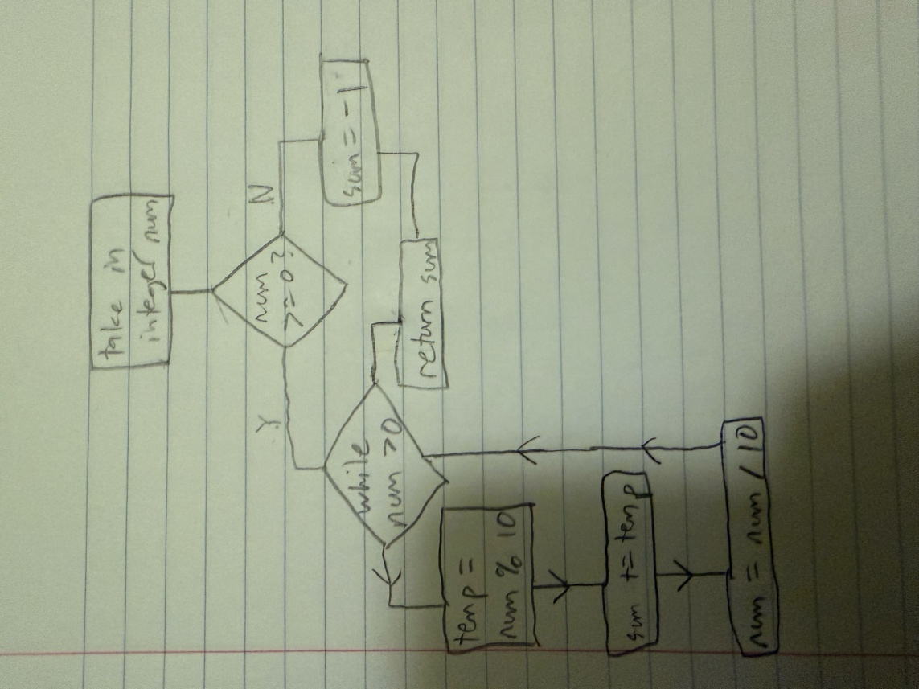

1. (2 pts – 1 pt for return type, 1 pt/parameter) Provide the prototype for a function called calc_sum_digits() that accepts one integer and returns the sum of the digits.

int calc_sum_digits(int);

1. (8 pts – 1 pt for the function header, 6 pts for algorithm, 1 pt for return value) Provide the function definition for calc_sum_digits(). Also, be sure to provide the function header for calc_sum_digits(). Precondition: input parameter integer must be >= 0.

int calc_sum_digits(int num) {

int temp = 0, sum = 0;

if (num >= 0) {

while (num > 0) {

temp = num % 10;

sum += temp;

num = num / 10;

}

}

else {

sum = -1;

}

return sum;

}