Renta-PH.net — Tenant User Guide
Version 1.0 · For tenants renting through Renta-PH.net
Your landlord uses Renta-PH.net to manage your lease, rent, and utilities. This guide shows you how to use your tenant portal.

1. Getting started

1.1 Portal setup
Your landlord will send you an invitation email with a link to set up your portal account.
Click the link in the invitation email.
Create a password for your portal account.
Log in at renta-ph.net/portal with your email and password.
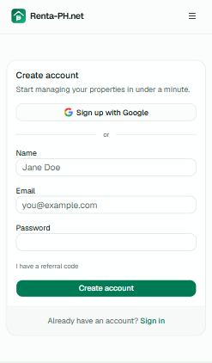

1.2 Your portal dashboard
After logging in you see:
Your current balance (rent + any charges).
A "Pay" button if something is due.
Your payment history.
Any pending payments awaiting your landlord's verification.
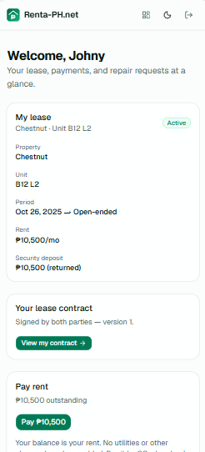

2. Paying rent

2.1 Check your balance
Your balance is shown on the portal dashboard. It includes:
Rent for the current billing period.
Electricity and water (if your landlord sub-meters or bills you for utilities).
Any other charges your landlord has added.
If nothing is due, you'll see "Nothing is due right now."
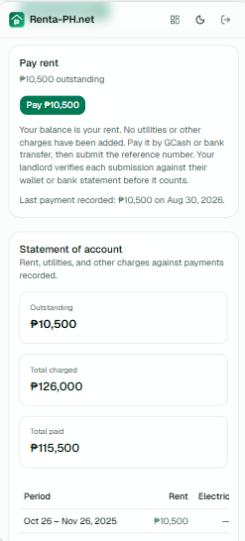

2.2 Pay by GCash or bank transfer
Click "Pay" on your dashboard.
Choose GCash or bank transfer.
Follow the instructions — send money to your landlord's GCash wallet or bank account.
Enter the reference number from your payment.
Submit. Your landlord will verify it against their statement.
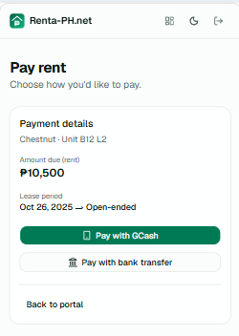
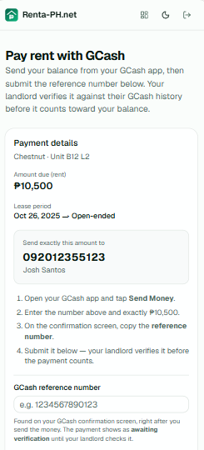
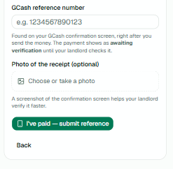

2.3 After you submit
Your payment shows as "Pending" until your landlord verifies it. Once verified, it appears in your payment history and reduces your balance.
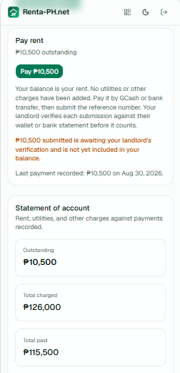

3. Viewing your statement
Your statement shows rent, utilities, and charges against payments, per billing period.
Each row is a billing period (e.g., Feb 14 – Mar 14).
Columns: Rent, Electric, Water, Other, Total due, Paid, Balance.
The statement is printable — use your browser's print function.
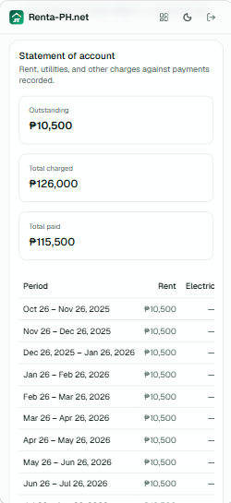
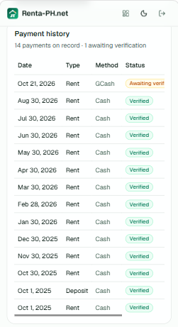

4. Maintenance requests
You can submit maintenance requests for your unit.
Go to "Maintenance" in your portal.
Describe the issue and attach photos if needed.
Submit. Your landlord will see it and update the status.
You can track the status: New → In progress → Resolved.
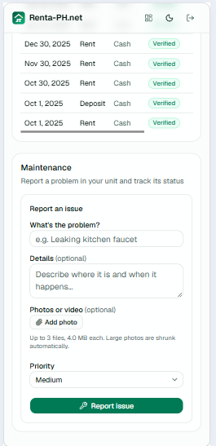

5. Viewing your lease and contract
You can view your lease details and signed contract from the portal.
Lease dates, rent amount, and deposit.
Your signed contract (PDF-ready, printable).
Contract reminders are sent automatically if you haven't signed yet.
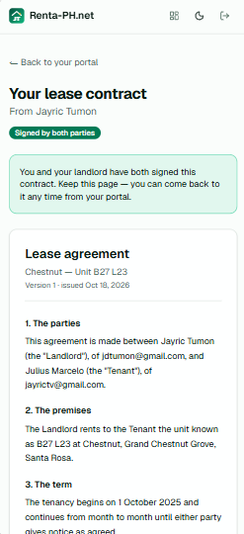

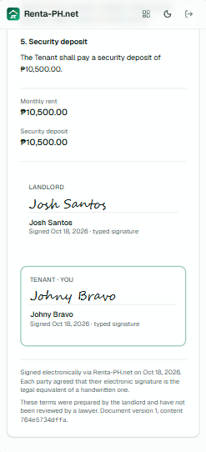

6. Tips
Pay before the due date to avoid late fees.
Keep your reference numbers — they're your proof of payment.
If your GCash or bank details change, tell your landlord so they can update the portal.
Check your statement regularly to catch any discrepancies early.

7. Troubleshooting

I can't log in
Make sure you're using the email your landlord invited. If you forgot your password, use "Forgot password" on the login page.

My payment isn't showing as paid
Payments submitted through the portal appear as "Pending" until your landlord verifies them. This usually takes a day or two.

I see charges I don't understand
Check your statement — it breaks down rent, electricity, water, and other charges per period. If something looks wrong, contact your landlord.

The portal won't load
Try a different browser or clear your cache. If the problem persists, contact your landlord.

