Renta-PH.net — Landlord User Guide
Version 1.0 · For property owners and managers
Renta-PH.net is a property management app built for Philippine landlords. It tracks your properties, units, tenants, leases, rent payments, utilities, and maintenance — all in pesos, with GCash and bank-transfer rent collection and a tenant portal.

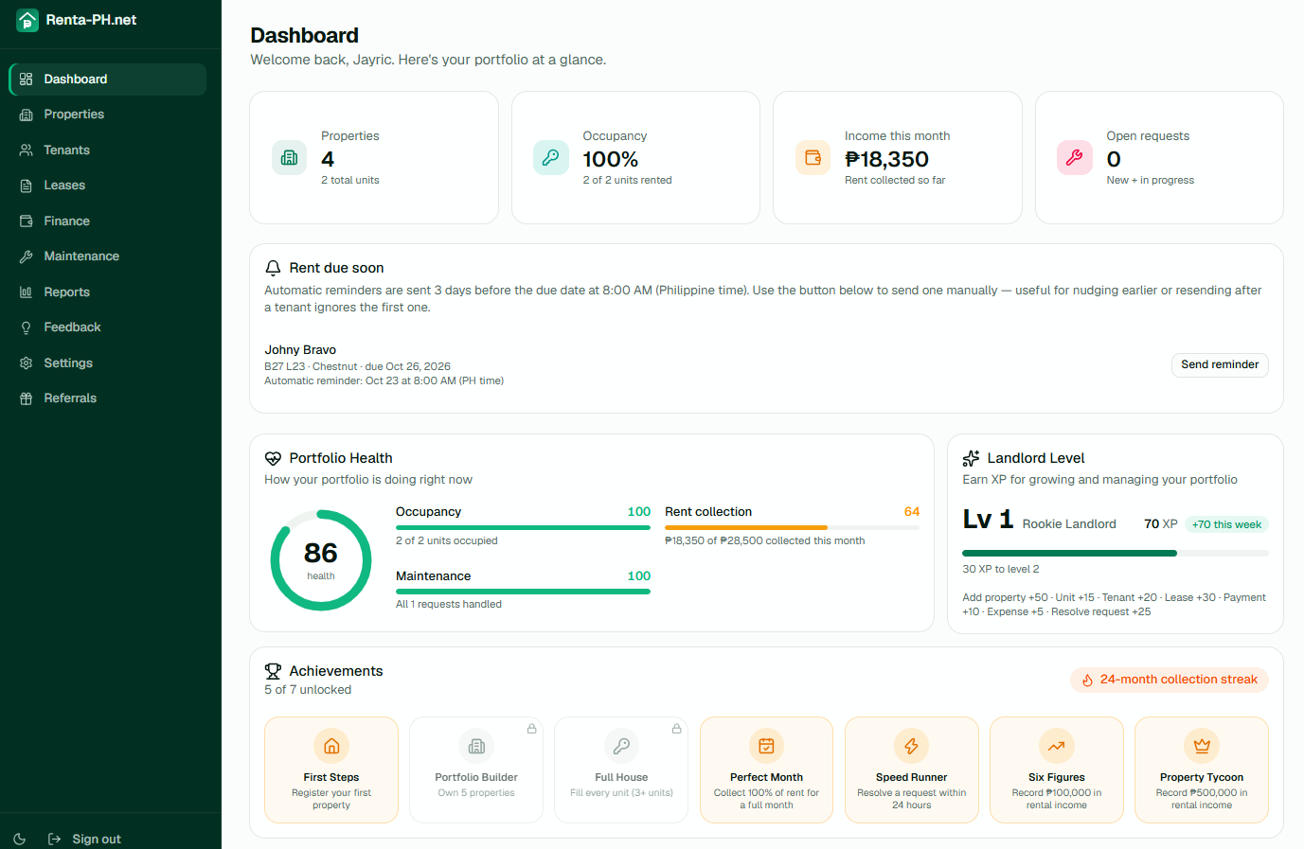

1. Getting started

1.1 Create an account
Go to renta-ph.net and click "Get started".
Enter your name, email, and a password. You'll receive a 6-digit verification code by email.
Enter the code to verify your email. Your account is created and a portfolio is set up automatically.
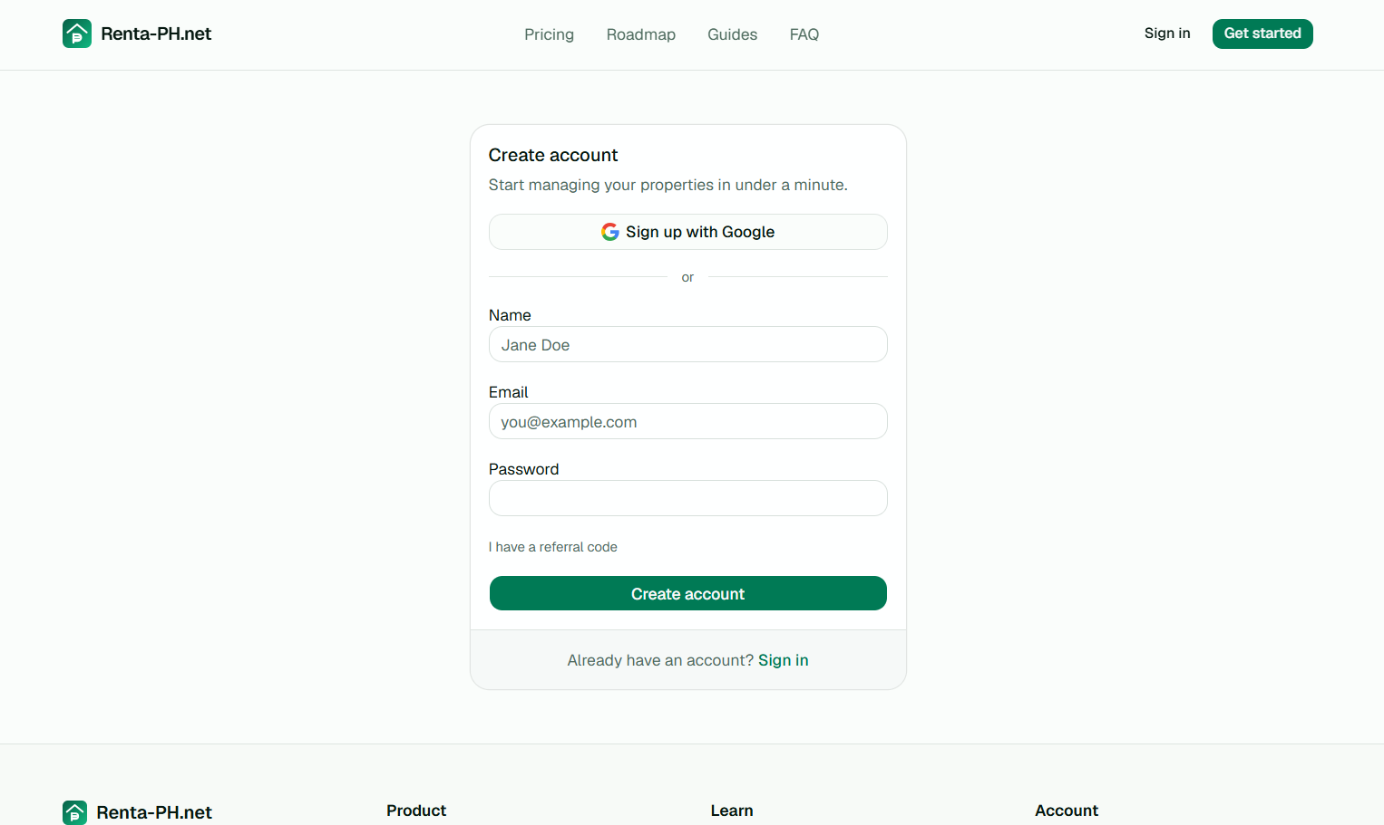

Email Verification Screen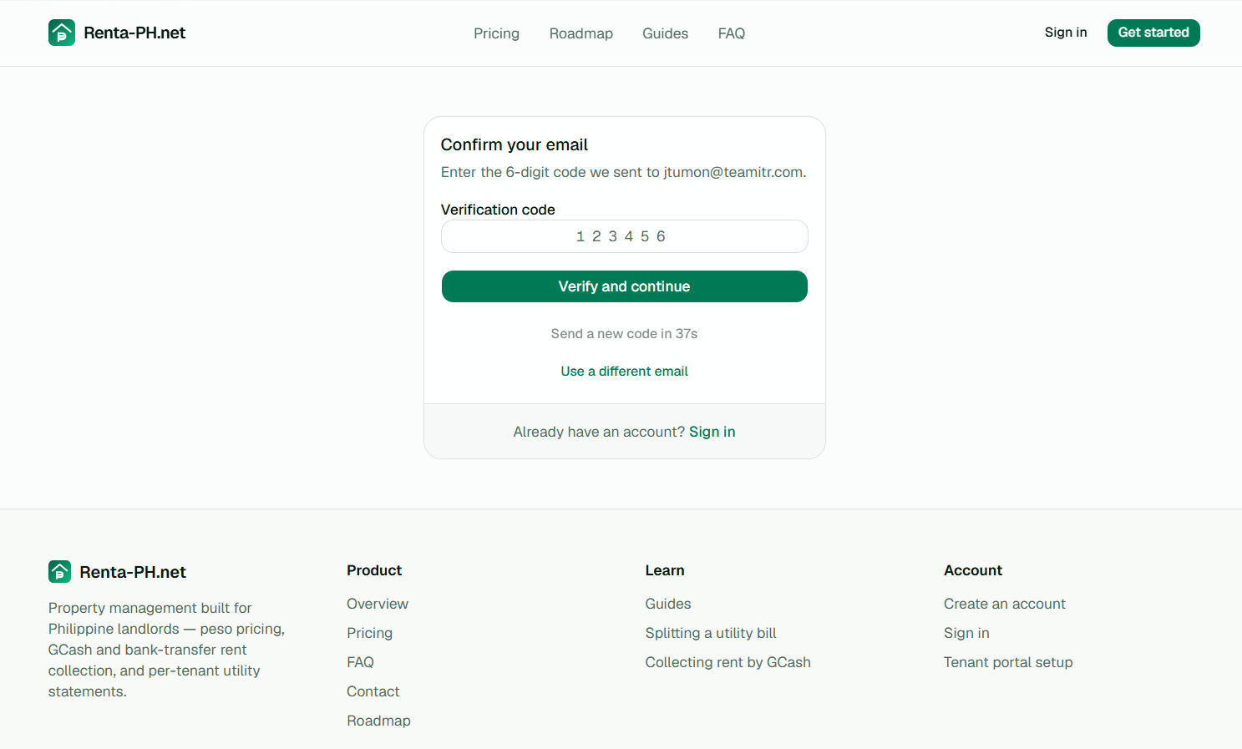

1.2 Your dashboard
After signing in you land on the Dashboard, which shows:
Total properties and units
Occupancy rate
Income collected this month
Open maintenance requests
Upcoming rent (leases due within 7 days) with a "Send reminder" button
Your gamification level, badges, and XP
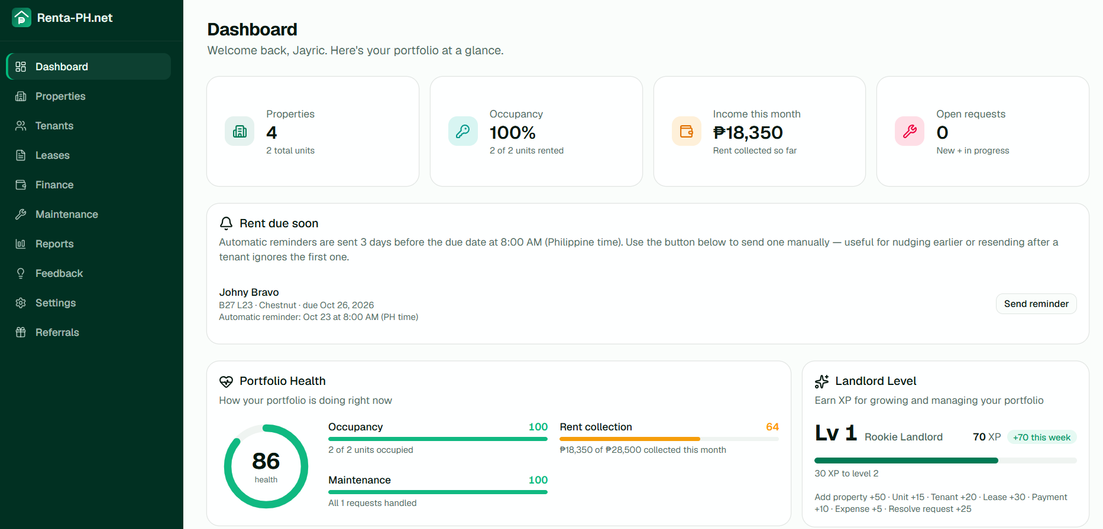

2. Properties and units

2.1 Add a property
Click "Properties" in the sidebar, then "Add property".
Enter the property name and address.
Click Save. The property appears in your list.

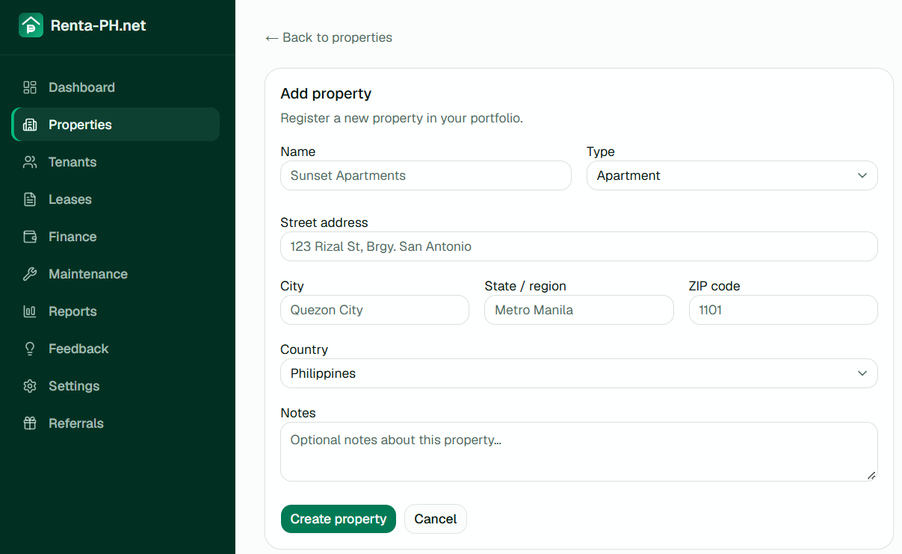

2.2 Add units
A unit is a rentable space inside a property (a room, apartment, or stall).
Open a property and click "Add unit".
Enter the unit name (e.g. "Unit 1A") and monthly rent.
Set the unit status: Vacant or Occupied.
If the unit has sub-meters for electricity or water, add them here.
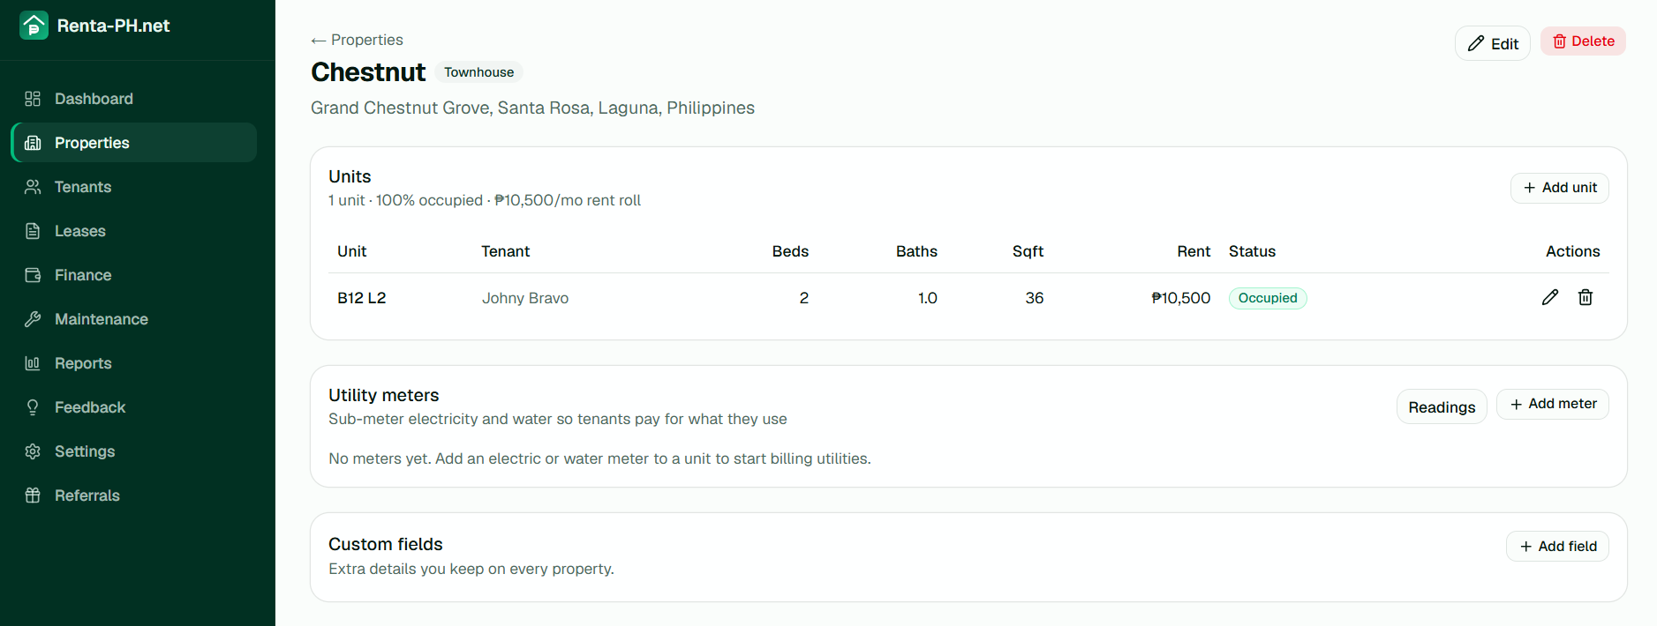

3. Tenants

3.1 Add a tenant
Click "Tenants" in the sidebar, then "Add tenant".
Enter the tenant's name, email, phone, and emergency contact.
Click Save.
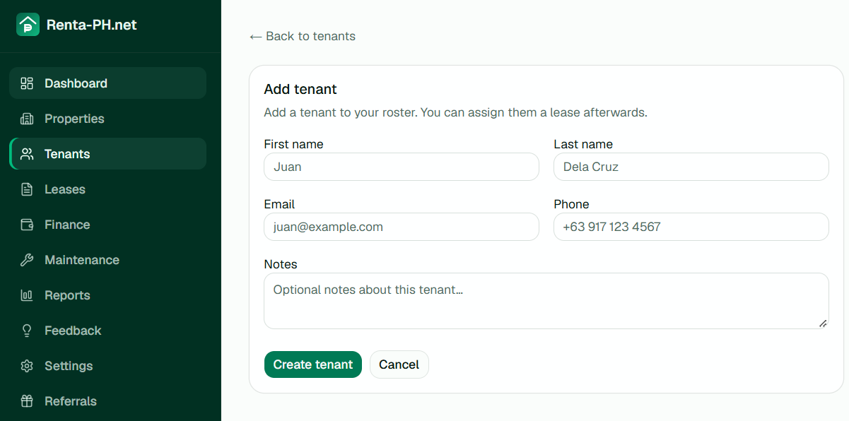

3.2 Invite a tenant to the portal
The tenant portal lets tenants view their statement, pay rent, and submit maintenance requests.
Open the tenant's record and click "Invite to portal".
An email is sent with a link to set up their portal account.
Once they accept, they can log in at renta-ph.net/portal.
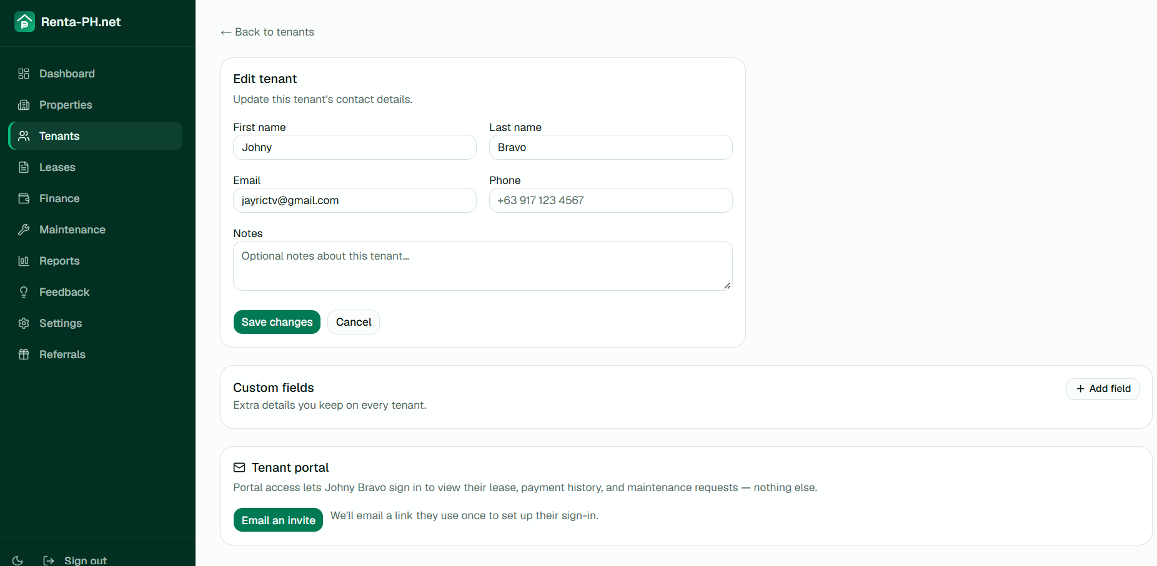

4. Leases

4.1 Create a lease
Click "Leases" in the sidebar, then "New lease".
Select the unit and tenant.
Set the start date, end date (optional), and monthly rent.
Set the rent due day (defaults to the start day). This anchors all billing periods.
Set the deposit amount if applicable.
Click Save.
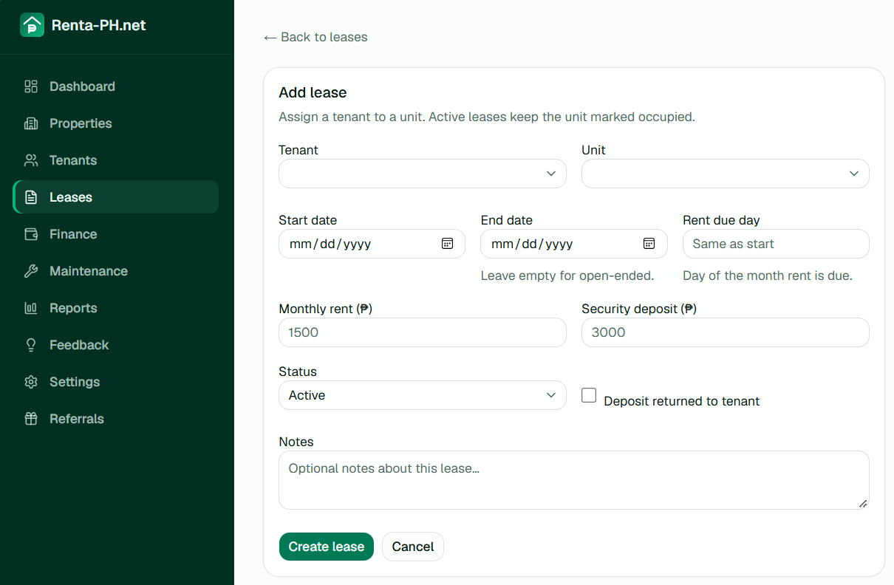

4.2 Manage a lease
Open a lease by clicking on the Tenant name. You can change the end date, rent amount, status, and notes. Existing contracts keep the terms they were signed with.
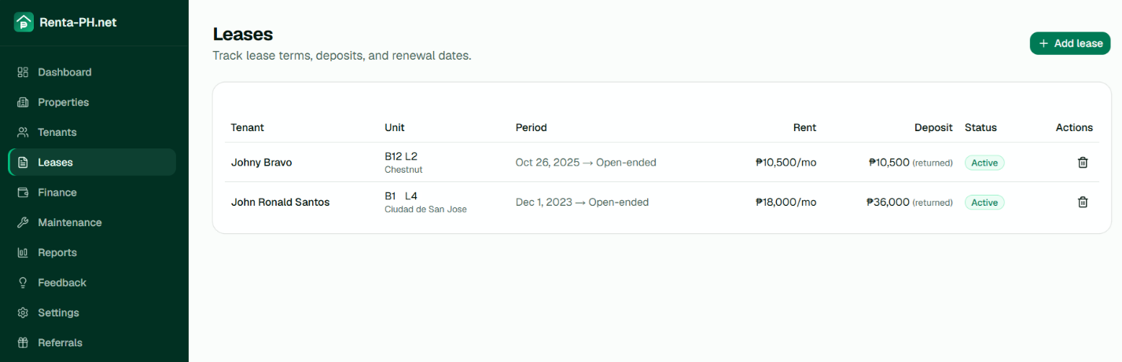

4.3 Lease status
Active — the tenant is currently occupying the unit.
Ended — the lease has expired or been terminated.
Draft — not yet started.

5. Rent collection

5.1 Recording a payment
When a tenant pays rent (cash, GCash, or bank transfer), record it:
Go to Finance → "Record payment".
Select the lease, enter the amount, date, and method.
For GCash/bank transfers, enter the reference number.
Click Save. The payment appears in the ledger and reduces the tenant's balance.
[Screenshot: Record payment dialog with lease, amount, method, reference]

5.2 Verifying tenant-submitted payments
When a tenant pays via GCash or bank transfer and submits a reference number through the portal, it appears as "Pending" in your finance ledger.
Go to Finance and find the pending payment.
Check your GCash or bank statement for the matching reference number.
Click "Verify" to mark it paid, or "Reject" if it doesn't match.
[Screenshot: Pending payment with Verify/Reject buttons]

5.3 Statement of account
Each lease has a statement showing rent, utilities, and charges against payments, per billing period. Both you and the tenant see the same numbers.
Periods run from one rent-due date to the next (e.g., Feb 14 – Mar 14).
Rent, electricity, water, other charges, total due, paid, and balance are shown per period.
The statement is printable — use your browser's print function.
[Screenshot: Statement of account table with periods and columns]

5.4 Rent reminders
Renta-PH.net automatically emails tenants 3 days before their rent due date with the amount and payment instructions (GCash/bank details).
The cron runs daily at 8:00 AM (Philippine time).
Each period is reminded at most once — no double-sends.
The dashboard shows upcoming rent (due within 7 days) with a "Send reminder" button for manual nudges.
Use the manual button to nudge earlier or resend after a tenant ignores the first reminder.
[Screenshot: Dashboard rent-due-soon card with Send reminder buttons]

6. Utility sub-metering

6.1 Adding meters to a unit
Open a property → open a unit → click "Add meter".
Select the type (electricity or water) and enter the meter label.
Set the rate per unit (e.g., ₱12.50 per kWh).
[Screenshot: Add meter form with type, label, rate]

6.2 Recording a meter reading
Go to the property's "Readings" page.
Select the meter and enter the current reading.
The system calculates consumption (current − previous) and the charge.
The reading is filed under the billing period it falls in.
[Screenshot: Meter reading entry with previous/current readings and charge]

6.3 Manual utility charges
If you split the actual utility bill by proportion instead of sub-metering, add a manual charge:
Open the lease → Statement of account → "Add charge".
Select type (electricity or water), enter the amount and description.
Select the billing period the charge belongs to.
[Screenshot: Add charge dialog with type, period, amount]

7. Maintenance requests
Tenants can submit maintenance requests through their portal. You see them in the dashboard and can manage them.
Go to "Maintenance" in the sidebar.
Each request shows the property, unit, tenant, description, and photos.
Update the status: New → In progress → Resolved.
Add notes or assign to a contractor.
[Screenshot: Maintenance request list with status and photos]

8. Contracts

8.1 Creating a contract
Open a lease → click "Generate contract".
Select the template (residential, bedspace, or commercial) and language (English, Filipino, or bilingual).
Review the terms — rent, deposit, dates, and any custom clauses.
Click "Issue contract". The contract is frozen as a snapshot.
[Screenshot: Contract generation with template and language selection]

8.2 Sending for signature
After issuing, click "Send to tenant".
An email with a signing link is sent to the tenant.
The tenant signs without needing an account.
You countersign from your dashboard.
[Screenshot: Contract page with Send to tenant button and signing status]

8.3 Reminders
If the tenant doesn't open the contract, reminders are sent automatically at 3 and 7 days.

9. Tenant portal
The tenant portal is a separate login for tenants. They can:
View their statement of account.
See how much is due and payment instructions (GCash/bank).
Submit a payment reference number after paying.
View and sign their lease contract.
Submit maintenance requests with photos.
[Screenshot: Tenant portal dashboard showing balance and pay button]

10. Reports and finance

10.1 Finance page
The Finance page shows all payments and expenses, with filters by property. You can record payments, verify pending submissions, and manage expenses.
[Screenshot: Finance page with payments and expenses tabs]

10.2 Reports
Three reports are available, exportable as CSV:
Cash flow — income vs. expenses per month.
Profit & loss — per property.
Occupancy — occupied units vs. total per month.
[Screenshot: Reports page with report type selector and CSV export]

11. Referrals
Every landlord gets a referral link. When someone signs up using your link and becomes a paying customer, you earn a bounty.
Share your link from the "Referrals" page.
Track signups and earnings.
Bounties are paid via GCash or bank transfer after a 30-day waiting period.
[Screenshot: Referrals page with link card and earnings summary]

12. Settings
Business name — shown on contracts instead of your personal name.
GCash details — wallet number and name shown to tenants.
Bank accounts — accounts tenants can transfer rent to.
Portfolio members — invite co-owners or managers.
Custom fields — extra details on properties, leases, and tenants.
Email delivery — test your email transport (Gmail or Resend).
Sign-in — connect or disconnect Google sign-in.
[Screenshot: Settings page with all cards]

13. Troubleshooting

I can't receive emails
Check Settings → Email delivery and send a test email. If using Resend, verify your domain in the Resend dashboard.

A tenant's payment isn't showing
GCash/bank transfer payments submitted through the portal appear as "Pending" until you verify them. Check Finance → pending payments.

The statement shows wrong numbers
Make sure meter readings are filed under the correct billing period. Charges are also period-specific — check the period selector when adding a charge.

I forgot my password
Use "Forgot password" on the login page. A reset link is sent to your email.

