UNIVERSITY OF TECHNOLOGY

School of Computing and Information Technology

Presented in Partial Fulfillment of the Course Requirement
Data Structures using C++

“Simple Solutions Now Payroll Management System”

Group Members:
Dale McFarlane – 0801422
Robert Campbell – 0701334
Dyonne Duberry – 0802189
Audley Gordon – 0802218
Lecturer: Tyrone Edwards
Tutor: D. White
Group: BSC2D
Main Menu

Upon running the executable file, the user will be presented with a menu as displayed in the image below.
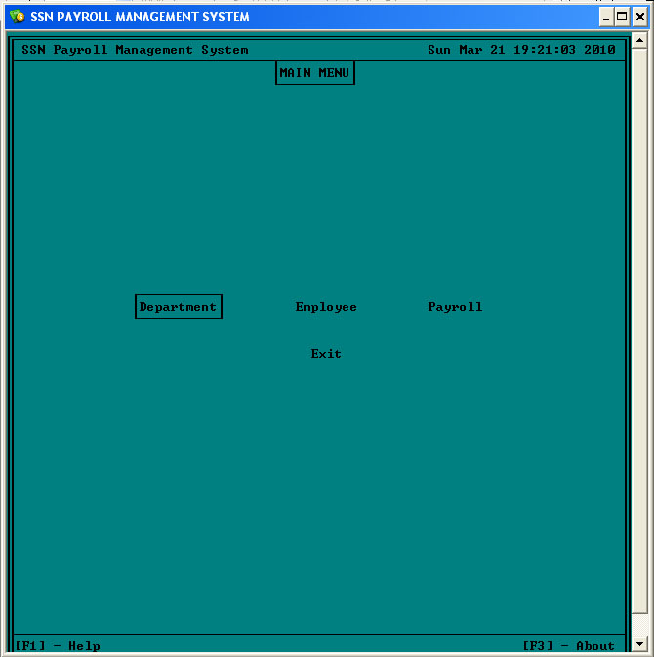

The user will be able to select any item from the menu by navigation it with the navigation keys (up, down and tab). The user selects an item by pressing the “Enter” key when the desired item is highlighted.

Department Menu
Upon selecting “Department” from the “Main Menu”, the user will be presented with the menu illustrated below.
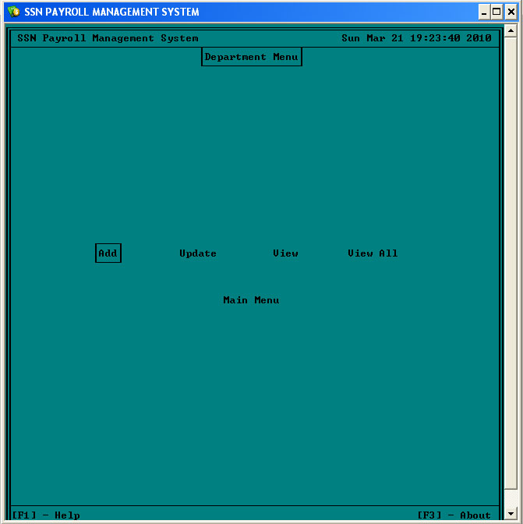

Upon selecting “add” from the “Department Menu”, the user will be taken to a form to enter the information on department as show below.
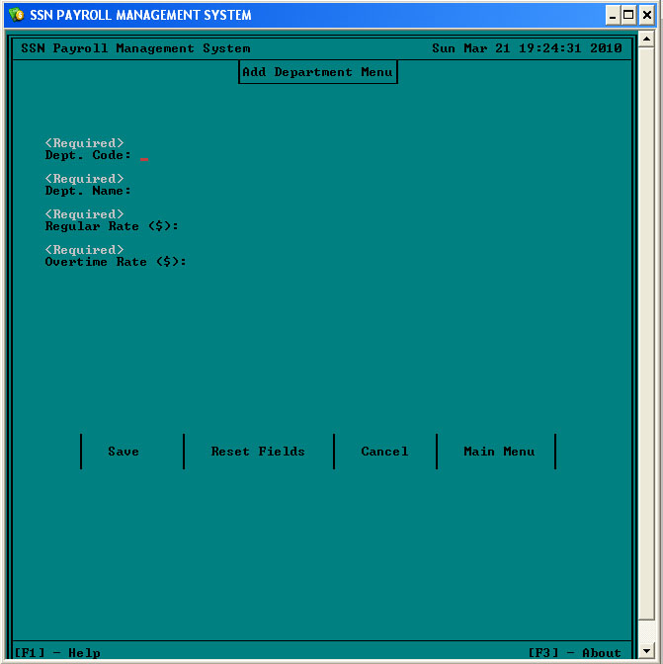

When the user completes the form below, they will be able to save the new department record e.g.
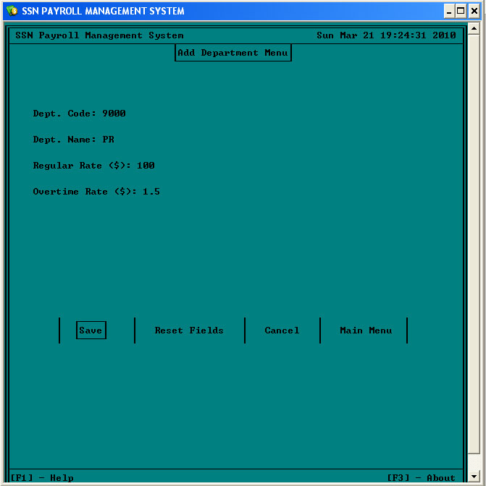
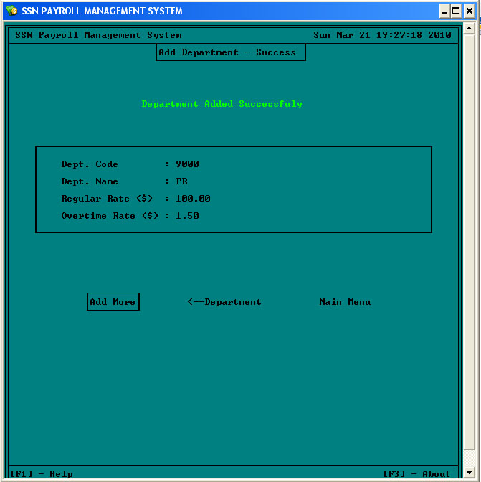

Department data can be updated to reflect changes. Dependent employee records will be automatically updated.
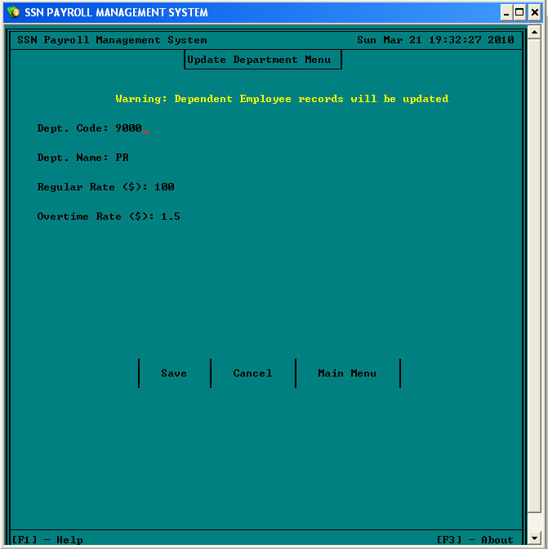

The user may select either of two view options; view a specific department code or view all of the department listing.
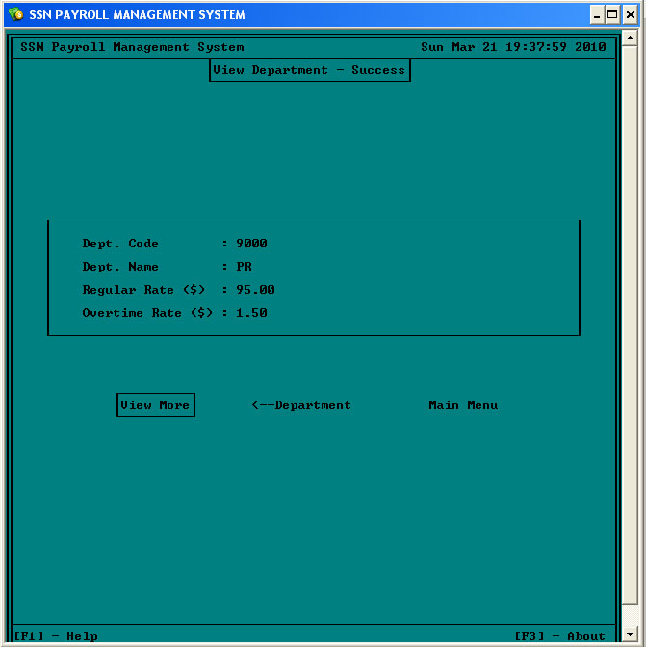

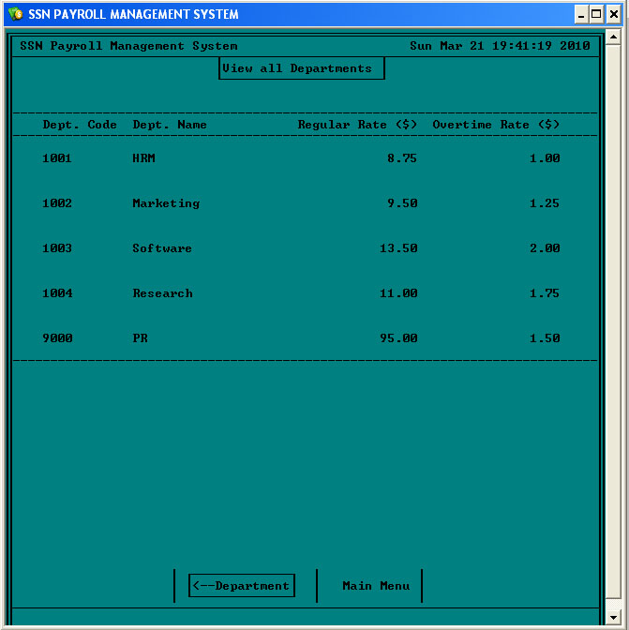
Employee Menu
The user will be presented with this menu if they select “Employee” from the main menu. After selection, the user has the choice to Add, Update, View, View Sorted, Delete or return to the Main Menu.
