UNIVERSITY OF TECHNOLOGY

School of Computing and Information Technology

Presented in Partial Fulfillment of the Course Requirement
Data Structures using C++

“Simple Solutions Now Payroll Management System”

Group Members:
Dale McFarlane – 0801422
Robert Campbell – 0701334
Dyonne Duberry – 0802189
Audley Gordon – 0802218
Lecturer: Tyrone Edwards
Tutor: D. White
Group: BSC2D
Main Menu

Upon running the executable file, the user will be presented with a menu as displayed in the image below.
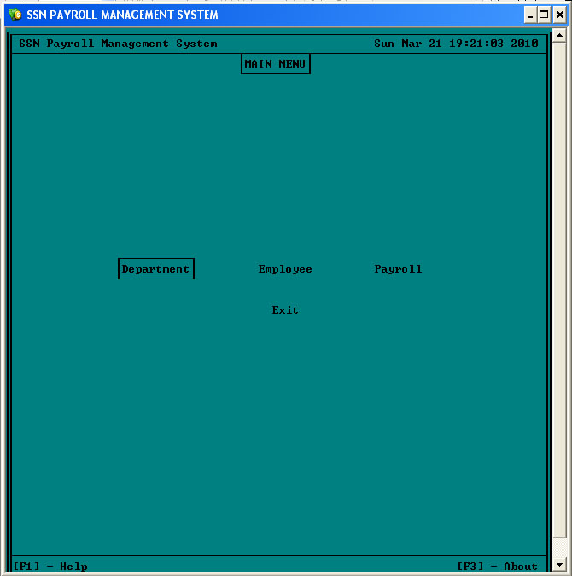

The user will be able to select any item from the menu by navigation it with the navigation keys (up, down and tab). The user selects an item by pressing the “Enter” key when the desired item is highlighted.

Department Menu
Upon selecting “Department” from the “Main Menu”, the user will be presented with the menu illustrated below.
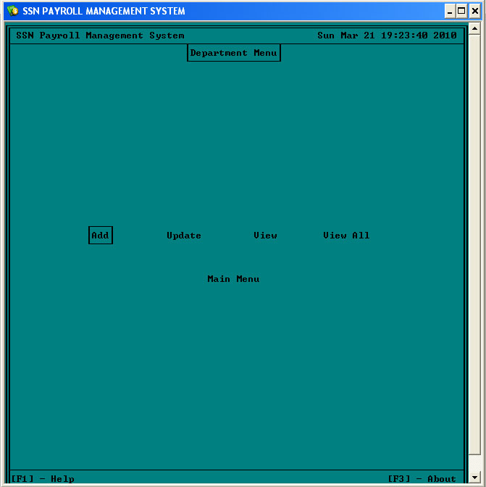

Upon selecting “add” from the “Department Menu”, the user will be taken to a form to enter the information on department as show below.
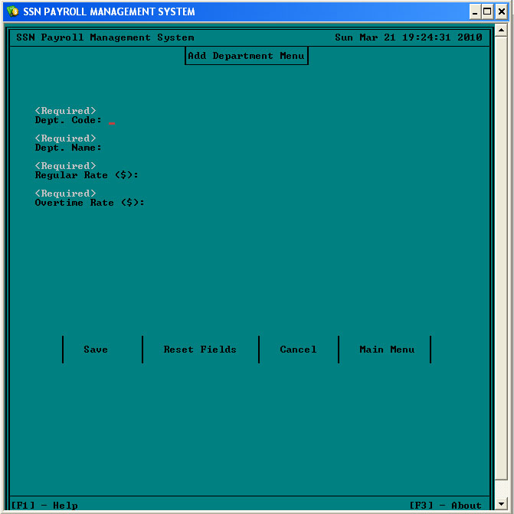

When the user completes the form below, they will be able to save the new department record e.g.
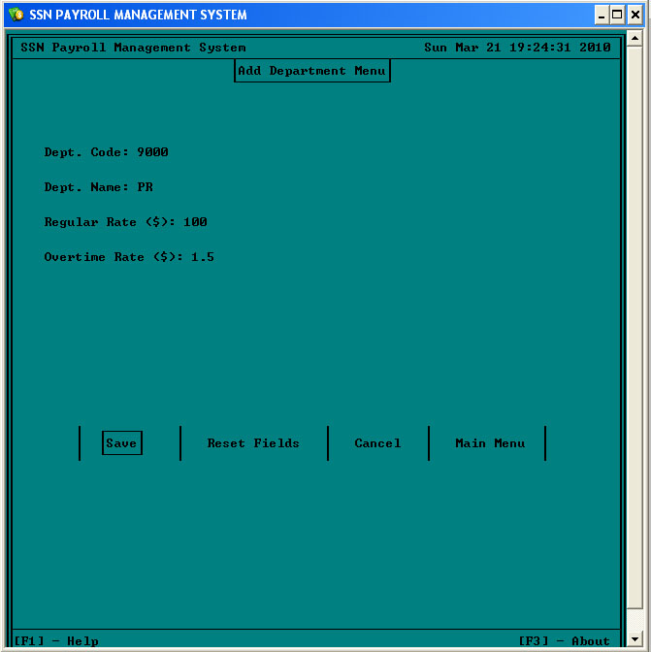
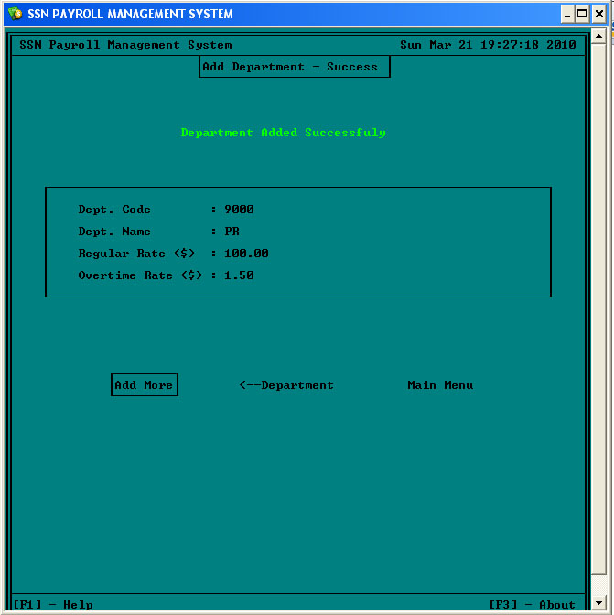

Department data can be updated to reflect changes. Dependent employee records will be automatically updated.
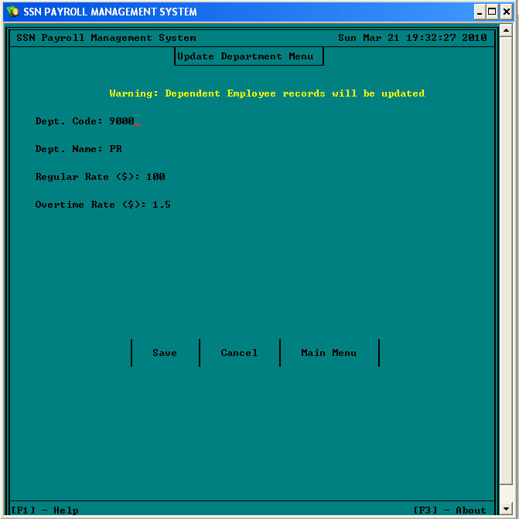

The user may select either of two view options; view a specific department code or view all of the department listing.
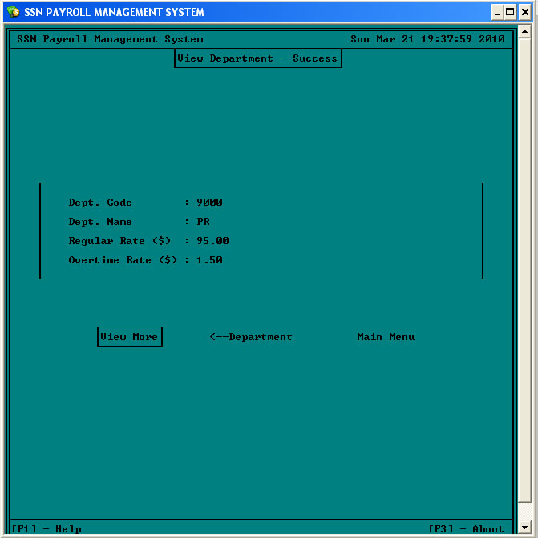

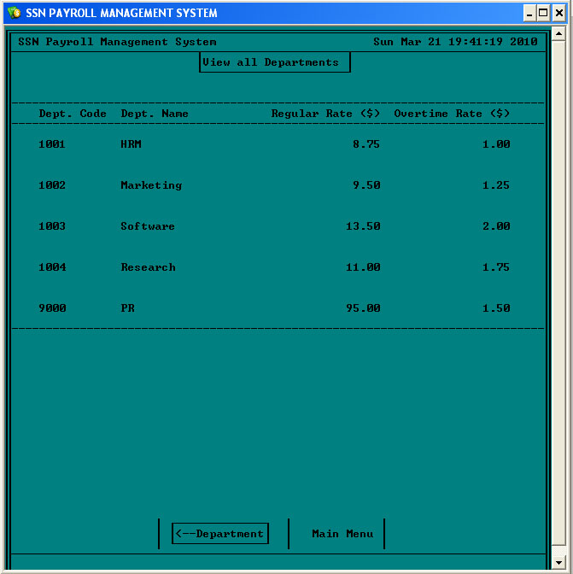
Employee Menu
The user will be presented with this menu if they select “Employee” from the main menu. After selection, the user has the choice to Add, Update, View, View Sorted, Delete or return to the Main Menu.
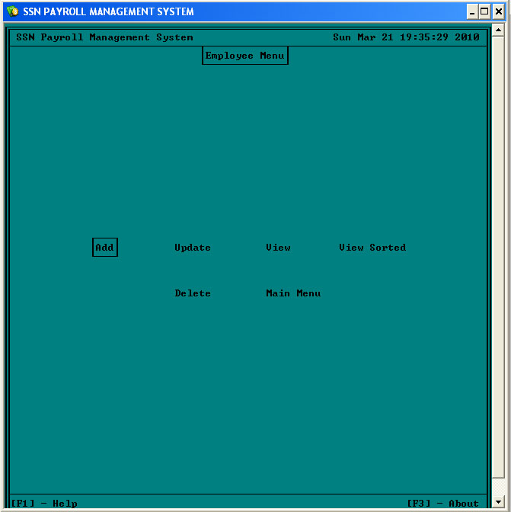
All the required fields must be filled out for each new employee that is created.
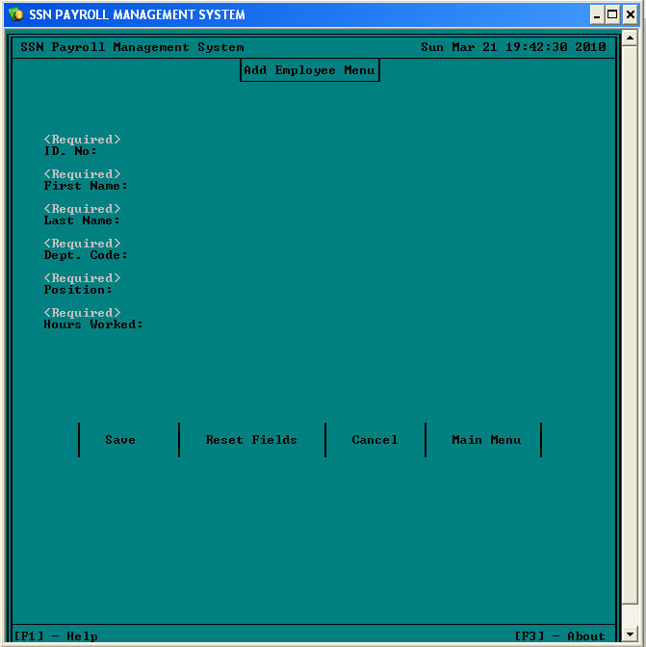

Employee credentials are confirmed after they are entered in the system to create a new user.
N.B. that the Department code must exist before an employee is assigned!!
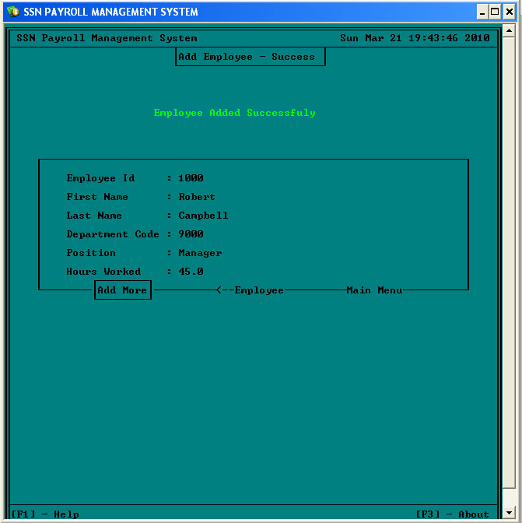
After searching for an existing employee, the user is able to make changes to the employee credentials.
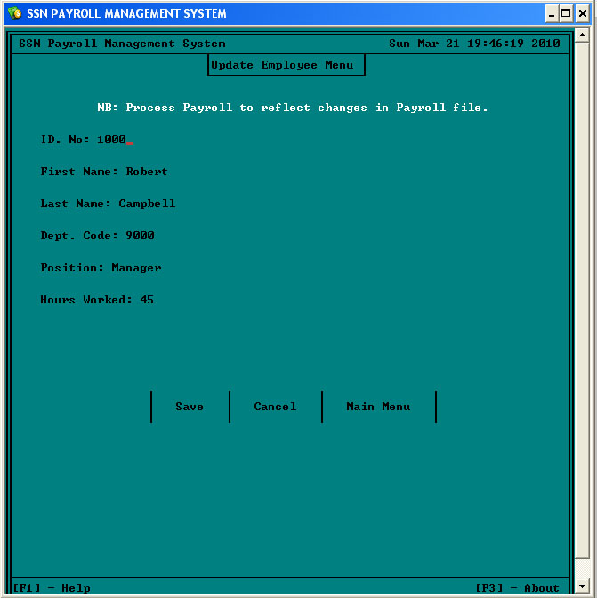
It is possible to create a sorted list of employees by selecting “View Sorted List” from the employee menu. Various methods can be used to sort the employee list (By ID, Last Name, Dept. Code etc.)
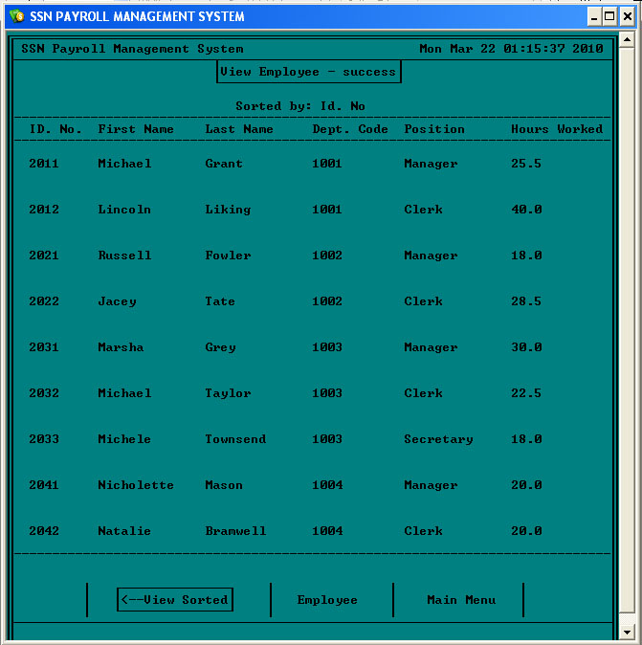

Payroll Menu
All payroll operations are accessed by selecting Payroll from the Main Menu. The user will then have the option to Process, View, or view the sorted Payroll.
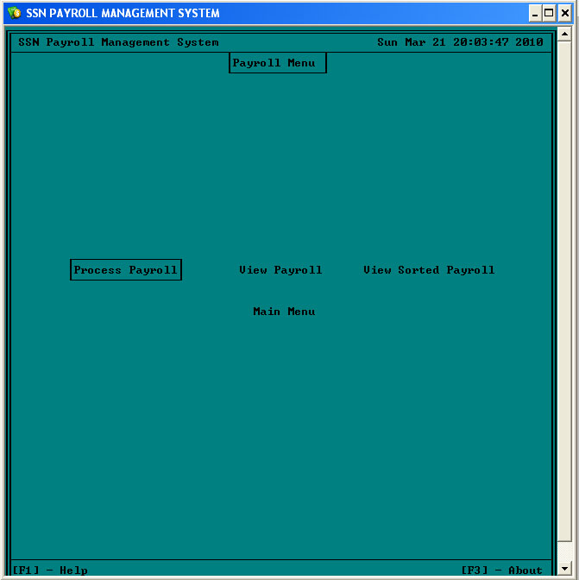
To view the payment info for an employee, select View Payroll and enter the employee Id Number. The credentials will be displayed as long as the information exists on file for that employee.
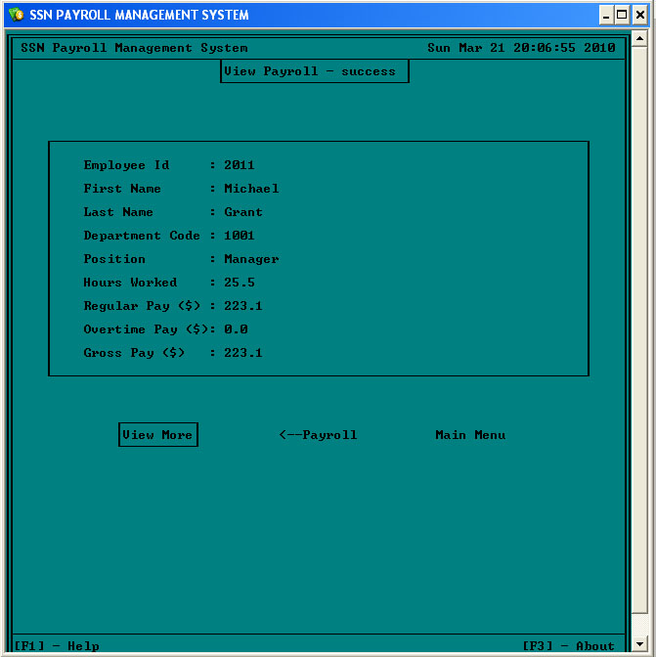

To view a sorted payroll, the user has the option to sort the payroll by Id number, Last Name, Department Code or the Position.
