**Caffeine Haven**

(Promotional Material for a New Cafe Opening)

Jay Sam Catacutan - Project Manager

LJ Malinao - Content Creator

Vea Alagad - Researcher/Writer

Nica Jane Dayot - Designer/Technical Specialist

**Introduction** Promotional materials are vital to the successful launch of a new café, helping to capture attention and draw in customers from day one. These materials can take many forms, including printed flyers, banners, and posters as well as digital content like social media posts, videos, and email campaigns. Each type serves to showcase the café’s unique atmosphere, highlight signature products, and announce special opening promotions. By combining eye-catching visuals with clear and consistent branding, promotional materials create excitement and build anticipation, encouraging potential customers to visit and experience what the café has to offer.

A well-executed promotional campaign goes beyond just attracting initial visitors—it also helps establish a loyal customer base. Highlighting the café’s personality through compelling imagery and messaging fosters an emotional connection with the community. Special opening offers, such as discounts and loyalty programs, incentivize repeat visits and word-of-mouth referrals, which are crucial for long-term success. Ultimately, investing in thoughtfully designed promotional materials ensures the café stands out in a competitive market and lays a strong foundation for growth and lasting customer relationships.

**Planned Main Ideas**

1. **Design & Branding of Promotional Materials**
   * Create a cohesive visual identity for the café, including a logo, brand colors, and fonts that reflect the café’s personality.
   * Develop both print and digital promotional assets such as flyers, posters, and social media templates.
2. **Pre-Launch Marketing Strategies**
   * Organize teaser campaigns on social media with behind-the-scenes photos, short videos, and countdown posts.
   * Distribute printed flyers in the local community and partner with nearby businesses for cross-promotion.
3. **Grand Opening Event Activities**
   * Plan an interactive opening event featuring coffee tastings, live music, and giveaways (e.g., free drinks or branded merchandise).
   * Invite influencers, media representatives, and community members to generate buzz and coverage.
4. **Post-Opening Engagement**
   * Outlined a follow-up marketing plan including customer loyalty cards, social media contests, and seasonal promotions.

## **Image**

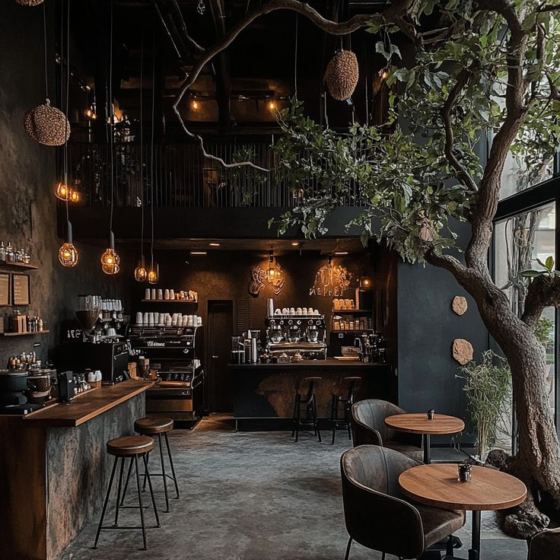

## 

## **Conclusion**

This proposal reflects our group’s dedication to creating a well-planned and engaging launch for a new café. By combining creative design, strategic marketing, and community engagement, we aim to ensure the café not only has a memorable grand opening but also establishes itself as a valued part of the local community. We believe that our approach rooted in thorough research and careful execution will lead to a successful and sustainable café business that customers will be excited to visit again and again.