**Assignment 3 – Report**

gbc.myCommunity

Jason Recillo, 100726948

# 1. Database Schema

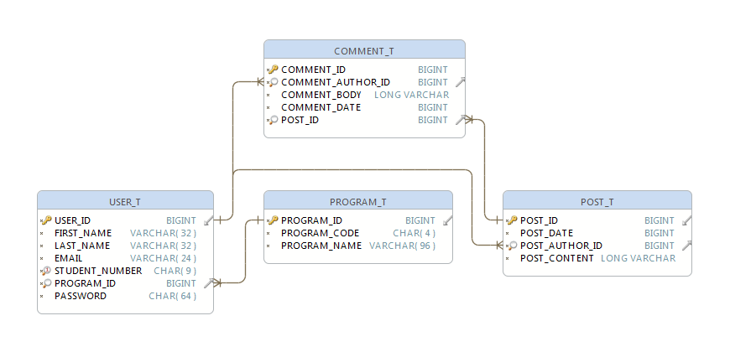

# 2. Data Access Layer (DAL) Implementation

All of the data access classes (located in the com.jaysan1292.project.c3062.db package) extend BaseDbManager, an abstract class which defines implementations for basic methods such as insert(), get(), update(), and delete(). Each class that extends BaseDbManager implements buildObject(), doUpdate(), doInsert(), and doDelete(), where the class can specify its own implementation on how to build an object, given a ResultSet from the database, update an existing object, add a new object, and delete an object, respectively. Subclasses themselves are of course free to add any new functionality which is relevant for the specific object it is managing, such as “get all comments for this post”, or “get all posts created by this user”.

# Technical Details/Other Notes

The database is created on startup and deleted on shutdown. On startup, a “realistic” amount of users are created, random quantities of posts are generated, and comments for those posts are also generated. On my computer, it can take an average of about 1 minute and 20 seconds to finish initializing, and this time can vary depending on the speed of the computer. So, if running via Eclipse, *make sure to increase the startup timeout* in order to allow the server to finish generating all the content. :) It helps to be able to view the console output to see how far along it is (although the output acts a little odd in Eclipse, as I use \r to update the indicator, and it seems to take those as a newline).